Evaluation of Flexural Strength of Concrete with Impregnated Different Polymers
Sapan Gupta¹ & Dr. Lokesh Singh² & R C Singh³
1M-Tech Scholar, Dept. of Civil Engineering, RSR-RCET Bhilai, India
2Assistant Professor, Dept. of Civil Engineering(HOD), RSR-RCET, Bhilai, India
3Assistant Professor, Dept. of Civil Engineering , RSR-RCET, Bhilai, India
---------------------------------------------------------------------***---------------------------------------------------------------------

Abstract— The polymer concrete is a composite that is obtained by the assimilation of a polymeric material into the concrete matrix. This is helpful in reducing water cement ratio and enhancing flexural strength of concrete matrix . This is carried out by impregnating polymer compound during the concrete mixing phase.
Here in this research study it is tried to evaluate the behaviour concrete properties with different types of polymers such as SBR-Latex, Poly Carboxyl ate Ether and Poly Ethylene Glycol. For this study M30 grade of concrete mix is prepared and carried; with different types of polymers and complete study on workability, strength, compaction, flexural strength has been studied.

Key Words — Polymer, Impregnating, Hydrated gel, Durability, Sustainability, SBR-Latex, Ethylene Glycol and Polycarboxylate.

INTRODUCTION

Polymer concrete is a part of group of concretes that use polymers to/or supplement or replace cement as a binding material. Polymer concretes are fairly high- performing materials that have been developed since the early 1960’s. Polymer concrete consists of well-graded aggregates bonded together by a strong resin binder instead or along with water and cement, which are alone typically used in cement-based materials. Polymer concretes are very strong, anticipated to be durable, and cures very rapidly, which is a significant deliberation in many civil engineering applications. This rock like material is a brittle material which is strong in compression but very weak in tension due to which cracks get developed and concrete fails simultaneously.

Classification of Polymer-Concrete Materials.
Significant progress has been made recently in both fundamental and applied research on all kinds of polymer/concrete system. There exist three principal classes of polymer concrete materials viz., (a) Polymer-
Portland Cement Concrete (PPCC), (b) Polymer impregnated Concrete (PIC) and (c) Polymer Concrete (PC).
- Polymer Portland Cement Concrete (PPCC) - A monomer, pre-polymer of dispersed polymer is incorporated into a Portland cement mix and a polymer network formed in situ during curing of the concrete.
- Polymer-Impregnated Concrete (PIC) - Previously formed concrete is impregnated with a monomer which is subsequently polymerized insitu. A polymer enhances the Strength Characteristics of the original concrete.
- Polymer Concrete (PC) - It is also known as Resin Concrete. A polymer is used to bind an aggregate together.

Water/cement ratio have a significant influence on the mechanical properties of concrete. The strength of concrete at a given age is assumed to depend primarily on two factors only: the w/c ratio and the degree of compaction [12]. Abrams’ law is well known for the relation of strength and w/c ratio of the concrete. The Abrams law developed for strength of 54 concrete is given below.

Where K1 and K2 are constants, c is mass of cement and w is mass of water.
This formula is valid over the range of water to cement ratio of 0.3 to 1.20. He has confirmed that the application of the Abrams’ law is valid to any duration between 3 to 365 days of concrete age. Researchers like (Rao) developed the empirical model expressions to predict the compressive strength and split tensile strength of mortar using water/cement ratio based upon Abram’s law and observed that it is applicable to mortars with water/cement ratio greater than 0.40.
The water–cement ratio is the ratio of the weight of water to the weight of cement used in a concrete mix. A lower ratio leads to higher strength and durability, but may make the mix difficult to work with and form. Workability can be resolved with the use plasticizers or super-

plasticizers. Concrete hardens as a result of the chemical reaction between cement and water (known as hydration, this produces heat and is called the heat of hydration). For every pound (or kilogram or any unit of weight) of cement, about 0.35 kg or corresponding unit) of water is needed to fully complete hydration reactions. However, a mix with a ratio of 0.35 may not mix thoroughly, and may not flow well enough to be placed. More water is therefore used than is technically necessary to react with cement. Water–cement ratios of 0.45 to 0.60 are more typically used. For higher- strength concrete, lower ratios are used, along with a plasticizer to increase flowability.

Functions of polymers in concrete.
Admixtures are classed according to function. There are five distinct classes of chemical admixtures: air- entraining, water-reducing, retarding, accelerating, and plasticizers (superplasticizers). All other varieties of admixtures fall into the subject class whose function includes corrosion inhibition, shrinkage reduction, alkali- silica reactivity reduction, workability enhancement, bonding, damp proofing, and colouring.
- Water-reducing admixtures usually reduce the required water content for a concrete mixture by about 5 to 10 percent. Consequently, concrete containing a water-reducing admixture needs less water to reach a required slump than natural concrete. The treated concrete can have a lower water-cement ratio. Hence; shows that the higher strength concrete can be produced without increasing the volume of the cement. Recent advancements in admixture technology have led to the development of mid-range water reducers. These admixtures reduce water content by at least 8 percent and tend to be more stable over a wider range of temperatures. Mid-range water reducers provide more consistent setting times than standard water reducers.
- Retarding admixtures, which slow the setting rate of concrete, are used to counteract the accelerating effect of hot weather on concrete setting. High temperatures often cause an increased rate of hardening which makes placing and finishing difficult. Retarders keep concrete workable during placement and delay the initial set of concrete. Most retarders also function as water reducers and may entrain some air in concrete.
- Accelerating admixtures increase the rate of early strength development; reduce the time required for proper curing and protection, and speed up the start of finishing operations. Accelerating admixtures are
especially useful for modifying the properties of concrete in cold weather.
- Superplasticizers - also known as plasticizers of high- range water reducers (HRWR), reduce water content by 12 to 30 percent and can be added to concrete with a low-to-normal slump and water-cement ratio to make high-slump flowing concrete. Flowing concrete is a highly fluid but workable concrete that can be placed with little or no vibration or compaction. The effect of superplasticizers lasts only 30 to 60 minutes, depending on the brand and dosage rate, and is followed by a rapid loss in workability. As a result of the slump loss, superplasticizers are usually added to concrete at the jobsite.
- Corrosion - inhibiting admixtures fall into the specialty admixture category and are used to slow corrosion of reinforcing steel in concrete. Corrosion inhibitors can be used as a cynical strategy for concrete structures, such as marine amenities, highway bridges, and parking garages, that will be exposed to high concentrations of chloride. Erstwhile admixtures include contraction - plummeting admixtures and alkali-silica reactivity inhibitors. The shrinkage reducers are used to control drying shrinkage and minimize cracking, while inhibitors control durability problems associated with alkali-silica reactivity.

Objective of Study.
The objective of this foremost thesis research work is to find effect of different polymer based super plasticizers in concrete matrix. What will be the effect of introduction of polymers in concrete, whether it enhances its mechanical properties or hinders its. The selected polymers like, SBR latex, PCE & PEG have different chemical formulation what be their effects on plasticity, curing, strength is to be studied. For this purpose OPC has been selected with all this three polymers to produce M30 grade concrete.

LITERATURE REVIEW

A.S. ElDieb et. Al. [1] “Self Curing Concrete: Water Retention, Hydration and Moisture Transfer” The objective of the research was to find out the water retention capacity and degree of hydration and moisture transport by using self-curing agent and compare to conventional curing of concrete. The self-curing agent used in this study was water soluble polymer polyethylene glycol.
The following could be concluded from the results obtained in this study.

- Self-curing concrete suffered less self-desiccation under sealed conditions compared to conventional concrete.
- Self-curing concrete resulted in better hydration with time under drying condition compared to conventional concrete.

Wen-Chen Jau [2] “Self Curing Concrete” The objective of this research work was to find out the effect of high performance self-curing agent on strength characteristics of self compacted concrete in comparison with ordinary concrete. The dosage of self curing agent was 1% and 2% by weight of cement.
There concluded from the results obtained in this study is the self curing concrete wherein a specific amount of the self-curing agent is added to the concrete such that a 10% higher compressive strength than that of concrete without curing. Compressive strength of self compacting concrete in this invention was improved significantly, or even higher than the compressive strength of standard moist curing.

Yoshihiko Ohama et. Al. [3] “Properties of Polymer- Modified Mortars Using Styrene-Butyl Acrylate Latexes with Various Monomer Ratios”, this work deals with the effect of the monomer ratio on the typical properties of the polymer-modified mortars with styrene-butyl acrylate latexes. The following could be concluded from the results obtained in this study.
- The properties are affected to a great extent by both monomer ratio and polymer-cement ratio, investigated the effect of the monomer ratio on the typical properties of polymer modified mortars with styrene butyl acrylate latexes.
- The properties (pore size distribution, flexural and compressive strengths, water absorption, and drying shrinkage) were affected largely by both monomer ratio and polymer cement ratio.

Jingjing Xiao et. Al. [4] “Effect of styrene–butadiene rubber latex on the properties of modified porous cement stabilized aggregate” A laboratory experiment was conducted in this study to improve the cracking properties of PCSA through the incorporation of styrene butadiene rubber (SBR) latex. The effects of SBR latex usage on permeability, compressive strength, flexural strength and anti-freezing ability of PCSA were investigated.
The following could be concluded from the results obtained in this study.
- Test results indicate that the air voids and permeability coefficient decreased with the increase of SBR latex dosages.
- The flexural strength and anti-freezing ability were improved when the SBR latex dosages is between 10% - 15%. While 7 days compressive strength has a slightly decrease while the 28 days compressive strength increased.

Amel Kamoun et. Al. [5] “Evaluation of the performance of sulfonated esparto grass lignin as a plasticizer–water reducer for cement” The objective of the work is an investigation of the preparation of a sulfonated esparto grass lignin (SEL) and its behavior as a plasticizing–water-reducing agent for cement–water systems. Conclusion from the results obtained in this study is SEL has a good plasticizing effect on mortars. It also permits a reduction of the water content in a given mortar mix without affecting the workability. SEL, as all LS-based plasticizers, leads to a moderate delay of the initial and final times of set. In addition, SEL allows an increase of the compressive strength after 28 days of age.

Raman Bedi et. Al. [6] “Mechanical Properties of Polymer Concrete” The polymerized monomer acts as binder for the aggregates and the resulting composite is called Concrete; because of its properties like high compressive strength, fast curing and resistance to chemical attacks polymer concrete has found ample applications.
The following could be concluded from the results obtained in this study.
- Comparative studies between epoxy and polyester resins report that epoxy polymer concrete has far superior mechanical properties and durability.
- The resin dosage reported mostly lies in the range of 10 to 20% by weight of polymer concrete. Higher resin dosage is recommended when using fine aggregate.

F. Puertaset. Al. [7] “Polycarboxylate superplasticiser admixtures: effect on hydration, microstructure and rheological behaviour in cement pastes” study was conducted on the effect of a polycarboxylate (PC) admixture on the mechanical, mineralogical, micro structural and rheological behaviour of Portland cement pastes. The following could be concluded from the results obtained in this study.
- PC admixture on cement hydration show that at very early ages an initial retardation of cement hydration is produced.

- Results from rheological studies it can be concluded that low dosage of PC leads to a substantial reduction (over 70%) in the yield stress.

Kaushal Kishore et. Al. [8] “Polymer modified mortars and concrete mix design” Out of a range of polymer-modified concrete, latex-modified mortar and concrete have superior properties, such as high tensile and flexural strength, excellent adhesion, high water-proofness, high abrasion resistance and good chemical resistance, to ordinary cement mortar and concrete.
The mix proportions of most latex-modified mortars are in the range of the cement; fine aggregate ratio = 1:2 to 1:3 (by weight), the polymer-cement ratio 5 to 20% and the water-cement ratio of 30 to 60%, depending on their required workability.

EXPERIMENTAL BACKGROUND AND ANALYSIS
Investigational efforts have been conceded by mixing natural and synthetic polymers in different proportions to the M30 grade concrete while mixing as per mix design data. The M30 grade concrete is prepared by using mix designing procedural guidelines as per IS: 10262 - 2009. The detailed concrete mix designing process erstwhile explained afterward. The various proportions of polymers like SBR- Latex, PEG and PCA are used within the proportioning of M30 grade concrete in following percentage of 5%.
These matrix mix masses were used to prepare specimens of cube and prism which are earlier examined for workability and further placed to testing for the determination of their mechanical strength via; compressive strength & split tensile strength. For workability tests is performed by slump cone test.

Table No. 1 - Properties of Aggregates used in the study conforming to IS: 383 -1970 and IS: 2386 - 1963.
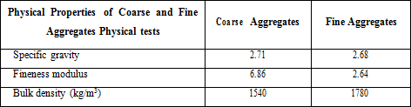
Type of Cement (confirming to IS-8113-1989) Used is OPC 43 grade. Exposure Condition from (IS 456: 2000) is assumed to be severe. Concrete is pump able with slump control value of 80 mm.
Table No. 2 –Proportion used in different types of concrete M30 Mix.
Type of Concrete | Cement  (m3) | Coarse Aggregate (kg/ m3) | Fine Aggregate (kg/ m3) | Water  (litre)
0%  polymer Concrete | 0.131 | 1153.452 | 669.925 | 193.44
5% PCE  Concrete | 0.14 | 1214.08 | 675.36 | 139.54
5% SBR  Concrete | 0.14 | 1214.08 | 675.36 | 156.59
5% PEG  Concrete | 0.14 | 1214.08 | 675.36 | 139.04

RESULT ANALYSIS

Table No.3. Test Results obtained via various test conducted.

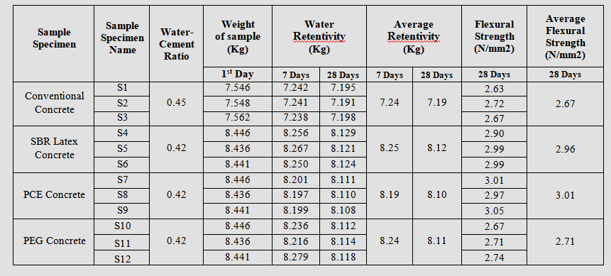

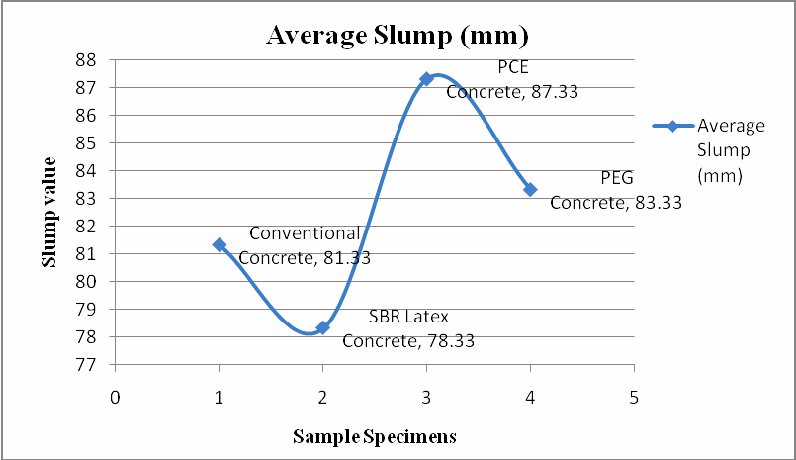
Graph 1: Results of Average Slump values as observed in test results

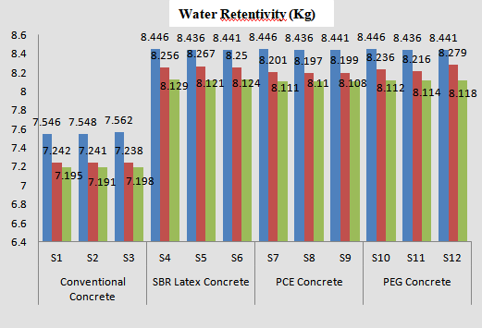

Graph2 Results of Water retentivity(KG) value after 28 days

5 . RESULT DISCUSSION.
- From the graph 1: it could be easily concluded that the observed Average slump values are best for PCE polymer, it has best workability attainment i.e. greater than 80mm as compared to others.
- From the graph 2: it could be easily concluded that the Water Retentivity are best for SBR than
that of others which is probably presence of adhesive latex mass which produces affinity for matrix materials to be compacted or be in contact.
- From the graph 3: it could be easily concluded that the observed Average Flexural values are best for PCE polymer. This is purely due to hardening of latex after 28 days whereas; SBR, PEG are lacking such bonding mass.
- From the graph 4: it could be easily concluded by bar that the observed average values are best for PCE polymer. This is purely due to hardening and adhesive nature of latex after 28 days whereas; SBR, PEG are lacking such bonding mass.

CONCLUSION
- Polymers impart better workability and hence; induce greater usability of concrete due to increase in plasticity.
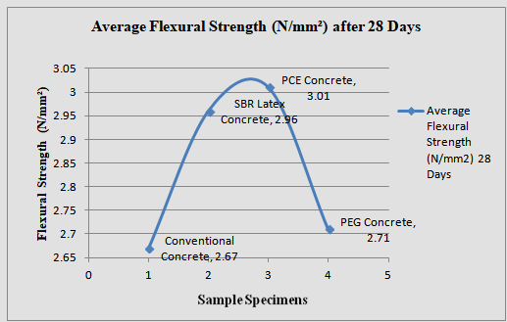
- Water Cement Ratio reduces considerably with the impregnation of polymers. It is observed that introduction of polymer upto 5% reduces water upto 14 -18%. of matrix mass.
- Higher compaction is also achieved by use of polymer; however conventional concrete compaction is higher in case of PCE & PEG.
- Compressive strength at 7 day is higher for conventional concrete then polymer based concretes, such as SBR but less than PCE and PEG. Whereas after 28 days it is higher for polymer based concretes.
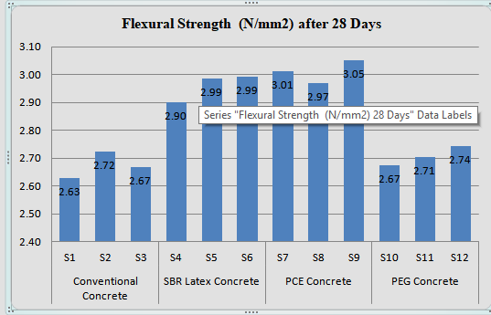
- The series for flexural strength at later age is PCE > SBR > PEG > Conventional Concrete, which shows that polymer impregnation increases compressive strength of concrete considerably.
- Split Tensile strength at 28 days is higher for SBR & PEG than PCE polymer concrete along with conventional concrete, which shows that polymer impregnation increases tensile strength of concrete actively.
- Modulus of elasticity is also increased after introduction of polymer concrete but it is higher for SBR concrete as compared to other polymer concrete.

REFERENCES.
- A.S.El-Dieb “Self Curing Concrete, Water Retention, Hydration and Moisture Transfer Construction and building materials 21 (2007) pp. 1282-1287.

- Wen-Chen Jau “Self Curing Concrete” (Us Patent
2008/0072799A1).

- Yoshihiko Ohama “Properties of Polymer-Modified Mortars Using Styrene-Butyl Acrylate Latexes with Various Monomer Ratios” Materials Journal Volume: 88 Issue: 1; (1999) pp. 55-61.

- Jingjing Xiao, Wei Jiang “Effect of styrene–butadiene rubber latex on the properties of modified porous cement stabilized aggregate” National Natural Science Foundation of China, pp. 102-108.

- Amel Kamoun “Evaluation of the performance of sulfonated esparto grass lignin as a plasticizer–water reducer for cement” Cement and Concrete Research 33 (2003) pp. 995–1003

- Raman Bedi “Mechanical Properties of Polymer Concrete” Journal of Composites; Volume 2013, Article ID-948745, pp 13-21.

- F. Puertas “Polycarboxylatesuper plasticiser admixtures: effect on hydration, microstructure andrheological behaviour in cement pastes” Advances in Cement Research, 2005, 17, No. 2, pp. 77–89

- Kaushal Kishore “Polymer modified mortars and concrete mix design” Source: http:// www. engineeringcivil.com/polymer modified mortars and concrete mix design.html

- S K Gupta & Mahesh Kumar “Use of polymer concrete in construction” Source: http://dda.org.in
/cee/Technicalpaper/technical17.

- IS: 10262-2009. Recommended guidelines for concrete mix design, Bureau of Indian Standards (Reaffirmed), New Delhi, 2000.

- IS: 456-2000. Indian standard recommended guidelines for concrete mix design, Bureau of Indian Standards.

- IS: 8112-1989. Specifications for 43-Grade Portland cement, Bureau of Indian Standards, and New Delhi, India.

- IS: 516-1959. Method of test for strength of concrete, Bureau of Indian Standards, New Delhi, 1959.
- IS: 2386 (Part I, IV, VI) - 1988. Indian Standard Method of test for aggregate for concrete, Bureau of Indian Standards, Reaffirmed, New Delhi, 2000.

- IS: 1199-1959. Indian Standards Methods of Sampling and Analysis of Concrete, Bureau of Indian Standards, New Delhi, India.

- Hans W. Reinhardt and Silvia Weber (Journal of materials in Civil Engineering/Nov.1998/208-209) “Self curing High Performance concrete”

- Norbert Delatte, Professor, Cleveland State University “Power point presentation of Self Curing Concrete”

- Rajamane N P, CSIR, Chennai an article on
“Introduction on Self Curing Concrete”

- Roland Tak Yong Liang and Robert Keith Sun “Self Curing Concrete” (Us Patent No-6468344 B1)

- Text book on “Concrete Technology-Theory and
Practice” by M. S. SHETTY.

- C. Vipul sanandan and E. Paul, “Performance of epoxy and polyester polymer concrete,” ACI Materials Journal, vol. 87, no. 3, (1990) pp. 241–251.

- OHAMA, Mix Design System for Polymer-modified mortars, proceeding of the second Australian Conference on Engineering Materials, (1981) pp.163-172.

- Shrikant Mishra “Polymer Modified Concrete - A Theoretical Review” International Journal of Trend in Research and Development, Volume 3(3), pp. 268-270.

