Triple Discharge Pump With Epicyclic Gear Train

¹S. P. Nagapure
‘Assistant Professor, Mechanical Department,
Manoharbhai Patel Institute of Engineering & Technology, Bhandara, India

¹PiyushDahekar,²Sagar Mandarkar, ³Yogesh Katore,⁴Akshay Gaidhane,⁵Aditya Kunjekar
Scholar, B.E. (Mechanical Engineering)
Manoharbhai Patel Institute of Engineering& Technology, Bhandara, Maharashtra.

Abstract— This paper gives outlines of Epicyclic external gear pump where one sun gear is meshed with three planet gears to achieve variable discharge rate as per the requirement. This paper describes techniques for the design, construction, and testing of a Epicyclic external gear pump. In many applications it is required to drive the actuators, hydraulic cylinder or hydraulic motors at variable speed. This is only possible by variable discharge from a variable displacement pump so it is not possible to use it. One method employed is to use a pump of higher discharge capacity. But higher capacity means higher cost and higher power consumption. Hence there is need of special pump system at low cost so that the requirement of variable discharge is met easily without much cost and set up.

Keywords— Pump, Epicyclic Gear, Maximum Discharge, External Gear Pump.

l. INTRODUCTION
This system comprises of three external gear pumps mounted in parallel around epi-cyclic gear train i.e. the sun gear of the drive train drives the planet gears mounted on the input shaft of each gear pump. The input to all three gear pumps come from a common tank where as the output from the gear pumps is delivered to a common manifold thus it is possible to get maximum discharge when needed. The minimum output available is that of one pump. Maximum output available is that of

three pumps.This is possible as each of pumps is capable of being de-coupled from circuit.
ll. OBJECTIVE
In this project we used the only one electric motor for running all the three simultaneously or individual pump due to which we save electricity and we get the variable flow of liquid. Epicyclic gear train are known to provide high power density and have become the gear train of choice for the main power flow in virtually all rotorcraft design. Planetary gear have only planet, rotational and translation mode critical speeds. Divergence instability is possible at speeds adjacent to critical speeds.

lll. WORKING OF TRIPLE DISCHARGE PUMP WITH EPICYCLIC GEAR TRAIN

The external gear pump consist of two gear in which one is driver gear and another is driven gear that meshes with each other.The system comprises of three external gear pumps mounted in parallel around epi-cyclic gear train. The sun gear of the drive train drives the planet gears mounted on the input shaft of each gear pump. The input to all three gear pumps come from a common tank whereas the output from the gear pumps is delivered to a common manifold thus it is possible to get maximum discharge when needed. The minimum output available is that of one pump maximum output available is that of three pumps this is possible as each of the pumps is capable of being de-coupled from circuit.

It is rotary flow positive displacement pump. It is more advantages due to low speed and inlet pressure requirement. Liquid enters the suction port between the rotorand gear teeth. Liquid travels through the pump between the teeth of the "gear-within-a-gear" principle. The two mesh gears divides the liquid and acts as a seal between the suction and discharge ports. The pump head is now nearly flooded, just prior to forcing the liquid out of the discharge port. Intermeshing gears of the idler and rotor form locked pockets for the liquid which assures volume control. Rotor and idler teeth mesh completely to form a seal equidistant from the discharge and suction ports. This seal forces the liquid out of the discharge port.

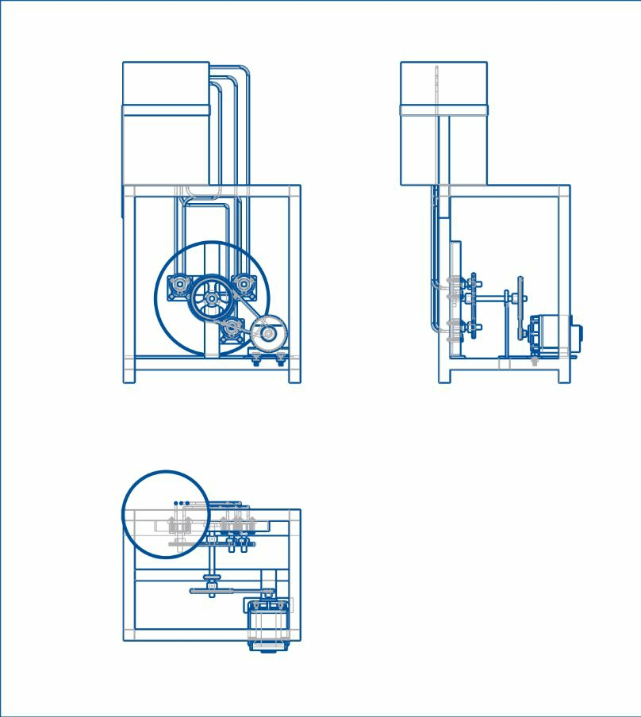

Fig: Triple Discharge Pump with Epicyclic Gear Train

1V. DETAILS OF THE COMPONENTS USED FOR TRIPLE DISCHARGE PUMP WITH EPCYCLIC GEAR TRAIN:

On the basis of design optimization done for triple discharge pump with epicyclic gear train the details of the components used, as given below.

Table No 1: Details of the components used
No. | Name of component | Major dimensions (mm) | Material
1 | Gear Pump | External gear pump | Cast iron
2 | Polyurethane Tubes | Dia. = 10mm | Polyurethane
3 | Bearing | Outer dia. =35mm, Rim width =11mm,  Rim thickness =5mm, Wt.=0.046kg | Mild steel
4 | Pinion | PCD=50mm, No. of teeth =30 | Cast iron
5 | Gear | PCD=120mm, No. of teeth =75 | Cast iron
6 | Stand (Frame) | Horizontal = 465mm, vertical =455mm | Mild steel
7 | Shaft | Dia. = 16 mm | Mild steel
8 | Pulley | Small Dia=20mm, Big Dia= 100mm | Stainless steel

V. CAD MODEL OF TRIPLE DISCHARGE PUMP WITH EPICYCLIC GEAR TRAIN
As per the designed and analytical calculation made following CAD model is developed by using different command.

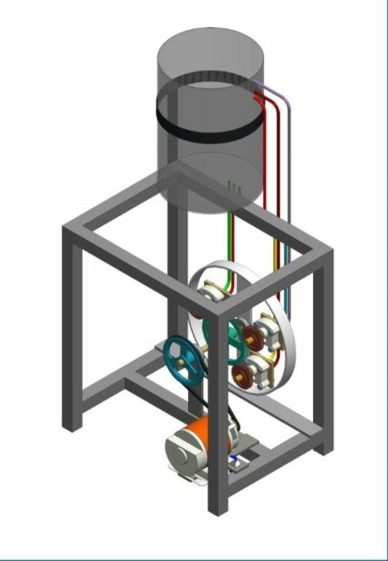

CAD Model of triple discharge pump with epicyclic gear train

VI. CONSTRUCTION MODEL OF TRIPLE DISCHARGE PUMP WITH EPICYCLIC GEAR TRAIN

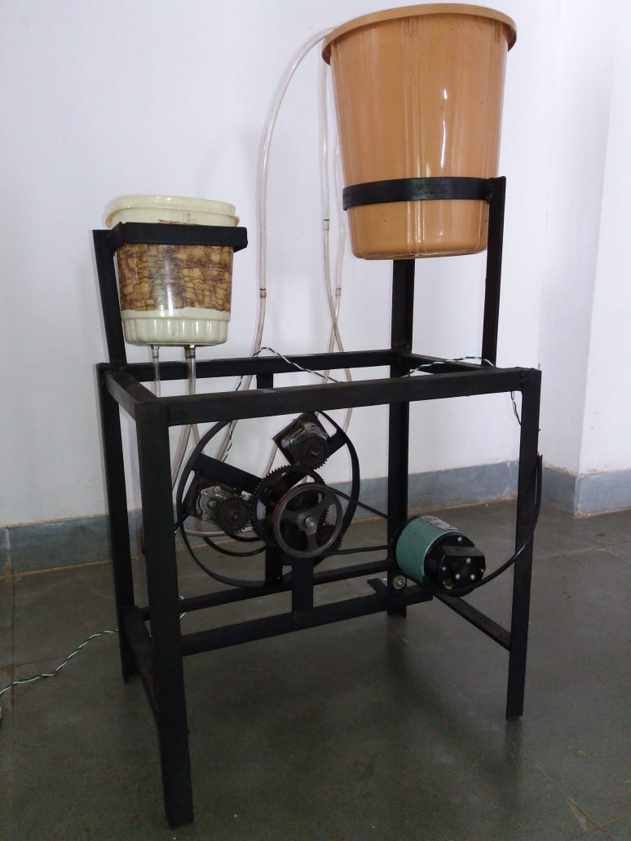
Fig(b): Front view

Fig(a): backward view

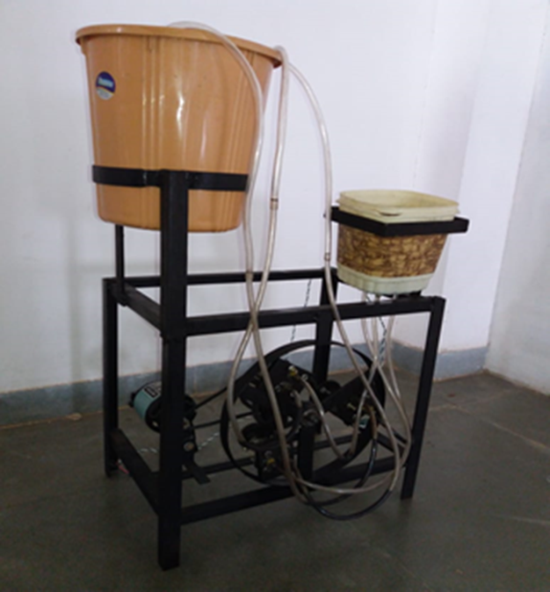

CONCLUSION

From the above review literature, we come to know that it has low discharge and time and electricity required is high. The above problem can be solved by using triple epicyclic gear train. By using planetary gear train and sun gear we can increase discharge also we can save electricity and time. Electricity can be reduced by using only one electric motor for running all the three simultaneously or individual pump and we get variable flow of liquid, which can be use to variable discharge of fluid.Due to compactness of the design of triple discharge pump, the cost of pump can be reduced.

References

[1] Planetary gear pump, wilson a. burtis,5011 harvardave, westminster, calif, filed oct. 24, 1963, ser.no. 318,670, 7 claims. (cl. (103–126).
[2] Piston pump with planetary gear drive, albert a. zalis, warren, mass appl.no.: 843, 955 , field oct 20 , 1977. oil pump for controlling planetary system torque , perryedwardphelan , harsens island , mi (u.s.); joseph palazzolo, livonia, mi(u.s.), appl. no.: 10/040,848, filled: dec. 28, 2001.
[3] Design analysis and testing of a gear pump research inventy: international journal of engineering and science vol.3, issue 2 (may 2013), pp 01-07 issn (e): 2278-4721, issn (p):2319-6483.
[4] proceedings 8th modelica conference, dresden, germany, march 20-22, 2011
[5] kinematics of an epicyclic gear pump c. k. wojcikj. mech. des.101(3), 449-454 (jul 01, 1979) (6 pages) doi:10.1115/1.3454077history: received june 01, 1978; online october 21, 2010 reddy et al international journal of advanced engineering research and studies e-issn2249–8974
[6] Shirley’s mechanical engineering design (mcgraw-hillseriesin mechanical engineering
[7] pump characteristics and applications, third edition (mechanical engineering) by michaelvolk (author)

