Design and Development of Parking Slot booking
System

Jugneet Singh Chattawal¹, Navin Shrirao ², Harsha Kadwe³, Krutika Lagad⁴
¹Mr. Ramanand Samdekar , Assistant Professor

S.B Jain Institute Of Technology Management and Research, Nagpur, India, 441501

Abstract – Most of the people have daily concern of finding a vacant parking space especially during rush hours because of increase in complexity of traffic. Parking of motor vehicles is becoming a major problem in day to day life. Currently parking is difficult and its impact is not limited itself. Hence this project offers an interactive Android Application so that user can quickly find vacant space for parking their vehicle and book parking space in their required date and time. It will also help the administrator to monitor the vacant slots availability so it can be used by next person. A user will register himself and after registration will be made to login into the application using all the required details. After successful login the user will be able to see the parking slots with their status. After selecting an empty slot the admin will send QR code to user using which a parking slot can be booked.
Keywords-Android application,Slot allocation,QR code.

INTRODUCTION
In today parking lots there are no standard system to check for parking spaces. Searching for a vacant parking space in a metropolitan area is the daily concern for most people and it is time consuming. The system heavily relies on human interaction with the physical space and entity. This leads to wastage of human manpower and also parking spaces at times. It commonly results more traffic load and air pollution in certain area only for an available parking space. This paper highlights the difficulties faced by the customers searching for spaces while parking vehicles, shows difference between manual and automated parking system. Parking slot booking system is based on android technology for avoiding parking problems which provides process of pre-booking the slot through the use of simple and interactive android application .The prime aim of this project is to develop an application that allows the user to book a parking slot. Once the user reaches the parking area then he/she can park the vehicle in the confirmed slot. Once user renounces his slot then it appears reserved for other users and after leaving the slot it is shown as available for another user.

METHOLOGY
Step1:- Users have to first register themselves to login into the system.
Step2:-The user can select available slot from a large parking slots either by seeing them on graphical view of parking area.
Step3:-User can click on slot to view the availability. If the slot is already booked it will be marked red and the available ones will be seen in green color.
Step4:-User can book the parking slot by entering the details such as vehicle number, in-out time.
Step5:-After successful booking of slot then admin will approve the request of user and send QR code to user.
Step6:-Admin will add slot and clear slot.
Step7:-Admin can see all the users registered into the system.
Step8:- The system will give all the booking slots and user details which was entered by user during registration and parking slot to the admin.
DESIGN

This project offers an Android Application where users can view various parking slots and select the slot to view whether parking slot is available or not. It will also help the operator to monitor the vacant slots availability so it can be used by next person.
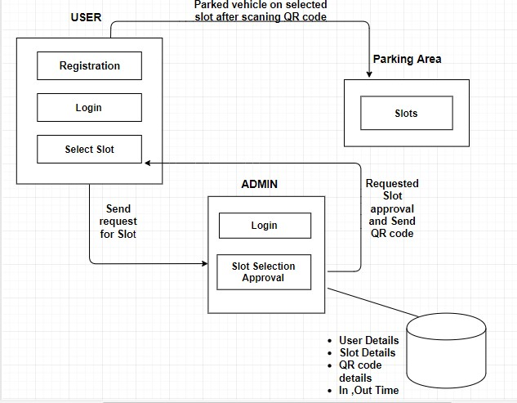
Fig.1-fig shows block diagram of parking slot booking system
There are separate login sections for user and admin. Each section verifies the user and checks whether the user is authenticate user or not. Every new user needs to register first then only can use the system. After login each user will jump to their respective profiles where they have various tabs of their responsibilities. The admin is responsible for every slots approval, slot allocation, de- allocation of slots and scanning the QR Code. User can book slot for parking. After performing their tasks, the users need to logout from the system.
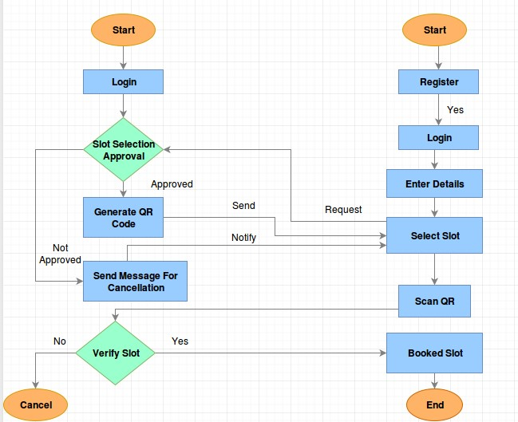
Fig.2-fig shows flow of parking slot booking system
CONCLUSION
Parking slot booking system is a proposed method that users use to reserve their parking spaces slot. The user will be able to view the empty parking slots on the application, from the empty slots user can select any slot that he/she desires to book for their vehicle. The user can also input the in-time and out-time for the parking slot that he/she has booked their parking slot. In this way the duration of booking is also available. Based on the booking the admin generates a QR code. In the parking slot booking system that is being developed the Twodimensional matrix barcode is used. The twodimensional matrix barcode is nothing but the Quick response barcode i.e. QR code for authentication of user as well as vehicle.

REFERENCES
- Ahteshamul osmani, Ashwini Gawade, Minal Nikam, Swati Wavare,“Smart City Parking System”, Research paper Department of Computer Engineering Vol 02, No3 2016.
- Chinmay Pawar, Ajay Wavhal, Akash Saigal, Aniket Patil, “Online parking slot booking”, International
Research Paper of Engineering and Technology Volume 05 ,03 Mar-2018.
- Ms Sneha Choudhari, Ms.Pratiksha Wasnik, Ms.Shraddha Chopde, “Online parking booking system“, International Journal for Research in Applied Science & Engineering Technology Vol 05 March 2017.
- Janhvi Nimble, Priyanka Bhegade, Snehal Surve ,
Priya Chaugule,”Automatic Smart Car Parking System”, International Journal of Advance in Electronics and Computer Science Vol-3,March-2016.
- Meng Li, Chen Deng,Weimin Zhu, “Intelligent Parking System based on Internet of Things
Technology”, Shangai University of Engineering Science Songjiang Shangai 2016,China Volume 124No.6,August 2015.

ACKNOWLEDGMENT
We would like to express deep sense of gratitude to our Project Guide Mr. Ramanand Samdekar, Department of Computer Science & Engineering, for being the cornerstone of our project. It was his incessant motivation and guidance during periods of doubts and uncertainties that has helped us to carry on with this project.
We would like to thank Mr. Animesh Tayal, Head of Department, Computer Science & Engineering for providing necessary guidance, support, motivation and inspiration without which this project would not have been possible.
We would like to extend our special thanks to Dr. S. L. Badjate, Principal of S.B. Jain Institute of Technology, Management & Research for his encouragement and best wishes.
We also like to acknowledge the help extended by the faculty members and non-teaching staff of Computer Science & Engineering Department for successful completion of our project.

