Effect Of Different Irregularities On Low Rise To High Rise Structures
Kaveri S. Kulkarni¹, Ms. P.K. Pardakhe²
¹ ME Student
Jagadamba College of Engineering & Technology, Yavatmal, India, 445001
²Assistant Professor
Jagadamba College of Engineering & Technology, Yavatmal, India, 445001
Received on: xxxx,20xx, Revised on: xxxx,20xx, Published on: xxxx,20xx

Abstract – The behavior of a building during an earthquake depends on several factors such as stiffness, lateral strength, and ductility, simple and regular configurations. The buildings with regular geometry, uniformly distributed mass and stiffness in plan as well as in elevation suffer much less damage compared to irregular configurations. But nowadays thirst and demand of the new generation engineers are planning towards an irregular configuration for better aesthetic perspective. Hence earthquake engineering has developed the key issues in understanding the role of different types of building configurations. Seismic analysis is a division of structural analysis and it involves the calculation of the different response of a building structure subjected to earthquakes with different irregularities.
Keywords- Response spectrum method, ETAB, IS 1893:2016, Plan irregularity, stiffness irregularity

INTRODUCTION
Irregular buildings constitute a large portion of the modern urban infrastructure. Structures are never perfectly regular and hence the designers routinely need to evaluate the likely degree of irregularity and the effect of this irregularity on a structure during an earthquake. Need for research is required to get economical & efficient lateral stiffness system for high seismic prone areas. For optimization & design of high rise building with different structural framing systems subjected to seismic loads. To improve the understanding of the seismic behavior of building structures with different irregularities.

Objectives:
- To check the analysis results of ETABS for lateral stability checks as per IS code 1893:2016 provisions for seismic loads.
- Analysis of 5 storied, 10 storied and 15 storied RC framed structure with different irregularities under seismic conditions. Irregularities considered are Re-entrant corner, mass irregularity, vertical geometric irregularity, plan irregularity and stiffness irregularity.
- To calculate the response of buildings subjected to seismic zone IV using response spectrum and to compare the results.
- Study the effect of seismic responses such as the storey lateral displacement, storey drift, storey shear, storey stiffness and mode period in zone IV.

PROBLEM STATEMENT
Six storey (G+5), Eleven storey (G+10) and Sixteen storey (G+15) reinforced concrete frame buildings have been considered & analyzed with the help of ETAB software by using Response spectrum method. Following properties are considered for buildings.
Analysis Property Data
a) Material used was M40 Grade Concrete.
b) Yield stress fy = 500 N/mm2
c) Compressive Cube Strength of Concrete = 25 N/mm2
d) Poisson’s ratio = 0.15
e) Analysis was done using ETABS Software 9.7
Building Details
a) Type of frame: Special RC moment resisting frame fixed at the base
b) Number of storey: G+5, G+10, G+15
c) Ground Floor height: 3m
d) Floor height: 3.0 m
e) Depth of Slab: 120 mm
f) Size of beam: (250 × 800) mm
g) Size of column: (400 × 900) mm
h) Spacing between frames : (i) 6 m in X & Y direction (General),
(ii) 30 m × 24 m in X & Y direction
i) Live load on floor: 2 kN/m2
j) Floor finish: 1.0 kN/m2
m) Thickness of wall: 230 mm
o) Density of concrete: 25 kN/m3
p) Density of masonry wall: 19 kN/m3
Depth of foundation from ground level = 1.5 m
Seismic Data
a) Type of soil: Medium
b) Seismic zone: IV
c) Importance factor: 1.2
d) Reduction factor: 5
e) Response spectra: As per IS 1893(Part-1):2016
s) Damping of structure: 5 percent

MODELING
The main aim of the model is to study the change in building responses (mainly deflection and storey drift) due to various irregularities as pee IS 1893:2016. The building is analyzed in 6 stages as follows,
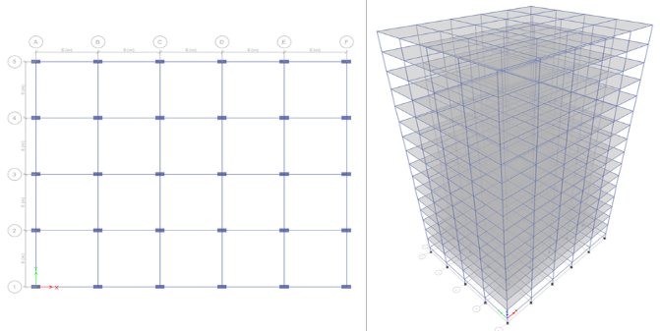
Fig. 1- Plan & isometric view of regular structure
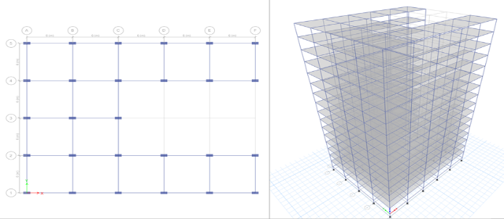
Fig. 2- Plan & isometric view of Structure with plan irregularity
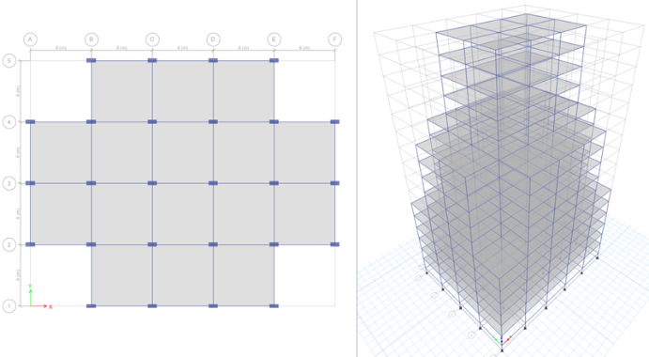
Fig. 3- Plan & isometric view of Structure with vertical irregularity
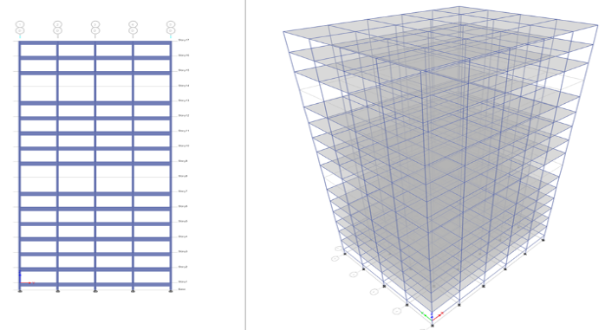
Fig. 4- Elevation & isometric view of Structure with stiffness irregularity
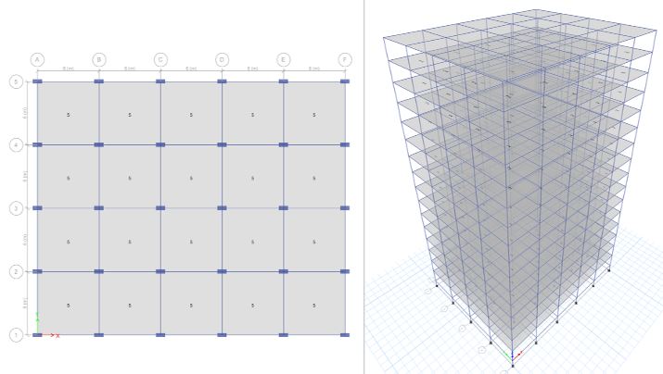
Fig. 5- Plan & isometric view of Structure with mass irregularity
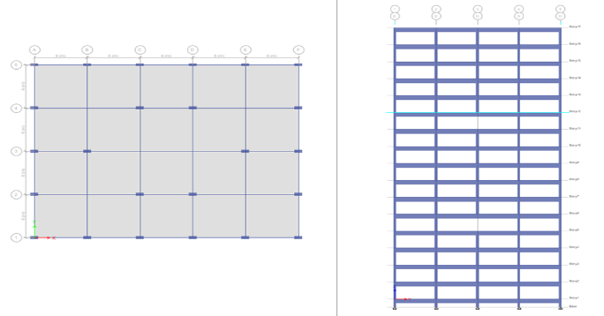
Fig. 6- Plan & Elevation of Structure with strength irregularity
RESULTS
Table 1- Base shear (kN) in X-direction
Type of Structure | Regular structure | Structure with plan irregularity | Structure with vertical irregularity | Structure with stiffness irregularity | Structure with mass irregularity | Structure with strength irregularity
G+5 | 3721.1648 | 2903.39 | 3783.62 | 3100.48 | 3760.02 | 3709.9
G+10 | 7108.5254 | 5556.11 | 6575.72 | 6491.15 | 7149.61 | 7090.51
G+15 | 7239.7738 | 5660.18 | 5425.95 | 6386 | 7292.96 | 7228.81
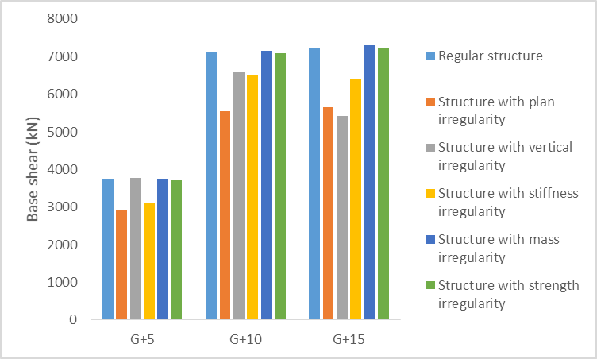
Fig. 7- Base shear (kN) in X-direction
Table 2- Base shear (kN) in Y-direction
Type of Structure | Regular structure | Structure with plan irregularity | Structure with vertical irregularity | Structure with stiffness irregularity | Structure with mass irregularity | Structure with strength irregularity
G+5 | 3719.99 | 2604.9 | 3781.53 | 3099.96 | 3760.87 | 3710.09
G+10 | 6381.6 | 4987.91 | 5903.98 | 5826.81 | 6418.45 | 6379.75
G+15 | 6474.81 | 5064.09 | 4854.43 | 5710.24 | 6523.98 | 6464.93
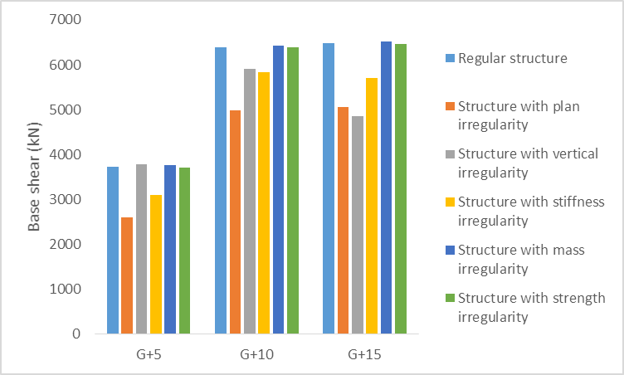
Fig. 8- Base shear (kN) in Y-direction
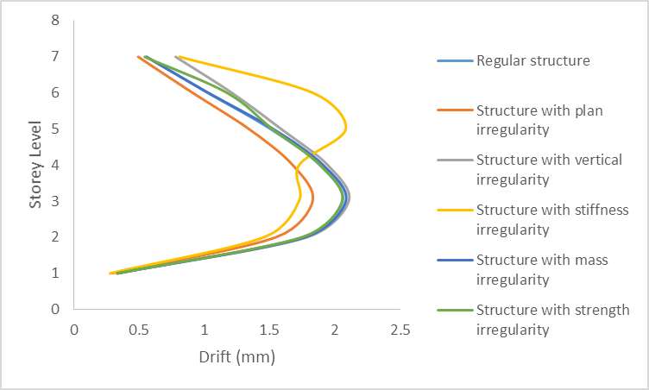
Fig. 9- Storey Drift (mm) in X-direction (G+5) building
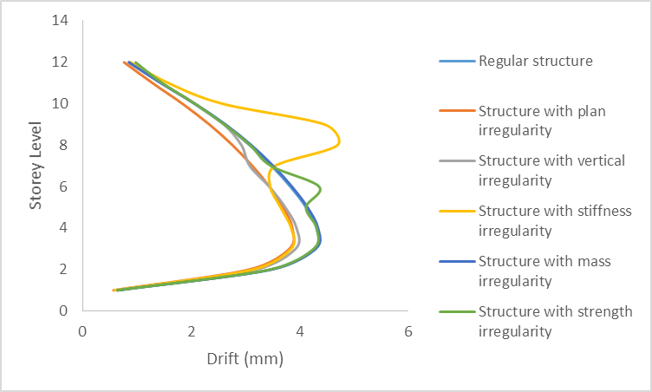
Fig. 10- Storey Drift (mm) in X-direction (G+10) building
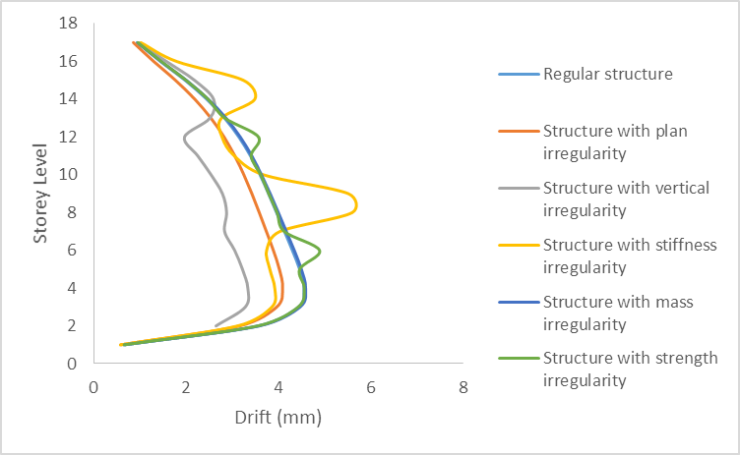
Fig. 11- Storey Drift (mm) in X-direction (G+15) building
Table 3- Maximum axial force (kN) in columns
Type of Structure | Regular structure | Structure with plan irregularity | Structure with vertical irregularity | Structure with stiffness irregularity | Structure with mass irregularity | Structure with strength irregularity
G+5 | 3818.677 | 3745.119 | 4063.997 | 3188.378 | 3980.474 | 4349.743
G+10 | 7249.73 | 6766.29 | 7222.21 | 6619.24 | 7411.18 | 9019.31
G+15 | 10478 | 9567.02 | 9813.1 | 9294.1 | 10788.6 | 12929.6

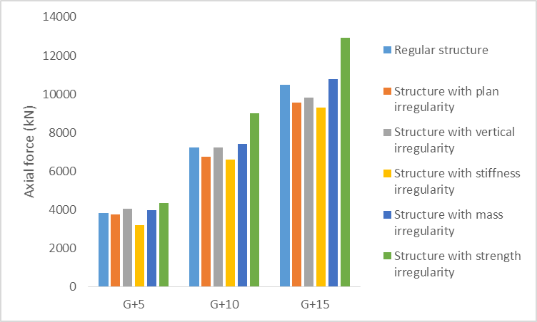
Fig. 12- Maximum axial force (kN) in columns
Table 4- Maximum moment (kNm) in beams
Type of Structure | Regular structure | Structure with plan irregularity | Structure with vertical irregularity | Structure with stiffness irregularity | Structure with mass irregularity | Structure with strength irregularity
G+5 | 438.194 | 408.514 | 445.906 | 378.077 | 441.877 | 443.717
G+10 | 695.937 | 697.463 | 653.889 | 641.869 | 699.215 | 715.411
G+15 | 707.716 | 728.373 | 568.996 | 633.728 | 712.192 | 743.402

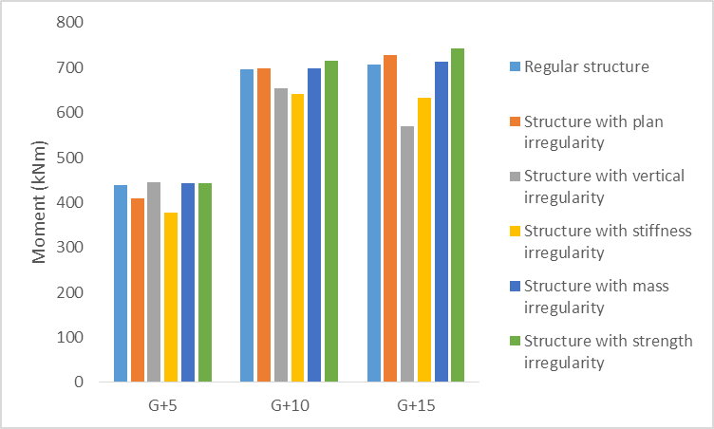
Fig. 13- Maximum moment (kNm) in beams
CONCLUSION
- In X direction, Lateral force or storey shear at each consecutive storey level for mass irregularity is more as compared to other types of irregularity. Vertical irregularity has least lateral force on consecutive story’s as compared to other types of irregularity. Approximately on an average 15% lateral force or storey shear is decreased or increased between all studied types of irregularities.
- In Y direction, Lateral force or storey shear at each consecutive storey level for regular structure is more as compared to other types of irregularity. Vertical irregularity has least lateral force on consecutive story’s as compared to other types of irregularity. Approximately on an average 15% lateral force or storey shear is decreased or increased between all studied types of irregularities.
- Storey drift ratio for stiffness irregularity is more as compared to other types of irregularity. mass irregularity has least drift ratio as compared to other types of irregularity. Approximately on an average 25% storey drift is decreased or increased between all studied types of irregularities.
- Axial force in column is rise upto 30% in building with strength irregularity as compared to regular structure.
- Moment in beam is rise upto 35% in building with strength irregularity as compared to regular structure.
ACKNOWLEDGMENT
I am thankful to Ms. P.K. Pardakhe, Asst. Professor Civil Engineering, Jagadambha College Of Engineering And Technology, Yavatmal, India. My guide and my beloved friends for their timely help rendered and the immense support extended for the submission of this paper.
REFERENCES
- Poonam, Anil Kumar And Ashok K. Gupta (2012). Study Of Response Of Structurally Irregular Building Frames To Seismic Excitations, International Journal of Civil, Structural, Environmental and Infrastructure Engineering Research and Development (IJCSEIERD) ISSN 2249-6866 Vol.2, Issue 2 25-31
- Anibal G Costa, Carlos S Oliveira and Ricardo T Duarte (1988). Influence of Vertical Irregularities on Seismic Response of Building, proceedings to ninth world conference on Earthquake Engineering, August 2-9, 1988 Tokyo Japan.
- G.F. Dargush , M.L. Green and Y. Wang(2004). Evolutionary Aseismic Design and Retrofit of Passively Damped Irregular Structures, 13th World Conference on Earthquake Engineering Vancouver, B.C., Canada August 1-6, 2004 Paper No. 1899.
- Devesh P. Soni and Bharat B. Mistry (2006). Qualitative Review Of Seismic Response Of Vertically Irregular Building Frames, ISET Journal of Earthquake Technology, Technical Note, Vol. 43, No. 4, December 2006, pp. 121-132.
- IS: 1893(Part1):2016. Criteria for Earthquake resistant design of structures, Bureau of Indian Standards.
- Yasser Alashker, SohaibNazar (2015). Effects of Building Configuration on Seismic Performance of RC Buildings by PushoverAnalysis, Open Journal of Civil Engineering, 2015.
- Snehal s. Pawar1, sanjaybhadke, Priyanka kamble (2016). Seismic Analysis of VerticallyIrregular RC Building, International Journal of Current Trends in Engineering & Research (IJCTER)e-ISSN 2455–1392, Volume 2 Issue 4, April 2016.

