Security Automation System by Unique Identifier

Ishwarlal Rathod¹, Anuprita P Linge², Dev Davda³, Rohit Manna⁴, Nividh Parekh⁵

Symbiosis University of Applied Sciences, Indore (M.P.)
Shri Shankarprasad Agnihotri College of Engineering, Wardha (Maharashtra)

ishwarlal.rathod@suas.ac.in

Received on: 17 March, 2024 Revised on: 20 April, 2024 Published on: 22 April, 2024

Abstract- Over the past decade, considerable progress has occurred in technology, leading to both its improvement and the emergence of various innovative applications in security and related domains. RFID, an acronym for Radio-Frequency Identification, is a technology used for identification and tracking by employing small radio frequency identification devices. In this research paper, we present the design and implementation of a security automation system that utilizes a UID (Unique Identification) card as a means to access and unlock the system. Our system leverages RFID technology to encode and verify the UID, thereby ensuring data authorization and security. Within this system, the Arduino Uno serves as an intermediary between the RFID reader and the system application, facilitating seamless communication and interaction.

Keywords: RFID, UID, Arduino UNO, Data Authorization, Radio-Frequency Identification.

- INTRODUCTION
In this innovation, security automation is accomplished through the utilization of an RFID (Radio-Frequency Identification) system. This system encodes a Unique Identification (UID) to both authorize and safeguard data. The RFID card is equipped with an embedded tag for the purpose of data reading [3].
Furthermore, a system application is employed to collect and transmit data. The data collected from the RFID system is conveyed to the system application for comparison and validation [4] [2]. This data transmission is facilitated through the use of IoT hardware, specifically the Arduino Uno. The Arduino Uno serves

as a crucial intermediary between the RFID system and the system application.
To grant authorization, each individual requiring access is provided with a UID card containing their unique identification code (UID). Subsequently, the individual can gain access to the system by scanning the RFID using their respective UID card [5] [6]. It's worth noting that each UID card possesses its own distinctive ID, allowing for precise monitoring of access events and frequency. This monitoring is made possible through the system application's database, which is connected to an ESP8266 Wi-Fi module for efficient data communication and recording [1].
This integrated approach ensures robust security, precise authorization, and comprehensive monitoring of system access, making it a valuable solution in various security and related fields.

- COMPONENTS USED
2.1 Arduino UNO
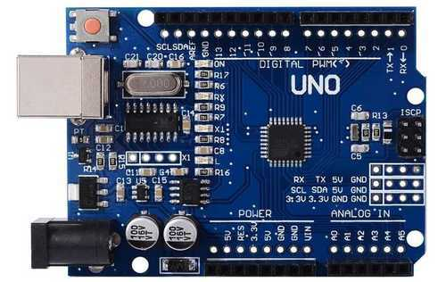
The Arduino UNO is a microcontroller board based on the ATmega328P. It incorporates a range of features, including 14 digital input/output pins, with 6 of them capable of functioning as PWM outputs. Additionally, it offers 6 analog inputs, a 16 MHz ceramic resonator, a USB connection, a power jack, an ICSP header, and a reset button, encompassing all the necessary components to support the microcontroller. Users can initiate operation by connecting it to a computer using a USB cable or by powering it with an AC-to-DC adapter or battery.
Figure 1-Arduino uno

2.2 SparkFun RFID Reader Breakout
This functions as a user-friendly breakout board specifically designed for RFID readers. The SparkFun RFID Reader Breakout simplifies the transformation of the 2mm pins into breadboard-friendly 0.1" headers. This adaptability allows for the option of soldering the reader directly onto the breakout board or making use of the 2mm sockets.
Importantly, the edges of this breakout board seamlessly align with the underside of the ID-12LA. While it is also compatible with the ID-20LA, it is marginally smaller than the edges. As previously stated, each pin of the RFID reader has been carefully exposed, covering VCC, READ, D0, D1, FORM, TIR, CP, both ANTs, RES, and GND.
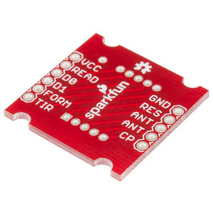
Figure 2-SparkFun RFID Reader Breakout

2.3 Adafruit RFID/NFC Card
This is an unprogrammed 13.56MHz RFID/NFC card, frequently employed for diverse applications such as train or bus passes and other systems that demand proximity card functionality. Housed within the card is a compact RFID chip coupled with an integrated antenna. The card operates in a passive manner, drawing power from the nearby reader/writer when held within a few inches of it.

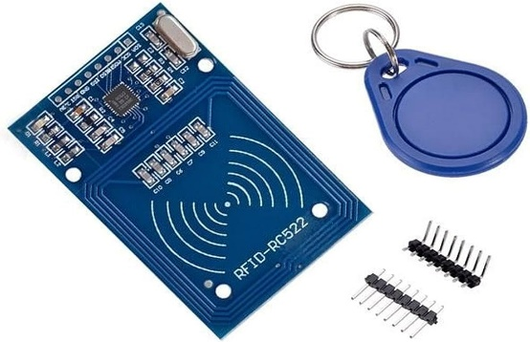
Figure 3-Adafruit RFID/NFC Card

- PROPOSED METHODOLOGY
The Security Automation System by Unique Identifier can be explained with the help of a block as shown in Figure 5 and the circuit diagram mentioned in Figure 4. The RFID tagging is an identification system that employs small radio frequency identification devices for tracking and recognizing objects or individuals. An RFID tagging system comprises three key elements: the RFID tag itself, a read/write device, and a host system application for gathering, processing, and transmitting data.

For instance, an RFID system can be employed to control access to a secured area, allowing entry only to individuals with the correct information on their RFID cards. The collected data is then sent to an application's database using an ESP8266 Wi-Fi module. Subsequently, this data can be consolidated, visualized, and analyzed using platforms like ThingSpeak, an IoT analytics platform.

Technical Specifications:
Input voltage: 3.3V
Frequency: 13.56MHz

- Prior to advancing to the coding phase, it is essential to download the essential library for this sensor from the specified repository. Unzip the contents of the "rfid-master" folder and integrate this library folder into the existing Arduino libraries.

- Subsequently, restart your Arduino IDE. At this point, your Arduino is prepared to accept commands and execute them as necessary.

- The Arduino code for this system is furnished at the conclusion of the methodology. Compile the code, and ensure the removal of any possible typographical errors.

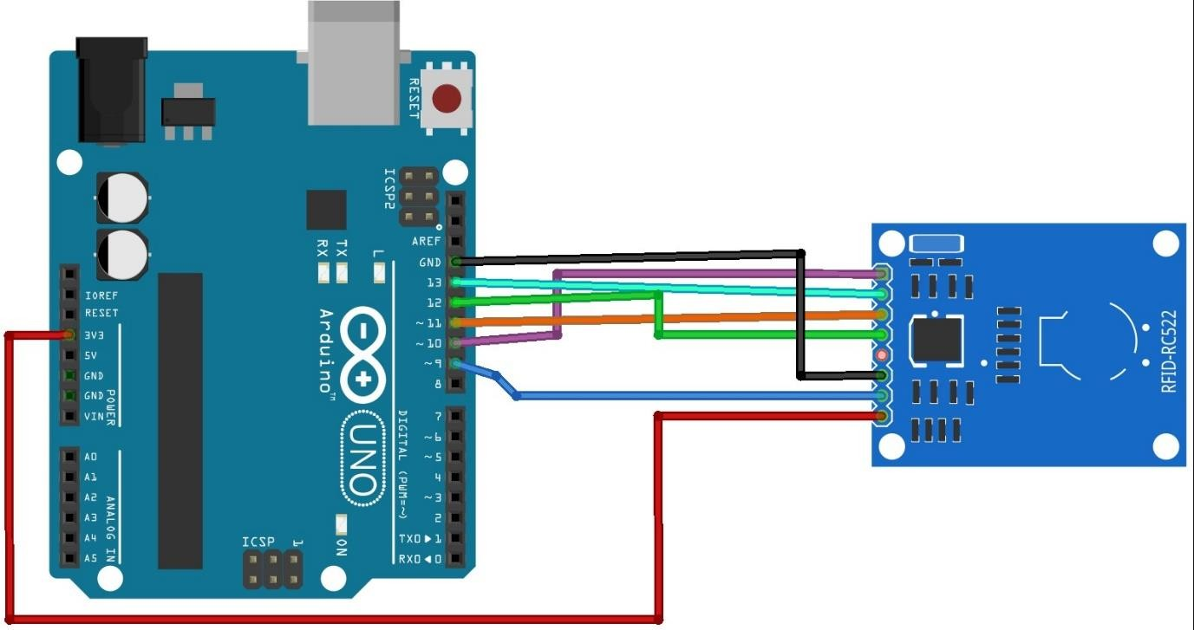
- SCHEMATIC DIAGRAM
Figure 4- Security Automation System by Unique Identifier

- Block Diagram
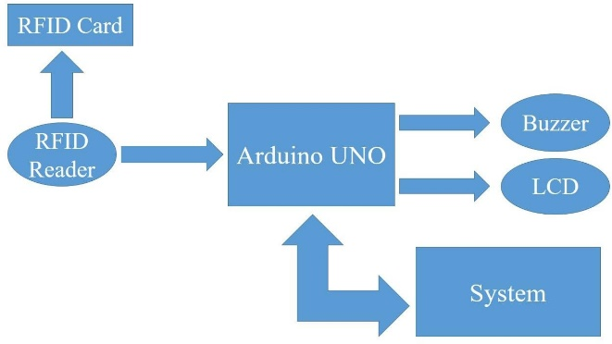
The block diagram shows the involvement of RFID Card in our research work, so that the system can be employed to control access to a secured area, allowing entry only to individuals with the correct information on their RFID cards.
Figure 5- Security Automation System by Unique Identifier Block Diagram
- RESULT
After implementing the project, the security system was successfully unlocked upon inserting the RFID card. The system utilized RFID tagging technology, an ESP8266 Wi-Fi module, and Arduino Uno. The technical specifications included an input voltage of 3.3V and a frequency of 13.56MHz. The implemented code ensured seamless functionality, allowing access only to authorized RFID cardholders.
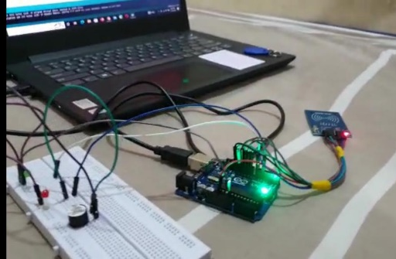
Figure 6-Implementation of Security Automation System by Unique Identifier
- CONCLUSION
In conclusion, Security Automation System by Unique Identifier has found diverse applications across various industries, enhancing efficiency and security. In logistics and supply chain management, it facilitates real-time tracking and inventory management. It also simplifies passenger ticketing and subscription card systems, streamlining access and transactions. In factory automation, it plays a pivotal role in process optimization and control. Moreover, RFID-based access control ensures secure entry to restricted areas. Additionally, the medical and food industries benefit from Security Automation System by Unique Identifier’s precision and traceability, ensuring the safety and integrity of products and processes. Overall, this technology continues to evolve, offering versatile solutions that significantly impact a wide range of industries and applications.

REFERENCES

[1] | E. S. A. Ahmed, “Internet of things applications, challenges and related future technologies,” Internet of Things (IoT) Applications, vol. 67, no. 2, pp. 126–148, 2017
[2] | Abhishek Yadav, Aman Singh, S.K Dubey and H.P Singh, "GSM Based Security System", International Journal of Advanced Technology in Engineering and Science, vol. 2, no. 4, pp. 81-84, 2014.
[3] | "Security analysis of a cryptographically-enabled RFID device", Proc. 14th USENIX Security Symp., pp. 1-16, 2005.
[4] | A. Ahmed, A. S. Quraishi, Z. Sattar and Z. B. Alam, ""RFID based Smart Office", unpublished, thesis report, 2008.
[5] | Charles Mutigwe and Farha Aghdasi, "Research Trends in RFID Technology", Interim: Interdisciplinary Journal, vol. 6, pp. 68-82, 2007.
[6] | Nadita Srivastava, "RFID Introduction Present and future application and security Implications", 2006

