Image Fusion Techniques based on DCT using energy coefficients and contrast measure.

Ramkrishna P. Patil
Assistant Professor
SSVPS B S Deore College Of Engineering, Dhule, India 424005
ramkrishna700@gmail.com

Received on: xxxx,20xx, Revised on: xxxx,20xx, Published on: xxxx,20xx

Abstract: - For the fusion process of two different image discrete cosine transform (DCT) is used. For image fusion process two different multi-focus images are utilized. Different fusion methods are used and their output is evaluated [2,3]. Fusion output is not satisfactory when utilizing methods with a block size of less than 64x64 and also a block size of 256x256 and 512x512. Some fusion methods using contras measure, amplitude, and energy coefficients accomplished well. The fused images are similar with the reference image. The image size is taken into consideration. The blurring percentage is not considered.

Keywords: DCT, amplitude, contrast measure, energy measure.

INTRODUCTION
The image fusion at pixel-level is a signal-level image fusion which constitutes the lowest processing level fusion, that is maximum or mean(average) operations are put in to the pixel values of the source images to result in the fused image. In image processing the input is an image and the output may be either an image or a set of image characteristics. Mostly images of two-dimensional signals are used as input, and standard image processing techniques are applied to it. The performance of process of image fusion is satisfactory for multi-focus and multi-sensor images of the same scene. The physical objects in the scene that are near to the camera are in focus and the far physical object gets blurred in multi-focus images. Opposite to it, when the long distant physical objects are focused then the nearer objects get blurred in the image.
Different image fusion techniques are evolved. Three important image fusion methods are used in this paper. Mean of pixels of the source images gives unacceptable effects in the fused image which includes decreased contrast and sharpness. To overcome these side effects new fusion techniques like multi-resolution [3, 6-7], multi-scale [8, 9], and statistical signal processing [10, 11] based image fusion are developed. To fuse the out-of-focus images a contrast-based image fusion algorithm in the DCT domain has been presented [9]. Local contrast is measured by 8x8 blocks. The fusion performance for different block sizes is also evaluated by using evaluation metrics such as fusion quality index, mean absolute error, psnr, ssim, spatial frequency, structural content to analyze the performance of fusion techniques.
In this paper a simple grayscale image is used. Fusion is done by using two blurred images. Blurring percentages is not considered.
DISCRETE COSINE TRANSFORM
Discrete cosine transform (DCT) is an effective transform It used in digital image processing. Excellent energy compactness properties of large DCT coefficients which are concentrated in the low-frequency region having [1, 10]. The discrete cosine transform (2D) of an image or signal of size is defined as
$$X\left(k1,k2\right)=α\left(k_{1}\right)α\left(k_{2}\right)$$
$$\sum_{n_{1}=0}^{N_{1}-1}{\sum_{n_{2}=0}^{N_{2-1}}{x\left(n_{1},n_{2}\right)cos\left(\frac{π\left(2n_{1}+1\right)k_{1}}{2N_{1}}\right)cos\left(\frac{π\left(2n_{2}+1\right)k_{2}}{2N_{2}}\right) }}$$
$$0 ≤k_{1 }≤N_{1}-1$$
$$0 ≤k_{2 }≤N_{2}-1$$
where
$$α\left(k_{1}\right)=\left\{\begin{aligned}\frac{1}{N_{1}}, { k}_{1}=0 \\ \sqrt{\frac{2}{N_{1}}}, &1≤k_{1}≤N_{1}-1\end{aligned}\right.$$
$$α\left(k_{2}\right)=\left\{\begin{aligned}\frac{1}{N_{2}}, { k}_{2}=0 \\ \sqrt{\frac{2}{N_{2}}}, &1≤k_{2}≤N_{2}-1\end{aligned}\right.$$
k₁ and k₂ are individually separate and distinct frequency variables, $\left(n_{1},n_{2}\right)$pixel index. Similarly, the inverse discrete cosine transform (2D) is defined as:
$$x\left(n_{1},n_{2}\right)=α\left(k_{1}\right)α\left(k_{2}\right)$$
$$\sum_{k_{1}=0}^{N_{1}-1}{\sum_{k_{2}=0}^{N_{2-1}}{X\left(k_{1},k_{2}\right)cos\left(\frac{π\left(2n_{1}+1\right)k_{1}}{2N_{1}}\right)cos\left(\frac{π\left(2n_{2}+1\right)k_{2}}{2N_{1}}\right) }}$$
$$0 ≤n_{1 }≤N_{1}-1$$
$$0 ≤n_{2 }≤N_{2}-1$$
IMAGE FUSION
Image processing has different sub-fields. Image fusion is one of them. In Image fusion part of two or more images is fused resulting in an image having all in focus objects. Image fusion application in medical science, forensic, and defense departments is of remarkable importance. Multi-sensor and multi-focus images of the same scene are used for the process of image fusion. [16-19]. To remove all the shortcomings in multi-focus images, and to achieve an image having all the objects are in focus, the process of image fusion is performed either in the spatial or transformed domain.
FUSION METHODS
Three fusion algorithms or rules are used in the image fusion process [2]. Let the X₁ be the DCT coefficients of the image block of size N x N from image I₁. Similarly let the X₂ be the DCT coefficients of the image block of size N x N from image I₂. Assume X_{f} be the fused DCT coefficients.
A. DCTae
Averaging of DC components is done. Largest energy frequency band AC coefficients are chosen.
B. DCTamc
Averaging of DC components is done and largest magnitude lowest AC components are chosen and remaining AC coefficients with the largest contrast measure are chosen. The contrast [8, 12-15] is measured as
$$C\left(k_{1},k_{2}\right)=\frac{X(k_{1},k_{2})}{\sum_{j=0}^{m-1}{E_{j}}}$$
Where $E_{j}=\frac{\sum_{j=t+p}{\left|X\left(p,t\right)\right|}}{Y}$
and
$$Y=\left\{\begin{aligned}j+1, &j<N \\ 2\left(N-1\right)-j+1, &j≥N\end{aligned}\right.$$
E_{j} is the average amplitude over a. j^{th} spectral band.
C. DCTame
Averaging of DC components is done and the largest contrast measure, lowest AC components are chosen and largest energy measure; the remaining AC coefficients are chosen.
FUSION METRICS
If a reference image is available following metrics can be utilized.
A. PSNR [2, 3, 5]
PSNR determines the degree of resemblance between reference images and output fused images. A high value shows fusion result of high quality..
PSNR$=20\log{10}\left[\frac{L^{2}}{\sqrt{{ \frac{1}{MN}\sum_{x=1}^{M}{\sum_{y=1}^{N}{ \left[I_{r}\left(x,y\right)-I_{f}\left(x,y\right)\right]}}}^{2}}}\right]$
B. Mean absolute error (Mae) [6]
The Mae between the fused output image and the reference image is defined as
mae(F,R)${ = \frac{1}{MN}\sum_{m=1}^{M}{\sum_{n=1}^{N}{ \left|R\left(m,n\right)-F\left(m,n\right)\right|}}}^{2}$

C. SSIM [2
The resemblance between the fused and the reference images is measured by SSIM. The range of SSIM is from -1 to 1. When both the images are identical the SSIM value is 1. High SSIM fused image would be considered. The SSIM is computed as
$$SSIM=\frac{\left(2μ_{I_{t}}μ_{I_{f}}+c_{1}\right)\left(2σ_{I_{t}I_{f}}+c_{2}\right)}{\left(μ_{I_{t}}^{2}+μ_{I_{tf}}^{2}+c_{1}\right)\left(σ_{I_{t}}^{2}+σ_{I_{f}}^{2}+c_{2}\right)}$$
D. Structural content [5]
Structural Content gives quality of image. The image is of good quality if the value of Structural Content is low. SC is defined as follows
SC$=\sum_{m=1}^{M}{\sum_{n=1}^{N}{x{(m,n)}^{2}}}=\sum_{m=1}^{M}{\sum_{n=1}^{N}{x^{∧}}}{(m,n)}^{2}$
E. Spatial frequency [2, 3, 5, 15]
The overall activity level in the fused image is indicated by spatial frequency. Pixel index is (x, y). The high SF fused image would be considered. Spatial frequency calculates the frequency changes vertically and horizontally along the image. Spatial frequency is measured using the equation
SPF=$\sqrt{{(RF)}^{2}+{(CF)}^{2}}$
Where
$RF$=$\sqrt{{ \frac{1}{MN}\sum_{x=1}^{M}{\sum_{y=2}^{N}{ [I_{f}\left(x,y\right)-I_{f}(x,y-1)]}}}^{2}}$
CF=$\sqrt{{ \frac{1}{MN}\sum_{y=1}^{M}{\sum_{x=2}^{N}{ [I_{f}\left(x,y\right)-I_{f}(x-1,y)]}}}^{2}}$
F. Quality index [16]
It gives information present in the image. Its value is in between -1 to 1. Fused image contains all the information from the source images if the value of this index is 1. It is defined as
$$Q=\frac{4σ_{xy}\overline{x}\overline{y}}{\left(σ_{x}^{2}{+σ}_{y}^{2}\right)\left[{(x)}^{2}+{(y)}^{2}\right]}$$
RESULTS AND DISCUSSION
The reference image (transport) is shown in Fig-1. By blurring the source image the complementary source images (images to be fused) are generated as shown in Fig-2. In Fig-4 to Fig-6, the output fused and the difference error images using the originated image fusion techniques are shown. The error image is the difference between the reference and the output fused image. 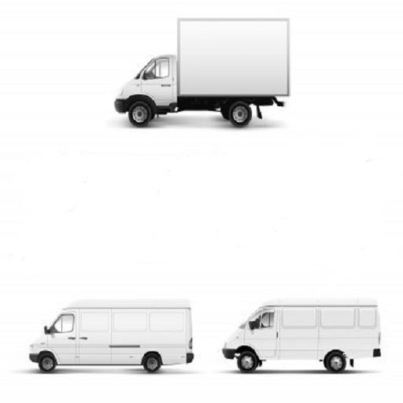
Figure 1: Reference image -transport
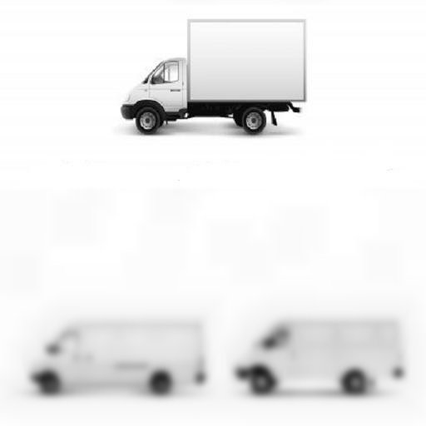
Figure 2: Complimentary Source image-transport1
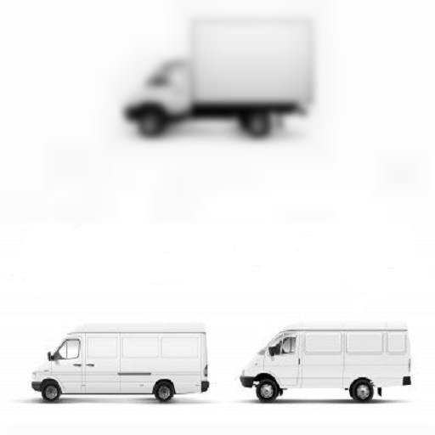
Figure 3: Complimentary Source image-transport2
The error image shows that the fusion rule DCTae provides excellent fusion results among all fusion techniques. Newly originated DCTamc and DCTame fusion rules give comparatively acceptable results with DCTae. The fusion quality evaluation metrics are shown in Table-1 and 3.

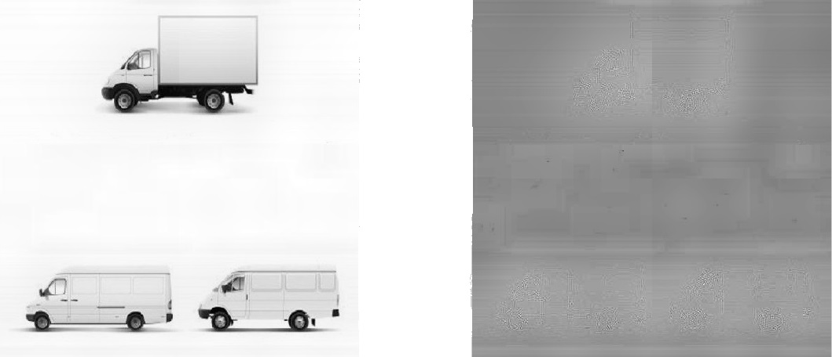
Figure 4: The output fused and error image using the DCTae fusion rule
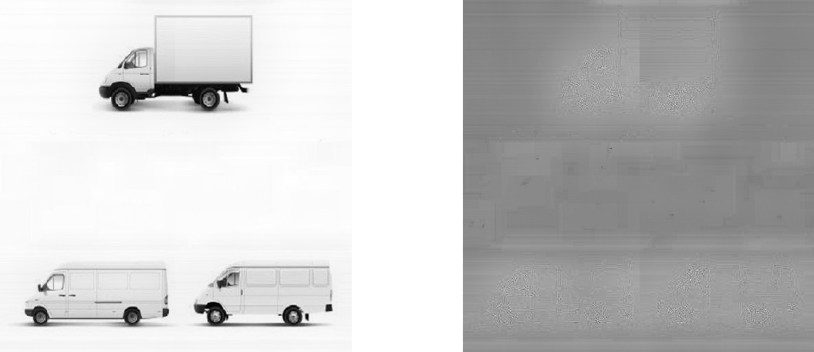
Figure 5: The output fused and error image using the DCTamc fusion rule

Figure 6: The output fused and error image using the DCTame fusion rule
The evaluation metrics values are

Table 1: DCTae

 | 2X2 | 4X4 | 8X8 | 16X16 | 32X32 | 64X64 | 128X128 | 256X256 | 512X512
PSNR | 55.692 | 57.2035 | 60.2745 | 63.1178 | 65.5799 | 67.1846 | 67.3391 | 65.5597 | 50.7717
Mae | 5.8207 | 5.4918 | 4.9273 | 4.3806 | 3.8293 | 3.7228 | 3.7834 | 4.4095 | 7.9779
SC | 1.0368 | 1.0358 | 1.0321 | 1.0302 | 1.0293 | 1.0287 | 1.0281 | 1.0272 | 1.0318
SF | 8.6056 | 10.4586 | 11.137 | 11.3012 | 11.2119 | 11.162 | 11.1623 | 11.1564 | 8.8379
SSIM | 0.969 | 0.9755 | 0.9793 | 0.9796 | 0.988 | 0.9884 | 0.9892 | 0.9908 | 0.8487
QI | 0.3249 | 0.3196 | 0.3191 | 0.3187 | 0.3472 | 0.3654 | 0.3898 | 0.4178 | 0.1685

Table 2: DCTamc

 | 2X2 | 4X4 | 8X8 | 16X16 | 32X32 | 64X64 | 128X128 | 256X256 | 512X512
PSNR | 55.1608 | 55.688 | 57.1885 | 60.1289 | 62.6879 | 65.1482 | 66.9022 | 67.2561 | 65.6207
Mae | 5.7298 | 5.611 | 5.2852 | 4.6398 | 4.1299 | 3.7875 | 3.641 | 3.6111 | 4.0112
SC | 1.0373 | 1.0368 | 1.0358 | 1.052 | 1.0321 | 1.0301 | 1.0287 | 1.048 | 1.048
SF | 5.4669 | 8.6051 | 10.4686 | 11.1838 | 11.3447 | 11.2497 | 11.1686 | 11.1706 | 11.1601
SSIM | 0.979 | 0.979 | 0.9855 | 0.9891 | 0.9885 | 0.9963 | 0.9865 | 0.9898 | 0.9907
QI | 0.3486 | 0.3433 | 0.3415 | 0.3413 | 0.3411 | 0.3609 | 0.3873 | 0.3916 | 0.3968

Table 3: DCTame

 | 2X2 | 4X4 | 8X8 | 16X16 | 32X32 | 64X64 | 128X128 | 256X256 | 512X512
PSNR | 55.1608 | 55.689 | 57.1682 | 60.1186 | 62.6645 | 65.1242 | 66.8561 | 67.2333 | 65.6185
Mae | 5.9498 | 5.8311 | 5.4881 | 4.8634 | 4.3545 | 3.9930 | 3.8684 | 3.8261 | 4.0213
SC | 1.0553 | 1.0548 | 1.0538 | 1.052 | 1.0501 | 1.0492 | 1.0486 | 1.048 | 1.048
SF | 6.6669 | 9.801 | 11.6687 | 12.3844 | 12.5483 | 12.4503 | 12.3696 | 12.1905 | 12.36
SSIM | 0.979 | 0.979 | 0.9854 | 0.9887 | 0.9883 | 0.9961 | 0.9852 | 0.9896 | 0.9964
QI | 0.3486 | 0.3403 | 0.3391 | 0.3366 | 0.3405 | 0.3601 | 0.386 | 0.3826 | 0.3973

The above result shows that DCTae fusion rules would provide good fused images. With block sizes less than 64x64 and 512x512, fusion performance is not good. For 512x512 image block size, DCTamc and DCTame give good results. Image block size decides fusion quality.
CONCLUSION
Three different types of image fusion rules dependent on discrete cosine transform (DCT) are used. Image fusion is done and evaluation metrics are used to evaluate fused image quality. For a block size of less than 64x64 and also a block size of 512x512 fusion result is not good using the three fusion rules. DCTae-based image fusion rule resulted well. For 512x512 image block size DCTamc and DCTame produced good result. Different evaluation metrics give results with slight change.
REFERENCES
- Jiezi Chen, (2023) “Digital Image Progressive Fusion Method Based on Discrete Cosine Transform”, Hindawi Journal of Mathematics Volume 2023, Article ID 9905604, 14 pages https://doi.org/10.1155/2023/9905604.
- V.P.S. Naidu, (2012) “Discrete cosine transform based image fusion,” Journal of Communication, Navigation and Signal Processing, Vol. 1, No. 1, pp. 35-45.
- VPS Naidu, (2010) “Discrete Cosine Transform-based Image Fusion”, Special Issue on Mobile Intelligent Autonomous System, Defence Science Journal, Vol. 60, No.1, pp.48-54.
- Gonzalo Pajares and Jesus Manuel de la Cruz, (2007) “A wavelet-based image fusion tutorial”, Pattern Recognition, 37, pp.1855-1872.
- V.P.S. Naidu and J.R. Raol, ( 2008) “Pixel-level Image Fusion using Wavelets and Principal Component Analysis”, Defence Science Journal, Vol. 58, No. 3, pp. 338-352.
- B. Ajazzi, L. Alparone, S.Baronti , R. Carla,( 1998 )“Assessment pyramid-based multisensor image data fusion”, Proc. SPIE 3500, pp.237-248.
- VPS Naidu and J.R. Raol,( 2008) “Fusion of Out Of Focus Images using Principal Component Analysis and Spatial Frequency”, Journal of Aerospace Sciences and Technologies, Vol. 60, No. 3, pp.216-225.
- Jinshan Tang,(2004) “A Contrast-based Image Fusion Technique in the DCT Domain”, Digital Signal Processing, Vol. 14, pp.218-226.
- N. Ahmed, T. Natarajan, and K.R. Rao,(1974) “Discrete Cosine Transform”, IEEE Trans. On Computers, Vol.32, pp.90-93,.
- R.C. Gonzalez and P. Wintz,(1987) “Digital Image Processing”, MA: Addison-Wesley.
- G. Strang,(1999) “The Discrete Cosine Transform”, SIAM Review, Vol.41, pp.135-14.
- Jinshan Tang, Eli Peli, and Scott Acton,(2003) “Image Enhancement using a Contrast Measure in the Compressed Domain”, IEEE Signal Processing Letters, Vo. 10, No,10, pp. 289-292.
- Qingling Sun and Jinshan Tan,(2003) “A New Contrast Measure based Image Enhancement Algorithm in the DCT Domain”, IEEE Systems Man and Cybernetics, Vol.3, pp.2055-2058.
- Jinshan Tang,(2004) “A Contrast based Image Technique in the DCT Domain”, Digital Signal Processing, Vol.14, pp.218-226.
- Z. Wang, A. C. Bovik, H. R. Sheikh and E. P. Simoncelli, (2004)"Image quality assessment: From error visibility to structural similarity," IEEE Transactions on Image Processing, vol. 13, no. 4, pp. 600-612.
- Z. Wang, A. C. Bovik,(2002) “A Universal Image Quality Index” IEEE Signal Processing Letters, Vol.XX, No. Y.
- Jun Kong, Kaiyuan Zheng, Jingbo Zhang, Xue Feng,(2008) “Multi-focus Image Fusion Using Spatial Frequency and Genetic Algorithm”, IJCSNS International Journal of Computer Science and Network Security, VOL.8 No.2.
- Ken Cabeen, Peter Gent, “Image compression and discrete cosine transform”.
- Abdul Basit Siddiqui1, Muhammad Rashid1, M. Arfan Jaffar, Ayyaz Hussain, and Anwar M. Mirza, (2011)“Feature classification for multi-focus image fusion” International Journal of the Physical Sciences Vol. 6(20), pp. 4838-4847.

