Study on Online Farm Related Goods Trading
Gaurav Anant Ambikar¹, Nilesh Y. Chaudhari²
¹PG student, GF’s GCOEJAL, Jalgaon-425001,Maharashtra,India,email ID- gauravambikar@gmail.com
²Asst. Professor,GF’s GCOEJAL, Jalgaon-425001,Maharashtra,India,email ID- cont.nilesh@gmail.com
Received on: xxxx,20xx, Revised on: xxxx,20xx, Published on: xxxx,20xx

Abstract –This study is related to the online farming product sell; with the helpof this system farmer can easily sell there farming product and customer can get this product in very less prices. Our system offers salient features including cost reduction,establishingdirect contact between farmer and customer, and easily availability of farm products. This will cut down the intermediaries which in turn benefit farmers and they will get the good price to their farm goods.
Keywords-Online Trading, Farm products, Android application,Middlemen
- INTRODUCTION
The motivation behind the online farm related goods trading is to connect the farmers from rural areas to the big market. Online farm related marketing creates new income opportunities for farmers with limited environmental impact. Farmers frequently consider marketing to be their major difficulty. Farmers are facing many problems such as poor rates, insufficient transport. Successful advertising requires learning new abilities, new techniques and innovative ways of obtaining information. Online farm related trading is the online platform for selling the farm products [6] [7].In the 21th century there is a large scope for online selling of farm products. So, online farm related trading is the better way to sale farm products such as grains and fruits. Due to this we avoid the merchants or commission agents.Thus, because of the commission agents, food prices soar. This online farm related trading is beneficial for both farmer and the customers. Farmer will getting better price of their product and the customer take product at minimal price. The system collects less information from both customer and farmer and provides the more output [1] [7].

II. LITERATURE REVIEW
Earlier, researchers worked upon online farm related trading such as E-trading of Agricultural Products from Farm to Customer Application , E-NAM : ONE NATION ONE MARKET[9], Online Farm Based Trading[5]etc . All these papers talked about digitization of the farm products. This will definitely accrue the income of the farmers by providing them the right price to their goods.
Different barriers in the existing system made it difficult for farmers to increase their income[8]. Existing gaps in the system can be solved by proposed android application. So, the structure and working of the system is easy to understand.
III. METHODOLOGY

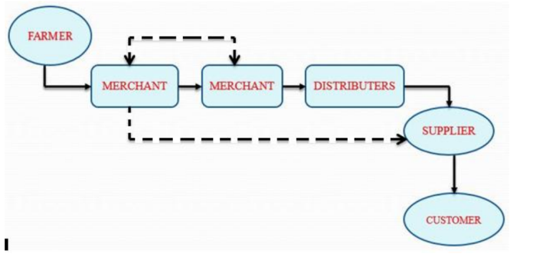
Figure 1: Architecture of thesystem
This system provides more income benefits to farmers and also useful for customer as compared to the existing system. Also the system contains the current market prices and news feeds related to the new technologies, so the user of the system will be aware of the new technologies and trends, used in farming. And also updated himself/herself day to day market prices, of farm products. The seller can post the free advertisement of their farming product with the help of android application then this post will be verified by the system administrator, after that their post will be visible to the end users. The following figure shows the working of the system.

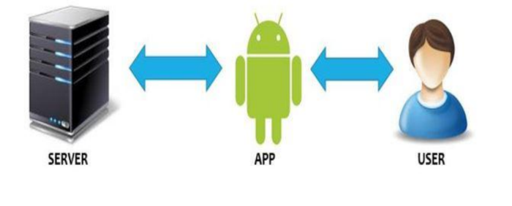
Figure 2: Overview of the system
This system helps to sell the farming related products, Such as agricultural grains, vegetables, milk and milk products etc. This system will work online in which the farmers and sellers can interact with each other. This system can abolish the role of middlemen. This system is easily accessible to everyone.

IV. DESIGN
Lossless Image Compression :
• Approaches of Differential Coding of Images: – Given an original image I (x, y), using a simple difference operator we can define a difference image d (x, y) as follows: d (x, y) = I (x, y ) − I ( x − 1, y) (7.9) or use the discrete version of the 2-D Laplacian operator to define a difference image d (x, y) as d (x, y)=4 I (x, y ) − I (x, y − 1) − I (x, y + 1) − I ( x + 1, y ) − I ( x − 1, y ) (7.10)
• Due to spatial redundancy existed in normal images I, the difference image d will have a narrower histogram and hence a smaller entropy
V. RESULT & DISCUSSION
With the help of this proposed system we can establish smooth contact between farmer and consumer. One can get fresh farm produce at one click. This will also ensure the best prices and demand for the farm products. Agriculture sector in India is dependent on the unpredictability of the monsoon. So, this platform will help farmers.
VI. CONCLUSION
The system is used to connect the farmers across the India to the Agricultural Market Produce Company(APMC) and Big Trading Markets without any intermediary/middlemen to gain profit in their farming related business. In this way, we can establish connectivity between market and farmers.
ACKNOWLEDGMENT
This is very important journey. Whenever we are standing on most difficult step of the dream of my life, We often remember the great almighty god for his blessings kind help and he always helps us in tracking off the challenges by some means on our lifetime. I would like to convey sincere gratitude to my guideand Prof. Nilesh Y. Chaudhari Dean, Examinations & Scholarship Affairs And Asstt. Prof., Dept. of Computer Engg. GF’s GCOE for his valuable guidance and support and who guided me and provided with his useful and valuable suggestions and without his kind cooperation it would have been extremely difficult for us to complete this dissertion. I would like to convey sincere gratitude to Prof. Pramod B. Gosavi Dean, I.Q.A.C. And Head, Computer Engg. Dept, GF’s GCOEfor his valuable guidance and support. I would like to express appreciationto Dr. V. H. Patil Principal, GF's GCOE, Jalgaon.Finally we are very grateful to inspiring parents who loving and caring support contributes a major share in completion of our task.
REFERENCES
[1]R. Baker and K. Yacef The state of educational data mining in 2009; A review and future vision Journal of Education Data Mining, vol.1,no.1,pp.3-17,2009.
[2] Anupam Mukharjee, Mitankar Das Sarkar, Amiya Halder(2012),Predictive Lossless Color Image Compression using Arithmatic Operation, International Journal Of Computer Applications(0975-8887), Volume 43,Page No.5.
[3]N.Neelamani, R. Queiroz, Z . Fan , and R. Baraniuk(2006),JPEG Compression History Estimation for Color Images , IEEE Trasactions on Image Processing,Vol.15 No.6, pp.1365-1378.
[4] Marie Bienkowskiet al.( 2012,April).Enhancing Teaching and Learn-ing Through Educational Data mining and Learning Analytics.U.S. Department of Education. Washington. [Online]. Available:http://www.ed.gov/edblogs/technology/_les/2012/03/edm-la-brief.pdf
[5]Online Farm Based Trading(2016) ,International Journal of modern Trends in Engineering andResearch Available:https://www.ijmter.com/papers/volume-3/issue-3/online-farm-based-trading.pdf
[6] http:/ /www.wikipedia.or
[7]http:/ /www.wikipedia.org
[8] E-trading of Agricultural Products from Farm to Customer Application, International Research Journal of Engineering and Technology(IRJET)Available: https://www.irjet.net/archives/V4/i3/IRJET-V4I3696.pdf
[9]A STUDY ON ONLINE TRADING PLATFORM FOR FARM GOODS - E-NAM : ONE NATION ONE MARKET , © 2019 JETIR January 2019, Volume 6, Issue 1 , Available: http://www.jetir.org/papers/JETIR1901A01.pdf

