Design Development of RC Ornithopter

Rajeshwari Mahadik¹, Himani Barmase², Aman Kokate³, Trupti Rangari⁴, Riya Shahare⁵, Prof.Mrs.Rupali.S.Tupkar⁶

Department of Mechanical Engineering
Priyadarshini College Of Engineering, Nagpur, India, 440019

amankokate466049@gmail.com

Received on: 05 April, 2022 Revised on: 11 May, 2022, Published on: 13 May,2022

Abstract- The project work consists of designing and developing an ornithopter which can be controlled by a remote controller. The project aims at focusing on maximizing the efficiency of flapping sector focusing on maximizing the efficiency of a (Unmanned Aerial Vehicle) sector where the predominant 'fixed wing UAV's' works in comparatively lower efficiency against 'flapping wing’ like an Ornithopter. The project consists of designing an Ornithopter and analyzing the feasibility of deploying of the same in law enforcement purposes, jungle warfare scenario and civilian purposes like topological mapping & wildlife protection. Equipment’s like high definition and thermal cameras, defense areas security purpose give a technological and mission oriented approach to the ornithopter.
Keywords- Ornithopter, Flapping,UAV
- INTRODUCTION
The purpose of this project is to develop a remote piloted electric-powered ornithopter (flapping-wing aircraft).To study and adopt best possible wing design for higher efficiency and better flight. A mechanism which produced a flapping motion was fabricated and designed to create flapping flight. The flapping flight was produced by using a single motor and a flexible and light wing structure. The thrust measurement was measure likewise but in two cycles only. Several observations were made regarding the behavior of flexible flapping wings that should aid in the design of future flexible flapping wing vehicles. The final ornithopter prototype weighs only 170 g, has a wing span of 75.8 cm, that could flap at a maximum 6 flaps per sec and produce a maximum thrust and lift of about 0.719 and 0.264 N respectively angle or phase characteristic were analyze too and studied. Being oscillated close to the resonance frequency of the system, only by the torque in flapping motion, the amplitude gained is a few times higher than that of normal case. The first prototype was made from acrylic using a laser cutting machine. The wings were made up of carbon rods and kite material Ripstop. First test showed that the wings were too heavy for the mechanism to work. The third prototype was a smaller single gear crank design which was fabricated using a 3D printer. Initial test proved that the second prototype could withstand the high frequency flapping and near resonance amplitude as designed. With remote control, the third prototype was able to take off, climb, cruise and land in flapping mode successfully. All are fascinating to design and build because of the endless possible variations. This has proven to be more challenging because of the limitation of our knowledge of aerodynamics of flapping-wing flight for ornithopters of this size.
- LITERATURE REVIEW
Harijono Djojodihardjo et al (1999) have done on "Numerical Modelling, Simulation and Visualization of Flapping Wing Ornithopter": The state of the art of flapping wing Ornithopter MAV is reviewed to provide a comprehensive insight into the geometrical, kinematic and aerodynamic characteristics of flapping bio systems. Then a generic approach is carried out to model the kinematics and aerodynamics of Ornithopter to mimic flapping wing to produce lift and thrust for hovering and forward flight, by considering the motion of a three dimensional rigid thin wing in flapping and pitching motion, using simple approach, applied to a two and quad wing flapping Ornithopter, which are modelled and analyzed to mimic flapping wing bio system to produce lift and thrust for forward flight. Considering bird’s scale Ornithopter, basic unsteady aerodynamic approach incorporating salient features of viscous effect and leading edge suction are utilizedK. D. Jones et al (2003) have done research work on" Bioinspired design of flapping-wing micro air vehicles". In this paper the development and flight testing of flapping-wing propelled, radio-controlled micro air vehicles are described. The unconventional vehicles consist of a low aspect ratio fixed-wing with a trailing pair of higher aspect ratio flapping wings which flap in counter phase. The symmetric flapping-wing pair provides a mechanically and aerodynamically balanced platform, increases efficiency by emulating flight in ground effect, and suppresses stall over the main wing by entraining flow. The models weigh as little as11g, with a 23cm span and 18cm length and will fly for about 20minutes on a rechargeable battery. Stable flight at speeds between 2 and 5ms –1 has been demonstrated, and the models are essentially stall-proof while under power. The static-thrust figure of merit for the device is 60% higher than propellers with a similar scale and disk loading With flying models in hand, we now went back to the wind-tunnel in order to gain a better understanding of the flow physics; hopefully allowing us to optimise the design. Since the pager motors used in the flying models had a relatively short lifespan, a model was built with the same fixed and flapping-wing geometry as the second radio controlled model, but with a larger fuselage to house a bigger motor and rotary encoder and with interchangeable parts. The new model, shown in Fig. 13, was attached to a two-component force balance to measure lift and thrust, and flow visualisation and unsteady LDV experiments were run.Streamlines were generated by a smoke wire which was constructed from 0⋅25mm diameter NiCr beaded wire, heated by passing a current through it, and using Rosco Fog Juice as the smoke agent. Imagery was recorded using either a digital still camera or a digital video camera with a high shutter speed to freeze the motion of the wings and streamlines. Details of the methods can be found in Jones and Platzer and Papadopoulos. Flow visualization. Benjamin J. Goodheart They focused on the history of ornithopter in flapping-wing designs incorporated in nano-scale unmanned vehicles, aviation design has in many ways come full circle. This paper examines the history of, and influences on, ornithopters and their design, and investigates developments and future trends of this uniquely inspired aircraft.
III- DESIGN AND WORKING
a). Frame:-
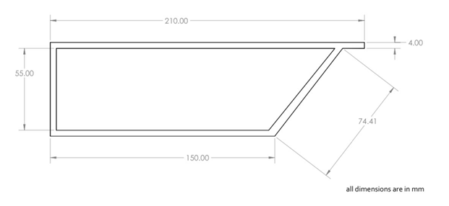
Fig 1- 2D Diagram of Frame
For construction of main frame the material selection was an important thing. As the weight of material and its strength are very important factor for this project It is liable to use Carbon Fiber in order to obtain light weight structure. But it is rarely available and the cost is also high. So we started finding the alternatives of Carbon Fiber. This disadvantage of Carbon fiber is been dismissed by Balsa wood. It a type of wood with very light weight, can be comparable with Thermo Cole but strength is good. so we decided to use Balsa wood for our structure.
b). Wing:-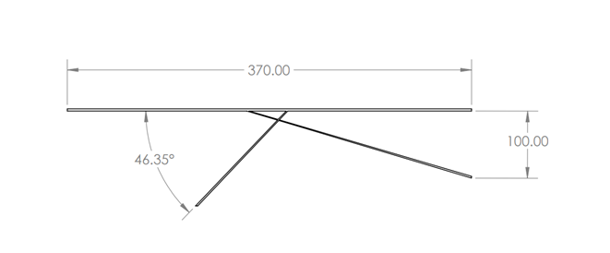
Fig 2- 2D Diagram of Wing

When building ornithopters, an efficient wing design can make the difference between failure and success. There are several general types of ornithopter wing. In this section, I'll describe the advantages and disadvantages of each type, and I'll tell you how to build them. This is where we talk about aerodynamics.
c). Gearbox:-Unless we use a rubber band for power, you'll probably need to gear down the motor, to give it enough torque to flap the wings. The gearbox can be one of the most challenging parts of your ornithopter to build. The information here will make it much easier. There are two ways to build an ornithopter gearbox. The simplest method is to space the gear axles along a linear rail or strut. This method is recommended for micro-sized ornithopters, which usually don't have ball bearings. The other method involves two or more plates with spacers between them. Bearings can be pressed into the plates to hold the gear axles. The plate gearbox design is better for dual-crank mechanisms and it lends itself to the more complex body designs typical of larger RC ornithopters.
Spur gears as shown are the best choice for ornithopters because of their low friction. You should avoid using worm gears. They might be tempting because they permit substantial gear reduction in a single stage, but the frictional losses are extremely high! A chain drive might be considered for large or manned ornithopters. By distributing the load onto more of the gear teeth, the chain drive permits weight reduction, and it is nearly as efficient as spur gears.
The limited supply of suitable gears long made it difficult to build electric-powered ornithopters. Recently, the plastic cluster-type spur gears from Didel have made it much easier to build gearboxes for ornithopter micro-air-vehicles. For larger ornithopters, gears are available from industrial suppliers like Stock Drive Products. Suitable cluster gears are not available in these larger sizes, and the pinion gears typically don't fit the same shaft sizes as the larger spur gears. The solution is to put the large spur gear on a shaft made of "pinion wire". This provides a simple, lightweight solution for achieving substantial reduction ratios.
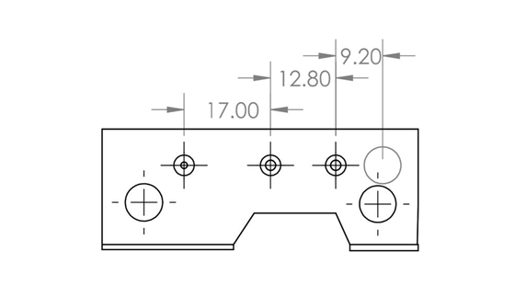
Fig 3-2D Diagram of Gearbox
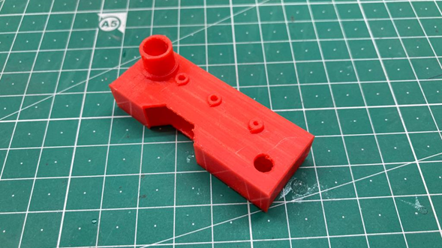
Fig 4- Actual Picture of Gearbox
d). Flapping Mechanism: Here is where we convert the rotary motion of your motor into an oscillating wing motion. This is what makes your device an ornithopter instead of an airplane or helicopter! Several different mechanisms and construction techniques are described. The Ornithopter Zone web site also has a software program that can help you design your own flapping mechanism. The purpose of the flapping mechanism is to convert the rotary motion of your motor into the reciprocating motion of flapping wings. There are many ways to do this, and I will describe only some of the more common ones here. The mechanism must be lightweight and fairly simple. Yet it must also provide a fairly symmetrical wing motion so the ornithopter flies straight.The basis for most mechanisms is called a "four-bar linkage". There is a rotating crank shaft, driven by the motor. As the crank goes around, the connecting rods push the wings up and down.
Dual Cranks: Another solution is to use two separate cranks. This requires an additional drive shaft and gear. This mechanism will probably weigh a little more than the outboard wing hinge mechanism shown above, but the flapping will be more symmetrical.
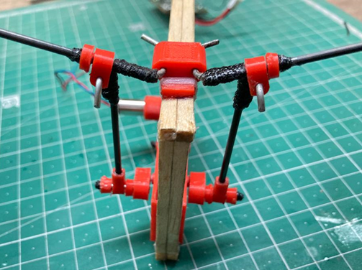
Fig 5- Actual Picture of Flapping Mechanism

e).Tail:- It's pretty easy to stabilize a free-flight ornithopter, but when you add radio control, some surprising things happen. Often the ornithopter refuses to come out of a turn! Just as there are several ways to steer an ornithopter, there are also some things you can do to avoid these problems. Getting an ornithopter to fly is only half the battle. For the sake of esthetics, we often depart from the tried-and-true control systems found in airplanes. If we insist on using a flat, triangular tail like a bird, this will increase the challenges of stability and control.
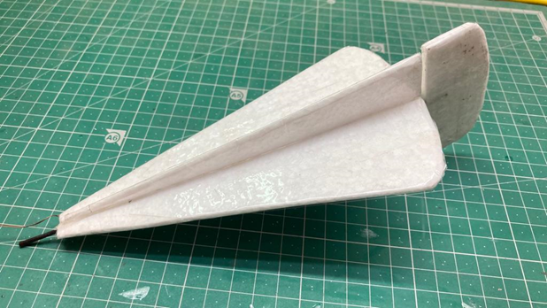
Fig 6- Actual Picture of Tail
IV- CALCULATION
Number of Rotation of crank per second = 6
Therefore, Number of Reciprocating motion = 6 per sec That is, Flapping Frequency (Flappling Rate) = 6 Flaps per second i.e. 6Hz
GEAR RATIO:- = 55/10 x 40/10 x 29/10
=63.8
Therefore, Gear Ratio = 63.8
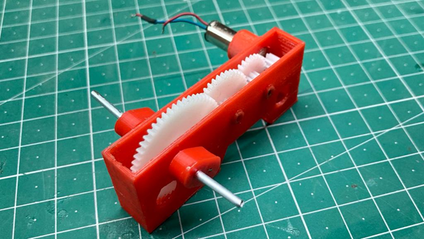
Fig 7- Actual Picture of Gearbox

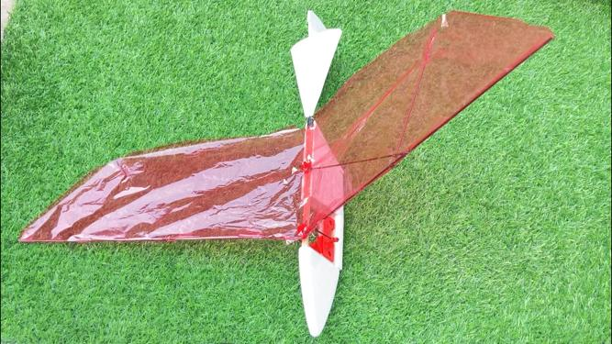
Fig 8- Actual Model of RC Ornithopter
V- CONCLUSION
The ornithopter was designed from the ground up with the needs of research in mind. All components have been designed to be as lightweight and high performance as possible so as to maximize payload capacity and are intended to fail in predicable and field repairable ways. Examples of this are the screw in wing spars and replaceable face plates. In addition to this all parts of the ornithopter are simple and inexpensive to fabricate and assemble. Manual and initial autonomous flight tests have been conducted and show that the ornithopter is capable of sustained flight with a full load of electronics and can be stabilized by simple controllers in common use in aircraft. Flight tests have also shown that the planned points of failure work as expected and allow repairs to be quickly accomplished in the field.
REFERENCE
- James D. DeLaurier, “An Ornithopter Wing Design, “Canadian Aeronautics and Space Journal, Vol. 40, No. 1, March 1994, pp. 10-18
- .Z. Jackowski, “Design and construction of an autonomous ornithopter”, Master's thesis, Massachusetts Institute of Technology, 2009.
- The Ornithopter Zone – Discovering Flapping Wing Flight, www.ornithopter.org
- Ornithopter Zone (www.ornithopter.org)
- https://www.instructables.com/id/Opensource-Ornithopter-Prototype-ArduinoPowered-a/
- .https://www.youtube.com/watch?time_continue=1&v=ruWvzF1fGHw&feature=emb_logo

