**Design and Analysis of an Automobile Radiator with and without Louvered Fins**

**Priyanka Vinod Dubey1, Dr. Bharat Chede2, Prof. S.M. Choudhary3 , Prof. Nitin Sawarkar4**

*1M. Tech student, 2Professor, 3,4Assistant Professor*

*Mechanical Engineering, Wainganga College of Engineering & Management, Nagpur*

*priyankadubey1704@gmail.com*

***Received on****: 25 March,2022* ***Revised on****: 27 April,2022,* ***Published on****: 29 April,2022*

***Abstract –*** *Radiators are heat exchanging devices used to transfer thermal energy from one medium to another for the sole purpose of cooling and heating. The majority of radiators are constructed to be used in cars, buildings, and electronics. In this thesis, the present design of the automobile radiator was analyzed. Further, the design is modified by adding louvers and varying the pitch of louvers. The performance of the modified designs is validated by performing fluid flow analysis.*

***Keywords-*** *Keyword should be times new roman size 10 italic, bold.*

1. **INTRODUCTION**

**F**or cooling, radiators transfer thermal energy from one medium to another. Radiators are used to cool internal combustion engines, which are found mostly in automobiles but also in piston-engine aircraft, railway locomotives, motorbikes, and stationary power plants. The radiator distributes heat from the fluid inside to the air outside, cooling the fluid and cooling the engine as a result. The vast majority of radiators are designed for use in automobiles, buildings, and electronic devices. The radiator is always a source of heat to its surroundings, whether for the purpose of heating or cooling the fluid or coolant provided to it, as is the case with engine cooling. Radiators, despite their name, generally transport heat through convection rather than thermal radiation, however the term "convector" is used more narrowly.

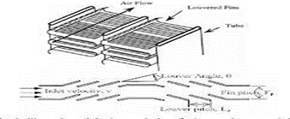

*Fig 1- Louvered fin radiator*

**II-METHOLOGY**

The following methodology is used to carry out the research work.

*Fig 2-Research Methodology*

**III- CALCULATION OF HEAT TRANSFER RATE, AND AIR & COOLANT OUTLET TEMPERATURE**

The heat transfer rate, air outlet & coolant outlet temperature are calculated and tabulated in the below table:

Table 1: Air Side calculations

|  |  |  |
| --- | --- | --- |
| **Sr. No.** | **Parameters** | **Value** |
| 1 | Coolant inlet Temperature | 92 ֯C |
| 2 | Air inlet Temperature | 27 ֯C |
| 3 | Total surface area of fins (AF) | 3264464.3 mm2 |
| 4 | Surface area of the tube between the fins (Aw) | 1178602.307 mm2 |
| 5 | Area of the fins (A) | 4443066.607 mm2 |
| 6 | Velocity of air, Va | 17m/s |
| 7 | Frontal area of the radiator through the air passes (AFR) | 84815.5 mm2 |
| 8 | Mass flow rate of air (ma) | 1.650934 kg/s |
| 9 | Reynolds no. for air Rea | 7005.345646 |
| 10 | Nusselt Numbers on Air Flow, Nua | 66.288228 |
| 11 | Heat transfer coefficient, ha | 255.141639 w/m2k |
| 12 | Efficiency of the fins, ηf | 0. 999885 |
| 13 | Air-side heat transfer coefficient based on the total surface area, ha! | 220.916239 w/m2.k |

*Table 2: Coolant Side Calculation*

|  |  |  |
| --- | --- | --- |
| **Sr. No.** | **Parameters** | **Value** |
| 1 | Coolant density, ρc | 1070 kg/m3 |
| 2 | Coolant mean speed, Vc | 0.8 m/s |
| 3 | Viscosity of coolant, μc | 0.00156025 Ns/m2 |
| 4 | Prandtl number for coolant flow, Prc | 29.13 |
| 5 | Reynolds no, Rec | 2902.252844 |
| 6 | kc | 0.44685 w/m.k |
| 7 | Heat transfer coefficient, hc | 3177.605847 w/m2.k |
| 8 | Mass flow rate of coolant (mc) | 0.921873kg/s |
| 9 | Fouling resistance for engine water, RF | 0.000175 m2.k/w |
| 10 | Heat transfer effectiveness, ε | 1388.22 w/K |

Table 3: Air & Coolant Outlet Temperature

|  |  |  |
| --- | --- | --- |
| **Sr. No.** | **Parameters** | **Value** |
| 1 | Coolant outlet Temperatures (Tc,out) | 77.53 ֯C |
| 2 | Air outlet Temperature (Ta,o) | 54.14416 ֯C |

**IV-PARTS OF RADIATOR**

Radiator consist of several parts:

* Core
* Tanks
* Side Support
* Gasket
* Pressure Cap

Core:

A Heating Core is a Heat Exchanger that takes heat from the coolant as it passes through it in order to keep the engine temperature stable. This is commonly accomplished by transferring heat from heated coolant flowing through the tubes via the Inlet tank from the engine cooling jacket. The heat evacuated from the tube by the coolant is transferred to the ram air flowing over the fins.



Radiator core

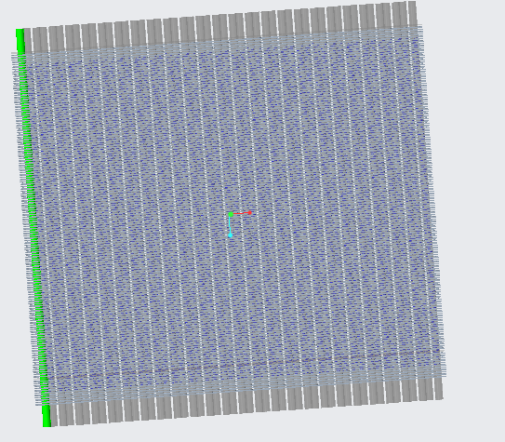

Model of the radiator core

Parts of Core:

Tubes, fins, and header are all joined together mechanically using a hydraulic press to extend the tubes over the header, resulting in a locking. This mechanical locking is further secured by the use of epoxy resin cx, which forms a solid joint between the header and tubes.

* Header
* Tubes
* Fins
* Turbulators

Header:

Each radiator has two headers. Each tube protrudes through perforated plates known as headers. The header connects the fin and the tube, allowing the tanks to be mechanically attached to the aluminium core.

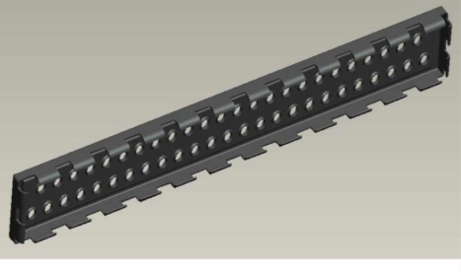

Header

Round Tubes:

It is used to hold coolant: warm from the engine, bloodless again to the engine. The heat exchange is achieved via the tube wall and the fin, eliminated through the air passing via the radiator.



Radiator Tube

Fins:

Between each tube is a Fin, which is a flat strip of aluminium. It's a heat transfer medium that transfers heat from the coolant tubes to the air travelling through the radiator. The louvres are angular cuts on the fin surface that create turbulence in the air, increasing the amount of heat sucked up by the air and hence increasing the amount of heat rejected by the radiator. To enhance radiator efficiency, the louvres must be as large as feasible, but airside pressure should be addressed because it rises with increasing louvre angle and might reduce radiator efficiency.



Fins

Turbulators:

The functions of turbulators are:

1. To enhance the turbulence inflow.
2. Increase the surface area inside the tube.



Turbulators

Tanks:

A coolant-filled radiator tank is a crucial structural component. It not only supports and links a radiator core to the car, but also the fan, motor, and shroud assembly (engine side), condenser, and perhaps transmission oil cooler, as well as power steering and hydraulic fan coolers. Each radiator contains two tanks: an inlet tank that receives hot coolant from the engine, and an outlet tank that receives cold coolant from the engine.

Side Support:

Two radiator side supports run parallel to the tubes, are crimped, and then brazed to the headers. The structure that keeps the fin tube matrix together is completed by side supports. It protects the radiator's first and last fins during handling prior to installation in a vehicle.

Gasket:

A radiator gasket helps in maintaining a leak-proof joint between tank and header. There are two gaskets per radiator.

Pressure Cap:

Pressure capes are placed on the radiator for multiple reasons.

The functions of the pressure cap are:

* Protect the radiator hoses
* Maintain the pressure in the cooling system
* Reduce cavitation
* Prevent or reduce surging.

It is very important to maintain constant pressure on the cooling system. The pressure should be near 103 kpa. In the case of Maruti 800 Pressure should not exceed 0.90 kgf/cm2.

**V- MODELLING OF RADIATOR**

The modeling of the radiator is done by using Creo Parametric 8.0. The actual model of the Maruti 800 car radiator is measured and prepared in software.

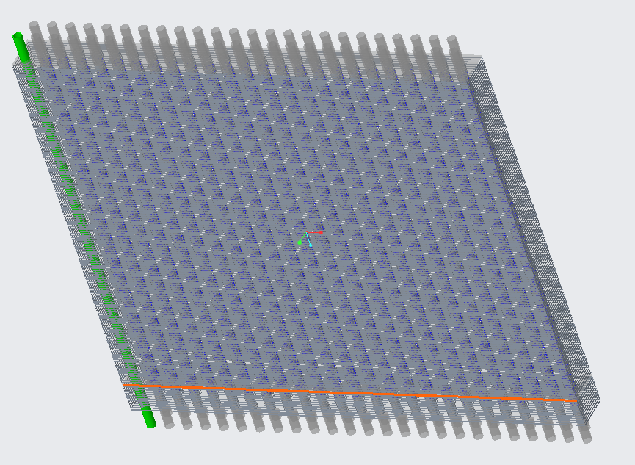

Radiator assembly

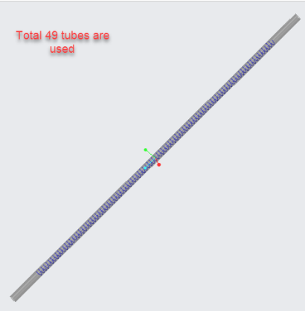

Tube assembly

**VI- ANALYSIS OF RADIATOR**

The heat transfer rates, thermal profiles, and overall efficiency of a Maruti 800 car's radiator are investigated and modelled. Creo Parametric 8.0 was used to create the model. To achieve the most accurate replica, all of the row's elements, including the hollow water tubes and fins, are recreated.

The goal is to do a CFD analysis of the radiator and replace the existing mechanism with a new one. The current mechanism is investigated first, and then the radiator design is adjusted to include louvred fins. The examination is done with air moving through the radiator at different speeds. The air velocity distribution over the radiator is calculated using ANSYS.

**CONCLUSION**

The following conclusions are marked from the above study:

* The geometric parameters of a louvred fin radiator, such as fin height, fin pitch, louvre angel, louvre pitch, and flow depth, have a significant impact on its performance.
* The flow regime over louvred fins is determined by frontal air velocity and louvre angle.
* With louver-directed flow, flow efficiency over louvred fins improves.
* Due to the lack of un-finned portions, 2D numerical models are insufficient to forecast the heat transfer coefficient. Both the heat transfer coefficient and the friction factor can be predicted using 3D numerical methods.
* As fin pitch increases, the friction factor (f) lowers..

**REFERENCES**

1. *Abhishek Gakare, Ashutosh Sharma, Mr. Gaurav Saxena, “Simulation Software Based Analysis of Automotive Radiators: A Review”, Journal of Automation and Automobile Engineering Volume 4 Issue 1.*
2. *Mr. Ramani Raj, C. Gowtham, H. Hemanth Sabari, S. S. Pranav Raj, P. S. Rajesh, “Reviews on Finite Element Analysis and Flow Characteristics on Radiator Fins”, IAETSD Journal for Advanced Research in Applied Sciences, Volume VI, Issue IV, April/2019, ISSN NO: 2394-8442.*
3. *S. Vinay & Dr. A. Karthikeyan & Mr. Vikash Kumar, “Improvement of an Automobile Radiator using Thermal Analysis”, IJRAR- International Journal of Research and Analytical Reviews, e ISSN 2348 –1269, Print ISSN 2349-5138.*
4. *P Vijaya Sagar, K Kiran Chand, “Thermal Analysis of An Automobile Radiator with and Without Louvered Fins”, Proceedings of International Conference on Recent Trends in Mechanical Engineering-2K15(NECICRTME-2K15), 20th – 21st November 2015, Vol.2, No.1, ISSN Number (online): 2454-9614.*
5. *Kola David, Abhishek Kumar, “CFD and Heat Transfer Analysis of Automobile Radiator Using Helical Tubes”, International Journal of Innovative Research in Science, Engineering and Technology, Vol. 8, Issue 5, May 2019, ISSN (Print) : 2347-6710.*
6. *Prabir Kumar Nayak, Mr. Santosh Kumar Tripathy and Dr. Ajit Kumar Senapati, “Heat Transfer and Entropy Generation Through Finned Tubes and Behavioral Analysis of Employees using Statistical and Correlation Methods”, Turkish Journal of Computer and Mathematics Education Vol.12 No.9 (2021), 606 – 621.*
7. *Thirumala Venkateswar Reddy K, K. Sandhya Rani, “Performance Improvement of an Automobile Radiator using CFD Analysis”, International Journal of Advanced Technology and Innovative Research, Volume.08, IssueNo.01, January-2016, Pages: 0131-0134.*
8. *Vishwa Deepak Dwivedi, Ranjeet Rai, “Modeling and Fluid Flow Analysis of Wavy Fin Based Automotive Radiator”, Int. Journal of Engineering Research and Applications, ISSN: 2248-9622, Vol. 5, Issue 1(Part 1), January 2015, pp.17-26.*
9. *T G Sakthivel, K M Abishek, R Aravindan Yadav, R Arivazhagan, K Balaji, “Design and Analysis of Radiator Fins”, International Research Journal of Engineering and Technology (IRJET), Volume: 08 Issue: 04 | Apr 2021, p-ISSN: 2395-0072.*
10. *John Babu Male, Mr. S. Rajasekhar and Mr. A.V. Sridhar, “Performance Improvement of an Automobile Radiator Using CFD Analysis”, International Journal & Magazine of Engineering Technology, Management and Research, Volume 02 (2015), Issue No. 12, ISSN No.2348-4846.*
11. *Junjanna G.C, Dr. N Kulasekharan and Dr. H.R. Purushotham, “Performance Improvement of a Louver-Finned Automobile Radiator Using Conjugate Thermal CFD Analysis”, International Journal of Engineering Research & Technology (IJERT), Vol. 1 Issue 8, October – 2012, ISSN: 2278-0181.*