Time History Analysis of Soft Storey Reinforced Concrete Structure
Dr. S.K. Hirde¹, Kishor S. Matsagar²
¹Professor, Applied Mechanics Department
Government College of Engineering, Amravati, India, 444604
²M.Tech Student
Government College of Engineering, Amravati, India, 444604

Abstract –In the present paper study of dynamic analysis of Ten storied RCC building considering influence of masonry infill wall on seismic responses of symmetrical structure is studied using time history analysis, for this purpose different models of RC frame with soft storey at different level is prepared. The equivalent diagonal strut method has been utilized in order to account for the stiffness and structural action of the masonry infill panels. Dynamic time history using three ground motion records has been used to perform the seismic analysis of the considered model configurations. The structural software package ETABS has been used in developing the building models and performing analysis .the various response parameters like base shear, storey drift, storey displacements etc are calculated to understand seismic behaviour. the result of this study shows that masonry infill wall influences the overall behavior of the structure when subjected to lateral forces.

Keywords-RCC Building Frame, soft storey, time history analysis, Masonry infill walls, diagonal strut.

INTRODUCTION

A large number of moment resisting frame buildings have been or are being constructed in all over the world .These types of buildings have functional uses such as parking garages, reception lobbies and any other open air
spaces which have no infill masonry walls and called soft or weak storey. according to IS 1893:2000 a soft

storey is one in which the lateral stiffness is less than 70 percent of that in the storey above or less than 80 percent of average stiffness of three storeys above. The open floor consists of a little or no infill walls so it has less frame-infill interaction and may significantly decreases both stiffness and strength of the floor, due to sudden decrease in stiffness and strength such structures
are more vulnerable to earthquake Since the distribution of the lateral forces in the high rise buildings is depend on the mass and the stiffness of the building. In-fill walls provide stiffness to the structures it improves the seismic behaviour of structures. Also opening provided in the masonry infill wall reduces the lateral strength of the structures.Present code of practice does not include provision of taking into consideration the effect of infill. It can be understood that if the effect of infill is taken into account in the analysis and design of frame, the resulting structures may be significantly different, presence of infill’s has been ignored in most
of the current seismic codes except their weight.However, even though they are considered non-structural elements & their influence was neglected during the modeling phase of the structure leading to substantial inaccuracy in predicting the actual seismic response of framed structures.The infill components increase the lateral stiffness and serve as a transfer medium of horizontal inertia forces, this paper discusses non-linear dynamic analysis of soft storey structure with soft storey at different levels.

METHOLOGY
In order to investigate seismic performance of RCC frame buildings with and without open soft storey a ten storey symmetrical reinforced concrete moment-resisting frame building is considered. The considered symmetrical building has of 16m in length and divided into 4 bays as shown in fig.1 below. The associated storey height considered is of 3.2m. In modeling building frame other relevant data is given as below,
Size of Building: 16 m X 16 m
Grade of concrete: M 25
Grade of steel: Fe415
Slab thickness: 150 mm Wall thickness: 230 mm
Size of columns: 300x650 Size of beam: 300 mm x 450 mm
Live load on floor : 3kN/m 2
Floor finishes : 0.75kN/m 2
Seismic zone: V
Soil condition: Medium
Importance factor: 1.2
Density of concrete: 25 kN/$m^{3}$
Density of masonry: 20 kN/ $m^{3}$
Different building models such as Bare frame, fully infill and Soft Storey models are prepared in ETAB Software package as shown in fig.1

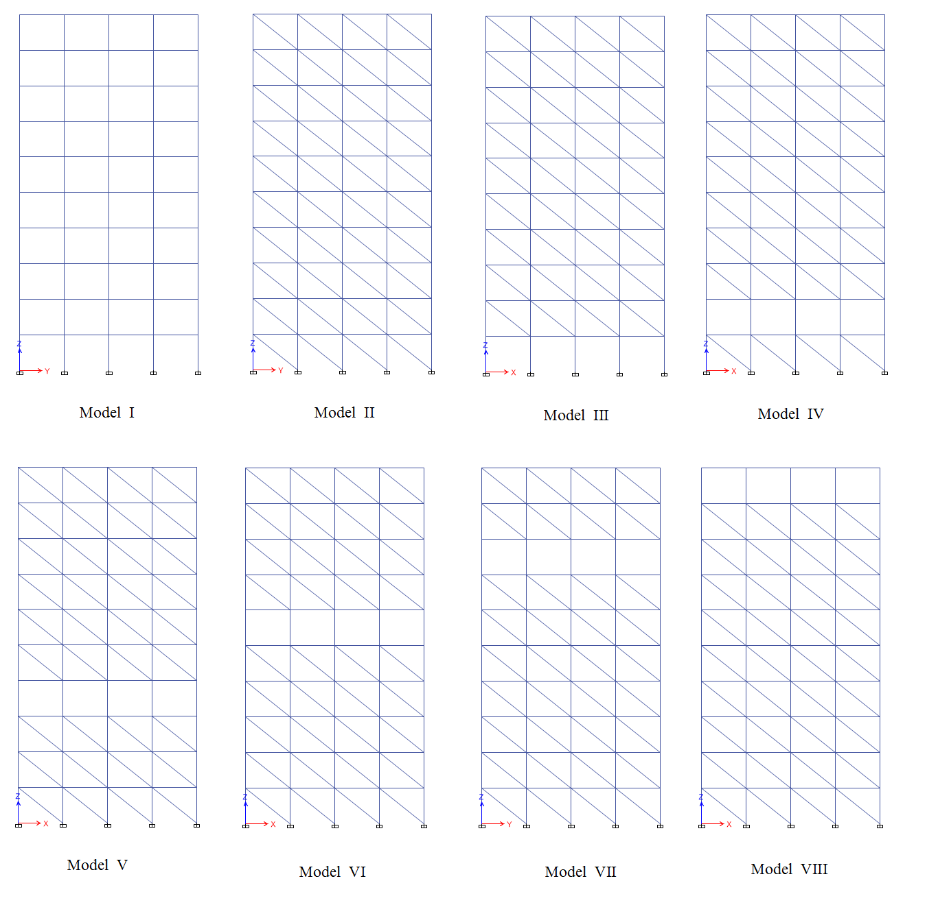Fig. 1 Frame building model

Modeling of Masonry Infill Walls
Infill wall is modeled using Equivalent diagonal
strut method to study the response of masonry infill frame buildings. In the current study, walls are modeled as panel elements without any opening. Requirements ofFEMA 356 will be followed to model the masonry infillwalls.
According to FEMA 356, masonry infill walls prior tocracking is modeled with an equivalent diagonal compression strut of width a. The thickness and modulus of elasticity of the strut are same as those of the represented infill panel. the thickness of the strut can be written in terms of the column height $h_{col}$ between centerlines of beams and thelength of panel L as:
a =.175${(λ_{1}h_{col})}^{-4}r_{inf}$
where the value of diagonal length of infill panel $r_{inf}$is,
$$r_{inf}=\sqrt{L_{inf}+h_{inf}}$$
The Coefficient $λ_{1}$which is used to determine equivalent
width of infill strut can be calculated as a function of the infill panel height $h_{inf}$modulus of elasticity of both frame materials$E_{fe}$and material of infill panel $E_{me}$,
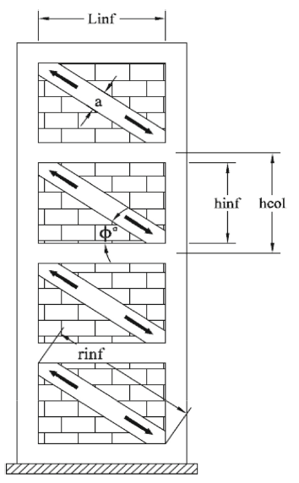
Fig.2 Equivalent diagonal compressive strut action

columns moment of inertia $I_{col}$, infill panel length $L_{inf}$and thickness $t_{inf}$.
${ λ}_{1}$=$\left[\frac{E_{me}t_{inf}\sin{2ф}}{4E_{fe}I_{col}h_{inf}}\right]$
Time History Analysis
It is also known as nonlinear dynamic analysis. It is an important technique for seismic analysis especially when the evaluated structural response is nonlinear. To perform such an analysis, a representative earthquake time history is required for a structure being evaluated. Time history analysis is a step-by-step analysis of the dynamic response of a structure to a specified loading that may vary with time. Time history analysis is used to determine the seismic response of a structure under dynamic loading of representative earthquake. For analysis purpose Imperial Valley(6.95), Kern County(7.36), Northwest Calif(6.6) time histories with their richter magnitude are selected.
Results and Discussion
Dynamic analysis for RC Frame building with soft storey is done by using time history analysis in earthquake zone V as per Indian standard code. Loads are calculated and distributed as per IS: 875 (part-1 to 3) 1987. The effect of location of soft storey at different height of building is evaluated. There is significant change in seismic parameters such as storey shear, storey drift is noticed and discussed below.
Distribution of storey shear forces due to the applied lateral load patterns is presented in Fig. 3 to Fig.8for the considered building models under Imperial Valley, Kern County, Northwest Calif ground motion records applied in both x and y directions, respectively. The plotted curves shows significant difference between the cases of considering masonry infill walls and the case of bare frame in which modelling of masonry infill is ignored.storey shear results of bare frame model show the lowest values among all other models consideredit has also been noticed that theMaximum shear at base is associated with the masonry infill model with soft storey at bottom level as shown in Fig.3.Regardless the direction of loading. it has also been noticed that the maximum shear at base is associated with the masonry infill model and models with soft storey at bottom level.
Since earthquake resistant design considers the shear at base as a governing parameter, the ignorance of masonry infill action underestimates the values of shear at bases and may lead to unsafe design.Masonry infill action magnifies the storey shear values with about 2.5 and 1.5 times as compared to bare frame.

Fig.3 Storey shearforces under the Imperial valley earthquake records for X-direction loading.

Fig.4Storey shearforces under the Imperial valley earthquake records for Y-direction loading.

Fig.5Storey shearforces under the Kern County earthquake records for X-direction loading.

Fig.6Storey shearforces under the Kern County earthquake records for Y-direction loading

Fig.7 Storey shearforces under the Northwest Calif earthquake records for X-direction loading

Fig.8 Storey shearforces under the Northwest Calif earthquake records for Y-direction loading

Fig.9Induced storey displacements under Imperial Valley earthquake records for x-direction loading.

Peak displacement patterns of the 10-storey bare frame
Building model and fully infill building model as well as the building model with soft storeys at different levels under three different time history earthquake records are
Presented in Figs. 9,10 and 11.Respectively. The two earthquake records are applied in two orthogonal directions. theexistence of soft storey causes a sudden change in the obtained peak displacements. This abrupt change leads to an increase in storey displacements just after passing the soft storey level which is highly pronounced under the Imperial valley records. The bare frame model produces higher peak storey displacements as compared to the masonry infill building frame models without and with soft storeys under three earthquakes. This can be due to infill frame building systems with and without soft storeys have higher stiffness than the bare frame building model under the applied dynamic lateral load. This added stiffness to the infill system is due to the presence of masonry infill walls.

Fig.10Induced storey displacements under KernCountyearthquake records for x-direction loading.

Fig.11Induced storey displacements under Northwest Calif earthquake records for x-direction loading.
Fig. 12and 17show the results of maximum storey drift ratios of 10-storey structure under Imperial Valley, Kern County, Northwest Calif ground motion records.These obtained results demonstrate the differences among the drift profiles of the building structure modelled as bare frame, fully infilled building model and infilled building models with soft storeys.As it can be seen from the figures, the bare frame building model has drift ratios of higher values than those associated with the considered fully infill frame building model underImperial Valley, KernCounty.it has also observed that presence of soft storey increases drift at that particular storey.

Fig..12 Storey drifts under the Imperial Valley earthquake records for X-direction

Fig..13 Storey drifts under the Imperial Valley earthquake records for Y-direction

Fig..14 Storey drifts under the Kern County earthquake records for X-direction

Fig..15 Storey drifts under the Kern County earthquake records for Y-direction

Fig..16 Storey drifts under the Northwest Calif earthquake records for X-direction

Fig..17 Storey drifts under the Northwest Calif earthquake records for Y-direction

CONCLUSION
The current research study has been carried out on reinforced concrete framed buildings fully as well as partially infilled under seismic loads. Dynamic time history analysis has been performed employing three ground motions. The influence of infill wall action on the seismic performance storey has been investigated. The following results summarize the main findings of the considered different scenarios of the structural models.
1. The masonry infill action has a significant influence on the performance of the building structure where
the induced structural responses for bare frame case do
significantly vary with the different configurations associated with masonry infill walls under
different earthquake loads.
2. Considering masonry infill action reduces the induced
storey displacements as compared to the bare frame case.
However, the induced storey moments and storey shear
forces increase with the incorporation of masonry infill
action.3 The level of soft storey has a significant role on the inducedstorey shear forces under different earthquake records.
4. Masonry infill walls enhance the seismic performance ofthe building structure during earthquake excitations in
terms of displacement control, storey drifts and lateral
stiffness.
5. Compared to the fully infilled frame building model, the infill frame models with soft storeys have sudden increase in the obtained responses at the specified soft storey levels regardless direction of loading and the type of the applied earthquake records as well. 6. Although the masonry infill action decreases the values of induced storey drift as compared to the bare frame case, the existence of a soft storey at a specified level highly magnifies storey drift at that level with values exceed those associated with the bare frame case.

REFERENCES
- IS 1893 (Part I): Criteria for Earthquake Design of Structures-Part I: General Provisions and Buildings (5th revision). Bureau of Indian Standards, New Delhi (2002)
- Hirde S.; Ganga T.: Seismic performance of multistory building with soft storey at different level with RC shear wall. In: International Journal of Current Engineering and Technology E-ISSN 2277-4106, P-ISSN 2347–5161 (2014)
- Mulgund, G.V.; Patil, D.M.; Murnal, P.B.; Kulkarni, A.B.: Seismic assessment of masonry infill RC framed building with soft ground storey. In: International Conference on Sustainable Built Environment (ICSBE-2010) Kandy, 13–14 December (2010)
- Setia, S.; Sharma, V.: Seismic response of R.C.C building with soft storey. Int. J. Appl. Eng. Res. ISSN 0973-4562, 7 (11)(2012)
- Amit, S.G.: Seismic analysis of frame with soft ground storey. Int.J. Pure Appl. Res. Eng. Technol1(8), 213–223 (2013)
- Agrawal, N.: Analysis of masonry infilled RC frame with & without opening including soft storey by using “Equivalent DiagonalStrut Method”. International Journal of Scientific and Research Publications, ISSN 2250-3153, 3(9), (2013)
- Morbiducci, R.: Nonlinear parameters of models for masonry. Int. J. Solids Struct. 40(15), 4071–4090 (2003)
- FEMA-306: Evaluation of Earthquake Damaged Concrete and Masonry Wall buildings—Basic Procedures Manual. Federal Emergency Management Agency (1999)
- Dolsek, M.P.; Fajfar, P.: Soft storey effect in uniformly infilledreinforced concrete frames. J. Earthq. Eng. 5(1), 1–12 (2001)

