PEDAL OPERATED DRILLING AND GRINDING MACHINE

S. S. Pawar¹, Ayush Khandale², Chintesh Punekar³, Gaurav Kayarkar⁴, Pratik Patil⁵

¹ Professor, Department of Mechanical Engineering, SRPCE, Nagpur
²³⁴⁵Students, Department of Mechanical Engineering, SRPCE, Nagpur

ABSTRACT
Human has applied energy through the use of arms, hands and back. With the invention of bicycle and pedaling, legs also began to be considered as a means to develop power from human muscles. A person can generate four times more power by pedaling than by hand cranking. At the rate of 1/4hp, continuous pedaling can be done for only short periods, about 10 minutes. However, pedaling at half this power (1/8hp) can be sustained for around 60 minutes. It is important to visualize new ways to bring power to the people as population continues to grow and power shortages continue to occur. Much of the power that is provided to people today is done in very un-sustainable ways; new ideas are needed to transition in to a post cheap-petroleum era. Pedal power enables a person to drive devices at the same rate as that achieved by hand cranking, but with far less effort and fatigue. Pedal power also lets one drive devices at a faster rate than before, or operates devices that require too much power for hand cranking. Over the centuries, the treadle has been the most common method of using the legs to produce power. Treadles are still common in the low-power range, especially for sewing machines. The maximum power output from treadles is very small; perhaps only 0-15 percent of what an individual using pedal operated cranks can produce under optimum conditions. The power levels that a human being can produce through pedaling depend on how strong the pedaling person is and on how long he or she needs to pedal. If the task to be powered will continue for hours at a time, 75 watts mechanical power is generally considered the limit for a larger healthy non-athlete. A healthy athletic person of the same build might produce up to twice this amount. A person who is smaller and less well nourished, but not ill, would produce less; the estimate for such a person should probably be 50 watts.
Keywords:- Drill Bit, Grinder, Mild steel rod, Shafts, Spindle, Bevel gears, Pedal Operated etc.
INTRODUCTION

The multipurpose machine that is ‘exercise bicycle’ which was basically used for exercising purpose has been modified for grinding, water lifting, washing machine and generation of electricity. The consideration for designing was to grind and used as blender, lift water to the height of 10 meter and to generate 14 volts, 4 ampere of electricity in most efficient way. Source of power utilized for above purpose is pedal power. Selecting ‘exercise bicycle’ for this application is due to its low cost, availability and design simplicity. The technical problem addressed by the utility model: the prior art, the process is relatively simple, small parts of the object is small grinder, using electric drive is not conducive to energy saving. according to the above technical solution, the operator holds the part to be machined, sit on the seat cushion, two feet on the foot pedal handle and rotate the handle, the handle foot drive shaft rotates, the first drive shaft on which two sprocket rotation,
the second sprocket by driving the first drive chain sprocket rotation, the first drive sprocket is rotated in the first rotation of the spindle sleeve, the first rotary drive sleeve is fixed on the disc rotation. Thus, the operator can be in the hands of grinding parts on the disc. This utility model the human-driven small grinder, the disc drive, the part to be processed feed, are entirely done by hand, not only to save processing costs, and energy saving. Previous devices and systems have been developed to analyze forces applied by a cyclist on a pedal. Such previous devices and systems have used strain gauges or piezo resistors mounted on a pedal, on other parts of a cycle, or on the shoes or cleats of the cyclist. The previous devices and systems, however, have required extensive calibration and complicated equipment, and therefore have been limited to use in the laboratory.
METHODOLOGY
- Components required: Bicycle assembly, Stationary shaft, Front wheel, Extension for free wheel, Hopper, Chain drive.
- Material Required: Martial can be selected SS304 for long life however any other Aluminium alloy, Magnesium alloy material also can be preferred with the paint system. Material need to be selected such a way to avoid any corrosion.
- Design Consideration: 1. The device should be suitable for local manufacturing capabilities. 2. The attachment should employ low-cost materials and manufacturing methods. 3. It should be accessible and affordable by low income groups, and should fulfil their basic need for mechanical power. 4. It should be simple to manufacture, operate, maintain and repair. 5. It should be as multi-purpose as possible, providing power for various agricultural implements and for small machines used in rural industry. 6. It should make use of standard bicycle parts wherever possible.
LITERATURE REVIEW
[1]Yang Jianhua, Manpower-driven small-sized grinder, the invention discloses a manpower-driven small-sized grinder comprising a frame, a spindle horizontally fixed on the frame.
[2]Dharwa Chaitanya Kirtikumar, designed and developed a multipurpose machine which does not require electricity for several operations like cutting, grinding etc. This is a human powered machine runs on chain drives mainly with human efforts.
[3] S.G.Bahaley, Dr. A.U. Awate, S.V. Saharkar, designed and fabricated a pedal powered multipurpose machine. It is a human powered machine which is developed for lifting the water to a height 10 meter and generates 14 Volt, 4 ampere of electricity in most effective way.
[4] Linxu, Weinan Bai, Jingyu Ru,Qiang Li, designed and developed an automatically reciprocating pedal powered electricity generator (ARPPEG) in conjunction with the management and control over harvesting the kinetic energy, electricity generation, electric storage and the output of electricity.
3D SOLID DIAGRAM
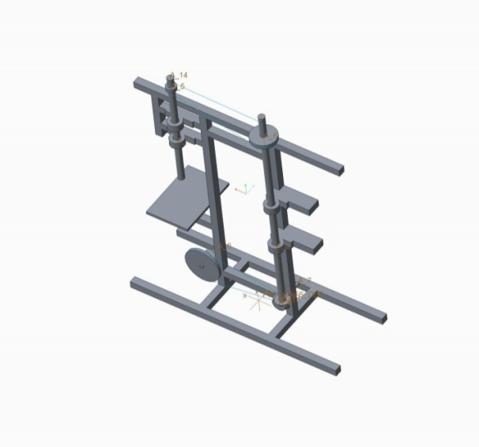
COMPONENTS
- Sprocket
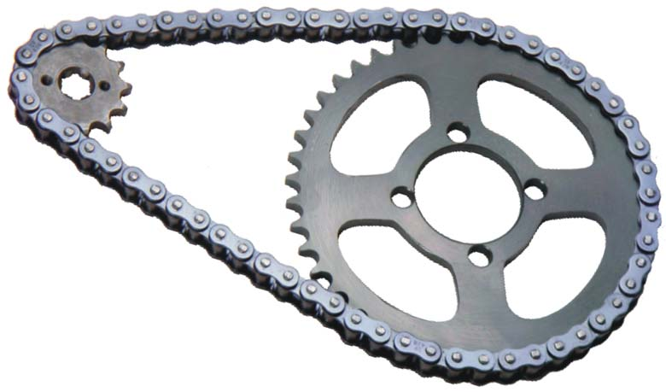
A sprocket or sprocket-wheel is a profiled wheel with teeth that mesh with a chain, track or other perforated or indented material. The chain converts rotational power to pulling power, or pulling power to rotational power, by engaging with the sprocket.
- Bevel Gear
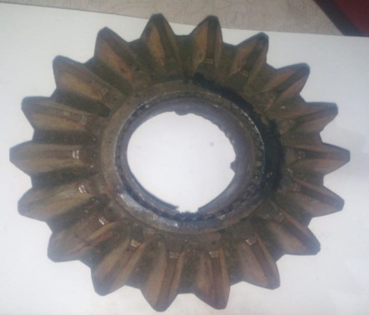
Two important concepts in gearing are pitch surface and pitch angle. The pitch surface of a gear is the imaginary toothless surface that you would have by averaging out the peaks and valleys of the individual teeth.
- Drill Bits
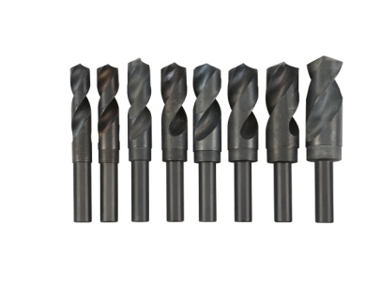
Drill bits are cutting tools used to remove material to create holes, almost always of circular cross-section. Drill bits come in many sizes and shapes and can create different kinds of holes in many different materials.

CALCULATION
Sprocket 1:
This sprocket 1 is pedal operated.
Pitch (P₁) =12.3mm
No. of teeth=48
Material is steel (C45).
Sprocket 2:
Sprocket 2 transmitted the power to the Bevel gear.
Pitch (P₂) =12.3mm
No. of teeth=18
Material is steel (C45).
Sprocket 3:
Sprocket 3 mounted on a vertical bevel gear spindle.
Pitch (P₃) =13.4mm
No. of teeth 43 Material is steel (C45)
Sprocket 4:
Sprocket 4 is mounted on the drill spindle.
Pitch (P₄) =13.4mm
No. of teeth=15
Material is steel (C45).
Sprocket has 48 teeth on driver (gear) wheel.
Freewheel has a 18 teeth on driven (pinion) wheel.
Velocity Ratio=$\frac{Np}{Ng}=\frac{tg}{tp}$
$$\frac{Np}{120}=\frac{48}{18}$$
Np=320 rpm
Velocity ratio=2.667
Bigger bevel gear teeth is 18(gear). Ng=320 rpm.
Smaller bevel gear teeth is 10(pinion).

$$\frac{Np}{Ng}=\frac{tg}{tp}$$
$$\frac{Np}{320}=\frac{18}{10}$$
Np=576 rpm
Bigger sprocket has 43 teeth (gear).
Smaller sprocket has 15 teeth (pinion).
$$\frac{Np}{Ng}=\frac{tg}{tp}$$
$$\frac{Np}{576}=\frac{43}{15}$$
Np=1651.2 rpm = 1652 rpm
Velocity ratio=2.867
Cutting speed of a drill bit.
$$V=\frac{π×D×N}{1000}$$
$$V=\frac{π×8×1652}{1000}$$
$$V=41.51 m/min$$
CONCLUSION
- Time saving is much more in machine operated by motor as compared to our pedal operated machine but there is no need of electricity.
- Cost of labour is nil.
- Only human power is needed.
- Useful for village people where villagers are facing power cut off daily for several hours.
- Cost of our equipment is 50% less compared to cost of traditional machine in use.

REFERENCES
[1] Dharwa Chaithanya Kirthikumar, “A Research on Multi Purpose Machine”, International Journal for Technological Research in Engineering (Vol.1, Issue.1, ISSN:2347-4718) (2013).

[2] S.G.Bahaley,Dr.A.U.Awate,S.V.Saharkar, “Performance Analysis of Pedal Powered Multipurpose Machine”, International Journal of Engineering Research and Development (IJERD) (Vol.1, Issue.5,eISSN:2278-0181) (2012).
[3] Linxu, Weinan Bai, Jingyu Ru,Qiang Li, “Design and Implementaion of the Reciprocating Pedal Powered Electricity Generating Device”, Advanced Materials Research (Vol.282-283 (2011) pp 735-738.
[4]. Heinrich Arnold1”The recent history of the machine tool industry and the effects of technological change “University of Munich, Institute for Innovation Research and Technology Management, November 2001.
[5]. Dr. Toshimichi Moriwaki “Trends in Recent Machine Tool Technologies” Professor Department f Mechanical Engineering Kobe University ,NTN Technical Review No.74(2006).
[6]. T. Moriwaki “Multi-functional machine tool” ,Department of Industrial and Systems Engineering, Setsunan University, Neyagawa, Japan CIRP Annals - Manufacturing Technology DOI:10.1016/j.cirp.2008.09.004
[7]. Frankfurt am Main “Multi-purpose machines ensure enhanced “, 1 January 11.
[8]. “Selecting and Planning the Process of Manufacture: Dr. Pulak M.Pandey. http://paniit.iitd.ac.in/~pmpandey.

