SEISMIC ANALYSIS OF BUILDING USING DAMPERS IN SHEAR WALLS
Kapil P. Gunjal¹, Prof. Sanket S. Sanghai²
1M.Tech Student, 2Assistant professor
Department of Civil Engineering, G.H. Raisoni College of engineering, Nagpur, India

Abstract – To make building structures earthquake resistant, various methods adopted amongst which application of fluid viscous dampers (FVD) is a most recent one. But after more studies on this method it was found that there is need to optimize its use to make it cost effective. This paper gives some idea about to optimize the use of FVD in building with shear wall. In this study 12 storey RCC frame building models, with bare frame and with shear wall prepared in ETABS & was studied against four time history (TH) records of ground motions, by applying FVD at various positions. The maximum displacements, storey shear, base shear and storey drifts of the various models are compared to find out optimal location in between shear walls. This comparative study observes that to reduce seismic response of the building FVD are most effective and comparison of the various models gives the most suitable dampers location in between shear walls of the building.
Keywords- Fluid Viscous Dampers; Nonlinear Time History Analysis; damper locations.
INTRODUCTION
There are many methods of seismic response control of the building structures in structural engineering such as absorption of energy at plastic hinges, base isolation and energy dissipation. The energy dissipation devices like viscous dampers have been immensely developed in last 2 decades. Fluid Viscous dampers technology is basically very old (1860s) used by US military cannons & navy ships. Taylor Devices got permissions to sell this FVD technology to the whole public society from 1990s. Hence it is a recent one and yet needed to be explore especially in building structures, as it is advantageous to used as a huge energy dissipater devices for shock and vibrations and for seismic hazards protection. Many types of dampers are available in the market like steel dampers, viscoelastic dampers, friction dampers and tuned mass dampers etc. but FVD have wide range of variety and flexibility in application which preferred it mostly suitable in buildings. Recently this FVD technology used in RCC building frames to reduce seismic response of RCC buildings against 3d earthquake records and able to achieve higher values of percentage reduction in peak displacement [1]. In another research, retrofitting of a 7 storey building was carried out with nonlinear FVDs and revise modeling against minor, moderate and major earthquakes has been carried out with reduction in inter storey drifts and deformations[2]. Different types of bracings like K-type, diagonal, toggle for FVDs also studied to simplify the dampers installation inside the building frames [3].
Administrative buildings, hospitals, school buildings are the most important buildings need to prevent against earthquake using energy dissipation devices to ensure there operational services. Shear wall at core of the buildings gives better performance in seismic response and also takes most of lateral loads than that of the columns. Shear wall at the core positions with dampers installed in shear wall openings performs better and gives more reduction in response compare to shear wall at corners [4, 5]
A nonlinear damper dissipates more energy with lower damper force due to its longer hysteresis loop against seismic excitations than that of linear dampers [6, 7]. Especially for buildings more than 9 storey (30m), nonlinear FVDs are preferred rather than linear. To examine the nonlinear behavior of the structure nonlinear time history analysis has to be carried out to obtain hysteresis behavior of the dampers. Dynamic analysis of the structure usually stiffness and mass of the damper not taken to account as it is so small compared to structural member [8,9,10,11,12,13].
There is very less study carried out on the seismic response of the buildings with shear wall and dampers. Most of the researchers have studied application of FVD as a passive energy dissipating device into the building frame, but very less study has been carried out on the application of dampers in shear walls building structures. In this paper models behavior to nonlinear time history along with dampers used in the shear walls has been studied to determine the suitable positions of the dampers.
The main aim of this paper is to provide some research information on the effectiveness of the seismic performance of the building with dampers equipped in between shear walls at various locations against the nonlinear analysis with different TH records of ground motion. The other secondary objectives of this study are A) To study the response of the building with shear wall at core position. B) To find out most suitable locations of the FVDs in between the shear walls in building structure.
This paper is focused on nonlinear time history analysis of RCC building structure with FVD installed in between the shear walls which is at core position of the building. The response of the RCC building against various TH and to find most suitable FVD locations to reduces their seismic response by carrying out comparative study of different models in finite element software ETABS.
Damper modeling:-
According to functional behavior of dampers, they are classified as linear and nonlinear dampers. Generally force generated due to viscous dampers reduces the motion of the structure and this force is directly proportional to the relative velocity or also called as stroking velocity of the dampers produced between the its two ends and this relationship is defined by the equation given as :
F= CV^{α}
Where F = damping force generated by damper; C= damping coefficient; V= relative velocity of a damper; α = velocity exponent (generally taken as 0.1 to 2).Depending on the value of the alpha α, dampers behaves linear or nonlinear. For linear type α value is taken as 1. Any value besides 1 i.e. 0< α <0.9 & 1< α <2 values classify it as a nonlinear damper. While α=0 are purely friction dampers. From the previous studies (5) it was found that α value <1 gives more effective and dissipates more energy. As stroking velocity of the damper increases, the value of damping force increases in nonlinear FVD with lower rate. This protects device from excessive damping force which ultimately shows efficiency of the nonlinear FVD for α<1 value to limit the peak damping force value. That’s why nonlinear FVD more favorable for seismic vibration control and short duration or impulse type loads [7, 14, 15, 16, 17, 18].
METHODOLOGY
Analytical modeling information:-
For this study two models of 12 storey RCC building was modeled with bare fame and another with shear wall at core position in ETABS as shown in fig1) and 2). Total height of building is 36m.floor to floor height is 3m. Support base properties are fixed. Column size 600mmX600 mm and beam size 230mmX460mm. Shear wall dimension is 1500mm width and 230mm thickness. Slab thickness is 130mm. Material properties for concrete M30 grade and Fe 500 rebar are selected. Frame carries wall load of 9KN/m only. Loads on Slab in gravity direction are DL = 2KN/m² and LL = 4KN/m². ETABS takes self-weight by ETABS by default.
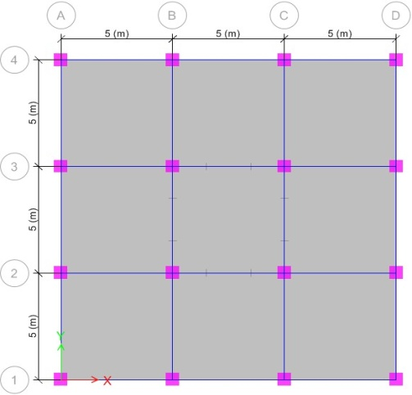
Fig.1) plan of building bare frame model 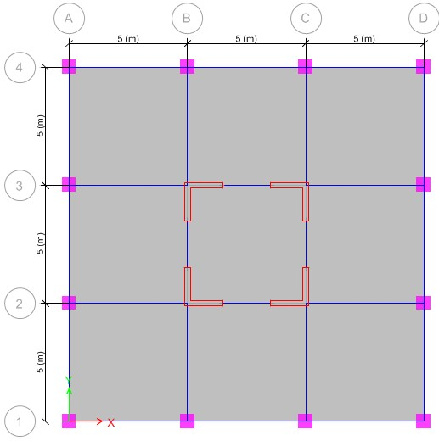
Fig.2) plan of building model with shear wall
Damper properties:-
Fluid Viscous Dampers properties used in building models are taken from Taylor Devices Inc. made in USA [19]. From that damper with 500KN damping force is selected. Stroking velocity suggested from previous research study is between 200 to 250 mm/sec. For this paper it is taken as 200 mm/s. Other parameters for dampers are calculated from equation 2 which are given below.
Table 1
Mass  (Kg) | Effective stiffness (KN/m) | Damping coefficient [KN*(s/m)^{α} ] | Velocity exponent
98 | 148750 | 102000 | 0.3

Nonlinear time history analysis:-
Fast nonlinear analysis (FNA) is adopted to get the seismic behavior of the building with FVD at different position in between the shear wall. It is most accurate and fast method of analysis than direct integration method of time history analysis and mostly preferred for the ETABS software.FNA has been carried out to study the nonlinear structural behavior to get exact structural elements deformation beyond their yield limit. Each TH record, first defined as a time history (TH) function from file and then defined as a load case and applied to both models. After that four different TH records are applied to the models which are mentioned in table1.
Table 2
Load Case Name | Load Case Type
Dead | Linear static
Live | Linear static
TH1-(El Centro) | Nonlinear Modal History (FNA)
TH2-(San Fernando)
TH3-(Northridge)
TH4-(Loma Prieta)
Mainly there are six cases of models to compare:1) Symmetrical Building Bare Frame (SBF) 2) Symmetrical Building with No Damper (SBND) 3) Symmetrical Building with Dampers at All storey (SBDA) 4) Symmetrical Building with Dampers at Bottom (SBDB) 5) Symmetrical Building with Dampers at Middle (SBDM) 6) Symmetrical Building with Dampers at Top (SBDT). For each case, analysis results were calculated and compared.
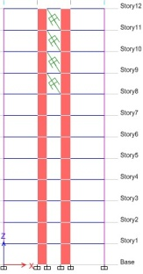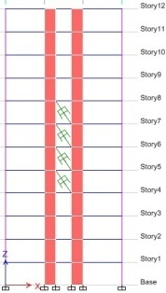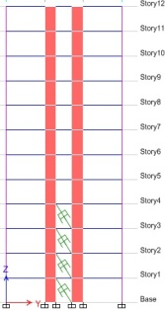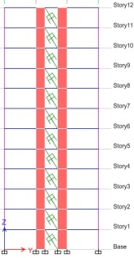
(a) (b) (c) (d)
Fig.3) Different locations of the FVD in a building model a)at top b)at middle c)at bottom d)at all storey
RESULTS AND DISCUSSION
After performing nonlinear time history analysis for four TH, all models results are compared in terms of maximum displacement, storey shear, axial forces, base shear and storey drifts.
Maximum storey displacement:-
The TH response of all four cases of 12 storey building models in terms of maximum storey displacements are plotted as in fig4. The displacements at the top of the models are maximum compare to base level. Bare frame model undergoes large displacement compare to models with shear walls. Dampers at base, middle level and at all storey have reduced 40 to 50% displacement compare to bare frame. The maximum reduction in displacement found in SBDA about 60% and after that SBDB about 30% compare to SBND and SBF.

(a)

(b)

(c)

(d)
Fig.4) Maximum storey displacement for earthquakes a)El Centro b) San Fernando c)Northridge d) Loma Prieta

Storey shear:-
The time history response of all four cases of 12 storey building models in terms of maximum storey shear are shown in fig.5.Storey shear at top reduced in SBDT & SBDB model about 40% of without dampers case, but other models shown some increase in storey shear about 10 to 18%. Up to 4th storey, the shear demand of the building is high and can be reduced by using dampers at this position. This is for short duration of peak response and gets better for other time step of response. SBDA shows increase in shear values in all four time histories and proves that it is not good to provide dampers at all storey.
(a)

(b)

(c)

(d)
Fig.5) Storey shear for earthquakes a) El Centro b) San Fernando c) Northridge d) Loma Prieta
Base shear:-
The time history response of all four cases of 12 storey building models in terms of base shear is plotted in fig. 6 which shows that SBDB has minimum base shear which is reduced up to the 26.62% of the model without damper. At the base position dampers are effective to reduce base shear as shear demand at the base of structure is high.TH3 needs higher damping value to get significant reduction as it is not showing any reduction in base shear at present. SBDA have shown base shear values much higher than other cases, which indicates that to provide dampers at all storey is not good for base shear too.

(a)

(b)

(c)

(d)
Fig.6) Base shear for earthquakes a) El Centro b) San Fernando c) Northridge d) Loma Prieta
Storey drift:-
The time history response of all four cases of 12 storey building models in terms of storey drift plotted in fig.7 which shows at the middle of the building drift value changes gradually increasing and at top stories it goes on decreasing. Dampers at middle position i.e. for SBDM storey drift are under control showing less variation compared to other cases. TH3 shows non uniform drifts at SBF, SBDM and SBDB positions. TH1, TH3 and TH4 shows less storey drift than TH2 position. Dampers at all storey evenly distribute drifts causing forces and reduces drift values more than SBND and SBF models. Larger drift values for SBF compare to other models shows that dampers are efficient to reduce storey drift

(a)

(b)

(c)

(d)
Fig.7) Storey drift for earthquakes a) El Centro b) San Fernando c) Northridge d) Loma Prieta

CONCLUSIONS
This research helps to understand the variation in seismic response of a 12 storey RCC building model with nonlinear analysis with nonlinear damper properties, placed at different locations in between the shear walls at the core position building. The conclusions made from this research work summarized as follows:
- Shear wall at core position of the building reduces seismic response the structure compare to bare frame model about 30 to 40% in every aspect of consideration.
- Dampers at top storey reduces displacement of the building more efficiently than dampers at all storey as it requires more numbers of dampers.
- Base shear values are reduced more in dampers at bottom position.
- Dampers at all storey increases storey shear values of the building, instead of that dampers at bottom and top provides good reduction values.
- Bare frame models are more susceptible to storey drifts compare to model with shear wall and dampers.
- Axial forces are reduced up to some extent using dampers at top position.
REFERENCES
- Hejazi, Farzad, Nima Ostovar, and Abdilahi Bashir. "Seismic Response of Shear Wall with Viscous Damping System." Global Civil Engineering Conference. Springer, Singapore, 2017.
- Lu, X. L., K. Ding, D. G. Weng, K. Kasai, and A. Wada. "Comparative study on seismic behavior of RC frame structure using viscous dampers, Steel dampers and viscoelastic dampers." In Proceedings of the 15th World Conference on Earthquake Engineering. 2012.
- Munir, A., and P. Warnitchai. "Optimal reduction of inelastic seismic demands in high rise reinforced concrete core wall buildings using energy‐dissipating devices." The Structural Design of Tall and Special Buildings 22.7 (2013): 543-568.
- Lin, Wen Hsiung, and Anil K. Chopra. "Earthquake response of elastic SDF systems with non linear fluid viscous dampers." Earthquake engineering & structural dynamics 31.9 (2002): 1623-1642.
- Ras, Abdelouahab, and Nadir Boumechra. "Study of nonlinear fluid viscous dampers behavior in seismic steel structures design." Arabian Journal for Science and Engineering 39.12 (2014): 8635-8648.
- Sinha, A. K., and Sharad Singh. "Structural Response Control of RCC Moment Resisting Frame Using Fluid Viscous Dampers." Technology 8.1 (2017): 900-910.
- Narkhede, D. I., and R. Sinha. "Shock Vibration Control of Structures Using Fluid Viscous Dampers." 15 WCEE (World Conference on Earthquake Engineering). 2012.
- Zhou, Ying, et al. "A practical design method for reinforced concrete structures with viscous dampers." Engineering structures 39 (2012): 187-198.
- Chen, Xue Wei, Jia Xuan Li, and Jack Cheang. "Seismic performance analysis of Wenchuan hospital structure with viscous dampers." The Structural Design of Tall and Special Buildings 19.4 (2010): 397-419.
- Kargahi, Mohsen, and C. Ekwueme. "Optimization of viscous damper properties for reduction of seismic risk in concrete buildings." 13th World Conference on Earthquake Engineering. 2004.
- Hwang, Amy. Viscous dampers: practical application issues for the structural engineer. Diss. Massachusetts Institute of Technology, 1998.
- Ras, A., and N. Boumechra. "Seismic energy dissipation study of linear fluid viscous dampers in steel structure design." Alexandria Engineering Journal 55.3 (2016): 2821-2832.
- Lee, David, and Douglas P. Taylor. "Viscous damper development and future trends." The Structural Design of Tall Buildings 10.5 (2001): 311-320.
- Bahnasy, A., and O. Lavan. "Linear or nonlinear fluid viscous dampers? A seismic point of view." Structures Congress 2013: Bridging Your Passion with Your Profession. 2013.
- Goel, Rakesh K. "Seismic response of linear and nonlinear asymmetric systems with nonlinear fluid viscous dampers." Earthquake engineering & structural dynamics 34.7 (2005): 825-846.
- Brando, Giuseppe, Federica D'Agostino, and Gianfranco De Matteis. "Seismic performance of MR frames protected by viscous or hysteretic dampers." The Structural Design of Tall and Special Buildings 24.9 (2015): 653-671.
- Kim, Jinkoo, Hyunhoon Choi, and Kyung-Won Min. "Performance-based design of added viscous dampers using capacity spectrum method." Journal of Earthquake Engineering 7.01 (2003): 1-24.
- Whittle, J. K., et al. "A comparison of viscous damper placement methods for improving seismic building design." Journal of Earthquake Engineering 16.4 (2012): 540-560.
- http://www.taylordevicesindia.com/Content/PublicAwarenessDocument/clyavvqdnuu.pdf
(Accessed on 15 Nov.2018).

