Farming Beneath the Solar Panels Via Agri-Voltaic System (AVS)-A Review

Sachin B Punde ¹, Bhavesh Bohra ², Swapnil Choudhary ² , Dr. Bharat Chede ³
¹ Student of Master of Technology, ² Assistant Professor, ³ Head of Department
Wainganga College of Engineering & Technology, Nagpur, India, 440012

sachinpunde89@gmail.com

Received on: 05 April, 2022 Revised on: 11 May, 2022, Published on: 13 May,2022

Abstract: - Renewable energy is becoming more important in India than ever before in order to achieve the country's goal of zero emissions by 2070. In India, Photovoltaic power generation is a key source of renewable energy production. By 2030, the government of India plans to construct 450 GW of renewable energy capacity, with solar accounting for about 280 GW (more than 60%). By 2050, solar capacity is expected to reach 1,689 GW, with 5,630 GW by 2070 (3). Photovoltaic electricity generation necessitates approximately 2 ha of land per megawatt (MW)(2). For achieving the country’s goal of developing PV-based electricity generation systems requires millions of hectares of land, while food security is becoming a greater concern as a result of the effects of climate change and the growing population of developing countries. The concept of incorporating Photovoltaic-based electricity generation and farming from a single land unit is commonly referred to as an agri-voltaic system. For sustainable development of the nation in the sector of food and energy, the agri-voltaic system can play a very crucial role. In this review study, the effect of the structure's shadow on the crops underneath it, as well as the distance between the two solar panels, has been investigated. Different solar panel design considerations and configurations are also investigated, with the goal of recommending crops or plants that can be grown below and between the solar panels with no or little yield decrease. The design and development of a system of rainwater harvesting from the surface of the top of the solar panel module have also been studied and the advantage of a rainwater harvesting system is that the water collected is sufficient for further irrigation of planted crops and also used to wash the solar panels for maintaining the effectiveness of the solar panels (4). Also reviewed the suitable crops for the agri-voltaic system, Land Equivalence Ratio, and the economics involved in agri-voltaic system. Various research have demonstrated that the agrivoltaic idea may be used in India as well as throughout the world, in any region, to generate power from the farmer's own land, possibly for his profit.

Keywords:- Agrivoltaic; Agriculture; Solar Photovoltaic; Land use; Solar Farm; Food; Energy; Shade
- INTRODUCTION
India's ambitious goal of being a net-zero carbon emitter by 2070 will necessitate a solar power capacity of the country reaching more than 5,600 GW. By 2060, coal use in the power industry will have to be reduced by 99 percent, while crude oil use will have to peak by 2050 and then fall by 90 percent over the next two decades. (3).
India's government addresses the COP26 climate summit with an ambitious vow to decrease carbon emissions to zero by 2070, making it the world's third-largest emitter. India has positioned itself as a global leader by being a founding member of the International Solar Alliance (ISA), which is one of the prominent alternatives for achieving this target.
In India, Renewable energy generation has a major share of photovoltaic (PV) electricity generation accounts for a sizable portion of. India had 100.6 GW of renewable energy capacity built as of October 2021, accounting for 25.77 percent of the total installed capacity. Solar power capacity in India is 47.7 GW. By 2030, the government plans to construct 450 GW of renewable energy capacity, with solar accounting for about 280 GW (more than 60%). By 2050, solar capacity is expected to reach 1,689 GW, with 5,630 GW by 2070 (3).
There are around 300 plus unobstructed and sunshiny days every year in our country, thus the solar energy relative frequency on India's geographical area is approximately 5,000 trillion kilowatt-hours (kWh). Indian land has a huge solar energy potential, but the price and availability of land are the biggest challenges in enhancing solar power generation. Acquisition of land is one of the most expensive affairs in India, both in terms of availability and time. A land allocation for the development of solar arrays must be balanced with all other necessities. PV-based electricity generation necessitates approximately 2 ha of land per megawatt (MW) of installation (23). Therefore, an electric utility-scale solar power plant requires about one kilometer of land (250 acres) for every 40–60 MW that it generates. The land needed to generate 5600 GW of solar energy until 2070 is 112000 km2 (2.8 Crore Acres)(3). Large areas of land, however, are required to replace fossil fuels and install PV-based electricity generation systems. At the same time, climate change and population growth are putting a strain on food security. The use of water-surface areas, such as reservoirs of the agricultural ponds, canals, lakes, and the sea, for large solar-power plants, as well as above-ground solar roofs in commercial and residential buildings, is a substantial alternative.
Along with all other above alternatives for harnessing solar power, farming beneath and between solar panels on agricultural land is also an option. Due to the growing population of the country, energy and food are both of great importance and land is limited for their production. Therefore, the concept of merging PV-based power generation with growing crops from a unit of land, has been developed and is known as an agri-voltaic system. Agri-voltaic System is one of the most promising alternatives for dual purpose farming beneath and between solar panels and harnessing solar energy.
It was proposed to incorporate solar Photovoltaic with agricultural crops which is known as agri-voltaic system (AVS) in 1982, but this was frequently discussed until the turn of the millennium. This technology which was also known as agrivoltaism is derived from the inter-cropping method used in agriculture to increase the land equivalent ratio and total revenue” [4]. Because of its dependability in variable-scale applications, AVS technology is gaining popularity. This concept combines the production of electrical energy and agricultural production in the same area of agricultural field. In other words, this results in a positive interaction, or symbiotic relationship, between these two productions in the same location. If only 1-2 percent of agriculture was converted to an AV system, solar generation may help India fulfill its energy demands.
The shade effect on crops below the PV structure was investigated in the review study. Different solar panel design considerations and configurations have also been studied and suggested so that the plant on the land below and between the solar panels can be grown with no or minimum yield loss. The design and development of rainwater harvesting from the top of the solar panel system have also been studied and the stored water is sufficient to provide additional irrigation as per required to the cultivated crops and is also used to wash the solar panels in order to maintain their effectiveness. Also studied the various crops suitable for the agri-voltaic system along with the effect on the land equivalence ratio (LER). Henceforth, It is demonstrated that the Agri-voltaic concept may be readily applied in India, and probably anywhere in the globe, at any site where electricity can be created utilizing the farmer's land for his personal gain, possibly with an additional income.

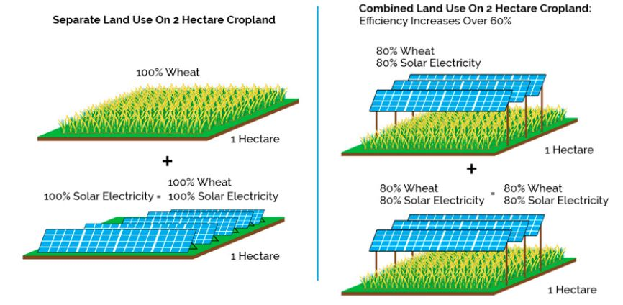

Fig 1- Comparison of efficiency in terms of LER between the traditional farming versus AVS.

II-CALCULATION OF SOLAR ENERGY INSOLATION
Sunshine duration is the parameter that is most commonly used to estimate global solar radiation because it is easily and reliably measured and data is widely available. In this study, authors used a readymade application made by the Indian Space and Research Organization (ISRO) from the website vedas.sac.gov.in for calculation of solar energy insolation (Irradiation). Annual Global Insolation in KWh/m²/year and Power Production of PV can be calculating by inserting the value of Latitude and Longitude of any location. For example point of view, we have calculate the Annual Global Insolation and Power Production of PV for Vidarbha reason only with the help of Solar Calculator app.

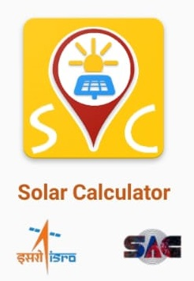
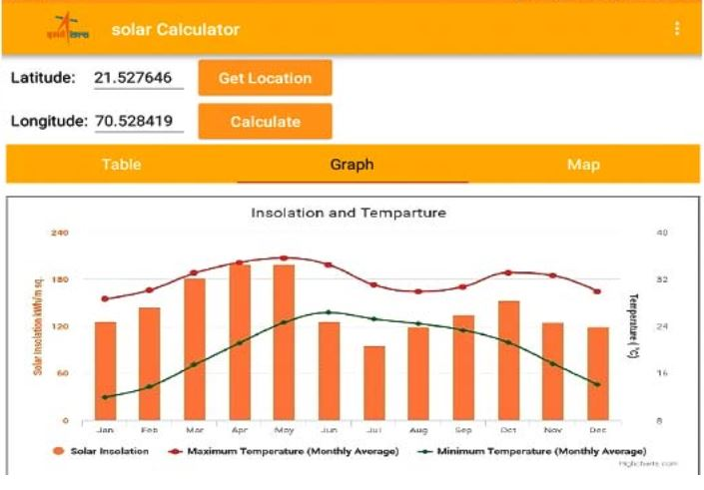

SOLAR ENERGY INSOLATION POTENTIAL IN VIDARBHA REGION ^{[19, 20]}
Name of District | Latitude | Longitude | Tilt angle for Solar PV | Annual Global Insolation in KWh/m²/year | Power Production of PV KWh/m²/year* | Avg annual Power Production in 1 hector of land in MWH
Akola | 20º42’ N | 77º10’ E | 18º | 1752 | 350.4 | 3.504
Amravati | 20º56’ N | 77º48’ E | 18º | 1755 | 351 | 3.51
Bhandara | 21º09’ N | 79º42’ E | 18º | 1807 | 361.4 | 3.614
Buldhana | 20º32’ N | 76º14’ E | 18º | 1746 | 349.2 | 3.492
Chandrapur | 19º57’ N | 79º21’ E | 17º | 1808 | 361.6 | 3.616
Gadchiroli | 19º49’ N | 80º27’ E | 17º | 1881 | 376.2 | 3.762
Gondia | 21º09’ N | 80º29’ E | 19º | 1813 | 362.6 | 3.626
Nagpur | 21º09’ N | 79º09’ E | 18º | 1755 | 351 | 3.51
Wardha | 20º45’ N | 78º30’ E | 18º | 1723 | 344.6 | 3.446
Washim | 20º13’ N | 77º10’ E | 17º | 1751 | 350.2 | 3.502
Yavatmal | 20º23’ N | 78º11’ E | 18º | 1788 | 357.6 | 3.576
*Considering 20% efficiency and energy loss.
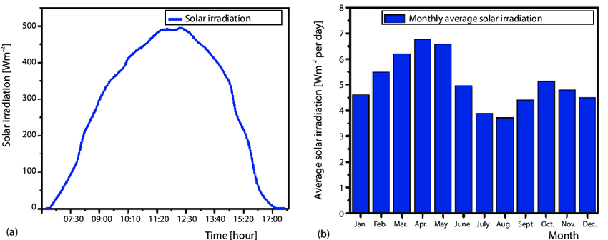

With above data, Authors try to show the solar energy harnessing capabilities of Indian states with an example of Vidarbha region which enable the

region to become energy sufficient, if 1-2 % of cropland could use in agri-voltaic system.

III -DESIGN CONSIDERATION AND CONFIGURATIONS OF AGRIVOLTAIC (AV) SYSTEM
The Land equivalence ratio (LER) value is used to determine the performance of the AV system, and if it exceeds one, the system is said to be optimal. The design of the AV system is critical for achieving better LER. To ensure that the maximum amount of solar radiation reaches the ground beneath the solar panel structure, the solar PV composition must be modified to meet the requirement of agricultural output. The following modification has been made: (1) the solar PV structure's elevation; (2) the configuration of the concentration of solar panels in one solar structure; (3) the optimization of the distance between the solar PV structures; and (4) the optimization of the solar panel's sloping angle. However, AVS creators should support the consideration that all changes and alterations to solar photovoltaic structures must agree to AVS approaches, agronomic management, choice of crop, and geographical regions. [1]
According to modeling studies, Solar panels are designed in a checkerboard pattern with air space between the set of solar panels and solar panels raised at 0.5 m above cultivated ground with pitch values of 7.6, 11.4 m, and solar panels placed in a chessboard orientation with air space between the set of solar panels are more proper. For 11.4 m separated panels, a reduction of 20% - 25% in sunlight is observed. Similarly, modeling studies infer a 25% - 30% of sunlight decrease for 7.6 m and chessboard pattern arrangement, and a 60% - 80% sunlight step-down for 3.8 m separated panels. As a result, solar panels with
a separation of 7.6 m or 11.4 m, or a chessboard design are recommended for the installation of the PV system, as sunlight will be reduced slightly. Even a reduction in light from the sun on crop production is restricted to the midday hours, which helps to reduce UV radiation. It is expected to a decrease in visible radiation of sunlight around noon will help the plant to develop and increase its productivity [2].
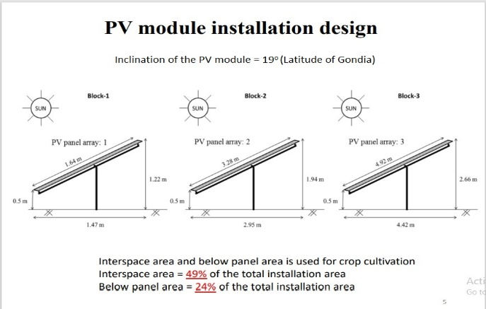

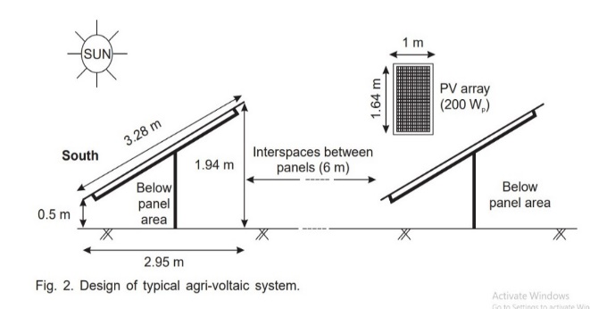

Using optical modeling, it is proved in the work [reference 22] that PV array layout and panel design have a considerable influence on the uniformity of field insolation in agro-voltaic systems. North-south axis systems are better to fix south-facing systems due to greater insolation uniformity and lower shadow duration. As a consequence, we find that greater PV area does not correlate linearly with reduced predicted agricultural production; that is, agro-voltaic systems may be optically engineered to maximize power output and expected crop yields.

IV-DESIGN OF RAINWATER HARVESTING SYSTEM IN THE AGROVOLTAIC SYSTEM
Rainwater can be harvested in addition to crop production. The stored water may be utilized to augment agriculture irrigation during the dry season, as well as to clean the panels of dust, which affects energy-generating efficiency.
Rainwater can be collected and stored from the top of the surface of the photovoltaic module in an agro-voltaic System (AVS). As a result, a rain-water harvesting system has been designed and developed in the AVS. The water harvesting system consists of rectangular MS sheet water collecting channels, underground water conveyance PVC pipes, and a 1 - 1.5 lakh liter subterranean water storage tank. The saved water will be utilized to clean PV panels as well as to supply irrigation for crops cultivated in the AVS, and to clean the deposited dust from the top surface of PV modules. Taking splashing loss and water conveyance loss into account, the efficiency of the developed rainwater harvesting system is approximately 70-80 percent. The reservoir's stored water may be utilized for additional agricultural irrigation and has the ability to provide 37.5 mm of irrigation over a 1-acre area. [4]
One more aspect we can explore in the agri-voltaic system i.e. aquaculture, Aquaculture can also develop in the available water storage tank which is made for rainwater harvesting, the aquaculture can only develop when the rainwater harvesting tank is open not underground.

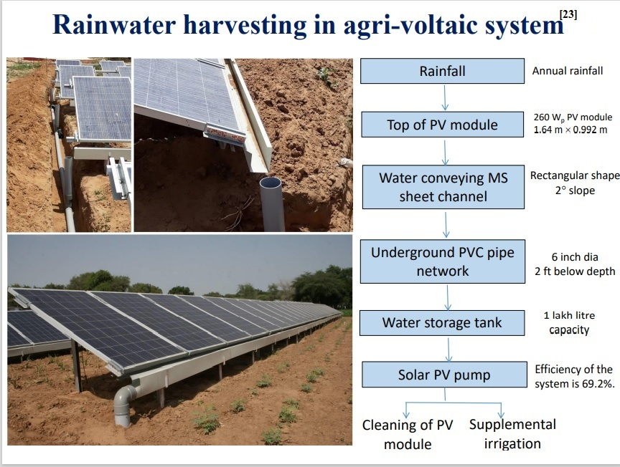

V -LAND EQUIVALENT RATIO (LER), SUITABLE CROPS PLANTED IN VARIOUS COMMERCIAL PLANTS AND THE ECONOMICS OF AGRO-VOLTAIC SYSTEM
The land equivalent ratio (LER) is a derived tool for deciding land utilization skillfulness in the production of both crops and electricity at the same time. The LER may be expanded to encompass any two (or more) production systems coexisting in the same region. LER is the ratio of the area of AVS installation to the total area required for achieving the AVS installation's agricultural and electricity generation [1]. The LER value is used to determine the performance of the AV system, and if it exceeds one, the system is said to be optimal. The design of the AV system is critical for achieving better LER.

PV Generation _{agri-vol} Crop Production _{agri-vol}
LER = +
PV Generation _{sole} Crop Production _{sole}

Various crops may be grown along with a photovoltaic system, below table 1 shows a variety of crops cultivated in agro-voltaic systems worldwide. In Central Arid Zone Research Institute, Jodhpur (Rajasthan) cultivated the mungbean, moth bean, cluster bean, isabgol, cumin, and chickpea, along with these, plants used for medicine e.g. sonamukhi, sankhpuspi, Aloe vera, etc. can be also be cultivated for their research.
AVS PV modules can be installed for Rs.49.8 per Watt of power, for a total cost of Rs.52, 33,000 to install a 105 kW capacity AVS. An additional 7 lakhs will be required to install a water harvesting system and a water storage structure. As a result, the total system cost was around Rs.60 lakhs, based on a rate of around Rs.57, 000 per kW of AVS. The annual gain from merchandising PV generated power will be a rough Rs.7.6 lakhs assuming a minimum daily production of 4 kWh per kW system., 300 clear shining days per year, and an average selling price of Rs.5 per kWh. Farming activity with the agri-voltaic system may yield revenue of 8,235/- Indian Rupees from Vigna radiata (mung bean) during Kharif and Rs.23,339/- from isabgol during rabi if the mungbean-isabgol crop cycle is implemented. Income from the agricultural activity is significantly lower than income generation from photovoltaic generated electricity, but it has several environmental and societal benefits. Cropping activities in AVS, for example, will wisely use precious atmospheric conditions in arid locations. such as Vidarbha located in the east of Maharashtra state minimize soil erosion through air current, and hence reduce the dust load on PV module, optimize the micro-climate surrounding the PV-module, allowing for more efficient power generation from the PV module, and ultimately, improve the land equivalent ratio (LER).The AVS break-even period is anticipated to be 9-10 years. Whereas the life-cycle of a PV module is 25 years, with a potency of more than 90% at the end of the 10th year, more than 80% at the end of the 20th year, and more than 75% at the end of the life cycle. As a result, installing an agri-voltaic system may be a realistic alternative in the future, particularly in the country's dry and arid regions.

VI -KEY FINDINGS AND BENEFITS OF AGRI-VOLTAIC SYSTEM
- Indian Farmers have the option of lending their land to the agri-voltaic system developer while continuing to farm conventionally in the system. As a result, his sources of income may diversify.
- Increased capacity for establishing high-value, shade-adapted crops in new markets – The PV panels' shadowing provides a range of additive and synergistic advantages, such as reduced plant drought stress and more stable temperature, as the panel maintains a higher temperature at night and a lower temperature during the day.
- Crop production can benefit from additional water savings as a result of reduced evapotranspiration and the detrimental effects of high radiation, while financial sustainability and rural electrification become possible. [15]
- According to a study that modeled the APV capability of Indian grape farmland, the yearly revenue of this farmland will be twice as compared to typical farms without applying APV while maintaining grape yields.[26]
- The capacity to keep agricultural production going while solar generating is operational. Allow for the recharging of damaged fields with nutrients and soil.
- Possibility of reducing water consumption.
- Boost PV performance — Planting vegetation beneath modules can assist to lower soil temperatures and improve solar efficiency.

VII -CONCLUSION
The installation of agri-voltaic technology offers a number of benefits that differ depending on geographical and atmospheric conditions. The AVS approach is advantageous in thickly populated developed and developing economies, where the renewable sources of energy development and gaining importance considerably. However, profitable cultivated land must be conserved. The LER value is used to determine AV system performance, and if it exceeds one, the system is said to be optimal. The structure of the solar PV structure and agronomic governance must be carefully considered for AVS to be profitable. It is found to be more feasible to install solar panels with a separation of 7.6 m or 11.4 m, or a chessboard pattern, as there will be a slight decrease in sunlight. Agro-voltaic systems can be planned to optimize power production and anticipated crop yields. An agri-voltaic system may be a feasible option for the future in dry and arid regions of the nation. Additionally, shade-adapted crops and crops cultivated in hot, dry areas may benefit from enhanced water savings as well as protection from the detrimental effects of high temperatures and excessive radiation. Furthermore, by incorporating the additional system of rainwater harvesting, the stored water can be used for supplemental irrigation of crops during the dry season as well as clean the solar panels of dust to increase the efficiency of electricity generation, Also aquaculture could be an additional option in stored water. Advances in AVS application are expected to drop down the reliance on non-renewable fuel sources, nullify the effects of environmental conditions and global warming, and commencement the need for the food-energy-water nexus.

REFERENCES
- Mohd Ashraf Zainol Abidin 1,2 , Muhammad Nasiruddin Mahyuddin 2,* and Muhammad Ammirrul Atiqi Mohd Zainuri 3, Solar Photovoltaic Architecture and Agronomic Management in Agrivoltaic System: A Review, Sustainability 2021, 13, 7846.
- T. Harinarayana1 , K. Sri Venkata Vasavi2*, Solar Energy Generation Using Agriculture Cultivated Lands, scirp.org/journal/sgre.
- www.energy.economicstimes.indiatimes.com
- P. Santra1, R. K. Singh2, H. M. Meena3, R. N Kumawat4, D. Mishra5, D. Jain6 and O. P. Yadav7, Agri-voltaic system: crop production and photovoltaic-based electricity generation from a single land unit, Indian Farming 68(01): 20–23; January 2018.
- Goetzberger, A.; Zastrow, A. On the Coexistence of Solar-Energy Conversion and Plant Cultivation. Int. J. Sol. Energy 1982, 1, 55–69.[CrossRef].
- Agrivoltaics in India- Overview of operational Projects and relevant Policies- Commissioned by Indo-German Energy Forum- Report by National Solar Energy Federation of India (NSEFI)
- Mavani, D.D.; Chauhan, P.M.; Joshi, V. Beauty of Agrivoltaic System regarding double utilization of same piece of land for Generation of Electricity & Food Production. Glob. Sci. J. 2019, 10, 118–148.
- Rangwala, M. 2019. Large scale AgroPV: Experience in Gujarat. REI Expo
- Application of Photovoltaic Systems for Agriculture: A Study on the Relationship between Power Generation and Farming for the Improvement of Photovoltaic Applications in Agriculture
- What would India need for moving to a 100% renewable energy scenario by 2050?
- Solar Farming Could Produce The Ultimate Cash Crop (greenfuture.io)
- Largest Farm to Grow Crops Under Solar Panels Proves to Be a Bumper Crop for Agrivoltaic Land Use (goodnewsnetwork.org)
- The Potential of Agrivoltaic Systems
- Ministry of New and Renewable Energy of India. 2020. Programme/Scheme wise Physical Progress in 2020-21 & Cumulative upto Oct, 2020. https://mnre.gov.in/the-ministry/physical-progress
- Majumdar, D.; Pasqualetti, M.J. Dual use of agricultural land: Introducing ‘agrivoltaics’ in Phoenix Metropolitan Statistical Area, USA. Landsc. Urban Plan. 2018, 170, 150–168. [CrossRef]
- IEA. World Energy Outlook 2021. Available online: https://www.iea.org/reports/world-energy-outlook-2020 (accessed on 21 January 2022).
- Leon, A.; Ishihara, K.N. Assessment of new functional units for agrivoltaic systems. J. Environ. Manage. 2018, 226, 493–498. [CrossRef]
- Agostini, A.; Colauzzi, M.; Amaducci, S. Innovative agrivoltaic systems to produce sustainable energy: An economic and environmental assessment. Appl. Energy 2021, 281, 116102. [CrossRef]
- Mapsofindia.com/lat_long/
- Vedas.sac.gov.in/solarcalculatorapp by ISRO
- Allison Perna, Elizabeth K. Grubbs, Rakesh Agrawal, Peter Bermel Design Considerations for Agrophotovoltaic Systems: Maintaining PV Area with Increased Crop Yield Purdue University, West Lafayette, IN, 47907, USA
- Ruwan Chamaraª, * Chalinda Beneragama^{b} Agrivoltaic systems and its potential to optimize agricultural land use for energy production in Sri Lanka: A Review Journal of Solar Energy Research Vol 5 No 2 Spring (2020) 417-431
- Priyabrata Santra Principal Scientist, ICAR-Central Arid Zone Research Institute, Jodhpur Agri-voltaic system Experiences with water harvesting systems.
- Carlos Toledo and Alessandra Scognamiglio Agrivoltaic Systems Design and Assessment: A Critical Review, and a Descriptive Model towards a Sustainable Landscape Vision (Three-Dimensional Agrivoltaic Patterns) Sustainability 2021, 13, https://doi.org/10.3390/su13126871
- Axel Weselek1 & Andrea Ehmann1,2 & Sabine Zikeli3 & Iris Lewandowski2 & Stephan Schindele4 & Petra Högy1 Agrophotovoltaic systems: applications, challenges, and opportunities. A review Agronomy for Sustainable Development (2019) 39: 35 https://doi.org/10.1007/s13593-019-0581-3
- Prannay Malu, Utkarsh Sharma, Joshua Pearce. Agrivoltaic potential on grape farms in India. Sustainable Energy Technologies and Assessments, Elsevier, 2017, 23, pp.104-110. ff10.1016/j.seta.2017.08.004ff. ffhal-02111403

