Energy Efficient Cluster Scheduling Technique to enhance the performance in Cloud Computing
Rupal Jain
M. Tech. Student
Vidya College of Engineering, Meerut
rupaljain0310@gmail.com
Sumit Chaudhary
Head of Department
Indrashil Institute of Science & technology, Kalol, Cadila Group, Ahmedabad
sumit.chaudhary@iist.edu.in
Rajendra Kumar
Professor/ Head of Dept.
Vidya College of Engineering, Meerut
rajendra.kumar@vidya.edu.in

Abstract

The processing assets and administrations can be proficiently conveyed and used with the utilization of distributed computing, making the vision of registering utility feasible. In different distinctive applications, execution of different administrations with countless needs to perform with least between correspondence. The strategy or thought to benefit as much as possible from an alternate arrangement of undertakings from the accessible assets in cloud proficiently is proposed in this paper. For the previously mentioned undertaking we require Energy Efficient Cluster Scheduling, in which all the unscheduled errands are put and another mapping is done to limit both the asset use and execution time. CloudSim is utilized for usage with a toolbox for displaying and reenacting distributed computing situations and the proposed asset provisioning calculation is assessed.

Keywords: CloudSim, cloud computing, execution time, performance analysis, Energy Efficient Cluster Scheduling, Resource usage.

1. Introduction

A cloud is a parallel and dispersed structure comprising of a gathering of interconnected and virtualized PCs that are powerfully open as at least one brought together registering assets [3]. The mutual assets, programming, and data given through the cloud to PCs and different gadgets are typically offered as a metered benefit over the Internet. A client in the cloud framework require not think about the place and different subtle elements of the figuring foundation. Along these lines the client can easily focus on their assignments as opposed to using time and information on knowing the assets to deal with the errands. Web is one premise of the distributed computing, in this way an unavoidable issue with Internet is that the system bottlenecks frequently happen when there is a lot of information to be exchanged. For this situation, the many-sided quality of asset administration stick on to clients and the clients have typically constrained administration apparatuses and confirmation to manage such issues [2].

Mists are characterized into three classes named open mists, private mists, and crossover mists [16]. Open mists are freely accessible remote interface for masses making and overseeing assets, private mists gives the nearby clients an adaptable and responsive private framework to deal with the workloads at their own particular cloud destinations and the half breed cloud empowers the supplementing neighborhood framework with the figuring limit from an outside open cloud. Open cloud administrations like Google's App Engine are interested in all anyplace round the clock. A case for private cloud is the utilization of GFS, MapReduce, and BigTable by Google inside the endeavor. The accompanying are the elements of distributed computing.

• High adaptability

• High security

• Easy to keep up

• Location autonomous

• Reduction in capital consumption on equipment and programming

Figure 1 demonstrates the four layer engineering of distributed computing and mists are seen as an expansive pool of processing and capacity assets that are gotten to through standard conventions with a dynamic interface [6]. Figuring assets, stockpiling assets, and system assets are equipment level assets which are available in the texture layer. Assets are virtualized to upper layer and end clients as incorporated assets are done in the brought together asset layer. To create and send stage on top of bound together assets, a gathering of specific instruments, middleware and administrations are included with the stage layer. The different applications that would be executed in the cloud condition are incorporated into the application layer.
Figure 1: Architecture of Cloud Computing
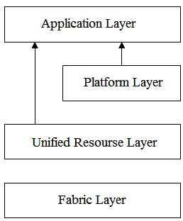

The conveyance instrument in distributed computing is considered as administrations and is sorted in three distinct levels named; programming administration, stage administration and foundation benefit [1]. The Software as a Service (SaaS) is a product conveyance display in that the applications are gotten to by basic interface like web program over Internet. Cases of SaaS-based administrations are web Mail, Google Docs, Facebook, and so forth. The Platform as a Service (PaaS) gives an abnormal state coordinated condition to fabricate, test, convey and have client made or obtained applications. Cases of PaaS-based administration are Google App Engine, Engine Yard, Heroku, and so forth. Framework as a Service (IaaS) guarantees preparing, capacity, systems, and other basic registering assets to the clients. Cases of IaaS-based administrations are Amazon EC2, IBM's Blue Cloud, Eucalyptus, Rackspace Cloud, and so on. Grouping is an essential and financially savvy stage for executing parallel applications that processes expansive measure of information with the hubs of a bunch through the interconnected system. Bunching is generally been utilized as a part of numerous information mining applications to amass together the measurably comparable information components. The calculations utilized for grouping must not expect the presence of a standard dispersion of specific parameters [20]. The execution of the group for logical applications by the utilization of completely using registering gadgets with sit out of gear or underutilized assets requires the planning and load adjusting systems in a successful way. A portion of the uses of bunch based administrations incorporate 3D point of view rendering method, sub-atomic progression reproduction, and so forth. In addition, the execution between the successful speed of processor and the different system assets keeps on developing speedier, which raises the requirement for expanding the usage of systems on groups utilizing different methods [18].

Whatever remains of the paper is composed as takes after. Area 2 audits about the related writing and segment 3 concentrate on the definite depiction of the proposed reservation bunch based distributed computing approach. Segment 4 subtle elements the exploratory setup and investigation the reservation group based distributed computing approach. At last, conclusion is given in segment 5.

2. Related Work

In this segment, we audit the earlier work on enhancing the outline methodology in distributed computing. Qian et al [14] proposed the utilization of cloud assets for a class of versatile applications, where application-particular adaptability in calculation is required with settled time-cutoff and asset spending plan. The versatile applications are augmented with Quality of Service (QoS) unequivocally and by powerfully fluctuating the versatile parameters the estimation of utilization particular advantage capacity is acquired. A multi-input multi-yield criticism control demonstrate based dynamic asset provisioning calculation is produced that embraces support figuring out how to change versatile parameters to ensure the ideal application benefits inside the time requirements.

Jaliya et al [9] proposed two cloud advancements Apache Hadoop and Microsoft DryadLINQ to two bioinformatics applications with the booking of errands. The applications have match insightful Alu grouping arrangement application and an Expressed Sequence Tag (EST) succession get together program. The execution of the innovation is contrasted and broke down and conventional usage under virtual and non-virtual equipment stages. Seokho et al [15] proposed an administration level understanding while at the same time reserving a spot for cloud administrations. The exhibited multi-issue arrangement component bolsters both cost and availability transactions between cloud specialists and tradeoff amongst cost and schedule opening utilities. The specialists make different proposition in an arrangement round to produce totaled utility with varieties in individual cost and schedule opening utilities.
Qian et al [13] proposed a system utilizing an estimation module in every visitor virtual machine to gauge each running executable in that virtual machine. The estimation module exchanges the deliberate qualities to the trusted virtual machine through a standard between virtual machine correspondence component. This additionally stores the qualities in an estimation table and the framework develops the qualities into a predetermined stage arrangement enroll. A memory watcher module is additionally added to guarantee handle reliability. Lei et al [11] proposed an open cloud utilization show for little to-medium scale mainstream researchers to use versatile assets on an open cloud site. Additionally, actualized a creative framework named DawningCloud, at the center of which a lightweight administration layers running on top of a typical administration benefit system. The framework has been assessed and found that DawningCloud spares the asset utilization to a most extreme sum.

Zibin et al [21] proposed a segment positioning system, named FTCloud with two positioning calculations for building flaw tolerant cloud applications. The main calculation utilizes segment conjuring structures and summon frequencies for making huge part positioning and second calculation efficiently combines the framework structure data and in addition the application architect's astuteness to distinguish the noteworthy segments in a cloud application. After this an ideal adaptation to internal failure procedure for the noteworthy cloud segments is naturally decided. Ganesh et al [7] researched the utilization of a detachable load worldview to outline effective procedures to limit the general handling time for performing huge scale polynomial item calculations in register cloud conditions. For post-handling a register cloud framework with the asset allocator dispersing the whole load to an arrangement of virtual CPU occurrences is prepared. At long last through reproduction the execution of the procedure is evaluated.
Daniel et al [4] talked about the open doors and difficulties for effective parallel information preparing in mists and displayed the venture named Nephele. Nephele is the main information handling structure to unequivocally abuse the dynamic asset allotment offered by both assignment booking and execution.

Specific undertakings of a handling employment can be doled out to different sorts of virtual machines that are instantiated naturally and finished up amid the occupation execution. Hong-Ha et al [8] considered the issue of planning lightpaths and processing assets for sliding framework requests in Wave Division Multiplexing (WDM). On each request a joint booking calculation chooses the begin time, hold a measure of figuring assets and give an essential lightpath. For getting an Integer Linear Programming (ILP) definition is produced and to accomplish adaptability heuristic calculations in light of joint asset planning is utilized.

Khawar et al [10] proposed a pilot work idea that has wise information reuse and work execution methodologies to limit the booking, lining, execution and information get to latencies. By this approach, huge upgrades in the general turnaround time of a work process can be accomplished. This is assessed utilizing CMS Tier0 information preparing work process, and afterward in a controlled situation. Min et al

[12] developed an accessibility driven planning plan that enhances the continuous Directed Acyclic Graph (DAG), iteratively by distributing two duplicates of one correspondence undertaking to two disjoint lightpaths for information exchange while fulfilling application due date prerequisites. Investigation exhibited the viability and attainability of the proposed planning plan.

Thomas et al [17] presented a model for assessing the business effect of operational hazard coming about because of changes. The model considers the system of conditions amongst process and administrations, probabilistic change-related downtime, instability in business prepare request, and different infrastructural qualities. The model is assessed utilizing recreations in view of the modern information. Xiao et al [18] proposed a correspondence mindful load-adjusting system that is fit for enhancing the execution of correspondence concentrated applications by expanding the successful use of systems in bunch conditions. Additionally a conduct display for parallel applications is included with the heap adjusting strategy with substantial prerequisites of system, CPU, memory and circle I/O assets.

Youthful et al [19] researched the issue of planning work process applications on networks and introduces a novel booking calculation for the minimization of use finishing time. The execution of framework assets changes progressively and the exact estimation of execution is troublesome, and the proposed rescheduling technique bargain the unexpected execution vacillations viably. Dharma et al [5] proposed an information replication calculation that is a provable hypothetical execution ensure, as well as can be actualized in appropriated way. This depends on a polynomial time incorporated replication calculation that diminishes the aggregate information record get to postpone by at any rate half of that decreased by the ideal replication arrangement.

3. Vitality Efficient Cluster Scheduling - Based Cloud Computing Approach

This area depicts the Energy Efficient Cluster Scheduling-based distributed computing approach in which the unscheduled undertakings are send to the reservation bunch. On the off chance that every one of the undertakings are booked, then no assignments will be moved to reservation bunch and the errands will be executed typically. At the point when there is a disappointment in the task of errands, such unscheduled undertakings will on the whole send to the reservation bunch. In the reservation bunch every one of the errands are planned all the while with no emphasis. At that point the errands will be executed in the cloud framework adequately. Along these lines will diminish the measure of asset utilization and lessen the calculation time when contrasted and the typical operation. Figure 2 demonstrates the stream outline and figure 3 demonstrates the structure of the reservation bunch based distributed computing framework separately.

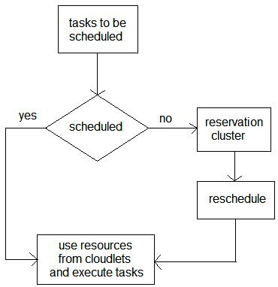
Figure 2: Energy Efficient Cluster Scheduling-based cloud computing approach

The pseudo code for the proposed calculation is portrayed underneath. Consider a system G(V, E) with an arrangement of N cloudlets in a cloud framework. The goal is to register the undertakings inside the cloud framework productively. That is the assignments ought to be finished with the accessible cloudlets in the cloud framework.
Figure 3: Structure of Energy Efficient Cluster Scheduling -based cloud computing approach
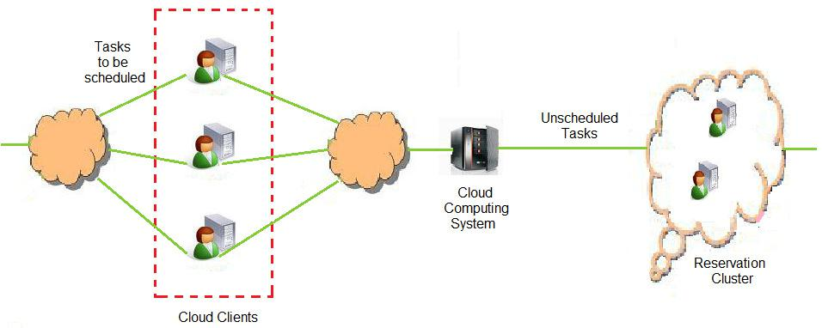

Pseudo Code for the Proposed Method

Contribution: For an application G(V, E) with N cloudlets in a cloud framework

Yield: Tasks booked inside the cloud framework

1. Compute the accessibility of cloudlets

2. Initialize asset utilization and execution time to unendingness

3. Generate an arbitrary timetable on the assignments

4. Share the undertaking to each cloudlet

5. If every one of the assignments are booked

6. Select the best asset utilizations and execution time

7. Endif

8. Place the unscheduled assignments on the reservation group

9. Find the quantity of unscheduled assignment

10. If the reservation group size is not adequate

11. Increment the extent of reservation group

12. Endif

13. Schedule the assignments in the reservation group at once

14. Compute the errands

15. Obtain the asset use and execution time

16. End the procedure

4. Simulation Results

This area portrays the usage strategy for the proposed Energy Efficient Cluster Scheduling - based distributed computing approach. For the recreation hundred cloudlets are viewed as and the most extreme size of the group is constrained to N/5, where N is the aggregate number of cloudlets utilized as a part of the cloud framework. For this situation the Energy Efficient Cluster size is twenty cloudlets. On the off chance that the unscheduled undertakings are more than the breaking point, progressively the size or number of reservation bunches will be augmented. In this reproduction, it is accepted to have a solitary Energy Efficient Cluster. Usage is completed on CloudSim, on the grounds that the rich arrangement of recreation offices engages us to execute and assess the Energy Efficient Cluster approach for heterogeneous disseminated registering situations. Figure 4 demonstrates the execution screenshot of the Energy Efficient Cluster - based framework utilizing CloudSim.

Figure 4: Energy Efficient Cluster -based approach implementation screenshot using CloudSim
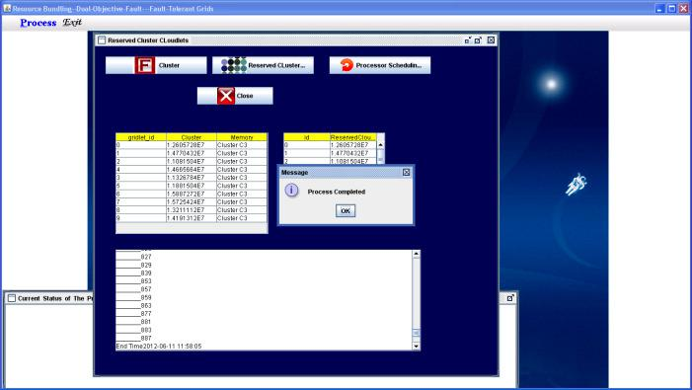

The execution measurements utilized for the investigation is the asset utilization and the execution time. The asset use is characterized as the normal measure of utilization of assets in the cloud framework. The execution time is characterized as the normal time taken to finish the undertaking. Figure 5 and 6 demonstrates the examination of asset use and execution time as for the quantity of cloudlets.

Figure 5: Analysis of asset use

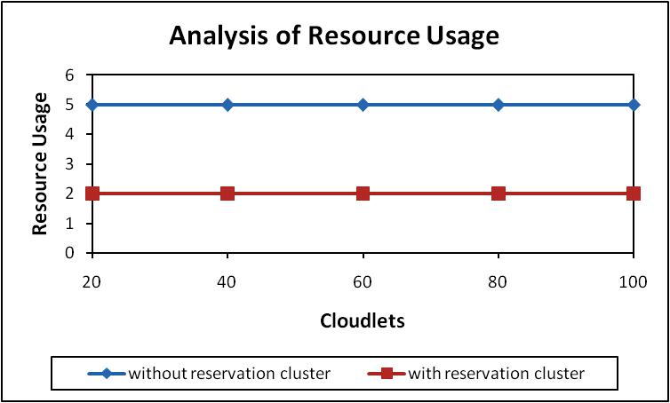

Figure 6: Analysis of execution time
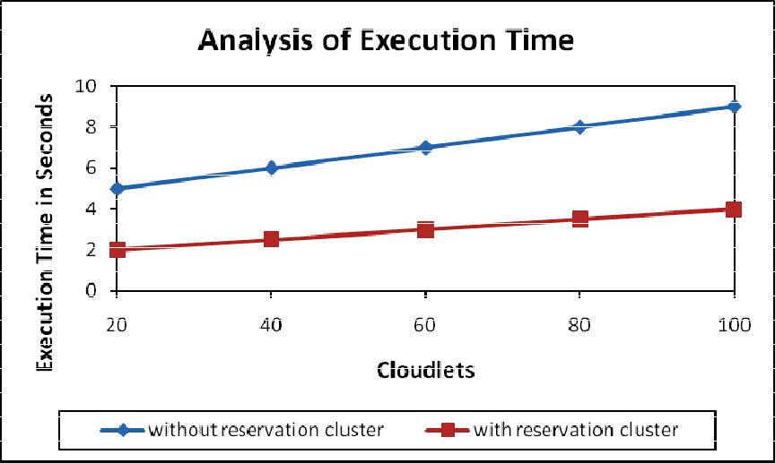

5. Conclusion

This paper characterizes Energy Efficient Cluster - based distributed computing framework. Group development is finished by the unscheduled undertakings, and after that rescheduling is accomplished for the cloudlets inside the bunch with no cycle or redundancy. As there is no emphasis, so the time requires finishing an assignment utilizing assets will be diminished. Examination has been done utilizing the CloudSim test system, in which the most extreme cloudlets utilized as a part of the cloud framework is 100 and the greatest cloudlets that a bunch can oblige is the aggregate number of mists separation by five. Examination demonstrates that the Energy Efficient Cluster - based approach is better as it effectively utilizes assets use and less calculation time when contrasted with ordinary strategy, which doesn't have bunch.

References

- M. Armbrust, A. Fox, and R. Griffith, “Above the Clouds: A Berkeley view of Cloud Computing Technical Report UCB/EECS-2009-28”, EECS Department, University of California, Berkeley, Feb. 2009.

- M. Armbrust, A. Fox, R. Griffith, A. D. Joseph, R. Katz, A. Konwinski, G. Lee, D. Patterson, A. Rabkin, I. Stoica., and M. Zaharia, “A View of Cloud Computing”, Communications of the ACM, Vol. 53, Issue 4, pp. 50-58, 2010.

- C. S. Buyya R. Yeo, S. Venugopal, J. Broberg, and I. Brandic, “Cloud computing and emerging IT platforms: Vision, hype, and reality for delivering computing as the 5th utility”, Future Generation Computer Systems, Vol. 25, No. 6, pp. 599-616, June 2009.

- Daniel Warneke, and Odej Kao, “Exploring Dynamic Resource Allocation for Efficient Parallel Data Processing in the Cloud”, IEEE Transactions on Parallel and Distributed Systems, Vol. 22, No. 6, pp. 985-997, June 2011.

- Dharma Teja Nukarapu, Bin Tang, Liqiang Wang, and Shiyong Lu, “Data Replication in Data Intensive Scientific Applications with Performance Guarantee”, IEEE Transactions on Parallel and Distributed Systems, Vol. 22, No. 8, pp. 1299- 1306, August 2011.

- I. Foster, Y. Zhao, I. Raicu, and S. Lu, “Cloud Computing and Grid Computing 360 degree compared”, Proceedings of Grid Computing Environments Workshop (GCE’08), pages 1-10, 2008.

- Ganesh Neelakanta Iyer, Bharadwaj Veeravalli, and Sakthi Ganesh Krishnamoorthy, “On Handling Large-Scale Polynomial Multiplications in Compute Cloud Environments using Divisible Load Paradigm”, IEEE Transactions on Aerospace and Electronic Systems, Vol. 48, No. 1, pp. 820-831, January 2012.

- Hong-Ha Nguyen, Mohan Gurusamy, and Luying Zhou, “Scheduling Network and Computing Resources for Sliding Demands in Optical Grids”, Journal of Lightwave Technology, Vol. 27, No. 12, pp. 1827-1836, June 15 2009.

- Jaliya Ekanayake, Thilina Gunarathne, and Judy Qiu, “Cloud Technologies for Bioinformatics Applications”, IEEE Transactions on Parallel and Distributed Systems, Vol. 22, No. 6, pp. 998-1011, June 2011.

- Khawar Hasham, Antonio Delgodo Peris, Ashiq Anjum, Dave Evans, Stephen Gowdy, Jose M. Hernandesz, Eduardo Huedo, Dirk Hufnagel, Frank van Lingen, Richard McClatchey, and Simon Metson, “CMS Workflow Execution Using Intelligent Job Scheduling and Data Access Strategies, IEEE Transactions on Nuclear Science, Vol. 58, No. 3, pp. 1221-1232, June 2011.

- Lei Wang, Jianfeng Zhan, Weisong Shi, and Yi Liang, “In Cloud, Can Scientific Communities Benefit from the Economies of Scale”, IEEE Transactions on Parallel and Distributed Systems, Vol. 23, No. 2, pp. 296-303, February 2012.

- Min Zhu, Wei Guo, Shilin Xiao, Anne Wei, Yaohui Jin, Weisheng Hu, and Benoit Geller, “Availability-Driven Scheduling for Real-Time Directed Acyclic Graph Applications in Optical Grids”, Journal of Optical Communication Network, Vol. 2, No. 7, pp. 469-480, July 2010.

- Qian Liu, Chuliang Weng, Minglu Li, and Yuan Luo, “An In-VM Measuring Framework for Increasing Virtual Machine Security in Clouds”, IEEE Security and Privacy, Vol. 8, No. 6, pp. 56-62, Nov.-Dec. 2010.

- Qian Zhu, and Gagan Agrawal, “Resource Provisioning with Budget Constraints for Adaptive Applications in Cloud Environments”, IEEE Transactions on Services Computing, 27 December 2011, DOI: 10.1109/TSC.2011.61.

- Seokho Son, and Kwang Mong Sim, “A Price and Time-Slot Negotiation Mechanism for Cloud Service Reservations”, IEEE Transaction on Systems, Man, and Cybernetics – Part B: Cybernetics, Vol. 42, No. 3, pp. 713-728, June 2012.

- B. Sotomayor, R. Santiago Montero, I. Martin Llorente, and I. Foster, “Virtual Infrastructure Management in Private and Hybrid Clouds”, IEEE Internet Computing, Vol. 13, No. 5, pp. 14-22, September/October 2009.

- Thomas Setzer, Kamal Bhattacharya, and Heiko Ludwig, “Change Scheduling based on Business Impact Analysis of Change-Related Risk”, IEEE Transactions on Network Service Management, Vol. 7, No. 1, pp. 58-71, March 2010.

- Xiao Qin, Hong Jiang, Adam Manzanares, Xiaojun Ruan, and Shu Yin, “Communication-Aware Load Balancing for Parallel Applications on Clusters”, IEEE Transactions on Computers, Vol. 59, No. 1, pp. 42-52, January 2010.

- Young Choon Lee, Riky Subrata, and Albert Y. Zomaya, “On the Performance of a Dual-Objective Optimization Model for Workflow Applications on Grid Platforms”, IEEE Transactions on Parallel and Distributed Systems, Vol. 20, No. 9, pp. 1273-1284, September 2009.

- S. Zhong, and J. Ghosh, “A comparative study of generative models for document clustering”, Proceedings of the SDM Workshop on Clustering High Dimensional Data and Its Applications, 2003.

- Zibin Zheng, Tom Chao Zhou, Michael R. Lyu, and Irwin King, “Component Ranking for Fault-Tolerant Cloud Applications”, IEEE Transactions on Services Computing, ISSN: 1939-1374, DOI: 10.1109/TSC.2011.42.

