PCE College Enquiry Bot
Kanchan Chopde¹, Sanket Mondhe², Nikita Sahu³, Shuklesh Deshbhratar⁴
¹Assistant Professor, Ms. Priyanka B. Dongre
Priyadarshini College of Engineering, Nagpur, India, 440019

Abstract – Existing systems such as websites for colleges has information about college (infrastructure, departments, faculties, placements etc) which needs to searched by traversing through website which becomes time consuming.
Our proposed system “College Enquiry Bot” which typically provide a text or voice-based user interface, allowing the user to type commands or queries and will get replies using an effective graphical interface, as if real person is talking to user.This Chatbot is typically a kind of service which will be your agent providing you enquiry information about College.

Keywords- Chatbot, text or voice-based,agent.
INTRODUCTION
People are using messaging applications now a days, it would be great to use a smart agent which would answer all queries. CHATBOT with its multiple usage over a large number of applications such as shopping, news updates, ticket reservations, customer service, entertainment, enquiry systems and much more.
Chat bots are fast, easily accessible and easy to use.

Chat bots are virtual agents which will converse like humans are interacting. They will try to answer your questions or doubts through chatting medium as if human is interacting with you.

This project deals with creation of a chatter bot which will answer College related queries quickly as possible .As a fresher or unaware person we need basic information to know about college ,this application will help in providing such enquiry information through chatting medium.

METHODOLOGY

UNITY 5.6.3p2 – for application building
Unity is basically a gaming platform which supports 2D as well as 3D gaming graphics.It is a cross platform and also used to build applications on android. Unity 5.6.3p2 is used to build this application. In making User interface unity proved to be a good application. All the designing ,animation ,pictures immersion,font styles,graphics buttons are built within this app.

Dialogflow (Api.ai )– for Database management
Api.ai is renamed as Dialogflow.The api.ai has SDKs which contain voice recognition, natural language understanding, and text-to-speech. Api.ai offers a web interface to build and test conversation scenarios. The platform is based on the natural language processing. Dialogflow also includes an analytics tool that can measure the engagement or session metrics like usage patterns, latency issues, etc.
Our Approach:
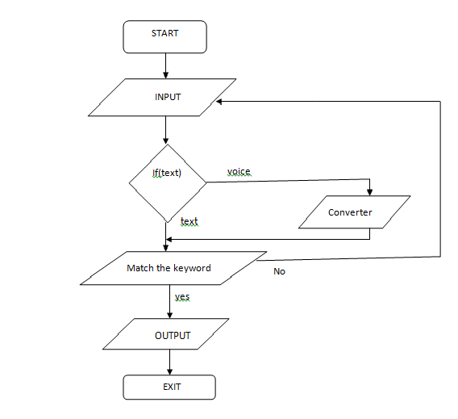
Fig1: Basic Flowchart

Fig1 shows basic flowchart of enquiry chatbot.
Simple process flow can be easily understood from this diagram.
- This system helps the student to be updated about the college activities and for new students all information related to our college.
- User does not have to go personally to college office for the enquiry instead he has virtual agent our bot helping him through his queries.
- Hence it saves time and is time efficient system.
- In modern era , generation has keen interest in texting rather than using mails, engaging them through chat bots will be a good option for our proposed system.

DESIGN
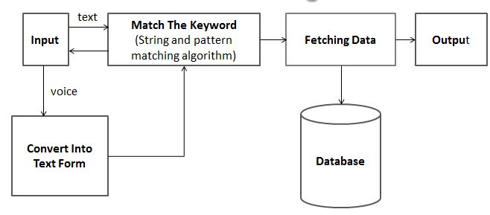
Fig2: Module design of Enquiry Bot

From fig.2 shows college enquiry chatterbot module design .
- User of the chat bot will input with queries i.e. will ask question to our virtual agent in form of text or voice. All user interaction is built in unity platform.
- Further this information depending on whether it is text or voice will be taken into consideration. If it is voice then first it will convert into text form and if it is text then directly Keywords of our questions will be matched using String and Pattern matching algorithms.
- The data from where matching of algorithm will take places comes from our database which is dialogflow here. It uses string matching and pattern matching algorithms. Dialogflow contains intents which are developer defined data initially fed into database.
- Final step involves fetching output on screen which is possible only after connectivity is established between Unity engine and Dialogflow.Hence result will be displayed on screen

CONCLUSION
This paper provides with an information on building an effective College enquiry bot. By using the information on use of database and application platform it becomes easier to built any application.It was a successful attempt in building a college enquiry bot which provided basic information about college.Chatbot has worked like a agent answering all question and making task easier.

REFERENCES
- Steven Gianvecchio, Mengjun Xie “Humans and Bot in internet chat: measurement, analysis and automated classification”IEEE/ACM TRANSACTION ON NETWORKING, VOL. 19, NO.5, OCTOBER 2011
- Ameya Vichare, Ankur Gyani, Yashika Shrikhande, Nilesh Rathod “A chatbot system demonstrating Intelligent Behaviour using NLP” International Journal of Advanced Research in computer Engineering & Technology Volume 4 Issue 10,October 2015

- Balbir Singh Bani, Ajay Pratap Singh College Enquiry Chatbot Using A.L.I.C.E International Journal of Engineering Research and General Science Volume 5, Issue 2, March-April, 2017 ISSN 2091-2730
- Imran Ahmed and Shikha Singh “AIML Based Voice Enabled Artificial Intelligent Chatterbot” International Journal of u- and e- Service, Science and Technology Vol.8, No.2 (2015), pp.375-384 http://dx.doi.org/10.14257/ijunesst.2015.8.2.36
- AMEY TIWARI,RAHUL TALEKAR, PROF.S.M.PATIL Dept. of InformationTechnology Bharati Vidyapeeth College of Engineering, Navi Mumbai,India. www.ijergs.org “College Information Chat Bot System “International Journal of Engineering Research and General Science Volume 5, Issue 2, March-April, 2017 ISSN 2091-2730
- Bayu Setiaji Department of Informatics Engineering STMIK AMIKOM Yogyakarta Yogyakarta, Indonesia e-mail: bayusetiaji@amikom.ac.id “Chatbot Using A Knowledge in Database” Human-to-Machine Conversation Modeling 2016 7th International Conference on Intelligent Systems, Modelling and Simulation
- Rachit Kulkarni,Ankit Methwani,Nakul Pawar ,Charmi Valecha Pooja Shetty.International “College Chat-bot”Journal of Advanced Research in Computer Engineering & Technology (IJARCET) Volume 6, Issue 4, April 2017, ISSN: 2278 – 1323
.

Details of Authors:
Sr.No | Photo | Details
1 |  | Name: Kanchan Chopde  College:Priyadarshini College of Engineering, Nagpur(PCE)  Branch:Information Technology  Email:kanchan.chopde96@gmail.com  Ph no.:9975179996
2 | 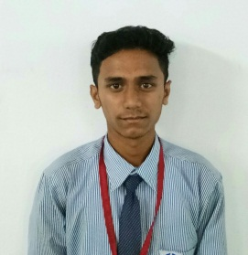 | Name: Sanket Mondhe  College:Priyadarshini College of Engineering, Nagpur(PCE)  Branch:Information Technology  Email:sanketmondhe97@gmail.com  Ph no.:9730411907
3 | 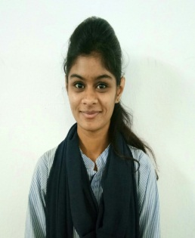 | Name: Nikita Sahu  College:Priyadarshini College of Engineering, Nagpur(PCE)  Branch:Information Technology  Email:nikitasahu744@gmail.com  Ph no.:7057214609
4 |  | Name: Shuklesh Deshbhratar  College:Priyadarshini College of Engineering, Nagpur(PCE)  Branch:Information Technology  Email:sdeshbhratar13@gmail.com  Ph no.:9975193083

