Design & Development of Automatic Vehicle Mover Using LIDAR System

Raj Uday Vichare, Pratiksha Dayanand Jadhav, Umakant Bhaskar Gohatre, Dnyanesh Balu Dhavade, Pushkar Mahendra Jawale.
Raj Uday Vichare., BE Student, Department Electronics and Telecommunication Engineering, Smt. Indira Gandhi College of Engineering,
Ghansoli, Navi Mumbai, Maharashtra, India 400701
rajvichare2757@gmail.com

Dr. Umakant Bhaskar Gohatre., Assistant Professor, Department Electronics and Telecommunication Engineering, Smt. Indira Gandhi College of Engineering,
Ghansoli, Navi Mumbai, Maharashtra, India 400701
umakantbhaskar@gmail.com

Received on: 29 March, 2023 Revised on: 16 April, 2023 Published on: 18 April, 2023

Abstract –The under-development systems will make it possible for previously unachievable technology to function in autonomous or self-driving automobiles. Improvements are done in the areas of vehicle safety and speed in accordance with our work, saving us time. The majority of accidents that occur on our roads are caused by drivers who are unable to react quickly enough to sudden circumstances. The rotating LIDAR sensor atop an autonomous vehicle plays a crucial role in the vehicle's ability to navigate its environment. Atop the car, this sensor gathers information about its immediate surroundings, which the navigation system uses to steer the vehicle safely in the desired route. When compared to conventional driving methods, this one has a lot more potential uses. Automated systems that monitor traffic in real time and respond to abnormalities are one solution. The time and effort spent on daily activities can be reduced significantly thanks to this technique. When this system is established or developed for self-driving automated cars, it will make the monitoring and identification of moving objects, which have been the most difficult tasks for decades, much simpler.
Keywords- Self-driving vehicles, LIDAR sensor, Navigation system, Sensors, Automation.
INTRODUCTION
The primary objective of this work is to provide a Lidar-based autonomous vehicle. Think of a small truck transporting some heavy industrial gear. This system might operate the vehicle more efficiently than any human driver. That vehicle gets you and your gear to your destination quickly and in comfort. Envision farm trucks that can operate autonomously and without breaks. Envision autonomous automobiles, capable of independently mapping their routes. Envision a scenario in which your vehicle drives itself, relieving you of all responsibility, and doing a better job of it than any human driver could. Imagine, as was said, a future in which industrial and agricultural vehicles are autonomously driven.
Optical remote sensing with Light Detection and Ranging (LIDAR) employs near-infrared light rays to gather data about the surroundings. Constant laser beams are directed at nearby objects, and the distance to each reflecting surface is calculated using the reflected beam's characteristics. It uses the tried-and-true technique of directing laser light at a target and then measuring the reflected light to identify subtle shifts in wavelength and time of return. It is not always possible to visit a site and take measurements by hand. For such measurements, it calculates the laser return time and wavelength. It creates a detailed map of the area it scans, often in three dimensions. The goal of developing autonomous vehicles is to make our lives less complicated and more efficient.
Embedded systems are the connecting or interfacing point between all other systems. Computer hardware, software, and sometimes various mechanical or other components come together to form an Embedded System, which is designed to carry out a certain task. Microcontroller-based software-driven real-time control systems that can operate on a wide variety of physical variables and in a wide variety of situations while remaining cost-effective and competitive in a global market are examples of embedded systems.

METHOLOGY
We're on the cusp of that future, one in which our elderly and disabled loved ones can live as independently as possible, in which commute time is time well spent, and in which the over 2 million people who lose their lives in traffic accidents each year can be drastically reduced, as 92% of these incidents are caused by human error.
Autonomous vehicles and self-driving systems never get sleepy or sick, never need rest or medication, never get distracted by passengers or other distractions, never have to be taught how to drive, and never drive recklessly. However, they will reduce pollution and accidents by autonomously calling for aid and driving more smoothly.
In this setup, we plan the automatic vehicle mover that will serve us without any help from human beings. Since LIDAR is the foundation of this system, the route taken by the vehicle does not need to be predetermined. This vehicle is fully automatic, so all we have to do is load it up with the materials or equipment it needs to get to its predetermined destination. From there, we can adjust the route it takes to get the goods to their final destination as quickly as possible via the most direct route. And since there are no humans involved, the vehicles can operate autonomously. In our mental model, we've programmed the vehicles to come to a complete stop in the presence of any barrier, be it another vehicle, a person, etc. It will determine whether or not that obstruction is in motion. If the car is stopped, it will reverse course and head in the desired direction. The horn will sound periodically to alert pedestrians and other drivers. This vehicle's weight sensor was likewise installed by us. It gives us an idea of how much cargo can be transported by that vehicle. The screen would display a notice saying the car is overweight and not ready to move if this circumstance applied. We can verify that the vehicle is ready to go or that the carrying weight is appropriate by removing some items from it.
A low-cost, low-power system with built-in Wi-Fi and Bluetooth, the esp32 microcontroller is what we're working with. The LIDAR sensor is constantly gathering information about its surroundings. It ensures a more rapid and secure arrival at the desired location for the vehicle.
Block diagram of a system - When we turn on the ignition, the microcontroller receives data from the lidar sensor and the weight sensor. The microcontroller selects what action to take based on data it receives from sensors, such as whether to move ahead, backward, turn right, or left.
Check the vehicle's carrying capacity before attempting to transport it. The weight-related data, such as whether or not the vehicle is being overloaded, is subsequently presented to us on the screen. If the weight of the cargo exceeds the car's carrying capacity, it can't be driven or moved.
The lidar then sends a signal to the microcontroller, telling it to gather information about the environment so that the vehicle can proceed in the path that will take the fewest amount of time and effort. The microcontroller Arduino receives data from the input sensors, which it then relays to the motor driver in the form of control instructions. The Arduino (microcontroller) is wired to a regulated power source along with the motor driver and other components (horn, indication lights, etc.).
That input signal is carried by the Arduino, which then looks for the fastest possible route there. It guarantees that the planned route is valid and that there are no immovable obstructions that would impede the vehicle's progress.
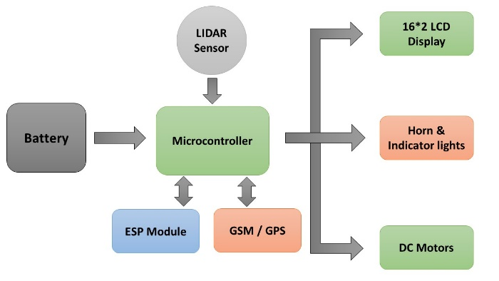
Fig. 1- Block Diagram of Automatic vehicle mover using Lidar sensor
The display (162 LCD display) allows us to see the vehicle's carrying capacity, as well as whether or not the vehicle is ready to go, the vehicle's number, or a custom name entered by an administrator.
An Arduino (microcontroller) is connected to the vehicle's horn and indicator lights so that it will honk for a few seconds if an object or person suddenly appears in the vehicle's path. Back-up warning lights, sometimes known as red lights or stop lights.

Hardware details –
Sr.No | Components
1 | Arduino Uno
2 | Lidar
3 | 16*2 LDC I2C display
4 | L293 Motor driver IC
5 | AT Mega 328 IC
6 | DC Motor
7 | GPS Module
8 | GSM Module
9 | Diode’s
10 | Led’s
11 | Capacitors
12 | Resisters
13 | Heat Sink
14 | Berg Pins/ Connectors
15 | Battery
System flow diagram - As can be seen in the schematic representation of Fig. 3.1.2.2, a circuit board and its associated components require a 12 VDC power source. The following procedures are carried out by the system after electricity is first applied: At first, the microcontroller verifies the online status of the GSM and GPS systems; then, it verifies the online status of the ESP; and, finally, when all modules are online, the microcontroller starts taking input data from the lidar sensor. Once the mapping process has begun, the lidar will begin a continuous 360-degree rotation, delivering data to the controller.
On the flip hand, GSM is patiently awaiting inquiries. When one device requests a Google Maps connection, GSM immediately begins providing precise position data via the GPS system to the requesting device. Longitude and latitude are predetermined in the GPS system, making precise positioning time-consuming. Connecting to a wireless network and entering a password initiates ESP's live streaming.
The controller verifies the GPS component is operational. If the GPS abruptly stops operating, the procedure to establish the location's longitude and latitude will begin again. During the mapping process, the lidar will inform us with a buzzer and modify the vehicle's travelling direction if it detects an obstacle or any avoidance. Its mission is to ensure that the vehicle arrives at its destination quickly and without incident.
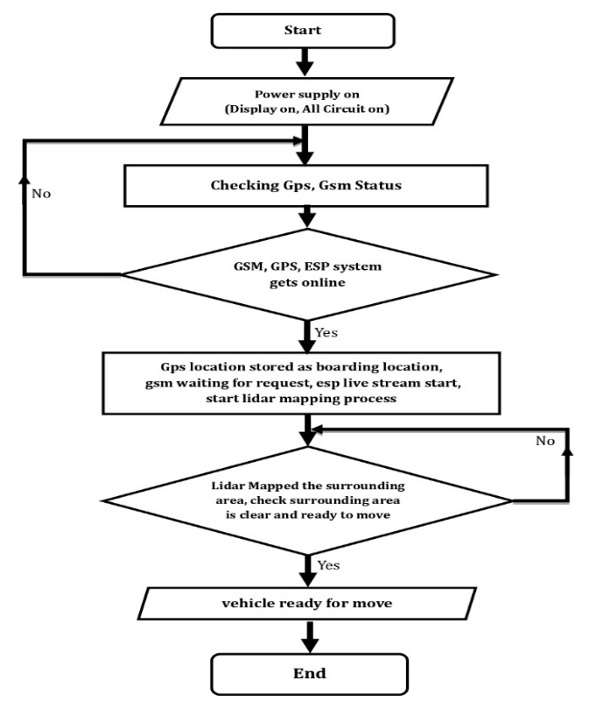Fig. 2- Flow Chart of Automatic vehicle mover using Lidar sensor
This vehicle is fully automatic, so all we have to do is load it up with the materials or equipment it needs to get to its predetermined destination. From there, we can adjust the route it takes to get the goods to their final destination as quickly as possible via the most direct route. And since there are no humans involved, the vehicles can operate autonomously. In our mental model, we've programmed the vehicles to come to a complete stop in the presence of any barrier, be it another vehicle, a person, etc.
The car in the direction it needs to go or towards its final destination. If there are obstructions in its path, the vehicle will be at a complete standstill. It was also linked to a sensor that detected body mass index, such that the vehicle would come to a complete stop and go in no particular direction if an overweight passenger was present.
DESIGN
The automobile The kinematic structure of a Hellenak consists of four wheels. The two back wheels are attached in the motors and share a common axis of rotation. In their starting position, the two front wheels are aligned on a common axis and are free to rotate. The turning is caused by the discrepancy in the velocity vectors of the uncommon wheels. Therefore, rather than testing individual components of the actuator anomaly vector, we do the Chi-square test on the full vector. No determination is made as to whether or not a specific actuator is misbehaving, but the decision outcomes from the hypothesis tests suggest whether or not the robot has actuator misbehaviours with a given level of confidence.
$$X=\left[\begin{matrix}x \\ y \\ ∅\end{matrix}\right]$$
$$x=\frac{(v1+vr)}{2}\cos{∅}$$
$$y=\frac{\left(v1+vr\right)}{2}\sin{∅}$$
$$∅=\frac{(v1+vr)}{2e}$$
The presented multichannel-based LiDAR system allows for an angular resolution of 0.07 0.027° (horizontal vertical) and a field-of-view (FoV) of 360 8.6° (horizontal vertical).
CONCLUSION
This is a major improvement for self-driving cars. This algorithm allows cars to self-navigate to a predetermined point by constantly obtaining directions from another car headed in the same direction. As the autonomous vehicle follows the path of another vehicle headed in the same direction, timing discrepancies are possible. The purpose of a robot's navigation process is to get it from its current location in an unfamiliar environment to its predetermined destination. One of the most important parts of autonomous systems is the navigation planning process. It's possible that the robotic vehicle will encounter unexpected barriers between its current location and its intended destination once it begins moving along the predetermined route. Therefore, the autonomous vehicle must navigate around the obstacles and take the most direct path to its destination. Use of autonomous vehicles like this one could one day occur on highways and other frequently frequented roads. When exploring unfamiliar territory, drivers can also take advantage of autonomous vehicles. An enhanced navigation system for driverless vehicles. One type of gadget that does this is called a lidar, which stands for light detection and ranging. This innovation is well into its second or third decade. In the past, it was employed to determine how far away a satellite actually was. These days, Lidar systems are widely employed in autonomous vehicles as the primary obstacle-detection sensor. We determined that the Lidar's pulse energy need only be quite little, and that the amount of energy in that pulse is what ultimately determines how far the device can send and receive signals..
ACKNOWLEDGMENT
We record our heart-felt gratitude and indebtedness to our guide Dr. Umakant Gohatre. for supervising us care and zeal throughout our project “Design & Development of Automatic Vehicle Mover Using LIDAR System” We would like to thank Principal Dr. Sunil S. Chavan. and Dr. V.P. Patil. (HOD OF EXTC DEPT and Vice Principal) of our prestigious institute for his helpful guidance and encouragement.
We are immensely thankful to all the respected teachers of EXTC Department for the hands to help that they offered to us with affectionate understanding whenever we needed it.
REFERENCES
- Suresh Katel, Rajendra Yarti, et al. June 2019, showed empirical assessment and error budget of accuracy in Airborne LiDAR derive elevation.
- Saroj Mondal, Sunil Barse, Jajilat Mehata, December 2019, worked on predicting forest stand characteristics with Airborne scanning LiDAR.
- Anton Rassolkin, Mairo Leier, Rosanic alin, Carsolis Forzic, April 2019, [3] "Self-Driving Car for Research and Education", June 2018.
- Takeuchi Saneri, Devid Hotward, et al. July 2018. In this work, LiDAR is used for the prole measurement of a continuous environment quantity
- Mallet Vectors, Jades Minayal, Rashit Quca, et al. 2018, worked on a Full-waveform topographic LiDAR. They presented a survey of the literature related to Airborne laser scanning (ALS).
- Rassolkin Vaimann, A. Kallaste, Resins Sell, "Selection of propulsion motor drive topology for further development of autonomous car", 2018, Energy and Electrical Engineering.
- Spinhirne esirian, Helan Losan, et al.2018, Micro Pulse LiDAR was developed in this system was an eye-safe, compact, solid-state LiDAR for proling atmospheric cloud and aerosol scat-tering.

