Smart Wheelchair

Diya Jaiswal¹, Priyanka Narad², Nisha Dukare³, Jay Bhore⁴
¹Rahul Bhandekar
Wainganga College of Engineering and Management, Nagpur, India, 441114

shraddhajaiswal786786@gmail.com, priyankanarad200@gmail.com, nishadukare53@gamil.com, jaybhore5@gmail.com
Received on: xxxx,20xx, Revised on: xxxx,20xx, Published on: xxxx,20xx

Abstract
Mobile platforms, by means of Bluetooth technology, The use of autonomous systems in the world to perform important and delicate task is rapid growing. However, its application in various fields cannot be over emphasized. This paper presents an obstacle detection and avoidance system for an fixed Lawnmower.

The system consists of two (Infrared and Ultrasonic) sensors, an Arduino microcontroller and a gear DC motor. The ultrasonic and infrared sensors are implemented to detect obstacles on the robot’s route by sending signals to an interfaced microcontroller.

The micro-controller redirects the robot to move in an alternate direction by actuating the motors in order to escape the detected obstacle. The performance evaluation of the system indicates an accuracy of 85% and 0.15 chance of failure respectively. In conclusion, an obstacle detection circuit was successfully implemented using infrared and ultrasonic sensors modules which were placed at the front of the robot to throw both light and sound waves at any obstacle and when a reflection is received, a low output is sent to the Arduino microcontroller which clarify the output and makes the robot to pause.

Keywords-- Arduino Uno,
Wheelchair, Voice Recognisation.

INTRODUCTION

An idea to easy the lives of those among us who are conflicting enough to have lost the ability to move their legs due to a significant amount of paralysis, accident or due to old age. Many differently disabled people usually depend on others in their daily life especially in moving from one place to another. For the wheelchair users, they need continuously someone to help them in getting the wheelchair moving. Their lives are made difficult by the fact that there is lack of an discreet control system for their wheelchairs that allows moving independently. Using an electrical wheelchair leads to a large amount of independence for persons with a physical disability who can neither walk nor conduct a mechanical wheelchair alone as it must great effort and help of other people. The problem is that in some cases the disability causes someone to lose the ability to use his hands, therefore in this case, the way of controlling a power wheelchair can be done using speech commands for hands-free patients noted to an fascinating and promising outcome. But, still the availability of the smart wheelchair solutions is often limited due to the high costs and not-so-friendly operation. By the proposed approach, described in this paper, the low-cost, simple and
friendly solution for the voice-controlled platform will be presented that is user friendly, fully-customizable according to the language spoken by the user and will help in improvement of users independent mobility. Using a Smartphone as the “brain” of a robot is already an active research field with several open opportunities and promising possibilities. Another recent and very successful technology, Bluetooth has changed how people use digital device at home or office, and has transferred old wired digital devices into wireless devices. This research is based on Voice-controlled Wheelchair design based on design and implementation of wireless remote-control solutions.

The project also integrate use of ultrasonic sensors to detect obstacles within range of 4 metres and notifies the system and stop the wheelchair till further command. In this work, Smart Wheelchair control using Arduino Uno microcontroller and Bluetooth Module via android application is presented. The rest of this paper is organized as follows: Section 2 specializes to display the related most new works. Section 3 concerns with the Flowchart of the project and application instruction. Section 4 discusses the result.

METHOLOGY
The system has two parts, namely; hardware and software. The hardware architecture consists of a embedded system that is based on Arduino Uno board, a Bluetooth Module, Motor Driver and an Android phone. The Bluetooth Module provides the communication media between the user through the android phone and the system by means of voice command given to the android phone. The user speaks the desired command to the “BT Voice Control for Arduino voice (AMR Voice Application)” software application installed in the android phone that is connected through Bluetooth with Bluetooth Module SR-04. The voice command is converted to an array of string and the string is passed to Arduino Uno connected to it. Once the Bluetooth Module receives the message, the command sent will be extracted and executed by the microcontroller attached to it and depending on the commands fed to the Motor Driver, the motors will function accordingly. The system will interpret the commands and control the Wheelchair accordingly via android application. Meanwhile, the ultrasonic sensor works while the circuit is on, and makes sure the path has no obstacle and if any obstacle occurs it notifies the Arduino and stops wheelchair till further command is obtained from the user.
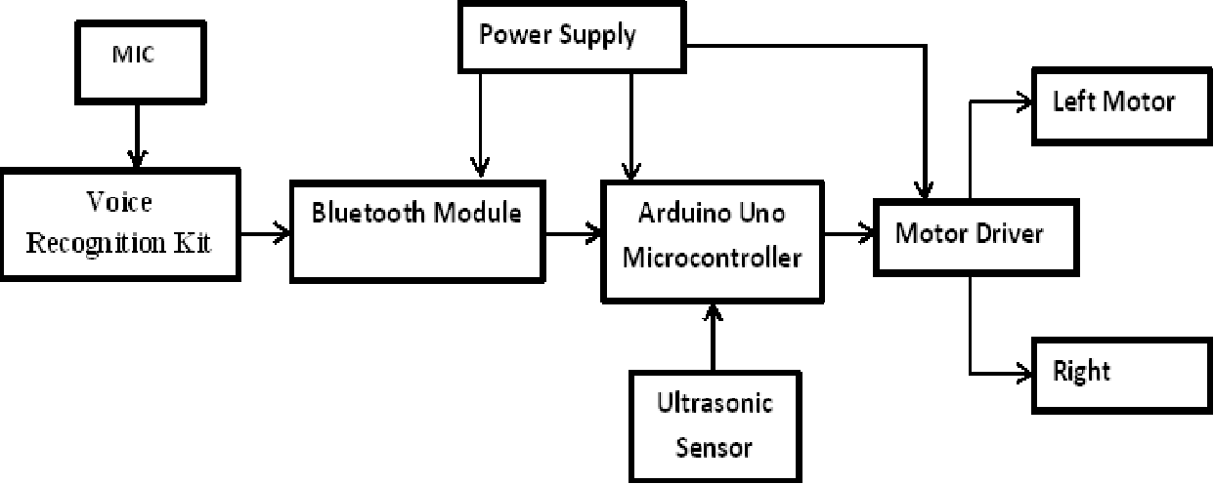
Fig.1 Block Diagram of Project

CONCLUSION
This project develop the design and construction of Smart Electronic Wheelchair with the help of Bluetooth Module. The circuit works properly to move as the command given by the user. After designing the circuit that enables physically disabled to control their wheel using an android application in their smart phones and it has also been tested and allowed. The detection of any obstacle is successfully controlled by the microcontroller. As the person switches on the circuit and starts moving, any obstacle which is expected to lie within a range of 4 meter will be detected by the Ultrasonic sensor. This system add to the self-dependency of differently disabled and older people.

ACKNOWLEDGMENT
We would like to place on record my deep sense of gratitude to Prof. Rahul Bhandekar Head of Department Computer Science Engineering, Wainganga College of Engineering and Management Nagpur, India for providing me infrastructural facilities to work in, without which this work would not have been possible and also for his generous guidance, help and useful suggestions, for his stimulating guidance, continuous encouragement and supervision throughout the course of present work. We would also like to extend our heart-felt thanks to our family and friends for their expenditure moral support, love and affection. Providing the transforming gift of mobility to the physically disabled people.
REFERENCES
[1] Azam, G., and M. T. Islam. "Design and Fabrication of a Voice Controlled Wheelchair for Physically Disabled People"
[2] Anusha, S., M. Madhavi, and R. Hemalatha. "HOME AUTOMATION USING ATmega328 MICROCONTROLLER AND ANDROID APPLICATION." (2015).
[3] Rajini, Gangadhari and Lr Siva. "Android Mobile Phone Controlled Bluetooth Robot Using Arm7 Microcontroller." (2015).
[4] Megalingam, Rajesh Kannan et al. "'Gest-BOT'-A Highly Convenient Locomotive Solution for the Elderly and Physically Challenged." Global Humanitarian Technology Conference (GHTC), 2012 IEEE. IEEE, 2012.
[5] Skraba, Andrej, et al. "Prototype of speech controlled cloud based wheelchair platform for disabled persons." Embedded Computing (MECO), 2014 3rd Mediterranean Conference on. IEEE, 2014.
[6] Sobia, M. Carmel, V. Brindha, and A. Abudhahir. "Facial expression recognition using PCA based interface for wheelchair." Electronics and Communication Systems (ICECS), 2014 International Conference on. IEEE, 2014.
[7] Klabi I., Masmoudi M.S., Masmoudi M., "Advanced user interfaces for intelligent wheelchair system", 1st IEEE Conference on Advanced Technologies for Signal and Image Processing, 2014, pp.130-136, Tunisia.
[ 8]. D. Floreano and J. Urzelai. “Evolutionary Robots with Online Self Organization and Behavioral Fitness”, June 2000.
[9]. J. Grefenstette and A. Schultz. “An Evolutionary Approach to Learning in Robots” Machine
[10] Learning Workshop on Robot Learning, New Brunswick, 1994.
[11]. G.Dudek and M.Jenkin. “Computational Principles of Mobile Robotics”, Cambridge University Press, New York, 2000
[12]. Oussama Khatib. “Real-Time Obstacle Avoidance for Manipulators and Mobile Robots”, Artificial Intelligence Lab, Stanford University, California.

