SURVEY ON VARIOUS SMART PARKING SYSTEM AND ITS TECHNOLOGY
Thanuja Murthy S, Sunitha K, Nikhila K, Rani S, Deepa S R
thanujamurthy1@gmail.com, sunithakprasad@gmail.com, kilarinikhila@gmail.com, ran9964@gmail.com, Deepaprashanth.g@gmail.com,

Abstract – In numerous rising nations where occupants and vehicles are increasing rapidly. Individuals would squander a specific amount of time searching for parking spot and propel the driver to stop a vehicle on the streets, which is the reason for genuine obstructing on the streets and moderate advance of movement. The state of searching for parking spot physically and movement blockage in stopping zones is because of the way that the data of existing parking spots isn't promptly available to the general population and not suitable to upkeep parking framework. A considerable measure of innovative work is being made everywhere throughout the world to execute predominant and more intelligent parking frameworks. In this paper we examine the idea of the savvy parking framework, their classifications and the sensor and indicator innovations utilized. The characterizations of different existing frameworks and sensors are classified. We audit advances of savvy parking framework to find which is the skilled strategy can be utilized to diminish the issues of parking framework to an incredible breadth.
Keywords- Parking Framework, Sensors, Indicators, Classification of parking framework
- INTRODUCTION
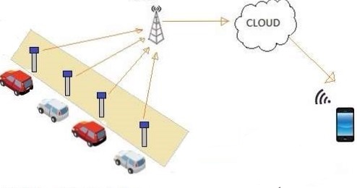
since the most recent couple of years individuals moving from residential areas to metropolitan urban communities have been developing quickly and they began to build up their way of life and to make their life simple in all methods for transportation, which drives a quick increment in number of vehicles. One thing that as colossal issue for people is that to locate an unfilled parking spot in the metropolitan urban communities, especially amid the surge hours or on occasion of special events. most of the circumstances the parking spots are left unfilled in light of the fact that they are not remotely accessible and individuals are unconscious of them. This

prompts activity blockage, individuals getting disappointed. There is a few shrewd parking
frameworks that are being utilized as a part of request to determine these inconveniences. maybe a couple of
them are utilizing the LED board to show the quantity of parking spots that are free in the parking area. However, that doesn't help individuals as they can't
discover those spots alone. The classifications of different frameworks and advances are clarified in the
accompanying areas. The examination between these different brilliant parking framework is additionally clarified to which method is proficient.
- SMART PARKING SYSTEM
smart parking systems can be characterized as a parking structure framework that uses different innovations to proficiently deal with the carport. At first the shrewd parking frameworks were actualized in Europe, USA and Japan. Presently all most every one of the nations began introducing these keen parking frameworks. The shrewd parking framework is executed in numerous situations with different highlights, which take care of their issues looked in their everyday exercises. The framework engineering of savvy parking framework comprises of three levels. the most minimal level containing the elements of detecting, information transmission is made in a center level, and upper level manages the capacity of information, handling and customer interfaces.

Fig1: Schematic representation of System Architecture
- ADVANTAGES OF SMART PARKING SYSTEMS:
• Travelers would know about the parking spot.
• Reduction in time spent to discover the parking spot.
• Reduced driver disappointment.
• Reduction in rush hour gridlock clog.
• Elimination of queues.
• Better conveyance of stream and parking.
• Revenues and profitability

- CATEGORIES OF SMART PARKING SYSTEM:
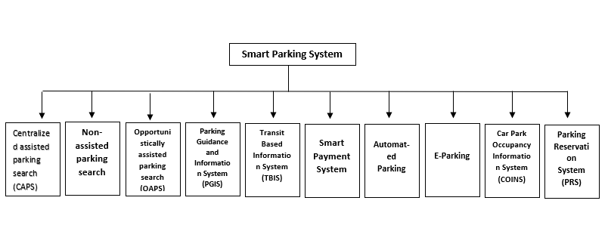Fig2: Classification of smart parking system
- CENTRALIZED ASSISTED PARKING SEARCH (CAPS):
In Centralized assisted parking search (CAPS), the data handling will be put on the central processor (server). The data will be gathered by the server from the sensor in parking slot and it takes the decisions.

- NON-ASSISTED PARKING SEARCH (NAPS):
The Non-assisted parking search (NAPS) does not comprise of the server, and data won't be given to the client. The client needs to generally look for the parking space in finding the accessible space. The space will be locked in by the client who achieves the vacant slot first.
- OPPORTUNISTICALLY ASSISTED PARKING SEARCH (OAPS):
There is a new approach called opportunistically assisted parking search (OAPS), which utilizes a Mobile Storage Node (MSN). The stream of data is made through this MSN. This prompt additional bring up in proficiency. However, the data coursed by this hub isn't generally helpful.
- PARKING GUIDANCE AND INFORMATION SYSTEM (PGIS):
The Parking Guidance and Information System (PGIS) can be utilized for categorizing, for example, entire city region or specific parking environment. This framework gives data to drivers about the accessibility of spaces for parking the vehicles in the parking zone. The data is sent by Static/dynamic variable message signs (VMS).The guidance required by users are provided by the PGIS, it has four components.
The four components are
- information dissemination mechanism
- information-gathering mechanism
- control center
- Telecommunication networks
With the assistance of a portable devices the current position of a driver is distinguished by utilizing Global Positioning System (GPS), and this framework is executed utilizing a web.
- TRANSIT BASED INFORMATION SYSTEM (TBIS):
The Transit based data framework (TBIS) gives the direction for park and-ride facilities. This framework prevails with regards to executing, and it diminishes the issue looked by the clients.
- SMART PAYMENT SYSTEM:
In the smart payment system, the payment is to be finished by the client for parking the vehicle. previously the money was gathered by the money counters, however the maintenance is convoluted. Later different procedures are utilized to collect the payment. Utilizing RFID advancements, the payment is made via Automated Vehicle Identification (AVI) tag. This RFID innovation and cell phones are contact free, where here the contact strategies are smart cards, debit cards and credit cards.
- AUTOMATED PARKING:
PC controlled mechanism are utilized as a part of robotized parking, where the security highlights are accessible. This framework puts the vehicles in its apportioned space by PC controlled docks/lifts and infrequently client inclusion is important. An introduction of three-level software design includes:
- Logical Layer (LL)
- Safety Layer (SL)
- Hardware Abstraction Layer (HAL)
to execute the correct and efficient storage of vehicles in a secure manner.

- E-PARKING:
E-Parking is where the SMS or the web is utilized for effective stopping. A smart payment mechanism is utilized as a part of this framework. Cell phones or reservation centers are utilized for reservation mechanism.
Few requirements are:
- Wireless Application Protocol (WAP)
- enabled mobile phones
- Personal Digital Assistants (PDAs).

- CAR PARK OCCUPANCY INFORMATION SYSTEM (COINS):
This system checks the opportunity for parking the vehicle by means of video sensor. The image processing method is utilized, and accessibility data is shown in a show board.
- PARKING RESERVATION SYSTEM (PRS):
PRS requires the establishment of parking reservation activities data centers, a correspondence framework between the clients and the PRS, real-time checking of the present parking accessibility, and appraisals the expected request. The expected request can be assessed in light of the measure of individuals who held a space and the anticipated number of non-reserved landings amid the following couple of eras that could be founded on recorded entry information. The clients would be able to reserve a parking spot and get a reaction from the PRS through an assortment of correspondence media, for example, phone, fax, or the web.

- CLASSIFICATION OF VEHICLE DETECTION TECHNOLOGY:
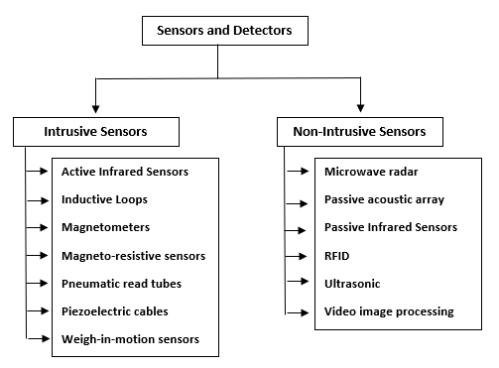
Fig3: Classification of Sensor technology.
- ACTIVE INFRARED SENSORS:
An active infrared sensor spots vehicle by creating infrared vitality and detecting the measure of vitality reverberated. The active infrared sensors are utilized in multi lane activities. An exact estimation of vehicle area, speed and class, numerous beams are estimated and spread from the sensor. This sensor would be touchy about ecological conditions.
- INDUCTIVE LOOP DETECTORS:
Inductive Loop Detectors (ILDs) are wire loops of a few measurements, which are energized with signals whose frequencies go between 10 to 50 kHz. The oscillation frequency of these inductive loops is specifically affected by the inductance of the loop which vacillates with vehicle nearness.
- MAGNETOMETER:
Magnetometer are of two types
- flux gate magnetometer
- induction or search coil magnetometer.
The flux gate magnetometers are not influenced by the climate conditions, but rather exact estimations of these conditions are required for exact identification. The induction or search coil magnetometers are additionally inhumane and are nosy sensors.

- MAGNETORESISTANCE SENSORS:
These sensors incorporate:
- Anisotropic Magnetoresistance Sensors (AMR)
- Giant Magnetoresistance Sensors (GMR)
- magnetic Tunnel Junction Sensor
extraordinary Magnetoresistance and Ballistic Magnetoresistance are supported by applying a consistent current. The AMR is utilized for vehicle identification and it has affectability towards position and orientation of the vehicle.
- PNEUMATIC ROAD TUBE:
In this the Vehicles are recognized by making pressure via air, which brings about shutting a switch and creates a signal when the vehicles move over it. Usage is less demanding and upkeep is less complex, yet it is touchy to temperature.
- PIEZOELECTRIC SENSOR:
Piezoelectric sensors include change of kinetic energy to electrical energy when the extraordinarily handled material is subjected to vibration or mechanical effect. It gives more exact esteem, however it needs numerous indicators. They are delicate influenced by high temperature and stress.

- WEIGHT-IN-MOTION SENSOR:
This sensor works by recognizing the weight of the vehicle and is utilized by expressway organizer, designers and offices who implement law.
The four technologies used in it are:
- bending plate
- piezoelectric
- load cell
- capacitance mat.

- MICROWAVE RADAR:
These sensors transmit energy utilizing a antenna and by utilizing the energy reflected back towards the antenna the vehicle is identified.
The two type’s radar sensors are
- Continuous wave radar (CW)
- Frequency modulated continuous-wave radar (FMCW).
They are not influenced by any variables but rather Doppler sensors would need to be made of auxiliary sensors to recognize ceased vehicle.
- PASSIVE INFRARED SENSOR:
these sensors distinguish the accessibility status of a parking spot in a parking region by detecting changes in the energy radiated by vehicles. The sensors are to be deployed in a multi lane situation to quantify vehicle speed. The sensor is influenced by heavy rain, snow and thick mist and furthermore, certain sorts of these sensors are not appropriate for nearness location.

- RFID:
Radio-Frequency Identification is used in techniques that are used for vehicle detection. The three units of RFID are
- Transceiver
- Transponder
- Antenna.
They are implemented effortlessly and maintenance is additionally less difficult. It gives high speed recognition. There are troubles looked in fulfilling protection issues.

- ULTRASONIC SENSOR:
The Ultrasonic sensors work by transmitting pulse wave forms in the range between 25 to 50 kHz to the street. Transmitted energies are reflected back the sensor and by which the vehicle nearness is distinguished. Their deployment is basic and they are touchy to the environment.
- VIDEO IMAGE PROCESSOR:
A Video image processor typically consists of:
- one or more cameras
- software for image interpretation
- microprocessor-based computer for digitizing and processing.
Investigation on continuous frames must be done carefully. These are caught by the video image processor and can be utilized as a part of identification of vehicles. It uncovers the contrasts between subsequent frames. The utilization of these video image processor makes the management easier and implementation will be simpler as it is available readily in most of the car park facilities which also includes basic surveillance systems. It provides easy addition and modification of Detection zones. Other than this it adapts easily to any geometric shaped space for coverage optimization. Wide-area detection can be provided when information gathered at one camera location are linked to other cameras, it is suitable for multiple lane detection. The number of cameras required for monitoring is reduced. without the need for delay the detection results obtained can be verified offline and in real-time.

- PASSIVE ACOUSTIC SENSORS:
The acoustic sensors detect nearness of vehicle through the acoustic energy or discernible sounds which are delivered by the vehicle by means of microphones which are introduced for recognizing vehicles. The preferences offered by these sensors are arrangement for numerous path activity in specific models and additionally detached discovery. They are inhumane to precipitation. They are influenced by cool temperature which influences information exactness. Certain models of these sensors are not prescribed with moderate moving vehicles in substantial rush hour gridlock.

- CONCLUSION
Utilizing the advances of parking framework, we can create parking framework as indicated by numerous conditions. Furthermore, we can utilize diverse kinds of sensors in light of their ability and proficiency. In view of the functionalities of sensors, they are conveyed in the parking frameworks
- REFERENCES
- G. Revathi, V R Sarma Dhulipala,“Smart Parking Systems and Sensors: A Survey”..
- Pranav Sahni, Nidhi Bhandari, Himanshi Khurana,” REVIEW OF SMART PARKING SYSTEM AND DIFFERENT SENSORS”. International Journal of Industrial Electronics and Electrical Engineering, ISSN: 2347-6982
- Khaoula Hassoune , Wafaa Dachry , Fouad Moutaouakkil , Hicham Medromi , “Smart parking Systems:A Survey”. 2016 IEEE.
- E. Kokolaki, M. Karaliopoulos, I. Starakakis, "Opportunisticallyassisted parking service discovery: now it helps, now it does not," Elseveir Journal of Pervasive and Mobile Computing (PMC), (2011 In Press).
- M. E. Tamil, D. Salleh and M. Y. Idna, 2007. Curtseys 1.0 “A mobile vehicle tracking system with GPS technology,” Proceedings of the SCORED 2007, May 14-15, Universiti Tenga Nasional, Malasiya, 2007, pp. 1-11.
- D.B.L. Bong, K.C. Ting and K.C. Lai, “Integrated approach in the design of Car Park Occupancy Information System (COINS),” IAENG Int. J. Comput. Sci., 2008, Vol. 35, pp. 7-14.
- S. A. Shaheen, C. J. Rodier and A. M. Akin, 2005, “Smart parking management field test: A bay area rapid transit (Bart) district parking demonstration,”.
- Sushil Patil, Devinder Singh, “Design and implementation of Parking System using Zigbee” in International Journal of Engineering Research & Technology (IJERT),ISSN: 2278-0181, Vol. 3 Issue 4, April – 2004.

