Finger print locker using Arduino

Prof.VickyChaudhari1,ChetanaPimpale²,PriyankaRajurkar³,ChetanGaikwad⁴,PoojaBothale⁵DepartmentofComputerScienceandEngineering.
1AssistantprofessorWaingangaCollegeofEngineeringandManagement,Dongergao,Nagpur,

India.
234AssistantprofessorWainganga CollegeofEngineeringandManagement, Dongergao, Nagpur,India.
vickychaudhari.wcm@gmail.com, chetanapimpale.vc929@gmail.com,priyankarajurkar63@gmail.com,chetan8928660868@gmail.com,poojabothale8720@gmail.com

Abstract—Thisconceptwhichisoffingerprintdoorlockerisrelatedtothesecurityissuesinthedaytodaylife,thephysical key can be made as duplicated to thesecurityissuesinthedaytodaylife,thephysical key can be made as duplicate is verycheap cost and the key can lost somewhere orthe key can steal, to overcome these issues wecanusebiometricsecuritygadgetsandtryimprovise the security much more because itcan never be stolen be stolen it cannot be lostand the staling chance of duplication are verylow to break the security. From the old timethe security the big issue for the company’shouses and other places is worried about thesecuritynowaday. The

traditional door locks can be bypasses by theduplicate keys, but the best solution for thissituationisbiometriclockswhichincludesFingerprint, Iris and Handprint scanners. Sothis project we are going to try to get upperlevelofsecurity.
Keywords-fingerprint,key,security,lock,scanner,buzer.
wherehumancannotfindwaystoprovidesecurity to his confidential belongings manually.Instead, He finds an alternative solution\ whichprovides better, reliable and atomizedsecurity.Thisisanerawhereeverythingisconnectedthrough network, where anyone can get hold ofinformationfromanywherearoundtheworld.Thus chances of one’s info being hacked are aserious issue.
Due to these risks it’s very important tohavesomekindof personalidentificationtoaccessone’sowninfo.Nowaday’spersonalidentification is becoming an important issue allaround.Amongmainstreampersonalidentification methods we mostly see passwordand identification cards techniques. But it is easyto hack password now and identification cardsmay get lost, thus making these methods quiteunreliable.

LITERATUREREVIEW

- Introduction
Papertitle | Details ofanotherpublication | Findings
FingerprintBased DoorAccessSystemusingArduino | MalabikaSarma,AmlanjyotiGogoi,RahulSaikia,DibyaJyotiBora  School ofComputing | Arduino BasedSmartFingerprintAuthenticationSystem.”- Intoday’s world  Home, offices,shops, banks

Thesedaysoffice/corporateenvironmentsecurityisamajorthreatfacedbyeveryindividual when away from home or at the home.When it comes to security system, it is one of theprimaryconcernsinthisbuyscompetitiveworld,

Proposedalgorithm
 | Sciences -InformationTechnologyThe AssamKazirangaUniversity,Jorhat,Assam,India | needexcessivesecurity measurefor safetymotive. Tosupplysecurityforthesearea,smart lock  system isinitiated. Thereare numerousinnovationalsmartdoorlocksare created tolockandunlockthe system.These typeoflocks hasfingerprint,Pin,password or  IOT by  unlockingthesystemusingmobilephone.Thesesystemdoesnothavesecurity peckingordertogrowthesecurity.

- Thefingerprintisscanned.
- The fingerprint is put in a condition where itscansforthe matchofthefingerprint.Ifmatchis found, it moves to step 3. Else it moves tostep6.
- The information of the person is recorded likename,timeofentry/exit,etc.
- The servo motor is started and accordingly thehook lock connected to the servo motor doesitsworkoflockingorunlocking.
- Awelcomemessageisdisplayed.
- Itwillcheckiftheunrecognizedfingerprintis

HARDWAREANDSOFTWARETOOLS
- HardwareTools
- ArduinoUnoR3
- FingerprintSensor
- IRFZ44N
- SolenoidLock
- FingerPrintSensor
- PowerAdapte

SoftwareTools
- ArduinoIDE
- Embedded-C

Objective
To create an advance system that will allowthe user to save and delete a fingerprint intothesystem.Toprovidestudentsbasicknowledge on how the fingerprint reader usedintheindustry.

Problemstatement
This system is used for safety in the lockersystem. We are using a fingerprint sensor toopen the locker. Who has authorized personstheyonlyopenthemlocker.Ifanunauthorizedholedfingermeanspersonlockerdoesnotopen.

Applications
- Used in Banks and Offices to secure thevaultsdoororsimplyforresidentialhousesdoorlocksystem.
- Fingerprintsecurity systemcanbeusedinATM,fingerprintoperatedVehicles.
- CanbeusedforvoterIDregistration.

.Wesavethefirstfingerprintinposition 1 and then we give it enter and

triedmore than 3times.Ifsuch attemptismade,itwillmovetostep7.Else,itwillmovetostep10.
- Storetheunrecognizedfingerprint.
- Storephotographofunauthorizeduser.
- Sendmessagetotheowner.
- Displayerrormessage.
- Repeatstep9.
followtheinstructions:
Ifthefingerprintwasregisteredcorrectly,itwillshowthemessage“Fingerprint DOES match!”, followed by theposition where it was saved and the message“Registered!”
To save more than one fingerprint, thesensor allows up to 162 fingerprints, we nowretype the number of the next position wherewewanttosaveit,whichinthisexample

would be position 2, we type 2 and pressenterandcontinueagainthesameinstructions until all the necessary footprintsare recorded, always indicating adifferentpositionsothatonealreadysavedisnotoverwritten.
Finally we load the final program thatwill read the fingerprints. If the fingerprintread matches one of those stored, the relaythat is connected to Pin 13 of the Arduinowill beactivatedfor3seconds
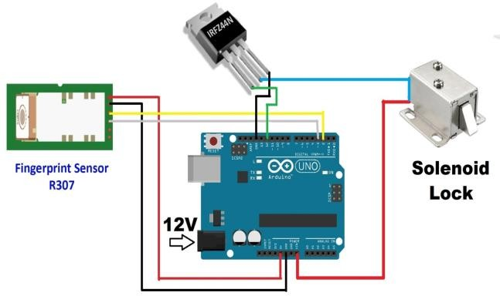
FirstweproceedtodownloadthelibraryforArduinofromthefollowinglink:

https: //github.com/Adafruit/Adafruit-fingerprint-S …Once downloaded, the library is unzippedand saved in: C: Program Files (x86) ArduinolibrariesItisnecessarytorenamethelibraryfolderincasethe“.cpp”file isfoundwith adifferentnameisin it.

Thesensorworksat57600baud,itcanbeconfiguredbut this is the defaultspeed,whenusing serial, the arduino uses the software seriallibrary.

#include<SoftwareSerial.h>

Ifitisrequiredtochangepins,theserialbysoftwarecanbedoneinthefollowinginstruction:

MySerialSoftwareSerial(2,3);

For the example of the fingerprint, if the arduinoisrequiredtoexecuteanactionafterhavingfoundafingerprint,itisnecessarytoindicateitinthissection ofcode:

Serial.Print (“found ID #”);Serial.Print(Finger.fingerID);
Serial.Print(“withconfidence”);

Serial.println (Finger.Confidence); Write thecodeherereturnfinger.fingerID;

We open the Arduino Serial Monitor to startrecordingthetracksandfollowtheinstructions:

Working
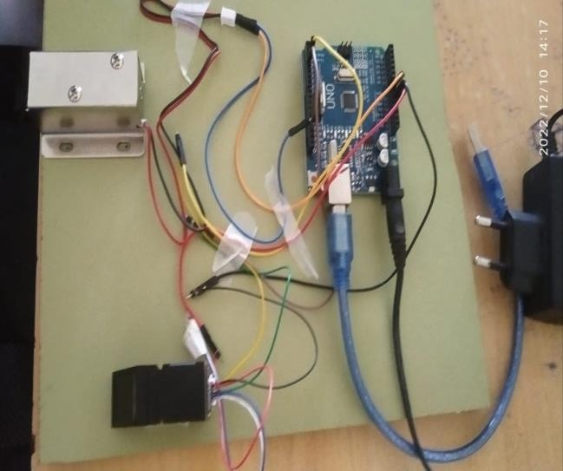

We save the first fingerprint in position 1 andthenwegiveitenterandfollowtheinstructions:

If the fingerprint was registered correctly, itwillshowthemessage“FingerprintDOESmatch!”,followedbythepositionwhereitwassavedandthemessage“Registered!”

To save more than one fingerprint, the sensorallows up to 162 fingerprints, we now retypethenumberofthenextpositionwhere wewant to save it, which in this example wouldbe position 2, we type 2 and press enterandcontinue again the same instructions until allthe necessary footprints are recorded, alwaysindicatingadifferentpositionsothatonealreadysavedisnotoverwritten.

Finallywe load thefinal program thatwillreadthe fingerprints. If the fingerprint readmatches one of those stored, the relay that isconnected to Pin 13 of the Arduino willbeactivatedfor3seconds.

HARDWARE DESCRIPTION OFFINGERPRINTBASEDDOORLOCKSYSTEM
- ARDUINO
Arduinoisanopen-sourceelectronicplatformbased on easy-to-use hardware and software.Arduino boards are able to read inputs – lighton sensor, a finger on a button, or a Twittermessage – and turn it into an output –activating a motor, turning on an LED,publishing some thing online. You can tellyour board what to do by sending a set ofinstructions to the microcontroller on theboard. To do so you use the Arduinoprogramming language (based on writing),and the arduino software (IDE), based onprocessing.Over the years Arduino has beenthe brain of thousands of projects, fromeveryday objects to complex scientificinstruments. A worldwide community ofmakers students, hobbyists, artists,programmers, and professionals – hasgathered around this open source platform,their contributions have added up to anincredibleamountof accessibleknowledgethat can be of great help to novices andexpertsalike.
Arduinowasbornattheivreainteractiondesigninstituteasaneasytoolforfastprototyping,aimedatstudentswithoutabackground in electronics and programming.As soon as it reached a wider community, theArduinoboardstartedchangingto adapttonew needs and challenges, differentiating itsoffer from simple 8-bit boards to products forIOT applications, wearable, 3D printing, andembedded environments. All Arduino boardsarecompletelyopen-source,empoweringuserstobuildthemindependentlyandeventuallyadaptthemtotheirparticularneeds. The software, too, is open –source anditisgrowingthroughthecontributions ofusersworldwide.

ADVANTAGESLIUMITAIONS&APPLICATION

  - ADVANTAGES
- Thisprojectprovidessecurity.
- Powerconsumptionisless.
- Usedcommonlyavailablecomponent.
- Circuitdiagramissimpleandeasy.
- Easytouseandsetup.
- Storageofupto200fingerprints.
- GenerallyitisusedinATM,fingerprintcarandhomedoorlocketcforsecurity.

LIMITATIONS
- Thelimitationsoffingerprintbaseddoorlocksystemare:

- Differentbiometric technologies need theuse of different devices that have a range ofcost.

- Entryanddeletefingerprintsneedtooperatemultiplesteps, theprogramis toomuchtrouble,convenienceisnotenough.

- Performance can be fluctuate to dry, wet,dirtyfingers.

Conclusion
Fingerprintdoorlocksaregreatinvestment for home or business. It providesgreatsecuritybyprovidingrestrictionstounwanted access. This device increases levelofsecuritybyaddinguniquebiologicalfeaturesofauthorizedperson.Foranyonewhowantsmoresecuritytotheirhomes,fingerprint based door lock system are bestchoice.
- References
- JigmeYeshi , Kazuhiro Murmatsu. DualDoor Lock System Using Radio-FrequencyIdentification and Fingerprint Recognition –2019.

- Hashem Alnabhi , Yahya Al- naamani ,MohammedAlmadhehagi,MohammedAlhamzi.EnhancedSecurityMethodsofDoorLockingBasedFingerprint-2020.

- VikasGoyal ,Himanshu Jindal Improvedfingerprintmatchingmiuatiaesingularpointsnetwork-2017

- ShilpashreeP.S,AbhishekKumarTiwari,AshutoshPrakashSaurabhKumarSingh,“Cloud Based Secured Locker” InternationalJournalofScientificResearch&Engineering Trends Volume 5, Issue, Mar-Apr-2019,ISSN(Online):2395-566X

- MeenakshiN,MonishM,DikshitKJ,Bharath S. Arduino Based Smart FingerprintAuthenticationSystem.In20191stInternationalConferenceonInnovationsinInformation and Communication Technology(ICIICT)2019Apr25(pp.1-7).IEEE.

- Patil,KarthikA,NiteenVittalkar,PavanHiremath,and Manoj AMurthy.“SmartDoorLockingSystemUsingIoT”07,no.05(2020):5.

- “(PDF)PasswordBasedDoorLockSystemUsingArduino,” ResearchGate.

- https://www.researchgate.net/publication/330998913_Password_Based_Door_Lock
_SystemUsing_Arduino(accessedAug.08,2021).

- Website link :https://www.elprocus.com/lcd-16x2-pin-configuration-and-its-working/RetrievalDate:23 May,2022

- Website link :https://components101.com/transistors/tip122-pinout-equivalent-datasheet RetrievalDate:25 May,2022

- Website link :https://components101.com/mosfets/irfz44n-datasheet-pinout-featuresRetrievalDate:24May,2022

- Website link :https://www.amazon.com/Degraw-DIY-Speaker-Kit-Amplifier/dp/B07CRVRG83Retrieval Date:26May,2022

- Website link :https://www.ledgreenlightint.com/RetrievalDate:20 May,2022

- Website link :https://components101.com/transistors/tip122-pinout-equivalent-datasheetRetrievalDate:25 May,2022

- Website link :https://www.explainthatstuff.com/fingerprintscanners.htmlRetrievalDate:15May,2022

- 13]SaiKYashwanthaspresentedtheiLock:State-of-the-artSophisticated DoorLockforWirelessDevices.

- Rohit Kumar Dubey , Jonathan Gosh andVrizlynL.FingerprintLivenessDetectionFromSingleImageUsingLowLevelFeaturesandShapeAnalysis-2016

.

