Automated Waste Segregationsystem
Dr.Amrita Ruperee1, KushalRaut2, Karan Singh3, Riddhesh Vanjara4,Varad Vartak5
¹Associate Professor, Vidyavardhini’s College of Engineering & Technology, Vasai - 401202, Indiaamrita.ruperee@vcet.edu.in
^{2,3,4}UG Student, Vidyavardhini’s College of Engineering & Technology, Vasai - 401202, Indiakushal.190401105@vcet.edu.in karan.190471101@vcet.edu.in riddhesh.190551101@vcet.edu.invarad.190561101@vcet.edu.in

Received on: xxxx,20xx, Revised on: xxxx,20xx, Published on: xxxx,20xx

Abstract—Urbanregionsandmetropoliseshavefacedanincrease in waste segregation problems owing to the rapidpopulation growth. The accumulation of huge quantities ofwaste has led to health hazards for workers. Scientific studiesshowthattheirlifeexpectancyofthemincludingtheiroffspring decreases. Indian waste is not directly segregated aswetordrywaste.ThetotalsolidwastegeneratedinthePalghar district is 613.6 MT/D. This main problem is owed tothe waste consisting of all types of materials such as metals,plastic,leftovers,etc.InIndia,Wastesegregationisdonemanuallybyworkers.TheabovefactorsandthelivingconditionsoftheworkerscallforanAutomatedWasteSegregation System at least in the initial stages of separationonthelandfills.TheproposedsystemfocusesonanAutomatedWasteSegregationSystemusingconveyorbelt,washing unit and other techniques. It emphasizes hardware intandemwithappositesensorstoreduceincompetenceandredundancy. In simple words, the proposed system aims toreducehumaninterventioninvolvedinwastesegregationusing effectiveautomationsuitableforlarge-scale waste.

Keywords—WasteSegregation,Conveyorbelt,washingunit,Automation,Eddy-currentseparation.
- INTRODUCTION
InIndia,whereurbanization,industrialization,andeconomic growthhaveledtoincreasedmunicipalsolidwaste(MSW)
generation per person, waste management is a major problemfor many urban local bodies (ULBs). The littered waste lyingaround, dumped on open lands, becomes a major breedinggroundforbacteriaandvirusesthatcausedisease.Tominimizeenvironmentalandpublicrisks,wastemustbesegregated,transported,handled,anddisposedofappropriately. The spread of diseases in metro cities and urbanareas makes waste management and segregation a necessaryprocess. A city with high population density faces a majorchallengewhenitcomestoeffectiveWM.Figure1.1illustrates how wastemanagement is handled on a manualbasisinIndia.
InanIndiantraditionalwastemanagementsystem,thefollowingstepsareinvolvedwhicharehealthhazardous,time-consuming,andinefficientforwastegeneratedinIndia.[3]

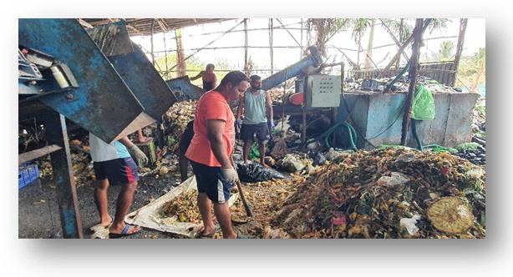
Figure1.1: CurrentSituationofLandfill

- The waste is collected from all households and largebinsacrossthecityand broughtinto the landfill.
- Later the accumulated waste in the landfill is manuallytakeninsmallquantitiesforprocessing.
- Thisincludeshandpickingthings,andseparatingplastics, metals, and non-biodegradable waste while itpasses through a conveyor belt or spread on a hugesheet.
- Furthersegregationroundstakeplacewhichfinallyresultsinthecategorizationofwaste:
  - Wet Waste: Bio-degradable waste which canbeusedasmanure,biogas, etc.
  - Solid Waste (Plastics): Molded into differentproducts which can be used by people. E.g.,Flowerpots,coasters, pens, etc.
  - E-Waste: Sent for further recycling or to scrapcollector.
- LITERATURE SURVEY
Waste generated by India each year amounts to 62 milliontons.[1]Theresearchcarriedoutprovidesasystemtosegregatewasteplasticbasedonitssizeandcolorbeforerecycling. Waste recycling plants use different sensors like IRSensors, Proximity Sensors, and Color sensors. The proximityand color sensor can be used to segregate waste based on sizeandcolor thereby reducing the intervention andalso the riskof health hazards for the workers. The research also conveysthe use of the Arduino UNO Board for controlling the entirefunctioningofthe proposedmodel[2].
The research explored the performance of different CNNClassification models like VGG-16, RestNet-50, Mobile Net,andDenseNet-121.Allfourmodelscouldseparatewasteinto

fourclasses-generalwaste,hazardouswaste,combustible,and recyclable. However, the research is based upon the wasteavailableinwesterncountrieswhichismajorlydrywastethereby making it inefficient for countries like India where thewasteismajorlywetandhybrid.[3]
TheDistrictEnvironmentalPlanbytheEnvironmentalDepartment Government of Maharashtra & MPCB highlightsdifferent plans for waste management, air quality control, etc.Total Solid Waste generated from Palghar District is 613.3MT/Dwhereinthedrywasteis290.9MT/Dandwetwasteis
321.05MT/D segregatedeveryday.[4]
Thus, most of the research conducted is done on an entirelydifferent type of waste which is not according to the Indianwaste which calls for surveying the Indian Waste as illustratedbelow:

LandfillPlant, Malad:

ThelandfillplantvisitsatMaladPlantledtotheidentification of the problem statement and current conditionof landfills in India which includes manual segregation on anactualpracticalscaleratherthanjustthenumbercounts.Figure 2.1 shows the homogenous mixture of waste that isprocured daily on a humongous scale which breaks down theworkingofanywesternmachinerysolutionsforwastesegregation.
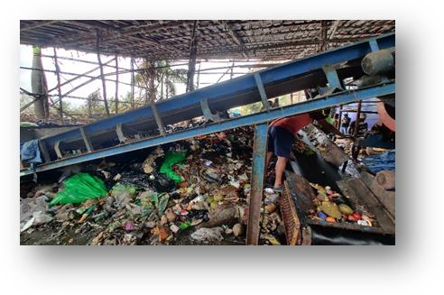

Figure2.1:LandfillVisitin MaladPlant

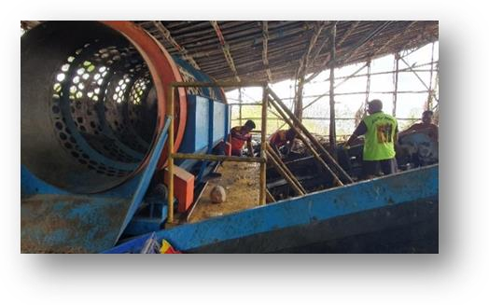

Figure2.2: UnusableMachineat MaladPlant
The workers are observed to be working in conditions asshown in Figure 2.2 which calls for health hazards. It alsoportraysthedrawbacksoftraditionalmethodsandfailingmethods including western hardware systems. Thus, the visitwidened the scope and horizon of the practical implication oftheproposedmodel.

ThakurRamnarayanCollege,Dahisar:
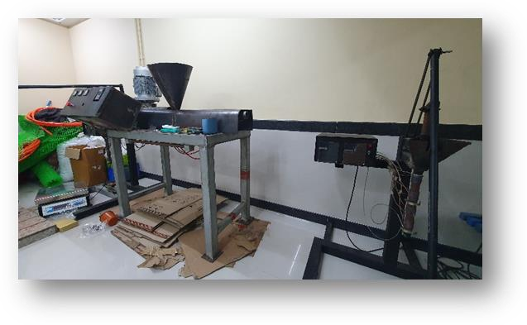
Figure2.3:ShredderDemonstrationinThakurCollege

ThevisittoThakurRamnarayanCollegewasaimedtoknow about the applications of the project in real-life post-waste segregation. The recycling of different types of plasticssuchasPET,HDPE,andPVCwasobservedwhichisobtainedafterdrywastesegregation.Theprocessofproduction of eco-friendly flower pots, coasters, barn floors,benches,etc.wasobservedclosely.Theworkingoftheshredder and injection molding process was demonstrated asshown inFigure2.3.

ComponentsDesigning&Manufacturing,Sativali,Vasai:

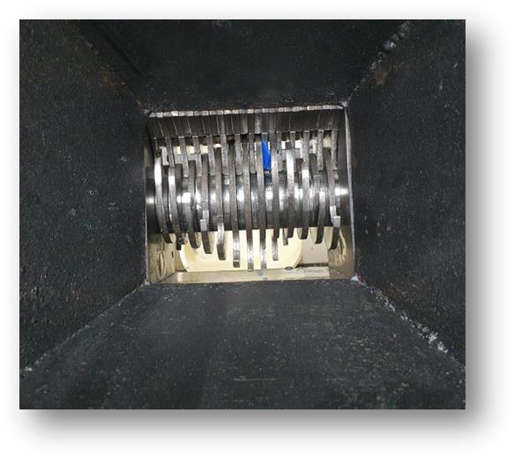The main aim of the visit tothemanufacturinghousewasto survey the actual implementation process of the proposedmodel. The designing process behind the production of theShredder,Conveyor,andotherassemblycomponentswasstudiedasshowninFigure2.4.

Figure2.4:BladeDesignofComponent

The Pricing, dimensions, and capacity of the componentswere discussed which gave a clear insight and idea into theindustrialmanufacturingprocesstailored to theproposal.

TechnoShellAutomationsPvt.Ltd.,Nashik:
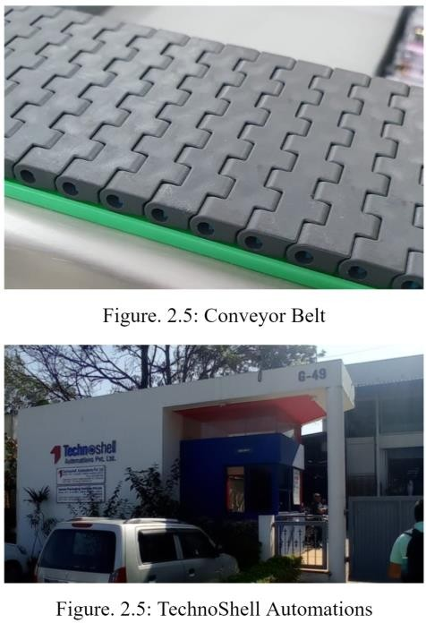
The main aim of visiting TechnoShellAutomations Pvt.Ltd. was to understand conveyor belts and looking at differenttypes of belts. Additionally, the specification of motor andhardware feasibility calculations were studied on discussionwiththe industry expert.

GreenSutra,GoShoonya:
ThemainobjectiveofvisitingGreenSutrawastounderstand theconceptofBOMand Materialneeded touse.
Later,moreinputsweretakenfromcollegefacultyforInventorDesignofWashingUnit.
- METHODOLOGY
On performing the necessary literature survey, the problemstatement was identified. The proposed solution includes isbasedon the aim tomakehardwarework in tandemwithappropriate sensors. This proposed model ultimately reducesinefficiency and redundancy. They are decided upon the basisofcomponents,sizing,pricing,andamountofautomationrequired for properexecution.

A.Proposed SystemModel

  - ProposedModel:
Theproposedmodelfirstbeginswithanintakewhichincludes an electromagnetic conveyor for separating ferroussubstances.Atthispoint,thewasteisalreadyshredded.
As shown in Figure 4.1, this shredded waste will be washedinside the washing unit. The washing unit washes them withhigh rpm tumble revolutions and dries it with drying action asanalogousto awashing unitbutwithhighcapacity.

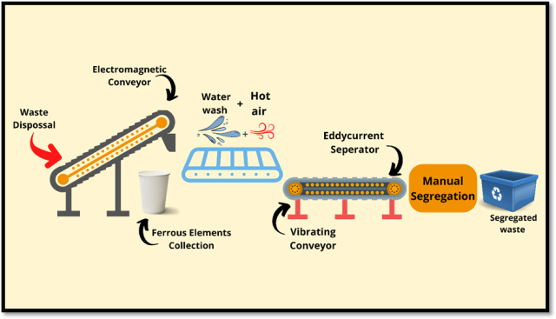
Figure4.1:BlockDiagramofProposedModel
Thewashedanddriedwastefurtherpassedthroughavibrating conveyor to loosen the waste that in turn would becoupled with an eddy-current separator as shown in Figure 4.3.At the last stage, human intervention would be required wherethe workers manually pick up the plastic waste for segregationtherebycompletingthesegregationprocess.
This proposed model paper focuses more on the aspect ofWashingUnit asshownbelow.

  - WashingUnit:
Thewashingunitasdiscussedinproposedmodelisresponsible for proper, effective cleansing of waste followedbydrying.

    - Design
The washing unit design consists of a main-frame structureover which the entire unit rests to provide stability while thewashing action isin process.Thebottom is supported by 3legs joining in unison. Extra support is also added to eachbeam in theform of reinforcement. The design of washingunitisasshown in Figures4.2.1,4.2.2,4.2.3,4.2.4.
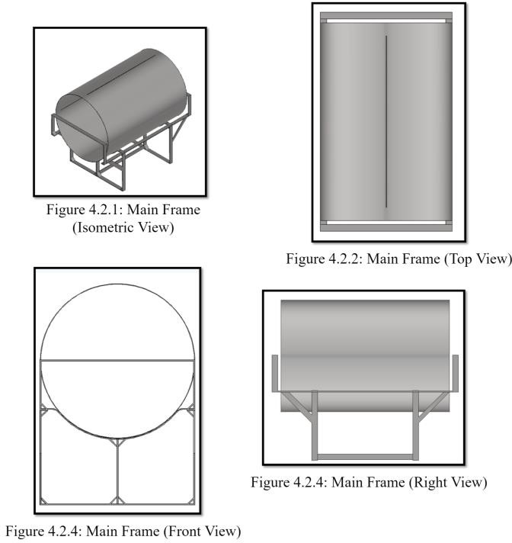

A water tank rests on the top of the main frame. This watertank houses a motor shaft on the circular side face which isused for washing along with water. This shaft exactly passesthrough the centre of tank and perforated tubas shown inFigure4.2.5. It further has2 inletsfor faster filling and 1outletfordrainingwhichcanbeplacedasperthemanufacturer. Inside the water tank, there is perforated sheetdrum where the actual waste is given as input. The perforationallows the water to cleanse it along with detergent and alsohelps during the draining process thereby leaving behind cleanplasticwasteasshown inFigure4.2.6,4.2.7, 4.2.8.
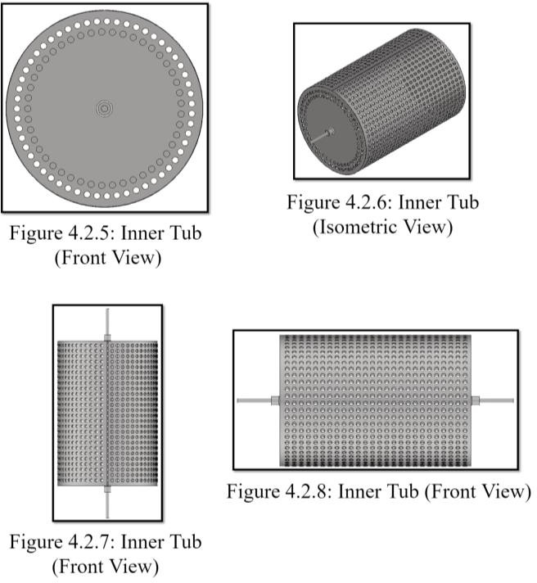
The face as shown in Figure 4.2.9, 4.2.10 covers the topcylindrical part from Figure 4.2.11. The tank has rubberizedwindow opening which can be used for loading the washingunit with plastic waste to be cleaned. Additionally, for safety,the drum can also be tied along the cylindrical body with theframe Pillow Block base mounting points against the Main-frame asshownin Figure4.2.12.
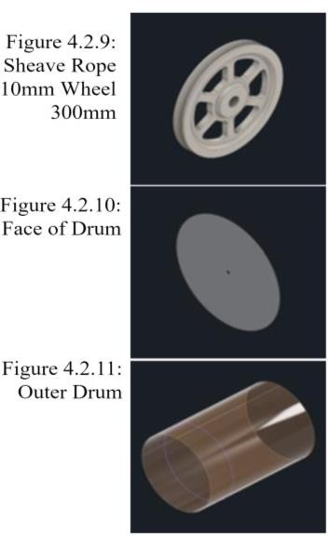
    - SpecificationsofWashingUnit

The following are the specifications of Washing Unit asmentioned in Table No.1. The BOM structure for each item isnormalforeachunitquantityalongwithPillowBlockdiagramasshowninFigure 4.2.12

Item | Des. | QTY | Description | Dimension  (mm) | Material
1 | FM  frame | 1 | MainFramehousing, | L x 50 x 8where L isthevariable  length | MildSteel 304Grade
2 | HPC –UCP206/PBT/W | 2 | UCP /PBT-  Pillowblock -Polymerandstainlesssteel - Basewith 2mounting  points | 163x 46 x  91 | Metaldependingonthepurchase
3 | Innertub | 1 | PreforatedMetalSheet Innertub | 1340x  920x 920  - Tub,300  x30x30-  shaft | Stainlesssteel Tub,MildSteel  Shaft
4 | SheaveRope10mmWheel  300mm | 1 | STEPAP214  Pulley | 300x300  x10 | Metal
5 | Face | 2 | OuterDrumCircular  faces | 1000x  1000x2 | Plastic
6 | Outer  Drum | 1 | Outer  Drum | 1500x  1000x5 | Plastic

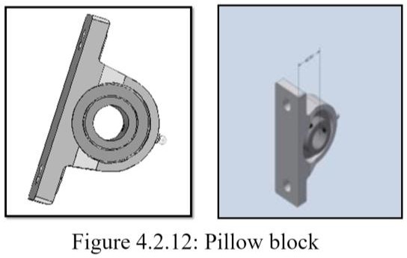

    - BillofMaterials(BOM)
A bill of materials an extensive list of raw materials,components,andinstructionsrequiredtoconstructandmanufacture a product. The following and table no. 1 is anestimatedmateriallistforwashing unit:

Metal perforated sheetfor inner drum,motor and shaft,bearings,rotarysealings,axials,hinges,latches,StainlessSteelscrews,nutbolts,rivets,rods,squarepipe,valve,etc.

    - WorkingofWashingUnit

      - Initiallytankisfilledwithwaterandwastesimultaneously.
      - The inner drum is designed in such a way that thewastecollideswiththerodorthebeamhavingbrush/bristle like structure to wash/clean the plasticwaste.
      - Somechemicals/liquids toocan beusedtoremovetheoilor stains.
      - Afterwashing thewateris drainedfrom thedrumand it is rotated again to remove or reduce the waterinside.
      - Thus, the waste is washed as well as dried so that itcanusedfor further recyclingprocess
- ANALYSIS&DISCUSSION
The implementation of the proposed model works on belowgeneric principles below irrespective of the deployment of theproposedmodelonegoesfor.Theproposedmodeldimensions and time of operations are calculated (approx.) foraninputpayload of5kg(1batch)asmentionedbelow:
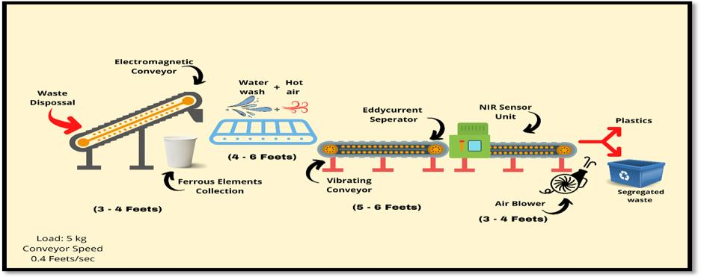
Figure5.1:DimensionsofProposed Model

- The proposed system includes different segregationstages, beginning with an electromagnetic conveyorthat separates ferrous substances. This takes about 15-20 secondsatslow-moderate speed.(approx.)
- Further, it passes onto a vibrating conveyor where itloosens out and spreads evenly. This step is expected totake5-8seconds. (approx.)
- The eddy-current separator at this stage separates thenon-ferrousmetals.Afterthisstage, mostoftheferrousand non-ferrous metals are removed. This step takesaround 15seconds. (approx.)
- Lastly, the conluding stage of segregation requireshuman interventiom to reduce the cost required foradditonal sensorsasshowninFigure 4.1.
- Optional: NIR sensor detects the plastic materialsbasedonspectroscopy,onwhichthematerialatthat
corresponding position is blown out using precisionhigh-pressure blowers as shown in Figure 5.1. Or it canbe replaced with robotic arms or manual segregationwhichisexpectedtotakearound20seconds.(approx.)
- APPLICATIONS&RELEVANCE TOTHE SOCIETY

The above proposed model reduces the time required fortraditional waste segregation by significant margin. Also, theefficiency and quality of life for workers improves because ofadded automation. Other practical applications can be derivedfromthe proposedsystemmodelasbelow:
  - Reducinghumanintervention.
  - UsingManuretogenerateElectricity.
  - ManuretomakeFertilizers
  - Buildingeco-friendlyproductsorforbuildingroads.
  - ImprovingHygieneofSurroundingarea
  - ReducingDumpingYardstoMakelandsforcultivation.

- CONCLUSION
Thus, the development of the project has started with athorough literature survey including several industrial visitswherevernecessary.Inconductingthesame,3potentialproposedmodelsareproposedfordesigningconsideringIndian Waste. The model is designed considering the initialpayloadwasteinputof5kgincludingthenecessarydimensions.Thedesignedprototypealsotakesintoconsideration the health of the workers involved in the processtherebyreducinghumanintervention.Themodularunitsofthe proposed model make it more reliable for future upgradesand repairs and extra add-ons for automation. Thereby thesegregated waste is obtained as wet compost or manure anddrywasteseparately.Themanurecanbeusedtomakecompost or bio-gas energy whereas the plastic waste can berecycledandreusedindifferentapplicationssuchasproducingeco-friendlyproductsor forbuildingroads.

ACKNOWLEDGMENT

We would like to express gratitude to the Respected PrincipalDr. Harish Vankudre, Head of the Department, Dr. AmritaRuperee. The progress of this project could not have beenpossiblewithouttheassistanceofourGuideDr.AmritaRuperee.Thecontributionsofthefacultyaresincerelyappreciated and gratefully acknowledged. We also would liketo thank Gopal Sir (GoShunya) and the staff members of theDepartmentofElectronicsandTelecommunication,Vidyavardhini’sCollegeofEngineering&Technologyfortheir cordial supportandfaithinus.
- REFERENCES:
- LAHIRY, S. (2017) INDIA'S CHALLENGES IN WASTE MANAGEMENT, DOWN TOEARTH. AVAILABLE AT:HTTPS://WWW.DOWNTOEARTH.ORG.IN/BLOG/WASTE/INDIA-S-CHALLENGES-IN-WASTE-MANAGEMENT-56753#:~:TEXT=OVER%20377%20MILLION%20URBAN%20PEOPLE,IS%2

0DUMPED%20IN%20LANDFILL%20SITES.(ACCESSED:OCTOBER28,
2022).

- SURESHKUMAR R, SUJI PRASAD S.J, ANNAS T, ARUNA L, INIYA D G,"AUTOMATIC SEGREGATION OF PLASTIC WASTE FOR RECYCLINGINDUSTRIES," INTERNATIONAL JOURNAL OF SCIENTIFIC &TECHNOLOGYRESEARCHVOLUME9,ISSUE02,FEBRUARY2020,ISSN2277-8616.

- C. SRINILTA AND S. KANHARATTANACHAI, "MUNICIPAL SOLID WASTESEGREGATION WITH CNN," 2019 5TH INTERNATIONAL CONFERENCE ONENGINEERING, APPLIED SCIENCES AND TECHNOLOGY (ICEAST), 2019, PP.1-4, DOI: 10.1109/ICEAST.2019.8802522. ENVIRONMENT DEPARTMENT,GOVERNMENT OF MAHARASHTRA AND MAHARASHTRA POLLUTIONCONTROL BOARD.“DISTRICT ENVIRONMENT PLAN,PALGHAR,2019”

- ENVIRONMENT DEPARTMENT, GOVERNMENT OF MAHARASHTRA ANDMAHARASHTRAPOLLUTIONCONTROLBOARD.“DISTRICTENVIRONMENTPLAN,PALGHAR,2019”

