**PREDICTIVE CONTROL OF 1- $Φ$ GRID CONNECTED REDUCED SWITCH 7-LEVEL TRIPLE BOOST INVERTER**

**C. Ganesh1, S. Sarada2, Y. Sireesha3, K. Vaishnavi4**,**D. Vani5**

*1,2Assistant Professor*

*Annamacharya Institute of Technology and Sciences, Rajampet, India, 516126*

*3,4,5UG Student*

*Annamacharya Institute of Technology and Sciences, Rajampet, India, 516126*

*Email of Corresponding Author: ganesh.challa@gmail.com*

***Received on****: xxxx,20xx,* ***Revised on****: xxxx,20xx,* ***Published on****: xxxx,20xx*

***Abstract –*** *Due to its reliability and great power handling capacity, multi-level inverters (MLIs) have been the preferred option for the majority of industrial applications. This multilevel inverter suggests an innovative 7-level triple boost inverter that can be controlled by the Model Predictive Control (MPC). This design decreases components just by using eight switches, one diode, and two capacitors for 7-level inverter. Two of the eight switches are also used in the path for charging the capacitors. This approach can overcome the limitations of traditional control methods used with MLIs because it is simple to implement. A greater variety of voltages can be obtained by the conventional system. The proposed 7-level MLI is controlled using a* *Finite Control ModelPredictive Control(FCS-MPC). MATLAB/Simulink can be used to model this 7-level structure. The results shows that the Control scheme can effectively track the load current as well as the system functions properly.*

***Keywords-*** *switched capacitors, triple boost, multi -level inverter, tracking performance, FCS-MPC, THD.*

**INTRODUCTION**

Due to several properties including less Total Harmonic Distortion (THD), less stress on the switches, and others, Multi-Level Inverters (MLIs) are currently receiving attention as a solution for moderate voltage high power applications [1]. In the writings [1], Traditional multilevel inverters can be broadly categorized into three groups: Flying Capacitor (FC) multi-level inverters, Cascaded H-Bridge (CHB) multi-level inverters, and Neutral Point Clamped (NPC) multi-level inverters [2]. A numerous components used and the complexity of controlling capacitor voltages are the main drawbacks of these topologies. Numerous MLI topologies have been presented in the literature as solutions to these issues.

For the conventional and reduced device count MLI, voltage amplification is not achievable. This level boost will be essential in system that convert renewable power since the low voltage generated by fuel cells and PV panels makes them unsuitable. The researchers developed the switching capacitor technology to produce a wider range of power values and greater gain from a single dc power supply. To significantly improve voltage levels, this method includes connecting the parallel capacitors with the Dc supply and also discharge them to a load in series with DC source [3], [4].

In [5], authors proposed a single dc power supply, 7-level triple boost configuration. The architecture is capable of generating negative voltage levels without employing an cascade bridge, and switches can block up to 2Vdc. Two capacitors connect the non-isolated interleaved power converter and an inverter in [6] to boost voltage. In [7], a novel topology involving fewer components and less power stress upon these switches was introduced to obtain a voltage of 3.

In [8], authors developed a structure with a triple gain. In [9], a generalized 5-level inverter is constructed from an unique 5 inverters with a gain of two. The capacitors may self-discharge to the source if they are overcharged, according to the inventors, who claim that their architecture may regenerate power. A full bridge inverters and 2, 3-level T-type structures were used in the architecture developed in [10] to obtain 7-level voltage, However, the number of switches is relatively more. All of the articles mentioned above can produce an output voltage with 7-levels and a gain of 3. There are numerous architectures described in the literature with 7-level output voltage, but they only have such a 1:1.5 boost ratio. [11] presents a new 8 switch boosting ANPC for a 7-level inverter. A half bridge and switched capacitor circuit are Due to several properties including less Total Harmonic Distortion (THD), less stress on the switches, and others, Multi-Level Inverters (MLIs) are currently receiving attention as a solution for moderate voltage high power applications [1]. In the writings [1], Traditional multilevel inverters can be broadly categorized into three groups: Flying Capacitor (FC) multi-level inverters, Cascaded H-Bridge (CHB) multi-level inverters, and Neutral Point Clamped (NPC) multi-level inverters [2]. A numerous components used and the complexity of controlling capacitor voltages are the main drawbacks of these topologies. Numerous MLI topologies have been presented in the literature as solutions to these issues.

For the conventional and reduced device count MLI, voltage amplification is not achievable. This level boost will be essential in system that convert renewable power since the low voltage generated by fuel cells and PV panels makes them unsuitable. The researchers developed the switching capacitor technology to produce a wider range of power values and greater gain from a single dc power supply. To significantly improve voltage levels, this method includes connecting the parallel capacitors with the Dc supply and also discharge them to a load in series with DC source [3], [4].

In [5], authors proposed a single dc power supply, 7-level triple boost configuration. The architecture is capable of generating negative voltage levels without employing an cascade bridge, and switches can block up to 2Vdc. Two capacitors connect the non-isolated interleaved power converter and an inverter in [6] to boost voltage. In [7], a novel topology involving fewer components and less power stress upon these switches was introduced to obtain a voltage of 3.

In [8], authors developed a structure with a triple gain. In [9], a generalized 5-level inverter is constructed from an unique 5 inverters with a gain of two. The capacitors may self-discharge to the source if they are overcharged, according to the inventors, who claim that their architecture may regenerate power. A full bridge inverters and 2, 3-level T-type structures were used in the architecture developed in [10] to obtain 7-level voltage, However, the number of switches is relatively more.

All of the articles mentioned above can produce an output voltage with 7-levels and a gain of 3. There are numerous architectures described in the literature with 7-level output voltage, but they only have such a 1:1.5 boost ratio. [11] presents a new 8 switch boosting ANPC for a 7-level inverter. A half bridge and switched capacitor circuit are

**II. PREDICTIVE CONTROL METHOD**

The suggested predictive control method is based on the assumptions that a fixed converter can only generate a finite number of operating modes and it's possible to forecast how the variables will operate in every switching state using models of the system. For the discrete time modeling of the current to fully forecast the load current, the voltage vector of each switch condition on the inverter output end is fed into the model. Following that, the potential vector with the smallest difference is chosen by comparing all the predicted values of the current with reference value. The single-phase inverter's following output is then regulated based on the switch condition determined by select voltage vector.

The steps involved in this control method are as follows:

1. Create a model of the inverter output side voltage vector.

2. Create a load current model.

3. Specify the quality function. G. Fig-1 depicts the model predictive control framework.



*Fig.1 Predictive Control Block Diagram*

(1) The measured load current value is i(K), and the reference load current value is i*(K).

(2) A load current forecasting model is used to calculate every potential load current values in the future.

(3) Compare results to determine the switch state with the lowest G value.

Discrete-time and mathematical models of the load current

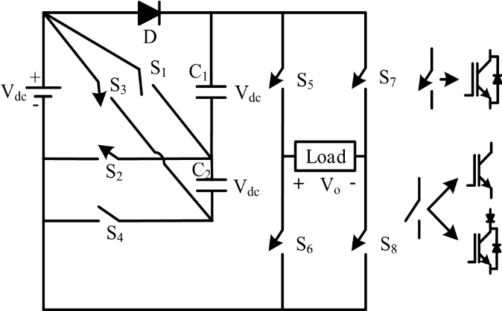**III. PREDICTIVE CONTROL FLOW CHART**

The predictive control's algorithm and pertinent principles are depicted in the flow diagram seen in Fig.2

**Sampling e(k) and i(k-1)**

**For j=1:8**

**V(j)=S(j)Vdc**





**j-8**

**Select the voltage vector of minimum G value**

*Fig. 2 Predictive Control Flow Chat*

The quality function can be minimized using the cycle represented in the diagram, which forecasts every output voltage, assess the quality function and saves the minimal value and the coefficient of determination of a corresponding switching state.

**IV. PROPOSED GENERALIZED TOPOLOGY**



This topology is from [18]. Due to the low voltage produced by sources of sustainable energy, an high gain inverter must be employed in applications that integrated renewable energy to match the grid voltage. Therefore, by additionally connecting the three elements (2 switches and 1 capacitor), as shown in fig. 3, The conventional 7-level configuration described above may be expanded to any number of levels.

*Fig. 3 Proposed 7-level inverter*

No. of switches = 2N+2 (1)

No. of capacitors = N-1 (2)

The highest load stress on the H-bridge = NVdc (3)

The highest load stress on the diode = (N-1) Vdc  (4)

One distinct diode & two series diodes were needed for such structure for any number of levels. There are two switches with Maximum Bridge Voltage (MBV) of Vdc, 2 switches with the MBV of 2Vdc, 2 switches with the MBV of 3Vdc, etc., among switches from S1 to S2N-2. During each output cycle, by carefully selecting the charging and discharge pathways, all capacitors may be evenly balanced at Vdc.

*Table1 Switching Formations And Their Impact On Circuit Switching Capacitors For 7-Level Topology*

|  |  |  |  |  |  |  |  |  |  |  |
| --- | --- | --- | --- | --- | --- | --- | --- | --- | --- | --- |
| **S1** | **S2** | **S3** | **S4** | **S5** | **S6** | **S7** | **S8** | **C1** | **C2** | **V0** |
| 0 | 0 | 1 | 0 | 1 | 0 | 0 | 1 | ↓ | ↓ | +3Vdc |
| 1 | 0 | 0 | 1 | 1 | 0 | 0 | 1 | ↓ | ↓ | +2Vdc |
| 0 | 1 | 0 | 0 | 1 | 0 | 0 | 1 | ↓ | - | +Vdc |
| 0 | 1 | 0 | 0 | 1 | 0 | 1 | 0 | ↓ | - | 0 |
| 0 | 1 | 0 | 0 | 0 | 1 | 0 | 1 | ↓ | - | 0 |
| 0 | 1 | 0 | 0 | 0 | 1 | 1 | 0 | ↓ | - | -Vdc |
| 1 | 0 | 0 | 1 | 0 | 1 | 1 | 0 | ↓ | ↓ | -2Vdc |
| 0 | 0 | 1 | 0 | 0 | 1 | 1 | 0 | ↓ | ↓ | -3Vdc |

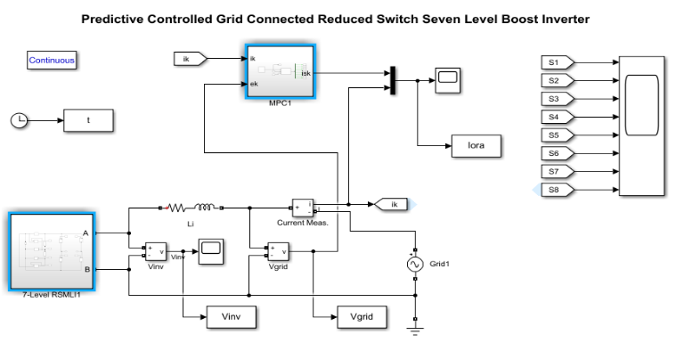**V. Control of the proposed 7L-MLI**

Considering an inductive load, the continuous-time model of the proposed 7L-MLI can be written as follows

$$v_{inv}\left(t\right)={Ri}_{o}\left(t\right)+L\frac{d}{dt}i_{o}\left(t\right) (6)$$

where the resistance is R, the inductance is L, and the output current is io. Typically, the discrete-time domain is used to construct the FCS-PC. The derivatives of a load current in the discrete-time domain can also be roughly represented as using the Euler forward approximation.

$$\frac{d}{dt}i_{o}\left(t\right)=\frac{i_{o}\left[k+1\right]-i_{o}[k]}{T_{s}} (7)$$

Ts is the sampling time, k is the current sample, and k + 1 is the next sampling time. Accordingly Equ (1) can be written in the discrete-time form as

$$v_{inv}\left[k\right]=Ri_{o}\left[k\right]+L\frac{i_{o}\left[k+1\right]-i_{o}\left[k\right]}{T_{s}} \left(8\right)$$

To design the proposed FCS-PC, the current prediction in the next sample can be realized by

$$i_{o}\left[k+1\right]=\left(1-\frac{{RT}_{s}}{L}\right)i_{o}\left[k\right]+\frac{T_{s}}{L}v_{inv}\left[k\right] \left(9\right)$$

Based on Table 1, the proposed MLI has 8 switching states producing 17 Voltage Vectors (VVs). Those 17 VVs are used in Equation (4) to predict 17 values of output current. Then, cost function is represented as

$$g\left[k+1\right]=\left|i_{o,ref}-i_{o}\left[k+1\right]\right| (10)$$

is used to choose the voltage vector with the lowest error.

**VI. RESULTS AND DISCUSSION**

Model predictive control strategies have been simulated using MATLAB/Simulink for a 1-Փ grid-connected triple boost inverter, as shown in fig.4. Parameters of the simulated system: V=100v, R=50, L=150mH, e=20v, TS=50µs

Fig.5 represents the conventional simulation model of the 7-level triple boost inverter. In Fig.5, a load current as well as its reference value were displayed. A load voltage waveform clearly resembles the one of the reference in many ways. According to this result, the current tracking result is perfect. The results show that predictive model control has potent anti-interference features, excellent dynamic performance, and behaviour that is like sine wave. The load current's tracking error is also found to be quite low.

*Fig.4 Conventional simulation model of 7-level triple boost inverter*

*Fig.5 Output waveforms of Voltage and Current of an inverter by using MPC.*

The reference current is 0.5A from 0 to 0.15 seconds, and the inverter acts as a 3-level inverter. The reference current is 2A during this time, and the inverter acts as a 5-level inverter. The reference current is 3.5A during this time, and the inverter acts as a 7-level inverter.

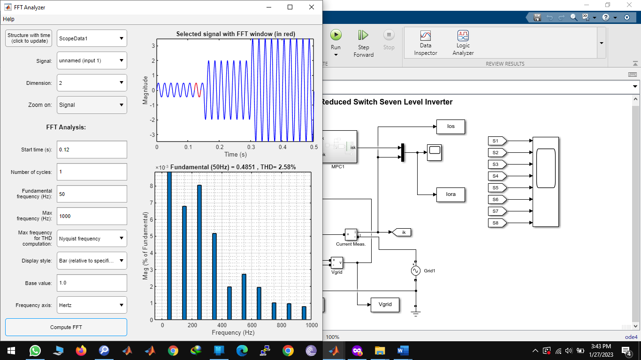The Total Harmonic Distortion for the fundamental current shown in Fig.6 is incredibly low, as well as the THD with different reference current values as shown in the figures below.

*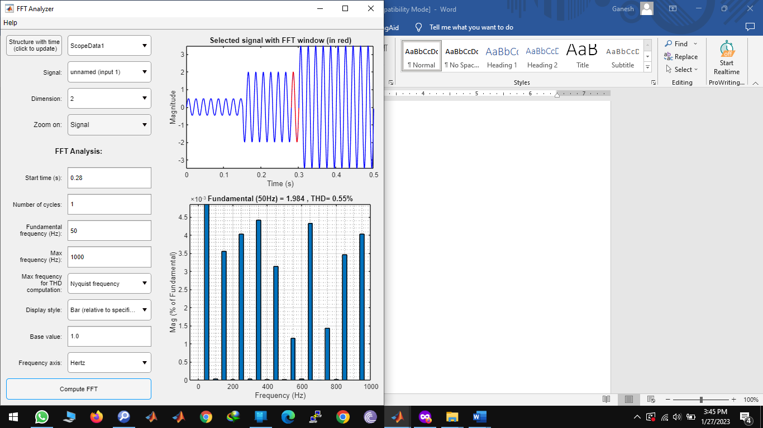 Fig.6(a) Harmonic spectrum of the reference current and the fundamental current, IL =0.5A*

*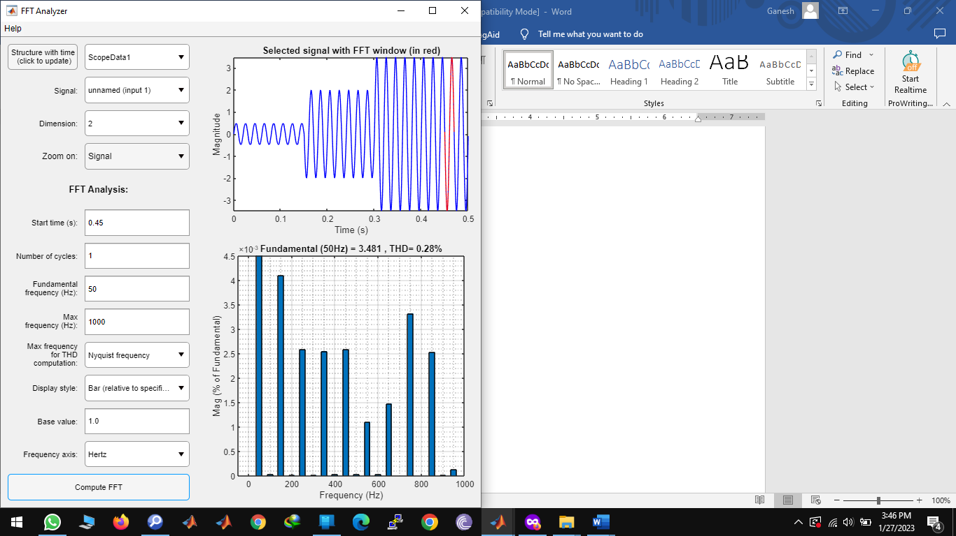 Fig.6(b) Harmonic spectrum of the reference current and the fundamental current, IL =2A*

*Fig.6(c) Harmonic spectrum of the reference current and the fundamental current, IL =0.5A*

# In fig.6 (a),6(b),6(c) shows that the fundamental current is perfectly tracking the reference current and the total harmonic distortion is decreasing.

*Table 2. Harmonic Spectrum analysis with change in load current*

|  |  |  |
| --- | --- | --- |
| **Reference current** | **Fundamental current (IL)** | **THD(%)** |
| 0.5 | 0.481 | 2.58 |
| 2 | 1.984 | 0.55 |
| 3.5 | 3.481 | 0.28 |

Table 2 shows that, as reference current increases, fundamental current rises as well, whereas Total Harmonic Distortion decreases.

**CONCLUSION**

A single phase grid connected reduced switch, triple boost inverter with seven levels is presented in this study. The output current of the 7-level-MIL is controlled using the Finite-Control-Set Model Predictive Control (FCS-MPC). The approach is simple to digitise and has a unique physical model. In contrast to the conventional single phase triple inverter control approach, it does not alter the PI settings and may achieve universal utilisation. According to the simulation findings, the model predictive control load current has a low harmonic content, a quick dynamic response, and high tracking performance. It has a highly promising future for development and can also successfully adhere to the guiding principles of grid-connected inverter control approach.

**REFERENCES**

1. *[1]Voltage Source Multilevel Inverters With Reduced Device Count: Topological Review and New Comparative Factors, A. Salem, H. Van Khang, K. G. Robbersmyr, M. Norambuena, and J. Rodriguez, IEEE Transactions on Power Electronics, vol. 36, no. 3, pp. 2720–2747, March 2021.*
2. *[2] A. Bughneda, M. Salem, A. Richelli, and D. Ishak, ‘‘Review of multilevel inverters for PV energy system applications,’’ Energies, vol. 14, no. 6, p. 1585, 2021.*
3. *[3] K. P. Panda, P. R. Bana, and G. Panda, ‘‘A reduced device count single DC hybrid switched-capacitor self-balanced inverter,’’ IEEE Trans. Circuits Syst. II, Exp. Briefs, vol. 68, no. 3, pp. 978–982, Mar. 2021, doi: 10.1109/TCSII.2020.3018333.*
4. *[4] K. Panda, P. Bana, O. Kiselychnyk, J. Wang, and G. Panda, ‘‘A single source switched-capacitor-based step-up multilevel inverter with reduced components,’’ IEEE Trans. Ind. Appl., vol. 57, no. 4, pp. 3801–3811, Jul. 2021, doi: 10.1109/TIA.2021.3068076.*
5. *[5] M. D. Siddique, S. Mekhilef, N. M. Shah, J. S. M. Ali, and F. Blaabjerg, ‘‘A new switched capacitor 7L inverter with triple voltage gain and low voltage stress,’’ IEEE Trans. Circuits Syst. II, Exp. Briefs, vol. 67, no. 7, pp. 1294–1298, Jul. 2020, doi: 10.1109/TCSII.2019.2932480.*
6. *[6] S. Dhara and V. T. Somasekhar, ‘‘An integrated semi-double stagebased multilevel inverter with voltage boosting scheme for photovoltaic systems,’’ IEEE J. Emerg. Sel. Topics Power Electron., vol. 8, no. 3, pp. 2326–2339, Sep. 2020, doi: 10.1109/JESTPE.2019.2955729.*
7. *[7] M. D. Siddique, J. S. M. Ali, S. Mekhilef, A. Mustafa, N. Sandeep, and D. Almakhles, ‘‘Reduced switch count based single source 7L boost inverter topology,’’ IEEE Trans. Circuits Syst. II, Exp. Briefs, vol. 67, no. 12, pp. 3252–3256, Dec. 2020.*
8. *[8] S. T. Meraj, M. K. Hasan, J. Islam, Y. A. B. El-Ebiary, J. Nebhen, M. M. Hossain, M. K. Alam, and N. Vo, ‘‘A diamond shaped multilevel inverter with dual mode of operation,’’ IEEE Access, vol. 9, pp. 59873–59887, 2021, doi: 10.1109/ACCESS.2021.3067139.*
9. *[9] R. Barzegarkhoo, S. S. Lee, S. A. Khan, Y. P. Siwakoti, and D. D. Lu, ‘‘A novel generalized common-ground switched-capacitor multilevel inverter suitable for transformerless grid-connected applications,’’ IEEE Trans. Power Electron., vol. 36, no. 9, pp. 10293–10306, Sep. 2021, doi: 10.1109/TPEL.2021.3067347.*
10. *[10] M. Chen and T. Chinese University of Hong Kong, ‘‘Novel cascaded seven-level inverter with embedded voltage boosting for renewable energy applications,’’ CPSS Trans. Power Electron. Appl., vol. 7, no. 1, pp. 58–70, Mar. 2022.*
11. *[11] A. Iqbal, M. D. Siddique, J. S. M. Ali, S. Mekhilef, and J. Lam, ‘‘A new eight switch seven level boost active neutral point clamped (8S-7LBANPC) inverter,’’ IEEE Access, vol. 8, pp. 203972–203981, 2020, doi: 10.1109/ACCESS.2020.3036483.*
12. *[12] W. Lin, J. Zeng, B. Fu, Z. Yan, S. Member, and J. Liu, ‘‘Switched-capacitor based seven-level boost inverter with reduced devices,’’ CSEE J. Power Energy Syst., early access, pp. 1–11, Jun. 2021, doi: 10.17775/CSEEJPES. 2020.02620.*
13. *[13] P. Panda, P. R. Bana, and G. Panda, ‘‘A switched-capacitor self-balanced high-gain multilevel inverter employing a single DC source,’’ IEEE Trans. Circuits Syst. I, Reg. Papers, vol. 67, no. 12, pp. 3192–3196, Dec. 2020, doi: 10.1109/TCSII.2020.2975299.*
14. *[14] M. D. Siddique, B. P. Reddy, A. Iqbal, and S. Mekhilef, ‘‘Reduced switch count-based N-level boost inverter topology for higher voltage gain,’’ IET Power Electron., vol. 13, no. 15, pp. 3505–3509, 2020, doi: 10.1049/ietpel.2020.0359.*
15. *[15] Y. Wang, K. Wang, G. Li, F. Wu, and K. Wang, ‘‘Generalized switchedcapacitor step-up multilevel inverter employing single DC source,’’ CSEE J. Power Energy Syst., vol. 8, no. 2, pp. 439–451, Mar. 2022, doi: 10.17775/CSEEJPES.2020.06280.*
16. *[16]J. Rodriguez and P. Cortes, Predictive Control of Power Converters and Electrical Drives, 1stedition New York: Wiley-IEEE Press, 2012.*
17. *[17] M. Abdelrahem, C. Hackl, R. Kennel and J. Rodriguez, “Efficient Direct-Model Predictive Control with Discrete-Time Integral Action for PMSGs”, IEEE Transactions on Energy Conversion, vol. 34, no. 2, pp. 1063-1072, June 2019*
18. *[18] A New Reduced Switch Seven-Level Triple Boost Switched Capacitor Based Inverter Pulavarthi Satya Venkata Kishore 1 , (Student Member, IEEE), Nakka Jayaram1 , Swamy Jakkula 1 , Yannam Ravi Sankar 2 , Jami Rajesh 1 , And Sukanta Halder3 , (Member, IEEE)*