**Fabrication of Pellet Making Machine**

**Prof. Nilesh R.Pathare1, Prof.C.K.Tembhurkar2**

*1,2Assistant Professor*

*Priyadarshini College of Engineering, Nagpur, India,440019*

***Abstract –*** *Engineering over the last decade there have been two major factors that have been driving the growth of the pellet fuel market. The first is the consistent rise in the cost of fossil fuels and price instability, and the second is the increased attention given to the effects of using fossil fuels such as oil and gas on The environment. Other factors that support the case for pellets is that they are a fuel that can be produced locally, from local wood and biomass materials. Local pellet production and distribution can produce an affordable fuel, while creating local jobs and keeping the carbon footprint to a minimum. One question that many people ask is why have pellets instead of just burning logs? Well there are many reasons, but firstly logs only come from trees that in general grow very slowly. Pellets can be made from practically any biomass material including straws, grasses, energy crops etc. For example hemp is set to be a biomass fuel leader. The other main reasons for pellets over logs are that pellets burn much more efficiently. This means pellets produce less ash, less smoke and more heat. Also pellets have a uniform size, shape, density and moisture content. These consistent qualities make it possible to design highly automated combustion systems such as modern wood pellet stoves and boilers.*

***Keywords-*** *pellet making machine, biomass fuel, extrusion*

**INTRODUCTION**

The CEN/Technical Specification 14588 Solid biofuels – Terminology, definition sand descriptions describes biofuel pellets as: densified biofuel made from pulverised biomass, with or without pressing aids, usually with a cylindrical form, random length typically 5 to 30 mm, and broken ends. In CEN/Technical Specification 14961 So id Biofuels – Fuel specifications and classes densified biofuel is further sub-divided into briquettes, which have a diameter larger than 25 mm, and pellets, which have a diameter of less than 25 mm.

The same technical specification also provides more details on the specifications of properties for wood pellets. Requirements and classes are formulated for diameter, moisture content, ash percentage, sulphur contents, mechanical durability, amount of fines, additives, and nitrogen content. The requirements for sulphur and nitrogen are only valid for chemically-treated wood or if additives have been used. Durability is measured to see how well the pellets are pressed. The higher the number, the better the quality. The amount of fines is measured at the final point in the production chain, just before the pellets are loaded out. Pressing aids, slagging inhibitors or any other additives have to be declared for the product.Wood pellets are usually made from clean conifer sawdust and planer shavings. The wood must have been debarked prior to passing through the sawmill. Sawdust of hardwoods can be mixed in with that of softwood, but successful production of hardwood pellets without binders is more difficult. If at all possible, dry sawdust and shavings (less than 15% moisture content) are used, because then the drying step can be used.

**WOOD PELLET MANUFACTURING PROCESS**

Our process for manufacturing [wood pellets](http://www.ecoenergy-sw.co.uk/wood-pellets/) for fuel involve placing clean wooden biomass normally between 0-5mm under high pressure through small round holes called a “die.” Eco Energy use ring die machines. The manufacturing process must have the correct conditions for the natural lignin in the wood to be released and bind the wood pellets together, we don’t use any glues or binding agents in our production or products, when the biomass “fuses” together, forming a solid mass. This process is called “extrusion.” Eco Energy’s manufacturing process forms high-quality fuel wood pellets, while other types of biomass may need additives to serve as a “binder” that have to hold the pellets together. Creating wood pellets is a small part in the overall process of manufacturing wood fuel pellets.

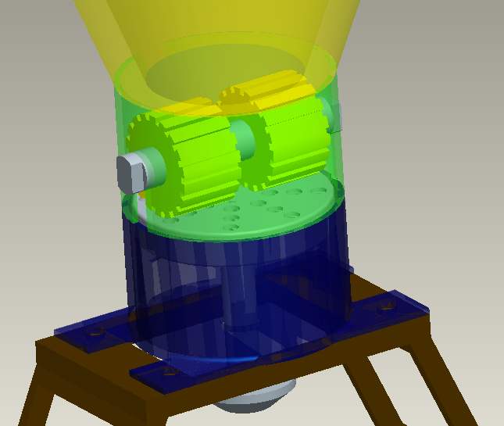

Fig.1. Pellet process

**EXTRUSION**

A highly sprung roller is rotated around the inside of the heated metal plate called a “die.” The die has multiple 6mm holes drilled through it of which allows the biomass to be compacted under high temperature and extreme pressure creating the carpet between the rollers and the die. This is the constantly under pressure and heat. When the conditions are correct the biomass particles pass through the die and will fuse into a solid mass this is where the natural Lignin in the wood acts as the binder turning into a wood pellets. The Blade slices the wood pellets to the required length as it passes out of the die. Sawdust is deemed one of the best feedstock for pelleting because the lignin that is naturally present in the wood this is what binds the wood pellets together under the correct conditions.

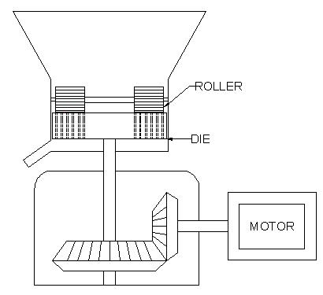

Fig.2. Line Diagram

Pellets are produced by compressing the wood material which has first passed through a hammer mill  to provide a uniform dough-like mass. This mass is fed to a press where it is squeezed through a die having holes of the size required (normally 15 mm diameter, sometimes 20 mm or larger). The high pressure of the press causes the temperature of the wood to increase greatly, and the lignin plasticizes slightly forming a natural "glue" that holds the pellet together as it cools. The image to the right depicts the basic design and operation of the ring die pellet mill. Unlike the flat die pellet mill design the ring die is positioned vertically instead of horizontally. The raw material enters the centre of the die and is compressed through the die with a series of compression rollers. Most ring die pellet mills have two compression rollers, however some ring die pellet mills have three maybe four compression rollers. The most common design of ring die pellet mill is where the die is powered and rotating, and the rollers move due to the friction and movement of the die. Before pellet compression in the pellet mill can take place the wood, straw, grass or any other form of biomass must be reduced in size. One fact that is not widely stated however is one of the most important facts in pellet production, "Only a raw material of consistent quality can produce consistent quality pellets". Part of this consistency is the size of raw material particles used in the pellet mill. Particles, which are too small or too large, can severally affect pellet quality and increase energy consumption.

**BIO FUEL PREMIUM WOOD PELLETS**

Elevating the ever growing land fill, Eco Energy does not harvest trees for production this offers you a true bio fuel. Eco Energy manufacture Wood Pellets that are cylindrical compressed pellets made from dry, natural recovered wood sawdust, wood shavings with a diameter of 6 millimeters. They are chemical additives free and using only the natural lignin in the wood as a binder. Wood pellets are available by the kilograms. Pellets are a uniform, standardized fuel of a consistent quality. Advantages also lie in the minimal amount of storage required.

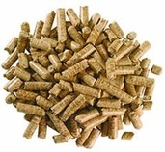

Fig.3. Wood Pellet

**SYSTEM DESIGN**

All batch fed wood boilers and most wood stoves with integral boilers should have an external heat store to take the heat from the boiler when a load is not present. If this store is large enough it can provide for the daily peak loads experienced when a heating system is started each day, and also provide hot water for sinks and showers. Various rules of thumb exist for sizing thermal stores associated with stoves and other batch fed boilers. European Standard EN 303-5 contains the following formula to calculate the size of storage tank required for a batch fed boiler within a stove.

Vst = 15TcQn(1-0.3(Qh**/**Qmin))

where Vst is the volume of the tank, Tc is the combustion time at rated heat output, Qn is the nominal heat output, Qh is the building heat load and Qmin is the minimum output of the boiler. In practice, however, the use of this equation may be unnecessary or too onerous. A commonly encountered rule of thumb suggests that the storage volume should be no less than 50 litres per kW (l/kW) of boiler rating. A range of between 50 l/kW and 75 l/kW is also often quoted although the upper end of this range may be too large for many applications and would, in turn, limit the size of boiler which could be fitted in a batch fed system. As with the design of all wood burning systems it is important not to oversize the boiler for reasons of capital cost and system efficiency.

**QUALITY CONTROL**

During production it is advisable to check pellet quality at least once a day. A sample is taken and fines are sieved out. The resulting sample is weighed and tested for durability in a durability tester. After tumbling the required number of revolutions, the pellets are screened again and weighed again. The amount of whole pellets should be in excess of 97.5% to classify as good grade wood pellets. A check should also be made for the amount of fines before the pellets leave the plant. At the final point in the production line the amount of fines in the goods should not exceed 1%. A declaration should be delivered with the pellets describing the raw material used, their durability and fines content, as well as their moisture content. If the figures are available, it is also useful to declare the energy and ash content emely dynamics and high speeds working which is combined with other portent aspects such as outstanding removal swarf, high flexibility, good genomics and with possibility automation.



(A) (B) (C)

Fig.4. (A) Good quality (B) medium quality (C) poor quality

**CONCLUSIONS**

Biomass pellets can be economically produced with a production cost of $51/t, assuming a raw material cost of Rs10/t and drying biomass from 40% to 10% moisture using dry shavings as fuel. Raw material and personnel costs are the major cost factors on the pellet production cost followed by dryer and pellet mill costs. An increase in raw material cost substantially increases the pellet production cost. Scale of the plant, burner fuel options, and the fuel cost had a significant influence on the pellet production cost. Small-scale pellet plants are more expensive to operate, which eventually increases the pellet production cost. A larger scale pellet plant with a production capacity (10 t/h) would produce less expensive pellets. Among the five burner fuel options tested, coal or wet biomass may considerably reduce the pellet production cost. However, environmental impacts due to the combustion of these fuels require further investigation to control potential emissions.

**REFERENCES**

1. *ASAE Standards, 49th Ed. 2003. EP496.2. Agricultural machinery management. St. Joseph, Mich.: ASAE.*
2. *Fasina, O. O., and S. Sokhansanj. 1996. Storage and handlingcharacteristics of alfalfa pellets. Powder Handling andProcessing 8(4): 361-365. Krokida, M. K., Z. B. Maroulis, and C. Kremalis. 2002. Process design of rotary dryers for olive cake. Drying Technology.*
3. *20(4&5): 771-788. Lehtikangas, P. 2001. Quality properties of pelletised sawdust, logging residues and bark. Biomass and Bioenergy.*
4. *351-360. Mani, S., L. G. Tabil, and S. Sokhansanj. 2003. An overview of compaction of biomass grinds. Powder Handling and Processing 15(3): 160-168.*
5. *Mani, S., L. G. Tabil, and S. Sokhansanj. 2004. Evaluation of compaction equations applied to four biomass species.*

[6] *Canadian Biosystems Engineering 46(1): 3.55-3.61.   
 Mani, S. 2005. A systems analysis of biomass   
 densification process. Ph.D. dissertation. Vancouver,   
 Canada: University of British Columbia, Chemical and   
 Biological Engineering..*

[7] *Mani, S., X. Bi, and S. Sokhansanj. 2005.   
 Environmental systems assessment of biomass   
 densification process. CSAE Paper No. 05081.   
 Winnipeg, MB: CSAE/SCGR.Mani, S., L. G. Tabil, and S.   
 Sokhansanj. 2006. Specific energy requirement for   
 compacting corn stover. Bioresource Technology   
 97(12): 1420-1426.*