A REVIEW ON PROFITABILITY EVALUATION OF INTELLIGENT TRANSPORT SYSTEM INVESTMENTS FOR METROPOLITIAN CITIES BASED ON COST BENEFIT RATIO

Karishma.S.Dahake1 , S.D.Ghodmare2 , Dr.B.V.Khode3

1 M.Tech Scholar, Civil Engineering Department, G.H.Raisoni College of Engineering Nagpur Maharashtra, India
2 Prof S.D.Ghodmare, Civil Engineering Department G.H.Raisoni College of Engineering Nagpur Maharashtra, India
3 Dr. B.V.Khode, Civil Engineering Department G.H.Raisoni College of Engineering Nagpur Maharashtra, India
e-mail: karishma.dahake@gmail.com

Abstract:- Commuters in urban areas suffer from traffic congestion on a daily basis. Intelligent Transportation System (ITS) provides solution to various problems with the help of new technologies. The paper aims to show overview of intelligent systems and their functions that could help to protect transportation infrastructure. The Objective of the paper is to Study ITS parameters investments and the fundamental different between ITS and road infrastructure investments and how they impact on the profitability evaluation. Hence the ITS cost benefit by device is taken for investments in physical infrastructure to make a comparison analysis of Nagpur city Intelligent Transportation System. The paper features the conclusions extricated from the investigations of various frameworks and furthermore gives the future extension in the field transportation to make it more easy to use and accessible.

- INTRODUCTION

Intelligent Transportation Systems is the application of computer, electronics, and communication technologies and management strategies in an integrated manner to provide traveler information to improve roadway safety, reduce congestion, efficiency of the road transportation systems, to solve and manage the traffic problems and enhance the mobility of people and goods.
ITS is an established route to resolve, or at least minimize traffic problems. Current transportation related problems cannot be solved by using a particular method but by using a suitable set of different methods depending on the decision situation and by comparing the results; a wider and

more realistic picture of investments can be obtained. Most studies indicate, the application of these systems reduce travel time, emission and safety savings and highlight different aspects of the profitability and efficiency of transport investments. Different nations have created methodologies and procedures, based on their geographic, social, financial and environmental background, to coordinate the different parts into an interrelated system. All in all, any of the ITS applications utilizes a Traffic Management Center (TMC) where information is gathered, analyzed and joined with other operational and control ideas to deal with the complex transportation issues. Although literature contains numerous studies that endeavor the propose solutions to this congestion problem, the problem is still prevalent

today. In order to detract the unsustainable impacts of the congested roadway problem. Intelligent Transportation Systems (ITS) has been utilized to improve sustainable transportation systems by comparing the ITS investments with road building investments and by comparing there cost-benefit ratios for implementation . The purpose of this paper is to analyze the sustainable impacts and performance of the utilization of ITS in the metropolitian cities.
ITS applications deployed to attain strategies goals include two components: intelligent infrastructure and intelligent vehicles.
Intelligent vehicle systems consist of collision avoidance, collision notification and driver assistance.
Intelligent infrastructure is primarily concerned with roadside traffic operations and management applications, such as freeway management systems, arterial management systems, crash
prevention and safety systems, RWIS, traffic incident management, transit management, emergency management, traveler information systems, commercial vehicle operations, intermodal freight management, etc.

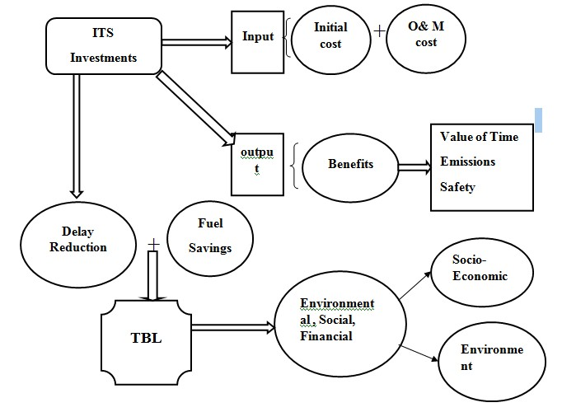

Figure 1: The summary of methodologies in use to determine sustainability and efficiency impacts of ITS
- LITERATURE REVIEW

Pekka Leviakangas and Jukka Lahesmaa (2002) studied ITS and infrastructure investments are compared with each other and how they impact on the profitability evaluation. Economic evaluation methods for ITS investments need improving , so comparative study is carried out by using suitable set of different methods. In this paper time savings are the most important factors dictating profitability.

Andrius Čiapas and Deividas Rinkevičius (2014) study aimed to analyze whether implementing a public transport priority system is economically beneficial, by estimating the benefit to cost ratio of investing in intelligent transit technologies. Author conducted various studies; such as interviewed public transport management company, surveyed the citizens and estimated the benefits and weighted them against cost of investments. And empirical design used to obtain cost and benefit ratio which determines whether the investment is beneficial to the city.

S. B. Pattnaik, S. Rajeev, and Anil Mukundan (1991) discussed the knowledge and the strategy used to arrive at phasing patters , for intersection to be signalized. The main objective discussed in this paper is to install signals, updated with changing traffic patterns. The methodology based on expert knowledge of experienced engineer for traffic signal design.

Evangelos Mitsakis (2015) examined the important to convert costs and benefits into equivalent values when conducting a Cost-Benefit Analysis and Compared to other transportation projects. ITS contain innovation solution for travel demand and traffic management. In this paper framework based on a CBA is given, evaluation of costs and benefits of ITS projects implemented in the

Thank you for using www.freepdfconvert.com service!

Only two pages are converted. Please Sign Up to convert all pages. https://www.freepdfconvert.com/membership

