**Role of Mechatronics in Agriculture Transformation**

**Ketan Jagtap1, Jayant Joshi2**

*1Lecturer in Mechanical Engineering, 2Lecturer in Electronics Engineering*

*Government Polytechnic, Nashik- 422 101, Maharashtra, India*

***Received on****: 15 December,2022* ***Revised on****:12 January,2022* ***Published on****: 14 January,2022*

***Abstract –*** *Mechatronics is an integrated and interdisciplinary approach to engineering design is increasingly being used in the design of cars, robotics, machine tools, washing machines, cameras, and a wide range of other technologies. Agriculture's development was a turning point in a human history. The ability of fully-modern humans to engineer the environment to provide enough food to sustain tremendous population expansion was the first major shift in their interaction with the environment. Agriculture ushered in a slew of innovations, ranging from the use of fire and prepared food to self-driving machinery. Modern agriculture has been totally revolutionized by technological developments ranging from robotics and drones to computer vision software. Farmers now have access to instruments that will assist them in meeting the growing demands of our world's population. This paper focuses the advanced Mechatronics based automation areas in agriculture sector such as challenges in agriculture sector, precision agriculture, farm automation, robots and machineries used for advanced farming with their benefits precisely. Present paper included a case study of a farmer from Village Bhatkhed, Dist. Jalgaon, Maharashtra. Also, authors have fabricated IDC & RSFIDC soil humidity sensors for soil humidity measurement. A farmer has used various mechanization tools such as inverter, sprinkler systems, drip irrigation, PV systems to increase the crop production for betterment of his life in the society.*

***Keywords-******Mechatronics, Precision farming, Farm automation, Robotics and Control systems.***

1. **INTRODUCTION**

Mechatronics refers to a concept in engineering technology in which mechanical engineering, electronics, and intelligent computer control are integrated in the design and manufacture of goods and processes in a coordinated and concurrently developing manner. A mechatronics system is more than a union of electrical and mechanical systems, and it is more than a control system; it is a comprehensive integration of all of them, with a concurrent design approach [1, 2]. Such an integrated and interdisciplinary approach to engineering design is increasingly being used in the design of cars, robotics, machine tools, washing machines, cameras, and a wide range of other technologies. If cheaper, more dependable and more flexible systems are to be produced, integration across traditional boundaries of mechanical engineering, electrical engineering, electronics, and control engineering must occur at the earliest phases of the design process. Mechatronics combines technologies such as sensors, measurement systems, drive and actuation systems, and microprocessor systems (Fig. 1), as well as the study of system behaviour and control systems.



*Fig. 1- Basic Elements of a Mechatronics System [1]*

In an unfriendly industrial environment, mechatronics systems can help create a competitive advantage. As a result, mechatronics has found a variety of uses in agriculture sector. Agriculture is one of the world's oldest industries, stretching back to the nomadic period. Agriculture's development was a turning point in a human history. The ability of fully-modern humans to engineer the environment to provide enough food to sustain tremendous population expansion was the first major shift in their interaction with the environment. Agriculture ushered in a slew of innovations, ranging from the use of fire and prepared food to self-driving machinery [4].

Agriculture sector has developed the society so far in 12,000 years, but it has been reached a fork in the road. With a projected worldwide population of 9.7 billion people by 2050, agricultural production will need to rise by at least 70% from current levels to keep up with nutritional trends. The demand on farmers to create nutritious products is now greater than ever putting our planet's health in threat. The expanding population isn't the only issue that modern farmers are facing it. What about labour shortages and customer demand for environmentally friendly food? Smart farming is the answer to all of these questions.

Therefore, the role of mechatronics plays a vital role in transforming the agriculture sector. Modern agriculture has been totally revolutionized by technological developments ranging from robotics and drones to computer vision software. Farmers now have access to instruments that will assist them in meeting the growing demands of our world's population. Because automated agriculture is such a broad topic right now, that will be focused on the most recent developments and their allegations. The application and integration of technology in agriculture has resulted in a variety of beneficial outcomes. It has not only reduced labour costs, but it has also reduced crop costs by providing tremendous yields. Present paper focuses the advanced automation areas in agriculture sector such as challenges in agriculture sector, precision agriculture, farm automation, robots and machineries used for advanced farming.

1. **CHALLENGES IN AGRICULTURE SECTOR**

It is a need in the world that the current challenges that face the agriculture sector need to be immediately addressed. Harvest and post-harvest losses of India's principal agricultural produce were projected at Rs 92,651 crore ($13 billion) in 2016, about three times the agriculture sector's 2016-17 budget. Between 2012 and 2014, almost 16 percent of fruits and vegetables worth Rs 40,811 crore ($6 billion) were lost [8]. Farmer’s lack of access to reliable and timely market information, a lack of supply and demand forecasting, poorly structured and inefficient supply chains, insufficient cold storage facilities and a shortage of proper food processing units, and a high level of intermediation between farmers and consumers are all the major causes of losses.

Low yield is one of the most pressing concerns confronting India's agricultural sector: India's farm production is 30-50 % lower than that of developed countries [6]. Low agricultural production is caused by factors such as average farm size, insufficient infrastructure, a lack of utilization of farm technologies and best farming techniques, decreased soil fertility owing to excessive fertilization, and continued pesticide use. Because Indian farms are small (70 percent are less than 1 hectare, with the national average being less than 2 hectares), they have limited access to financial services, credit (or lenders), support skills, educational services, and irrigation solutions.

***Consumer tendencies***

Due to the abundance of fast food and other unhealthy meals on the market, there is a demand for better dining options. The negative effects of junk food on our bodies have prompted a “return to basics” attitude, with customers all across the world yearning for plant-based, healthful foods. To accommodate the growing consumer demand, farmers need produce it in huge quantities.

*Shortages of labors*

Nowadays, it is very difficult to find a youngster who aspires to be a farmer. The truth is that the world's population is moving toward a more urban lifestyle, which means that the farming industry is facing a manpower crisis. Furthermore, during the previous decade, modern agricultural practices have altered, making it more difficult to train new personnel.

***Environmental responsibility***

The general public and local government want agricultural firms to be environmentally conscious and responsible in their processes. Farmers should choose to use less chemical components, especially insecticides. Agricultural business owners are looking for a solution to meet this social and ecological need, and farm automation may be the answer.

***Improper irrigation***

Despite the fact that India is the world's second-largest irrigated country after China, barely one-third of the planted area is irrigated. In a tropical monsoon country like India, where rainfall is unpredictable, inconsistent, and erratic, irrigation is the most critical agricultural input [9]. India will not be able to make sustained progress in agriculture unless and until more than half of the planted area is irrigated.

***Lack of mechanization***

Despite the large-scale mechanization of agriculture in some regions of India, most agricultural operations are still carried out by hand throughout the majority of the country, utilizing simple and traditional tools and instruments such as the wooden plough and sickle. Ploughing, seeding, irrigating, thinning and pruning, weeding, harvesting threshing, and transporting the crops all make little or no use of equipment. This is particularly true for small and marginal farmers. It is critical to mechanize agricultural activities in order to reduce labour waste and make farming more convenient and efficient. Agricultural implements and machinery are essential inputs for effective and timely agricultural operations, allowing for multiple cropping and hence increased the output.

***Less storage facilities***

In remote places, storage facilities are either non-existent or unhappily inadequate. Farmers are forced to sell their produce soon after harvest at market prices, which are almost always poor. Farmers lose their rightful income as a result of such distress sales. As a result, a scientific storage is essential to reduce the losses and to benefit both farmers and consumers.

1. **PRECISION FARMING**

Precision agriculture was first used in industrial manufacturing in the 1980s, and it involves the use of sensors, mechatronics, and automation to improve monitoring and interference procedures [3].With the advent of mechatronics and autonomous systems, there is an opportunity to develop a new generation of agricultural equipment based on small, smart technologies that decrease waste, reduce environmental effect, advance economic capabilities, and promote food sustainability. Sensory data collected by robotic platforms on the plantation also provides valuable information and insights into yield optimization, enhanced planning, resource levels required, and when and where resources are required to reduce waste and boost yields [4, 5].

Advanced technologies are becoming popular in farming and agriculture operations that include 3D Printing of foods, food designs and grains, another aspect is Genetic modifications (Genetic Engineering) in agriculture products [7]. Upcoming field is seawater agriculture in agriculture mechatronics playing an important role. It is combination of sensors, robotics, transportation of material, automation systems for cropping and water, machines, Internet of Things technology, information technology, telecommunication networks (Wireless Sensor Networks), machine learning, artificial intelligence, data handling etc.

1. **FARM AUTOMATION**

Farm automation, sometimes identified as "smart farming," is a type of technology that improves farm efficiency by automating the crop or livestock production cycle. Drones, autonomous tractors, robotic harvesters, automatic watering, and seeding robots are all being developed by a growing number of companies. Despite the fact that these technologies are still relatively new, an increasing number of traditional agriculture enterprises are incorporating farm automation into their operations [8]. Currently, advanced farming technology can be an important part of a farmer's day-to-day operations. Following are some of the advanced mechatronics based machines and devices used for farm automation.

***Harvesting robots***

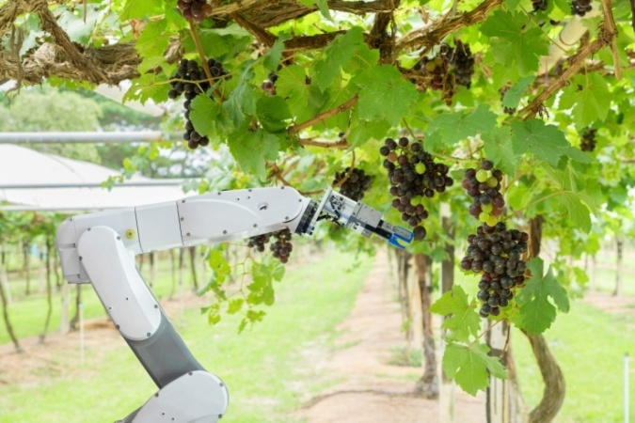

*Fig. 2- Harvesting Robot [13]*

As farmers battle with rising labour and energy expenses as well as falling profitability, robotics for harvesting is a promising emerging form of farm technology. Fruit and vegetable harvesting has always been a challenging task to automate. To avoid bruising and damage, harvest robots must be delicate with the produce. Up to 24 robotic manipulators work together from a mobile platform to pick the fruit that fulfils the farmer's quality criteria. Some machines are manufactured as to handle delicate fruits by pulling apples from a branch with a vacuum rather than claws or hand-like graspers.

***Autonomous tractors***

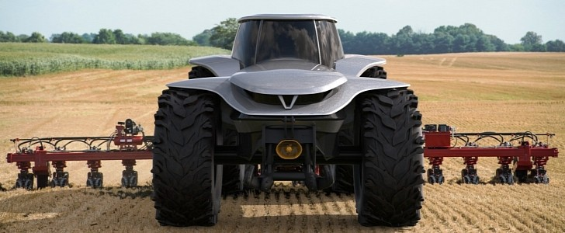

*Fig. 3- Autonomous Tractors [14]*

Tractors of this type can be controlled remotely. It is only essential to assist with the initial set-up and routine maintenance of the devices. With such technologies as vision systems, light detecting tools, GPS, and so on. Smart tractors will become increasingly self-sufficient over time. These are the autonomous tractors, which can remotely control several tractors, plan the machine's route, and receive real-time reports and alarms all without requiring direct human participation in the field.

***Seeding and weeding robots***

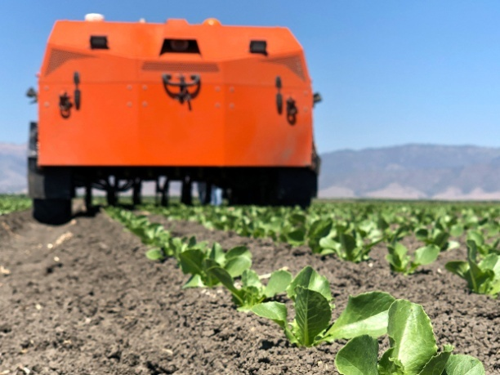

*Fig. 4- Seeding robot [15]*

Planting robots are laser-focused on a specific area of the field and work with extreme precision. This sort of farming robot makes use of artificial intelligence and computer vision to reduce pesticide use in the field and, as a result, produce high-quality crops. Farmers now have a new tool to combat and avoid herbicide-resistant weeds. Solar powered operated robots are also available for this purpose in the tribal areas. This is the most environmentally friendly method: a compact four-wheel machine moves over the field spraying herbicides with the least amount of damage to the crops and environment.

***Drones***

Drones can be used to remotely monitor conditions and potentially spray fertilizers, insecticides, and other treatments. They can also use imaging and infrared analysis to swiftly and cost-effectively identify problem regions, allowing farmers to address difficulties early on.

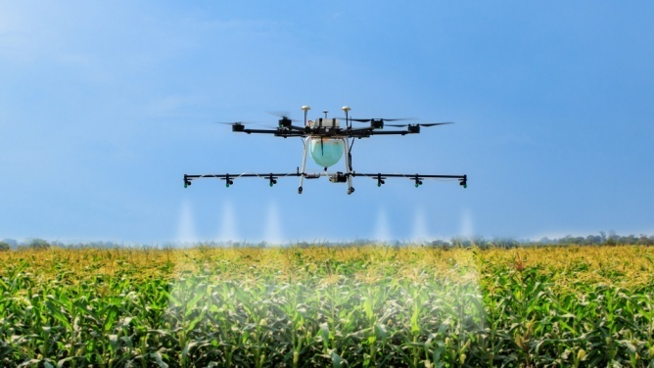

*Fig. 5- Drones in farming [16]*

Previously, the only way to get a good look at a field was to use helicopters or even satellites - but that is no longer the case. Using a drone is less expensive and does not necessitate any unique human abilities, such as those required to pilot a helicopter. Drones can shoot overhead images and movies, and the quality of the files is improving all the time. However, this is far from the only method drones can be used in agriculture.

***Robot assisted irrigation***

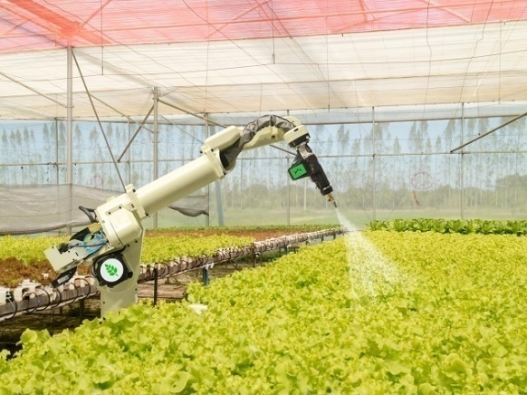

*Fig. 6- Robot assisted irrigation system [17]*

A Subsurface Drip Irrigation (SDI) system and unique sensors are the two main components of robot-assisted irrigation systems. SDI is well-known in the agricultural business because it allows for precise control of the amount of water utilized and when it is delivered to the plants. Even while these methods are clearly superior to manual plant-by-plant watering, they are not without flaws because they require human intervention. More advanced IoT sensors can independently monitor moisture levels and communicate real-time information to a smart device. The use of SDI and such sensors results in automated farming equipment that makes work easier and saves water.

1. **ROLE OF SENSORS IN AGRICULTURE SECTOR**

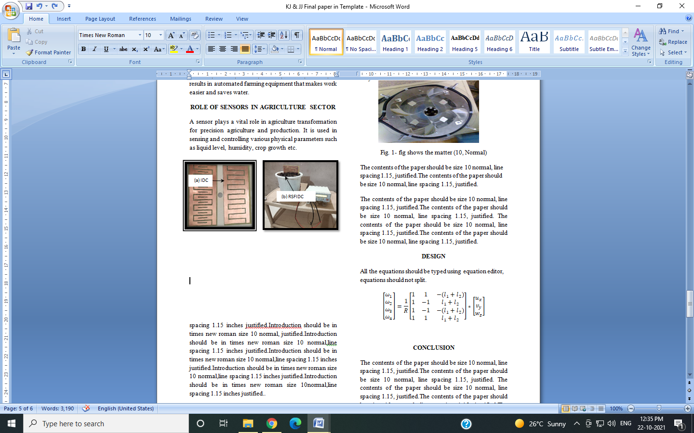A sensor plays a vital role in agriculture transformation for precision agriculture and production. It is used in sensing and controlling various physical parameters such as liquid level, humidity, crop growth etc.

**(a) (b)**

*Fig. 7- (a) Photographs of fabricated IDC & RSFIDC soil humidity sensors, and (b) Photograph of soil humidity measurement set up using IDC and RSFIDC [8]*

In agriculture, hydrology, cropping pattern, gardening, green house instrumentation systems, packaged food quantifying systems, it is essential to measure and estimate the water content and water retention in particular sort of soil. Water requirement for healthy growth of crop depends upon fertilizer as well as water retention by the soil at the roots of particular crops or trees. Water supply to the crops is one of the vital factors to achieve good yield point of a farm. Water retention varies according to the type and nature of soil. Hence, it is essential to measure humidity that is water content retention by the soil needed for particular crops. Nowadays, measurement and analysis and controlling of moisture content in the soil is an important in addition to physical and chemical properties of soil. Authors have reported configurations of inter-digital capacitor (IDC) sensors for moisture measurement in agriculture sector [8]. The two configurations of planar sensors proposed are; conventional IDC and rectangular slotted fingers IDC capacitor (RSFIDC). The novelty of this research work is cutting rectangular slots in the fingers of IDC. FR4 substrate is used to fabricate this sensor.

1. **BENEFITS OF AGRICULTURE AUTOMATION**

One agrobot has the power to alter the course of history. Smart farm automation technology has a lot of potential to make a big change. This sector of technology holds the key to solving several global challenges and developing environmentally beneficial techniques. Farm automation technology handles important concerns such as population growth, labour shortages on farms, and shifting consumer demands. The advantages of automating traditional agricultural procedures are enormous. Following are the benefits of it.

***Consumer demands***

As previously discussed, consumer expectations and preferences are shifting. Therefore, there is a need for food to be fresh and delivered fast to stores and markets. Farmers can save time and money by using agrobots. Production reaches consumers faster, fresher, and more sustainably by automation technology. Increased productivity through automation increases yield and rate of production, which lowers consumer costs.

***Labour efficiency***

Labour accounts for more than half of the cost of running a farm, and 55 percent of farmers think labour shortages are a problem. As a result, 31% of farmers are switching to less labor-intensive crops [6]. Harvest robots, on the other hand, have enormous promise. Routine chores can be automated using robotics technology, lowering labour costs and reducing the amount of people required in the agriculture industry, which is now experiencing a labour shortage. In three days, a single strawberry robot harvester could pick a 25-acre region and replace 30 farm labourers.

***Environmental impact***

Farm automation can help make agriculture more profitable while also decreasing its environmental impact. Pesticides and fertilizers use can be reduced while greenhouse gas emissions are reduced using site-specific application software.

***Improved safety***

Farming automation has a significant advantage in terms of safety. These devices can work for long periods of time and in hazardous conditions without being affected by rain, sleet, snow, or other inclement weather. Farmers will have fewer injuries as a result of this, which will likely result in lower expenditures.

1. **CONCLUSION**

The agricultural sector is rapidly evolving into a critical industry that must rely heavily on modern control systems to handle the increasing complexity of agricultural systems, necessitating increasingly sophisticated methods. Precision farming is the foundation of today's contemporary agriculture, in which crop production is made more efficient via the use of sophisticated control systems. Precision agriculture is essentially manuring and irrigating according to necessity and with extreme precision.

The application and integration of mechatronics in agriculture has resulted in a variety of beneficial outcomes. It has not only reduced labour costs, but it has also reduced crop costs by providing tremendous yields. Advanced mechatronics based machines and devices used for farm automation are discussed and the understanding of the methods may be improved to design better processes.

**ACKNOWLEDGMENT**

The authors are grateful to the support of Prof. D. P. Nathe, Joint Director, Technical Education, Regional Office Nashik & Principal, Government Polytechnic, Nashik, India. Also thankful to Prof. R. N. Khadse (HoD, Mech. Engg), Prof. G. C. Khursade (HoD, Electronics Engg.) and Dr. P. V. Rathod (HoD, Electronics Engg.) from the Institute for their constant support.

**REFERENCES**

1. William Boltan (2015), Mechatronics- Electronic Control Systems in Mechanical and Electrical Engineering, Sixth Edition, Pearson Education Ltd., UK.
2. M. D. Singh and J. G. Joshi (2006), “Mechatronics” Prentice Learning Pvt. Limited, New Delhi, India, Pages: 496, ISBN**-**10: 8120329864 , ISBN-13: 978-8120329867.
3. J. Azeta, C. A. Bolu, F. Alele, E. O. Daranijo, P. Onyeubani, A. A. Abioye (2019), Application of Mechatronics in Agriculture: A review, International Conference on Engineering for Sustainable World, Journal of Physics: Conference Series, 1378, pp 1-10.
4. Sigrimis N., Antsaklis P. and Groumpos P. P. (2001), Advances in control of agriculture and the environment. IEEE Control Systems, 21(5), pp 8-12.
5. Stentz A., Dima C., Wellington C., Herman H. and Stager D. (2002), A system for semi-autonomous tractor operations. Autonomous Robots, 13 (1), pp 87-104.
6. Astrand, B., and Baerveldt, A. J. (2002), An agricultural mobile robot with vision-based perception for mechanical weed control, Autonomous robots, 13 (1), pp 21-35.
7. Joshua M. Pearce (2015), “Applications of Open Source 3-D Printing on Small Farms” Organic Farming, Vol. 1, Issue 1, pp. 19–35.
8. Jayant G. Joshi, Mandar P. Joshi, Balwinder Singh Dhaliwal and Shyam S. Pattnaik (2020), Soil  Humidity Measurement using Microstrip Interdigital Capacitor (IDC) and Rectangular Slotted Fingers Interdigital Capacitor (RSFIDC), Technical Volume of 35th Indian Engineering Congress 2020, The Institution of Engineers (India), Kolkata (IEI) and Celebration of Centenary, pp. 947-953.
9. https://www.startupindia.gov.in
10. https://www.easternpeak.com
11. https://www.plugandplaytechcenter.com
12. https://www.yourarticlelibrary.com
13. https://agfundernews.com
14. https://www.autoevolution.com
15. https://spectrum.ieee.org
16. https://archive.factordaily.com
17. https://www.eletimes.com