Smog-its constituents, Effects & Ways to Eliminate –An Overview
Shweta Matey, Shanmuganathan Mudaliar, Utkarsh Nalawade, Pratik kadam
Mechanical Department, Lokmanya Tilak College of Engineering, Mumbai University
Sector 4, Koparkhairne, Navi Mumbai, Maharashtra, India
svm4ltjss@gmail.com

Abstract- Here we are about to discuss the formation of smog, it’s chemical constituents, the effects of smog not only on human beings but also on vegetation and surrounding environment. Major Air Pollutants responsible for smog are carbon oxides (CO, CO2) , nitrogen oxides and nitric acid (NO, NO2, HNO3) , sulphur dioxide and sulphuric acid (SO2, H2SO4), suspended particulate matter (SPM) ,ozone (O3) ,volatile organic compounds (VOCs). Efforts to control smog around the world have had signiﬁcant inﬂuence in improving air quality in metropolitan areas, but each city faces its own speciﬁc challenges, and strategies that work in one region are not always applicable to others.
Keywords - smog, ground level ozone, VOCs, SPM.
  - INTRODUCTION
The word “Smog” was first coined by Dr. Henry Antoine Des Voeux in 1905. Smog is a kind of air pollution originally named for the portmanteau of smoke and fog in air. This term smog may seem to be appropriate name for the phenomenon that is often observed in populated areas when visibility is reduced and the sky has hazy orange hue. Appearances however can be deceiving. But this term does a poor job of elaborating the actual constituents in the atmosphere which causes the haze, the colour, and the toxicity of smog, whose presence can often be invisible.

The chemical constituents of present day smog which cause the most serious health risks are ozone and fine particulate matter, but also present are the primary ingredients that lead to these compounds, such as nitrogen oxides, volatile organic compounds (VOCs) and sulphur dioxide. Ozone and a lot of fine particulate matter are not emitted directly but are formed due to the reactions that take place in atmosphere in presence of sunlight. Therefore this modern mixture of pollution whether it is visible or invisible, it is best described as Photochemical smog. Nitrogen oxides are formed due to reaction of nitrogen and oxygen under high temperature and pressure are released into the atmosphere from the exhaust gases of vehicles, coal power plants, and industrial manufacturing factories. The emission of VOCs are from manmade sources such as gasoline, paints, solvents, pesticides and biogenic sources such as pine and citrus tree emissions. Particulate matter relates to very small liquid droplets & solid droplets (diameters less than 2.5 microns) suspended in the atmosphere. Although vast majority of these particles are too small to be visible to our naked eyes, their interaction with light is responsible for reduced visibility and hazy appearance in case of smog event and they are another health hazard. They are emitted directly into the surroundings due to incomplete combustion fossil fuels, construction and industry activities, nucleation and condensation of precursor gas species.

Scientifically, smog is divided into two types: reducing smog and oxidizing smog.
Reducing smog (also known as London, or winter smog), is the designation for the mixture of city and industrial smoke with mist, occurring during the year, typically during winter with the strong effect of inversions. Depending on the industrial pollution, winter smog is primarily composed of sulphur dioxide SO2 and of certain other substances, which are subject to oxidation easily. These substances often have strong reducing effects on their surroundings.
Oxidizing smog was discovered in the 40s of the 20th century in the California City of Los Angeles. It is also known as California, Los Angeles, photochemical, or summer smog.). Photochemical smog is driven by the U.V energy from the sun, and sOn a smoggy day, there are literally thousands of reactions that occur in the atmosphere. Fortunately, there are a few that can help us to initially understand the formation of photochemical smog.
Some the important chemical reactions that take place during the formation of smog is given below
1. NO + O₂ NO₂ + U.V. O + NO
In this first reaction, we start with Nitric Oxide (NO), which we already know is emitted from various combustion processes. It combines with oxygen in the atmosphere to form nitrogen dioxide (NO2), which has a characteristic brown colour that should be familiar to anyone who has lived in a smoggy region. When the U.V. rays of sunlight strike the NO2 it breaks off single oxygen radical (O) that triggers many subsequent reactions of photochemical smog.
2. O + O₂ O₃
In this second reaction, we see how the single oxygen radical helps form ozone (O3). A variety of molecules can act as catalysts for this reaction.
3. O₃ + NO O₂ + NO₂
This third reaction is called a scavenging reaction, and it happens normally in the evening. Because it converts ozone to O2, the net result is a drop in the ozone concentration in the evenings.
4. RC + O RCO + O₂ RCO₃
The fourth reaction shifts our attention to the hydrocarbons (represented here as RC). When combined with the oxygen free radical, it forms RCO, which represents a variety of aldehydes and ketones. Some of these constituents can combine with oxygen to form peroxide radicals (RCO3).
5. O₂+ RCO₃ O₃ + RCO₂
The fifth reaction demonstrates the importance of these peroxide radicals (RCO3) - it enhances the formation of ozone.
6. NO + RCO₃ NO₂ + RCO₂
The last reaction shows a more subtle role of the peroxide radicals by enhancing the formation of nitrogen dioxide we know that the nitrogen dioxide will go on to form more ozone.
All of these chemicals are generally highly reactive, oxidising and poisonous. Smog is therefore considered to be problem which arises because of modern industrialization. Its presence is felt in all leading cities across the globe but it is more common in cities with sunny, warm, dry climates and large number of motor vehicles. Because it travels with it & can affect sparsely populated regions as well.
1.2 EFFECTS OF SMOG
Smog possesses a serious health hazard in many cities across the globe & continues to endanger human lives & species in many ways. Various harmful chemical constituents mentioned above such as Ground level ozone, sulphur dioxide, nitrogen dioxide and carbon monoxide are harmful to human beings as well as species. They can cause inflammation in breathing passages, decrease the lungs working capacity, pain while inhaling deeply, wheezing & coughing. It can lead to eye and nose irritation and it dries out the protective membranes of the nose and throat and interferes with the body’s ability to fight to fight infection, increasing susceptibility to illness. Heavy smog is responsible for decreasing the UV radiation greatly. Thus Heavy smog results in a low production of the crucial natural element vitamin D leading to cases of rickets among people. When a city or town gets covered in smog, the effects are felt immediately. Smog can be responsible for any ailment from minor pains to deadly pulmonary diseases such as lung cancer.
During the 1952 smog episode in London it was found that, the people exposed to the incident had detrimental effects on the lungs. In addition to combustions of coke and coal, the people of London were exposed to diesel emissions. This exposure led to the systematic inflammation of the respiratory and cardiovascular systems. Sulphur dioxide is water soluble, if inhaled it may lead to complete absorption upper linings of the lungs. It is estimated that almost 12000 people lost their lives during the incident.
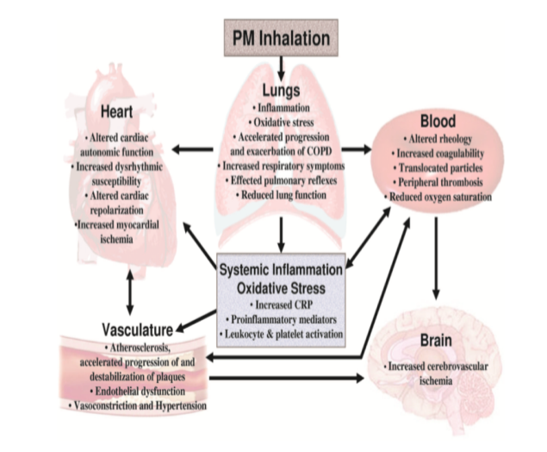
Fig -1 Effects of smog
The effects are not only limited to human beings. Even Vegetation is not spared. Vegetation is easily harmed & the main agents that cause damage are ozone and nitrate compounds. Sensitive crops, trees and other vegetation are harmed at lower ozone concentrations than human health. The growth and productivity of plants are disturbed and there may be increase in vulnerability to diseases and even plant death may occur. Smog can also accelerate deterioration of rubber, plastics, paints & dyes. Metals, stones, sculptures even clothing is directly affected smog. In India, mainly Delhi and its surrounding areas are affected by smog due to heavy vehicular movement and thermal power plants. According to archaeologists & experts even the turning of Taj Mahal into yellow is somewhat connected to the alarming rise in air pollution levels.
A research data concludes that in China since 2011, there is over 60% increase in number of people suffering from lung cancer over the past decade mainly owing to the alarming rise in air pollution levels. The report also states that the cities of Shanghai, Guangzhou, Xi’an & Beijing suffered a combine loss US $1.08 billion in economic losses.

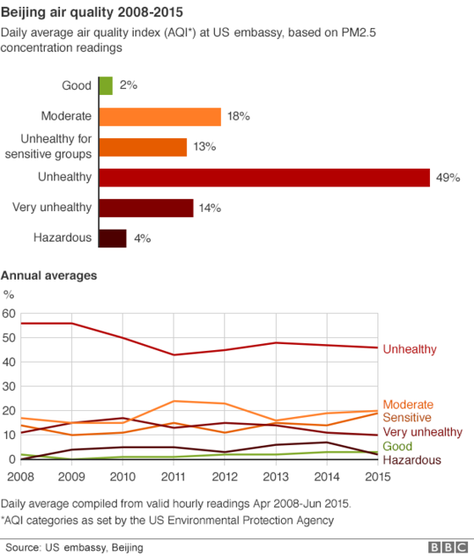
Fig -2 Smog concentration levels
1.3 WAYS TO ELIMINATE
According to scientists the release of certain chemicals such as diethyl hydroxylamine into the atmosphere in smog filled region at the right time, right place and at the optimum amount would help significantly eliminate the smog. This chemical has the potential to react and remove free hydroxyl radical that provides itself an essential link in the photochemical smog chain reaction. Although this might seem to the perfect solution to the problem but this has its own side effects and disadvantages. The chemical might take longer time to react and due to this the sunlight hours may be reduced. There are possibilities that the chemical might be carried away due to winds and might get deposited in buildings, roads and most importantly people might face severe health issues. So proper evaluation needs to be done on the safety of chemical smog compressors.
According to a document released by the China Meteorological Administration says that from 2015, local weather authorities will be allowed to use cloud seeding to create rain and clear the country’s notorious smog. It’s part of the government’s plan to invest 1.7 trillion Yuan ($277 billion) in tackling air pollution. The idea is that these provide nucleation points for ice particles to form around, which then fall as rain or snow, clearing the smog below.

2. LITERATURE REVIEW
According to institution of chemical engineers, urban smog and its harmful effects on health and the environment may be a thing of the past following a full-scale test of a chemically engineered air purifying pavement in The Netherlands. The experiment, which was conducted over a one year period, managed to reduce nitrogen oxide air pollution by up to nearly half (45%) in ideal weather conditions and by nearly a fifth (19%) over the duration of a whole day. The findings have been published by Eindhoven University of Technology which undertook the research in two adjacent streets in Hengelo, eastern Netherlands. The experiment involved monitoring air pollution in a ‘control street’ with normal paving blocks covering approximately 100 metres in length. A second street was installed with a 150 metre long ‘photo catalytic’ pavement and both streets were measured for levels of nitrogen oxides. The potential of ‘photo catalytic’ surfaces to reduce air pollution have been known for several years. This latest experiment used titanium oxide, which can be easily sprayed onto surfaces, and has the ability to remove chemical pollutants from the air and turn them into less harmful chemicals such as nitrates.
According to J. A. GEDDES and J. G. MURPHY, University of Toronto, Canada, There are multiple ways in which it is possible to reduce ozone formation. This could be interpreted as ‘cutting off’ arrows in the ozone production cycle shown in Fig. 10.1. For example, one could reduce the supply of new VOCs and NOx by reducing their emissions. However, reducing primary emissions will not always be effective. Ozone is rapidly produced because of the regeneration of radicals once production has been initiated (propagation), so one must also consider the chemical reactions in the atmosphere that remove OH and peroxy radicals from the cycle. When two radicals react with each other, the product is a non-radical species and the reaction is called a termination reaction. NOx and OH radicals react with each other to form nitric acid (HNO3). Additionally, NOx and organic radicals react with each other to produce organic nitrates. Finally, the peroxy radicals can react with themselves to form stable peroxide compounds. In all these termination reactions, th essential ingredients that produce ozone are removed. The competition between propagation and termination controls the rate of ozone formation. When termination reactions are infrequent, the ozone production cycle can proceed over and over again, recycling NOx and OH so that for every molecule of NOx, dozens of O3 molecules can be produced. Conversely, when termination reactions happen more quickly than propagation reactions, NOx, OH and peroxy radicals will be removed from the cycle before they can be recycled and ozone production grinds.
Adopting our ‘cool communities’ strategies of reroofing and repaving in lighter colors and plantings shade trees can effect substantial energy savings directly and indirectly. In our target city of Los Angeles, annual residential air-conditioning(A /C) bills can be reduced directly by about US $lOOM and, because these strategies serve to cool the air in the Los Angeles basin and reduce smog exceedance levels by about 10%,an additional savings of US$70M in indirect cooling and US$360M in smog-reduction benefits-a total savings of about US $l/2B per year-is possible. Trees are most effective if they shade buildings, but the savings are significant even if they merely cool the air by evapotranspiration. In Los Angeles, avoided peak power for air conditioning can reach about 1.5 GW (more than 15% of the city’s air conditioning). Generalized to the entire U S, we estimate that 25 GW can be avoided with potential annual benefits of about US$5 B by the year 2015. Recent steps taken by cities in the warmth half of US towards adoption of cool communities include incorporation of cool roofs.
3.CONCLUSION
Despite more than 60 years of research and analysis in air pollution across the globe, still smog seems to be one of the most important issues that the world faces even today. It seems it will take a very long time to ‘solve’ this issue. To end this, firstly public awareness is a must & for this social media & internet play a vital role. Secondly, countries should have a proactive approach to share their knowledge, past experiences and transfer appropriate technologies with other countries to achieve the common goal of completely eradicating smog and making this planet a better & safe place to live in.
Although various researches and analysis have been carried out and preventive measures are in the process of implementation or implemented still results are not as desired. Even though we are of the opinion of prevention of the smog at the initial phase itself, it’s wise enough to completely eliminate them in order to avoid further more damages and causalities.
REFERENCES
- The science of smog: a chemical understanding of ground level ozone and ﬁne particulate matter J. A. GEDDES and J. G. MURPHY, University of Toronto, Canada.
- Cool communities: strategies for heat island mitigation and smog reduction ’ Arthur H. Rosenfeld a,*, Hashem Akbari b32, Joseph J. Romm ‘TV, Melvin Pomerantz b34 ” US Department oj’ Energy, EE-40, 1000 Independence Ave. SW, Washington, DC, USA ‘Lawrence Berkeley National Lrrhoratory, Berkeley, CA, USA Accepted 24 October 1997.
- Safety Of chemical smog suppressor- Final technical report, August 1997.

- Health Effects of Fine Particulate Air Pollution: Lines that ConnectC. Arden Pope III Department of Economics, Brigham Young University, Provo, UT
- Douglas W. Dockery Department of Environmental Health, Harvard School of Public Health, Boston, MA.
- Photochemical Smog Pollution and It Mitigation Measures -Bina Rani1, Upma Singh2, A K Chuhan3, Diwakar Sharma4, Raaz Maheshwari3

