**Manufacturing Processes Part II: A Brief Review on Rolling & Extrusion**

**Vallabh Bhoyar1, Swapnil Umredkar2**

*1 Student*

*G.H.Raisoni College of Engineering, Nagpur, India, 440016*

*2 Student*

*G.H.Raisoni College of Engineering, Nagpur, India, 440016*

***Abstract****- This paper deals with the review study in order to identify and understand the various rolling and extrusion processes. Also, introduction to various variable in rolling and extrusion, advantages and disadvantages of processes. Rolling can be used to offer desired shape to the metal like section, T-section, L-section, channel section. Its also practiced in order to provide final shapes to applications like rods, sheets, strips and pipes. Extrusion is a manufacturing process used to create objects of a fixed cross-sectional profile. A material is pushed through a die of the desired cross-section. A brief and concise review of the contributions made by the previous researchers in the area of extrusion and rolling process has been presented.*

**INTRODUCTION**

**F**orming processes of metal is also known as mechanical working processes. In these processes specific mass of alloys and metals are concentrated by mechanical forces, are also known as primary shaping processes. As a result of mechanical forces, the required size and shape of machine part can be achieved with higher economy in time and material. Material may undergo “plastic deformation” is the requirement of mechanical working during it’s processing. Malleability and ductility are important properties of alloys and metal in case of metal forming. There are both hot and cold metal forming operations because work piece material is not malleable or ductile as per requirement at ordinary room temperature, but can obtain so when heated.

When a single crystal is subjected to an external force, it first undergoes elastic deformation; that is, it returns to its original shape when the force is removed. For example, the behaviour is a helical spring that stretches when loaded and returns to its original shape when the load is removed. If the force on the crystal structure is increased sufficiently, the crystal undergoes plastic deformation or permanent deformation; that is, it does not return to its original shape when the force is removed.

In crystal structures, plastic deformation takes place by two basic mechanisms. First is the slipping of one plane of atoms over an adjacent plane (called the slip plane) under a shear stress. The second and less common mechanism of plastic deformation in crystals is twinning.

**GENERAL PARAMETERS OF DEFORMATION**

* Material being deformed must be characterized

1. Strength or resistance for deformation
2. Conditions at different temperatures
3. Formability limits
4. Reaction to lubricants

* Speed of deformation and speed sensitivity

**ROLLING**

When requirement of metal is in long length of uniform cross section, the process which is applied for the deformation is known as rolling. Rolling is more economical than forging. In this process, between two rolls which are rotating plastically deformed metals and alloys are being pressed into semifinished or finished product. It is a rapid process of forming metal into desired shape by plastic deformation. Initially, into the space between two rolls metal is pushed, therefore a “bite” once taken by roll of edge of material, by the friction material gets pulled in between the surface of rolls and material. As it is squeezed (and pulled along) by the rolls, the material is subjected to high compressive force. In this method metal is compressed between two rotating rolls to increase in length and reducing its cross-sectional area. Rolling is most widely used mechanical working process used in industry today. Fig. shows rolling of rectangular slab of thickness $t_{1}$, which after rolling is reduced to $t_{2}$. Also frictional forces between the rolls are responsible for drawing out the metal. Rolling can produce a bar having constant cross-section throughout its length. It can produce many shapes such as I, T , L, C and various channel sections. Rolling is done in both i.e. hot rolling and cold rolling.

**PRINCIPLE OF ROLLING**

Work in the form of bar is passed between two rollers rotating in opposite directions. These rollers exert high compressive force on the stock due to squeezing actions. Figure shows rolling of rectangular slab of thickness t1, which after rolling is reduced to t2. Also, frictional forces between the rolls are responsible for drawing out the metal. Rolling can produce a bar having constant cross-sectional throughout its length. It can produce many shapes such as I, T, L, C and various channel sections. Rolling is done in both i.e. hot rolling and cold rolling. Normally rolling is considered as hot rolling unless it is specified as cold rolling.

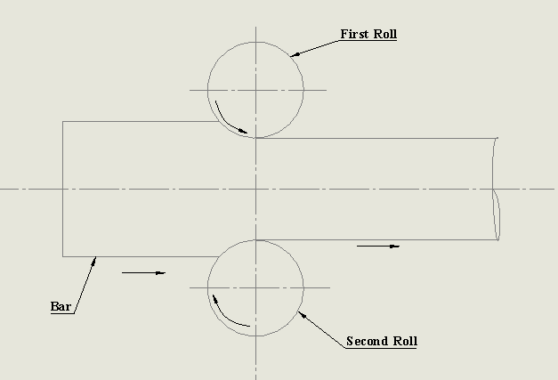

Figure 1: Rolling principle

**HOT ROLLING**

In hot rolling process, the metal in a hot plastic state is passed between two rolls revolving at the same speed but in opposite direction. As the metal passes through the rolls, it is reduced in the thickness and increased in length. The metal provided for hot rolling first cast into ingots of suitable form i.e. rectangular, square or round. These ingots then heated in gas fired furnace to attain uniform working temperature. Then these ingots are taken to rolling mills for hot rolling processes. The flow of metal during rolling is continuous and almost in longitudinal directional. Hot rolling produced components like plates, bars, sheets, wide variety of bars and sections, rods and other structural shapes.

**COLD ROLLING**

Cold rolling is a finishing operation generally performed on products of hot rolling to give good surface finish, dimensional accuracy and strength of material. Bars of different shapes, sheets, rods, strips produced by hot rolling are commonly finished by cold rolling process. Cold rolling is done below the recrystallisation temperature of the metal. These operations consist of cleaning the stock in the form of sheet or strip in acid solution to remove scale. Next step is to wash in water and then dried. This cleaned metal is then passed through set of rolls. In each pass, there is slight reduction in area. The process is repeated until the required thickness is obtained.

**TYPES OF ROLLING**

The machine in which the rolling operation is performed is known as rolling machine. A set of rolls and the housing in which they are mounted are known as stand. One method to classify the rolling mills is according to number of rolls in the working stand. They are:

* Two high rolling mill
* Three high rolling mill
* Continuous mill
* Four high rolling mill



Figure 2: Two high roll mill

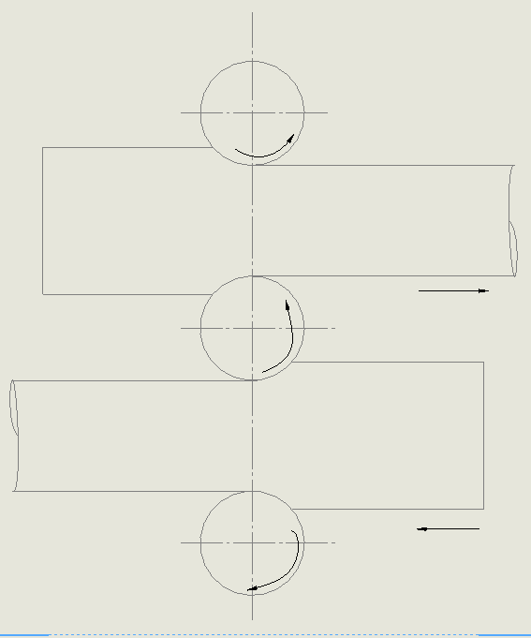

Figure 3: Two high roll mill

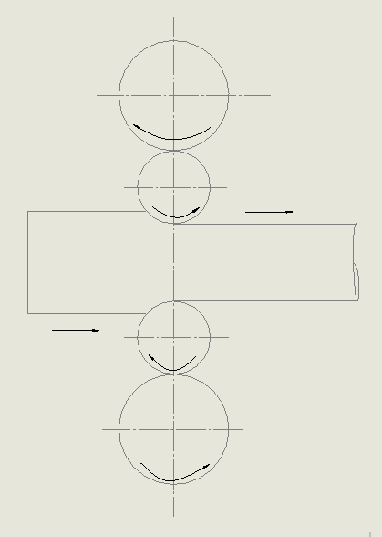

Figure 4: Four high roll mill

Several metals are rolled into variety of shapes by hot as well as cold rolling. These metals include aluminium, copper, magnesium and their alloys. Various grades of steel including structural steel are commonly employed to rolling processes. Different types of shapes are formed in rolling processes. Those are I-section, T-section, L-section, C-section.

Table No.1: Comparison of Hot and Cold Rolling

|  |  |
| --- | --- |
| **Hot rolling** | **Cold rolling** |
| Metal heated above recrystallization temperature is fed to the rollers. | Metal below the recrystallisation temperature is fed to the rollers. |
| Poor dimensional accuracy and finish. | Good dimensional accuracy and finish. |
| Suitable of production of large section. | Deformation is limited to the small section. |
| Very thin sections cab not be obtained. | Thin sections can be produced. |
| Roller radius is generally higher in size. | Comparatively roller radius is smaller. |
| Wide range of shapes like billets, blooms, slabs, sheets, bar, etc. can be produced. | Suitable for production of plates, sheets, foils, etc. |

**EXTRUSION**

Extrusion may be defined as a metal working process in which stock of metal enclosed in a container is pushed to flow through the opening of die. Extrusion process produces continuous lengths of uniform, non-uniform cross-sections from a metal billet. The cross-section produced are either solid or hollow. An extrusion process is carried out by a extrusion press. The process of extrusion is most commonly used for the manufacture of solid and hollow sections of nonferrous metals and alloys e.g., aluminium, aluminium-magnesium alloys, magnesium and its alloys, copper, brass and bronze etc. An extrusion carried out by extrusion press. It has three major components:

1. The container or cylinder
2. Die
3. Plunger with ram

A heated metal billet is placed in the container and forced out through a die by a ram or plunger. The billet coming out from the die takes the shape of the die openings. The pressure is applied either hydraulically or mechanically. The extrusion operation is similar to the squeezing of toothpaste. Mostly non-ferrous alloys are worked in this process. Broadly extrusion process is classified as :

1. Direct extrusion
2. Indirect extrusion

**DIRECT EXTRUSION**

It is also called as forward extrusion. Direct extrusion process is shown is shown in figure. Flow of metal through the die and movement of ram are in the same direction. A dummy block is placed between the hot metal and ram. As the piston moves, the metal first deforms and fills the container shape. As the pressure increases, it is then forced out through the die opening, producing an extruded product. The process continuous until a small amount of metal remains in the cylinder. Finally, it is then cut-off at the die opening and the process completes. Direct extrusion is a popular method as the process is very simple.

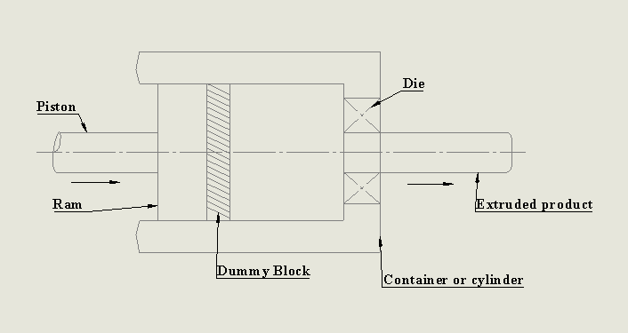

Figure 5: Direct Extrusion

**INDIRECT EXTRUSION**

It is also known as backwards extrusion. In this process, the metal flows in opposite direction of the ram. The ram in this process is a hollow one. The die is mounted on hollow ram as shown in figure. In direct extrusion billet is extruded by hollow ram which is also referred as punch. The die is attached to the ram, thus pushed into the billet which is stationary inside the container. During the process there is no friction between the metal billet and the cylinder walls. Extrusion force required less is as compared to direct extrusion but the press machine is somewhat complicated as compared to direct extrusion. As compared to direct extrusion, this method finds limited applications. Both the extrusion processes i.e. direct and indirect may be done hot or cold depend on material.

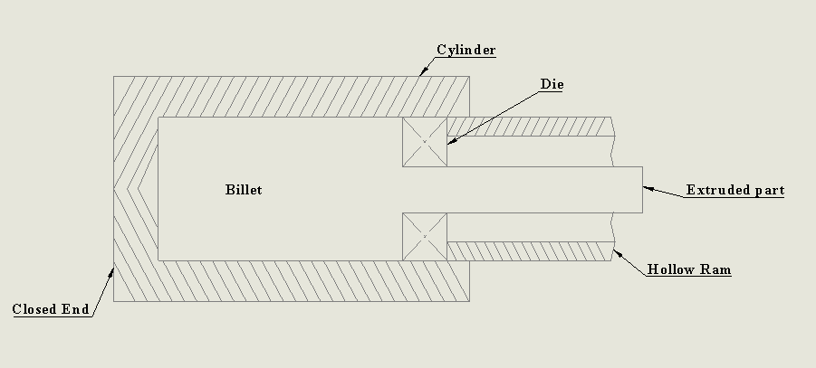

Figure 6: Indirect Extrusion

**ADVANTAGES**

1. cross-section not possible by rolling can be extruded.
2. Tolerances upto 0.4 mm can be achieved which is superior than rolling.
3. Cost of extrusion press is less as compared to rolling.
4. Grain size of extruded part is superfine.
5. Large reductions are possible as compared to rolling.
6. Small parts or lots can be produced in large quantities economically.
7. Extrusion products are light in weight and stronger than casting.
8. Generally brittle materials can also be very easily extruded by these processes.

**DISADVANTAGES**

1. The extrusion process is applicable to only those shapes which has constant cross-sections.
2. Scrap or waste after process is more than the rolling.
3. Productivity is less than the rolling.
4. Tooling cost is more and useful life of tooling is less.

**APPLICATIONS**

1. The extrusion process is mostly employed on non-ferrous metals like aluminium, copper, magnesium etc.
2. Production of seamless tubes made from special alloy steels.
3. Variety of cross-sectional shapes such as circular, square, rectangular, hexagonal etc. either in solid or hollow form.
4. Tubes and pipes of complex configuration.

**PRESSURE REQUIRED FOR EXTRUSION DEPENDS UPON**

1. strength of material
2. the extrusion temperature
3. reduction in cross-section required
4. the speed of extrusion

**EXTRUSION PRODUCTS**

Typical parts produced by extrusion are trim parts used in automotive and construction applications, window frame members, railings, aircraft structural parts. Example: Aluminum extrusions are used in commercial and domestic buildings for window and door frame systems, prefabricated houses/building structures, roofing and exterior cladding, curtain walling, shop fronts, etc. Furthermore, extrusions are also used in transport for airframes, road and rail vehicles and in marine applications.



Figure 7: Extrusion Products-1



*Figure 8: Extrusion Products-2*

**REFERENCES**

1. *Rathi, M. G., & Jakhade, N. A. (2014). An Overview of Forging Processes with Their Defects. International Journal of Scientific and Research Publications, 4(1), 2250–3153. Retrieved from www.ijsrp.org*
2. *Milutinović, M., Vilotić, D., & Movrin, D. (2008). Precision forging–tool concepts and process design. Journal for Technology of Plasticity, 33(1–2), 73–88.*
3. Advanced Manufacturing Processes, Dinesh Lohar, Tech-Max publications
4. Advanced Manufacturing Processes, Prashant Ambdekar, S. Agrawal, Nirali Prakashan
5. *Anon. (1978). Cold Forging and Extrusion. Engineering (London), 218(9), 855–859.*
6. *Naresh, P. (2016). Design and Analysis of a Hot Forging Dies. International Journal of Engineering Treends and Advanceed SCiences (IJETAS), (August), 22–32.*
7. *T. Altan & M.Shirgaokar. (2003). Process Design in Impression Die Forging. Handbook of Workability and Process Design, 278–290.*
8. *Tittley, J. (1985). The fundamentals of metal forming. Production Engineer, 64(9), 7. https://doi.org/10.1049/tpe.1985.0215*
9. *Brown, R., & Burns, T. (2005). Lectures Notes on Dermatology. 42, 43, 44, 180.*
10. https://doi.org/10.1051/mfreview/2016007