Smart Stick with Smart Navigation System

Swapnili Karmore¹, Mr.Aditya Larokar², Roshan Thakre³, Dhanjay Netam⁴,
Neeraj Parate⁵, Parinay Ainchwar⁶, Arvind Jadhav⁷

¹Associate Professor, Data Science, G H Raisoni Institute of Engineering and Technology, Nagpur,
² ^{3,} ^{4,5,6,7} Student, Department of Computer Science and Engineering, G H Raisoni Institute of Engineering and Technology

swapnili.karmore@raisoni.net

Received on: 11 June ,2022 Revised on: 08 August ,2022, Published on: 10 August,2022

Abstract -Assistant to Blind People a “Smart Stick for Guiding Navigation to Blind People” is world widely required, Several Researcher have already proposed this research work in order to provide Solution To This Problem in this paper we are going to develop A Smart Stick For Blind Person By Navigating them and by using some standard Sensor to make that stick for proficient by using Arduino embedded C. We tried to cut the cost of the development of this product by making it more suitable and reliable. The Blind stick is a modern stick designed to improve mobility for visually disabled people. This is an innovative, blind brace, which facilitates human beings with visible disabilities flow efficaciously. The principle purpose of this research paper is to provide a simple, within your budget and effective solution for the visually impaired. The concept at the back of the stick's nature turned into to make it structurally identical, i.e. compact, light-weight and easy to handle, yet provide the customer with a optimistic attitude on the dangers alongside their strolling course
Keywords: Smart Stick, Arduino, Distance, Blind Navigation

I-INTRODUCTION

Blindness is a term that describes people who cannot use their ability to see. Humans can receive eighty percent of information from the environment through their sight vision. Hence it became difficult for blind people to fit into the natural life. So they either used a simple white cane, a dog, or with the help of other humans. As Compared to World, at least 2.2 Billion people suffer from near distant. According to the first World Vision Report released by WHO on October 8, 2019, in at least 1 billion or almost half of these people, vision loss could have been prevented or had to be addressed. Refractive errors and cataracts are the major causes of vision loss and blindness.

Most people with visual impairment and blindness are over the age of 50 (WHO estimates); however, it can affect all ages. In the future, these visual impairment cases are expected to increase. As a result, people need cost-effective products to move smoothly without any problems and hassles. Hence it is necessary to propose a smart solution to it. Our product is proposed as a smart solution to the inconveniences faced by the blind and visually impaired. The main aim of the system is to provide an efficient navigation aid for blind persons that gives them a sense of sight by providing information about their surroundings and the objects around them.

This device has very light in weight and it is also portable. It provides the best travel assistance for the individual. A blind person can move freely from one place to another without help of the others. The main objective of this initiative is that the visually impaired people reach their destination with full confidence and be alert in case of any obstacle in the middle of the stay. There in the circuit, a buzzer/speaker is used to alert when obstacles are detected. If an obstacle is detected it will beep. Its sound volume will depend on the distance of the obstacle from the sensor or stick. We have used an ultrasonic sensor in the circuit to measure the distance. There are two circles on it, one circle sends or releases ultrasonic waves i.e. a sound pulse at a high frequency all around and the other measures the duration of the resonance of that sound to get it back in the mirror. This process continues until the sensor is receiving power, with one circle acting as the transmitter, and the other as the receiver to collect repeated sound signals. There should be other obstacles like mud on the road or fire in the surrounding area. Water sensor for mud-water and flame sensor for fire are used in the circuit to sense these types of impedances. All components of the circuit get power from a 9V battery connected to the circuit.

II. LITERATURE SURVEY
One of the researcher stated in his paper regarding smart stick: The hardware based project” Smart Belt for Blind People” uses a belt connected with hardware component ultrasonic sensor which is used to find the barrier for blind person. The whole project is implemented in such a way. The space which is calculated by smart belt, as an acknowledgement blind person receive the audio message from ultrasonic sensor, where in which he hears the distance calculated using a speaker. It is also has a buzzer which vibrates when barrier is detected [1]
Another researcher have stated in his paper that : The “Smart Walking Stick” describes about the project which uses an ultrasonic sensor for finding various objects and intruder and Raspberry Pi [10] as an main component ,it also has a camera connected with stick , it is used for capturing the photos of the various objects which are detected .The number of objects are analyzed based on the number of the objects are already stored in the storing component of the smart walking stick . This stick is very expensive due to the use of high-end camera and also because of the storage capacity of the stick is very high for storing large amount of data. This stick sometimes gives inaccurate results because the obstacles are detected through ultrasonic sensor are different in size and shape that’s the reason it gives not correct results [2].
Another researcher have stated in his paper that: - The “Smart stick for the Blind People” is a used to find exact location where the person wanted to reach. This system uses Ultrasound sensor and water sensor and also uses IR sensor for finding the various obstacle. However, this project just gives and warn to a blind person if any one of the sensor is triggered, it also uses a buzzer to warn the blind person. This stick does not uses any position identifier or location indicator like GSM and GPS [3].
Another researcher have stated in his paper that: - The project which is known as “Wearable Goggle with Ultrasonic Obstacle Sensor” used for Blind Person.

This goggles uses a pairs of ultrasound sensor on both side detect the obstacles the goggles are used to find the obstacles comes near the blind person while travelling from one place to another place. This system is not robust as the sensor having the goggles makes it heavier and also it is unable to find the major obstacles such as vehicles and water or flame [4].
Another researcher have stated in his paper that:- The “Pothole detection” for visually impaired uses a camera that clicks image 14 frame at a time and it uses image processing concept for finding the pothole. Problem with this system use of camera makes it expensive, and also a large number of photos clicks at a time required the large amount of data storage device. The goggles are used to find the obstacles comes near the blind person while travelling from one place to another place [5].

From above research work it is observed that no one research have fully satisfaction in their work because of use their hardware they are not able to list the ports of functionality and not able to cut the cost of product. So our try is to design and develop such type of project which work on some evaluation parameters like cost, complexity, size, accuracy, weight.

III. PROPOSED METHODOLOGY

Smart Stick is only the way through which we can help blind people as the increasing world blindness is also increasing so we need a product through which people will get help we have decided to make a cost-effective product which can be easily available for any age people. In this smart stick we are using very useful sensor which cut the cost of product and make it the best which can be very familiar with any age people. There are Arduino which is coded in embedded c language which gives output by sensing the environment. Ultrasonic, Water, Fire, Sensors are used for sensing the environment. Each sensor has its own sensing power like water will be sensed by water sensor, fire will be sensed by fire sensor, and Distance and objects will be detected by using ultrasonic sensor. For Output we used buzzer, vibration motor which will be audible and by using vibrator we can feel the vibration in hand whenever the object is detected buzzer will make a sound by which the blind person will be alert. If the fire will detected the sensor will give alert through speaker by saying “Fire Is Detected”. As The distance between blind and object is less the buzzer will buzz very fast through which he/she
will get idea that the object is close.

3.1 COMPONENTS OF SMART STICK:
3.1.1 Water Sensor: Water Detector Water sensors are available for
detecting water levels inside tanks, however they are highly expensive. Our goal is to detect the presence of water regardless of its level. As a result, we used a free option. In Fig. 8, two wire probes are displayed; they fit at the bottom of the stick and detect obstacles such as water pits, puddles, and water spread. When the wires come into contact with water, the circuit is shorted, which causes the micro controller to be interrupted, the vibration motor to be activated, and a warning message to be played that says "Attention, there is water."

3.1.1 Arduino Uno: The ultrasonic sensor interfacing with the micro controller, the arduino programming codes and the real sensor is installed at the micro controller changed into part of our system. The arduino uno is an atmega328p (records sheet)-centred micro controller tool. It has fourteen bodily outputs and ports, six of them pmw output. it is feasible to apply 6 analog inputs and 16 MHz quartz crystal. The moisture sensor includes two samples of wire that depend upon the precise water resistance to sensing the water in touch. The RF transmitter became interfaced with the arduino layout codes at the microscope and the RF transmitter was connected to the microscope

3.1.2 Vibration Motor: Motor vibration the DC vibration automobiles used in cellular telephones are of this sort. It requires a 3v to 5v power source with a current of roughly 125 ma. The pwm (pulse width modulation) approach can be used to programme this sort of motor to control its speed.
3.1.3 Buzzer: Buzzer A "piezo buzzer" is essentially a little speaker that will be directly attached to an Arduino. The term "piezoelectricity" refers to the ability of certain crystals to deform when electricity is applied to them. The crystal will produce sound if an electrical signal is applied at the correct frequency.

3.1.4 Ultrasonic Sensor:
Ultrasonic sensors perform well for close barriers, unlike laser sensors, which can't acquire an accurate reading when an object is so close (less than 15 cm). Furthermore, radar sensors are capable of detecting both close and remote objects with comparable accuracy, but their medium accuracy prevents them from detecting small obstacles.

3.1.5 Flame Sensor:
The light from the flame can be detected by a flame sensor. The wavelength mechanism underpins it. Within a particular range, the light from the ignition emits. The flame sensor detects and responds to the wavelength. The electromagnetic radiation principle is used by the receiver of this sensor. The sensor's response time is 3-4 seconds; it absorbs the sensor's radiation and responds to it. Like an ultrasonic sensor, the sensor's accuracy can be adjusted. When compared to smoke and temperature sensors, flame sensors are extremely accurate and quick to respond.

3.2 ARCHITECTURAL DIAGRAM OF SMART STICK:
In smart stick there are different parts which can be seen by naked eye like vibration motor, battery, buzzer, arduino uno, ultrasonic sensor, water sensor, fire sensor. Each parts perform different functions water sensor is used for sensing the water, fire sensor is used to detect fire nearby, ultrasonic will detect the objects which come in front of person, vibration motor is used through which the person will be sensed in his hands. There are led lights through which the person coming he will have idea that any person is coming.

IV. RESULTS

[a] Smart Blind Stick

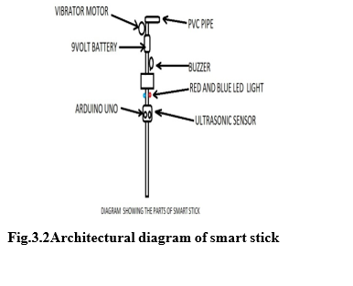
After implementing the smart stick it will look like this all components are there in this stick buzzer, arduino, fire sensor, water sensor, vibrator motor all are connected in below diagram,

3.3 BLOCK DIAGRAM OF ARCHITECTURE:

In block diagram there is a block architecture which includes power supply, buzzer, arduino, vibrator motor, ultrasonic sensor, fire sensor, water sensor, led. All the parts are connected to arduino uno which is all controlled by it. The coding is written in embedded c language in which each sensor is coded which perform each task
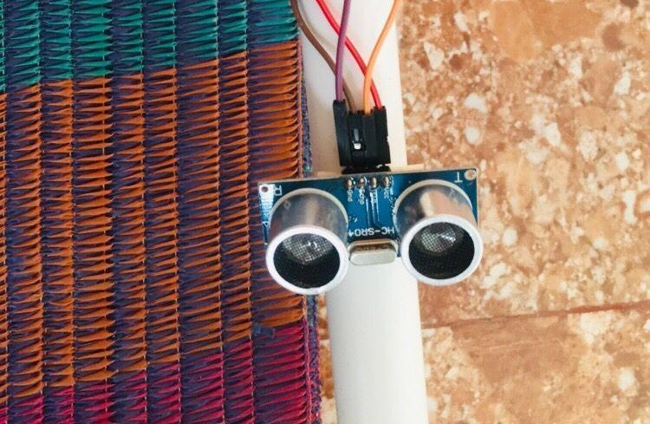
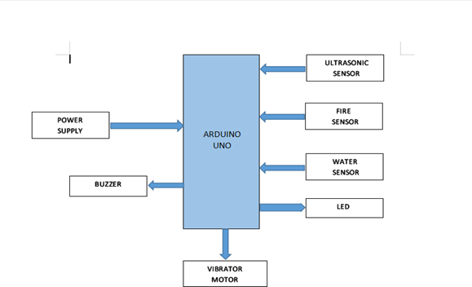
Fig.3.3 Block diagram of architecture
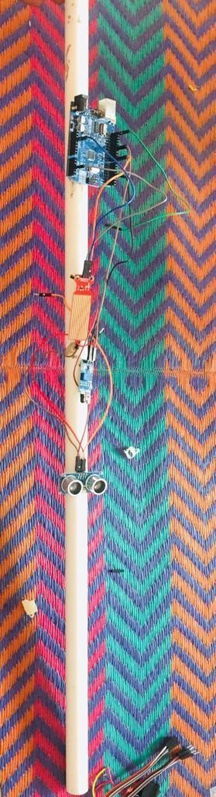

Fig [a] Smart Blind Stick
[b] 9V Battery

Battery is connected of 9V for power supply to all the components.

Fig [b] 9V Battery
[c] Vibration Motor

Vibration motor is used for getting sense to human body by feeling the vibrations that is why vibration motor is used in handle of a smart stick

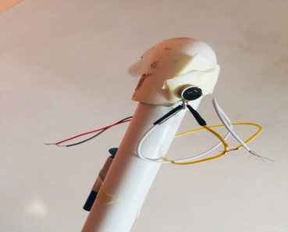

Fig [c] Vibration Motor

[d] Arduino Uno

Arduino is placed in the middle of a smart stick through this all the sensors are functioned.

Fig [d] Arduino Uno

[e] Ultrasonic Sensor

This is used to detect the object in front of people

Fig [e] Ultrasonic Sensor

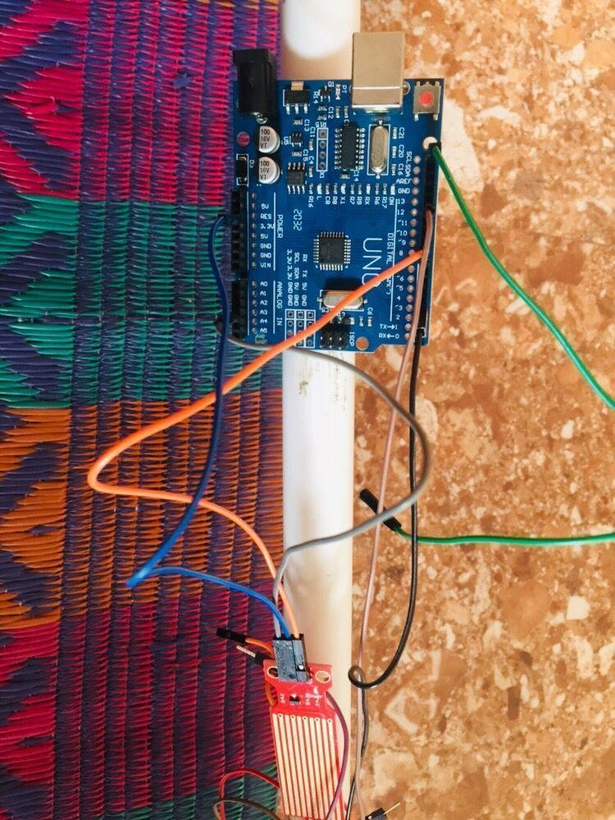
V. FUTURE SCOPE:

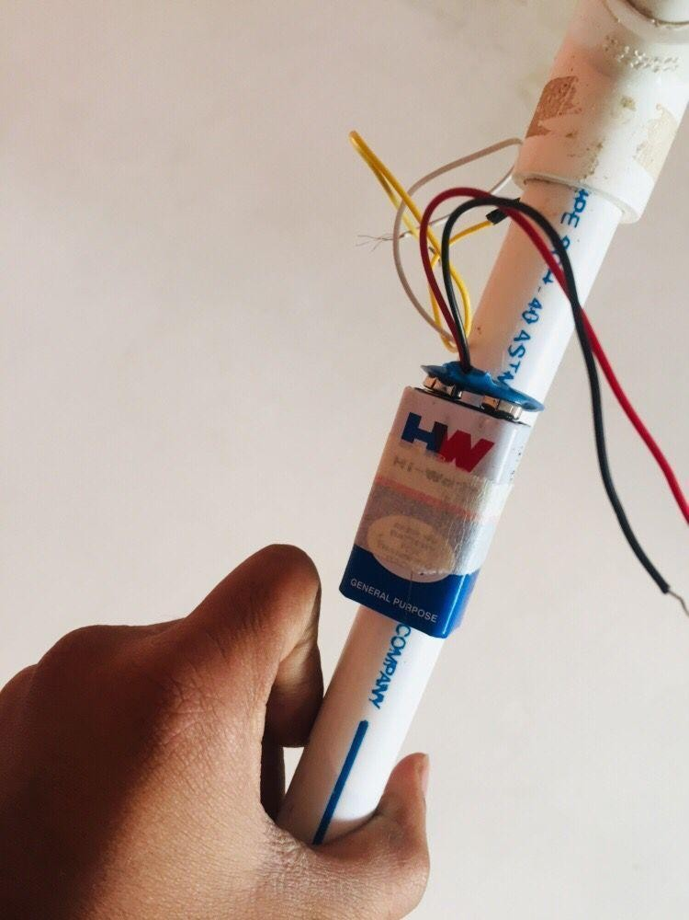
This stick will help in future by becoming a aiding product for blind people. This will be a advanced product for visually impaired people. This stick is cost effective, it has reliability,it is mobile, and it is light weighted. It can be big research because we used sensors for more safety and security purpose this will help in getting proper help for knowing the path. This product can be a third eye for visually impaired people .It is accurate,it provides extra safety
VI. CONCLUSION:

At this stage work has been completed in order to design and implement an smart stick for the blind person. The smart stick has interface for easy and comfortable work for visually impaired people. It's safe and cheap. This results in effective to detect obstacle in range of five meters. It offers low value, reliable, lightweight, low electricity and green navigation with fast, short response instances. Smart Stick only the way through which we can help blind people as the increasing world blindness is also increasing so we need a product through which people will get help we have decided to make a cost-effective product which can be easily available for any age people. In this smart stick we are using very useful sensor which cut the cost of product and make it the best which can be very familiar with any age people. There are Arduino which is coded in embedded c language which gives output by sensing the environment. ultrasonic, water, fire, sensors are used for sensing the environment. Each sensor has its own sensing power like water will be sensed by water sensor, fire will be sensed by fire sensor, and distance and objects will be detected by using ultrasonic sensor.

REFERENCES:

[1] Amit Kumar Thakur, Rajesh Singh, Anita Gehlot, “Smart Blind Stick For Obstacle Detection And Navigation System”, © 2018 Jetir October 2018, Volume 5, Issue 10.

[2] Srinivas, G. M. Raju, D. Ramesh, S. Sivaram, ”Smart Blind Stick Connected System Using Arduino”, Volume 6 Issue 2 April – June 2019.

[3] Pratik N. K, Poornesh V, Shashikant, Shreedhar Kudva & Saritha A N, Smart Blind Stick, International Journal Of Latest Trends In Engineering And Technology” Vol. 8 2012.

[4] Ihab A. Satam, Mokhaled N.A. Al-Hamadani, Alaa H. Ahmed, “Design And Implement A Smart Blind Stick, Jour Of Adv Research In Dynamical & Control Systems”, Vol. 11, No. 8, 2019.

[5] Shruti Dambhare, Prof. A Sakhare, “Smart Stick For Blind: Obstacle Detection, Artificial Vision And Real-Time Assistance Via Gps”, 2011.

[6] World Health Organization, “Visual Impairment And Blindness,” Fact Sheet N “282”, Oct 2014.

[7] T. Terlay and W. M. Penrod,”K’sonar Curriculum Handbook” June 2008.

[8] L. Whitney, “Smart Kane to Hepl Blind Navigate”, availablr from 2009

[9] J.M Hans Du Buf. J. Barraso, Jato M.F. Rodrigues, H. Paredes, M. Farratoto, H. Fernandes J.JOS. V. Tetxetra, M.Saletro,”The Smart Vision Vavigation Prototype for Blind Users”, International Journal od Digital Content Technology and it’s Appication, Vol.5, No.5, PP 351-361, May 2011

[10] J. Ulrich and J. Barenstein,”The Guide Cane-Applying Mobile Robot Technology to assist the Visualiy Impoired”, IEEE Transaction on System , Man, and Cybernetics-Part A: System and Humans , Vol.31, No.2, PP131-136, 2001

[12] Design Of Non-Weighing Type Desert Plant Lysimeter Observation System Based On Pic18. In Information Management, Innovation Management And Industrial Engineering (Iciii), 6th International Conference On Ieee,Vol. 3, Pp. 42-44, 2013.

[13] N.Mahmud, R.K.Saha, R.B. Zafar, M.B.H. Bhuian, And S.S.Sarwar, “Vibration And Voice Operated Navigation System Forvisually Impaired Person,” In Informatics, Electronics & Vision (Iciev), International Conference On Ieee, Pp. 1-5, 2014.

[14] Amjed S. Al-Fahoum, Heba B. Al-Hmoud, And Ausaila A. Al-Fraihat, “A Smart Infrared Microcontroller-Based Blind Guidance System”. Active And Passive Electronic Components, 2013.

[15] Su, B., & Wang, L.“Application Of Proteus Virtual System Modelling (Vsm) In Teaching Of Micro Controller”. In E-Health Networking, Digital Ecosystems And Technologies (Edt), 2010 International Conference On Vol. 2, Pp. 375-378, 2010.

[16] Direct Mode Is 1932. (2009, January 5) [Online]. Https://Www.Futurashop.It/…pdf_eng/7300-Isd1932.Pdf.

[17] Bhatlawande, Shripad S., Jayant Mukhopadhyay, And Manjunatha Mahadevappa. "Ultrasonic Spectacles And Waist-Belt For Visually Impaired And Blind Person." Communications (Ncc), National Conference On. IEEE.

