Advances in Development of Cooling Tower - A review
Rahul V. Fulzele¹, Sushant Gajbhiye²
¹PG Student, Department of Civil Engineering, Guru Nanak Institute of Engineering and Technology, Nagpur
²Assistant Professor, Department of Civil Engineering, Guru Nanak Institute of Engineering and Technology, Nagpur

ABSTRACT:
Natural draught cooling towers are increasingly popular in nuclear and thermal power plants today. They lead to efficient electricity generation and a careful balance with the environment. These towers with incredibly thin shells are impressive structures because of their sheer scale and adaptability to flat loads. Thermal power plants depend heavily on hyperbolic cooling towers. Among natural draught cooling towers, hyperbolic cooling towers are the most commonly used shape. The taller and heavier the tower, the more complex loads and personal weight it is subject to. The paper provides a history of cooling towers and includes information on the most recent natural draught cooling towers. The various simulation, research, and construction technologies are summarised, and the problems encountered are addressed. Furthermore, it offers a range of cooling tower examinations which will provide restructured data for researchers and models working in the field of hyperbolic cooling towers.

1. INTRODUCTION:
Cooling towers are an essential part of power generating networks, and they also help to safeguard the environment. While hyperbolic cooling towers are commonly associated with nuclear and thermal power plants, they are often used to some degree in significant chemical and other industrial plants. They are high rise reinforced concrete buildings in the shape of doubly curved thin-walled shells of complex geometry, as are their study and construction. In these unique systems, the in-plane membrane actions mainly resist applied pressures, with bending playing a secondary role. The history of cooling towers can be traced back to the nineteenth century when condensers were used for steam engines (1902). The first hyperboloid-shaped cooling tower was designed in 1918 near Heerlen by Dutch engineers Frederik van Iterson and Gerard Kuypers and stood 35 metres tall. Prior to 1930, the first 68-meter-tall structures in the United Kingdom were constructed in Liverpool, England. Soon after, heights and capacities improved, and the first cooling tower with a height greater than 100 metres was built at the High Marnham Power Station in the United Kingdom. The 200-meter-high cooling tower installed in 2002 at the Niederaussem power station in Germany was the world's tallest hyperbolic cooling tower until the Kalisindh thermal energy plant was completed in Rajasthan, India, in June 2012. This plant's two towers (Fig. 1) have a height of 202 metres and a base diameter of 142 metres each.
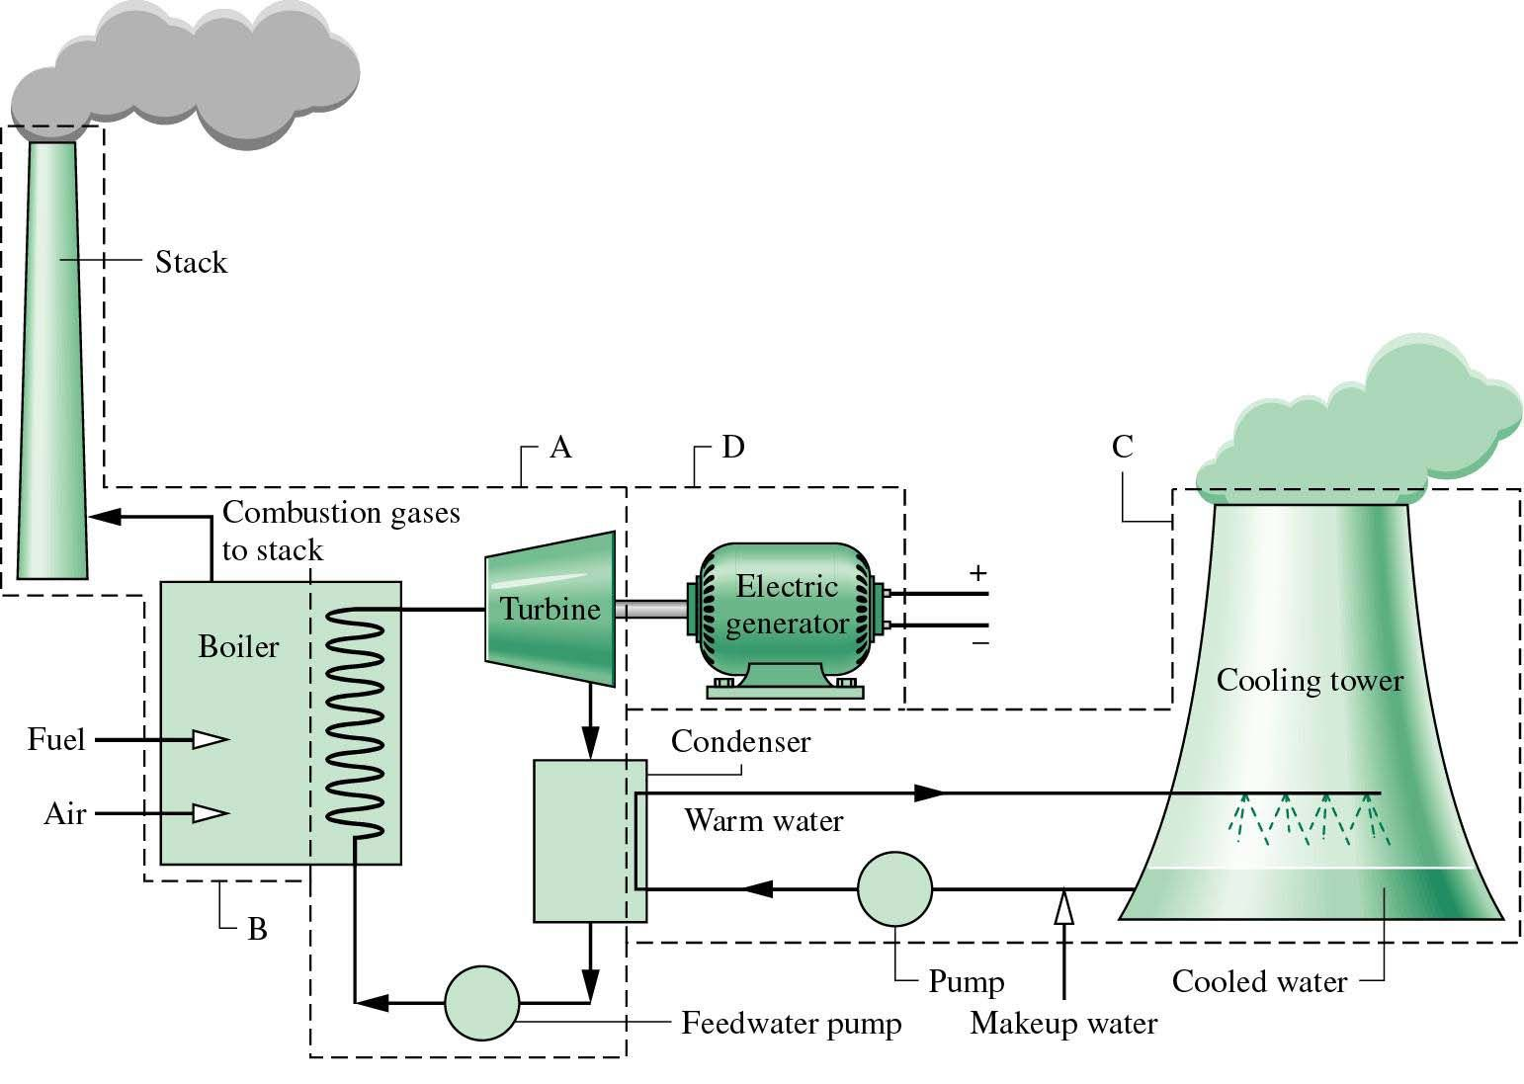
Figure 1. Typical schematic of thermal power plant

Natural draught cooling towers are the most efficient methods for cooling nuclear power plants because they reduce the amount of water used and prevent thermal contamination of natural water sources. As a result, they will balance environmental considerations, expenditures, and maintenance costs with the needs of a stable energy source.
Cooling towers in fossil-fired power plants can be used for more than just cooling water refrigeration; they can also be used to discharge cleaned flue-gases, saving a chimney entirely. This is a unique feature of contemporary European power plants. Figure 1 depicts the most recent cooling tower projects completed or under construction in Germany. The power plants will have a combined capacity of approximately 6 G.W. and will be powered by lignite coal (Boxberg, Neurath, and Niederaußem) or hard coal (Datteln and Hamm). More hard coal-fired power plant projects are planned or under development in Moorburg, Lünen, Wilhelmshaven, Mainz, Maasvlakte, Antwerpen, and Staudinger. They are expected to be completed by 2014 – a massive power plant renewal programme for Germany.

Figure 1 depicts the evolution of natural draught cooling towers over time. Technical cooling systems were first used towards the end of the nineteenth century. The well-known hyperbolic shape of cooling towers was pioneered by two Dutch architects, Van Iterson and Kuyper, who built the first 35-meter-high hyperboloid towers in 1914. Capacity and heights quickly improved until, around 1930, tower heights of 65 m were reached. The High Marnham Power Station towers in Britain were the first to achieve heights of more than 100 metres. Today's tallest cooling towers, which are situated at several EDF nuclear power plants in France, achieve heights of about 170 m. It is also expected that 200-meter-high towers would be built in the early twenty-first century.

2. TYPES OF COOLING TOWERS
The classification of the cooling tower is as shown in figure 2:
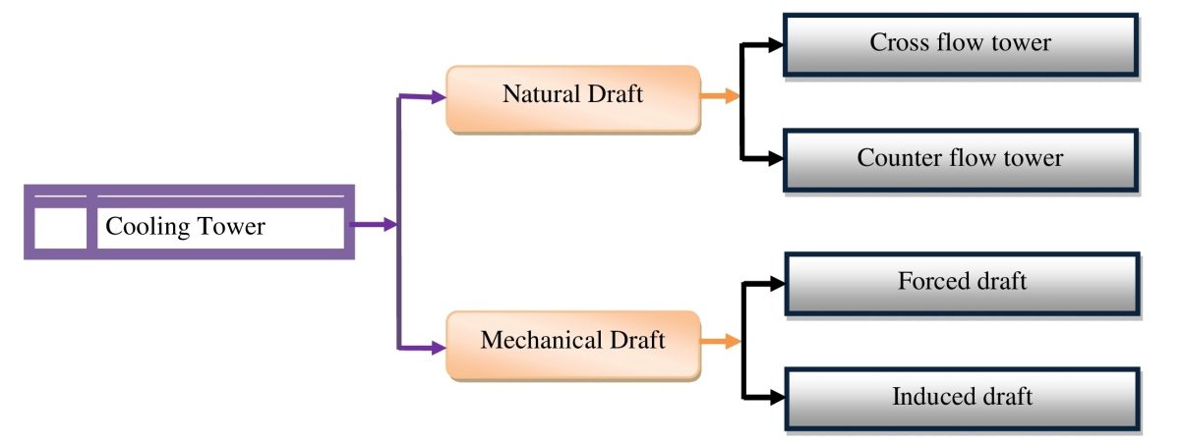
Figure 2. Classification of cooling tower

2.1 NATURAL DRAFT COOLING TOWER:
The natural draught or hyperbolic cooling tower takes advantage of the temperature differential between the outside air and the cooler air inside the tower. Figure 4 depicts a natural draught or hyperbolic cooling tower schematic (a). Since hot air rises, fresh cold air is forced through the tower by an air inlet at the bottom while hot air flows upwards into the tower. Because of the tower's design, no fan is needed, and there is almost no movement of hot air, which could impact results. The tower casing, which can reach a height of 200 metres, is made of concrete. Since massive concrete buildings are costly, these cooling towers are often used for extensive heat duties. Natural draught towers are classified into two types: cross flow towers and counter flow towers. While construction is dependent on complex site requirements, crossflow towers draw air over the falling water and the fill is located outside the tower. In contrast, counter flow towers draw air up from the falling water and the filling is then situated within the tower..

2.2 MECHANICAL DRAFT COOLING TOWER:
Natural draught towers have been phased out of many installations due to their massive size, design problems, and high expense. Figure 4 depicts a mechanical draught hyperbolic cooling tower schematic (a). Big fans push or draw air from circulated water in mechanical draught towers. Water flows downwards over fill surfaces, increasing the interaction time between the water and the air. The cooling rates of mechanical draught towers are affected by various factors, including fan diameter and speed of operation, fills for system resistance, and so on. Mechanical draught cooling towers are classified into two types: forced draught and induced draught.

3. FINITE ELEMENT MODELING
The first cooling tower shell was studied using a shell bending theory in 1967 [1]. Later, Antonov [2] used a fourth-order ordinary differential equation for the normal displacement, ignoring the tangential displacements and their derivatives in the geometrical equations of a bending shell theory. The FEM was first used to analyse hyperbolic cooling tower shell configurations in the 1970s. For the first time, flat triangular finite elements were used. Lochner [3] used a curvilinear triangular shell element with three nodes. Konderla found the numerical solutions of symmetrical [4] and asymmetrical [5] problems of hyperbolic shells of revolution inside the boundaries of a geometrically nonlinear shell theory a year later, using the FEM. Authors [6]-[9] cover detailed investigations on finite element modelling and appropriate elements used in cooling towers analysis.
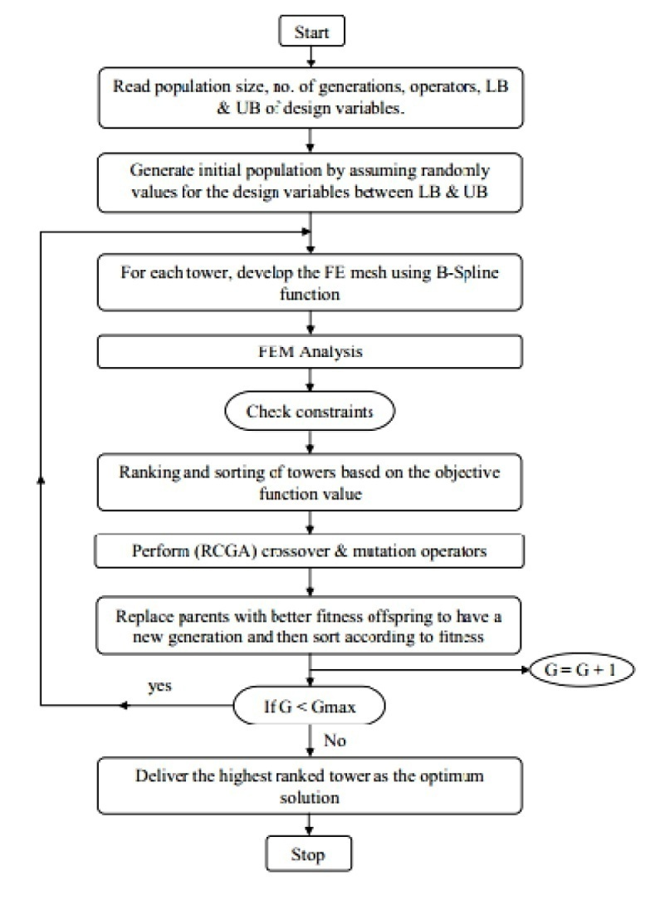
Fig. 3 Flow chart for optimum shape and design of cooling towers [10].

4. NONLINEARITY AND ULTIMATE LOAD
Tensile cracking of concrete has been used in finite element analyses of R.C. systems for the last four decades. To that end, two distinct models have been widely used, all of which are complex and time-consuming: the discrete-cracking model and the smeared-cracking model. To examine the final behaviour of such systems, various nonlinear causes, such as material nonlinearities in the concrete and reinforced steel, tensile cracking, bond effects between concrete and steel in cracked concrete, known as stress stiffening, significant displacement effects, and so on, must be taken into account.
Mang et al. [11] published a detailed numerical investigation of an R.C. hyperbolic cooling tower at Port Gibson, Mississippi, USA, using the Finite Element Method (FEM). They examined the cooling tower shell in terms of massive displacement, concrete splitting, steel yielding, and concrete inelastic behaviour. According to their findings, the complete nonlinear analysis must be conducted while determining the ultimate power of the cooling tower shell since the ultimate load factor obtained by the nonlinear analysis is significantly smaller than that obtained by the buckling analysis. Milford and Schnobrich [12] calculated a load factor of 2.1 when accounting for stress stiffening, crack rotation, and geometrical nonlinearity. Later experiments by Hara et al. [13], Min [14], and Noh [15] came to the same conclusion. Thirty years later, Jia [16] used a different programme to study the same tower using the finite element approach to see if the assumptions based on these observations still apply if much stronger concrete is used and geometric imperfections are taken into account. Considering the significant displacement impact, Mahmoud and Gupta [17] obtained a load factor of 1.73. They suggested that the collapse of the Port Gibson Tower in Mississippi was caused by circumferential buckling near the throat rather than reinforcement yielding, which disputes previous researchers' findings.

5. LOADING, ANALYSES AND RESPONSES
The NDCT shell systems are subjected to stochastic environmental loads such as wind, earthquake, and thermal gradients. Other typical load conditions and multiple unintended loads, such as explosion, that hyperbolic cooling towers often encounter during their lifespan are dead loads, settlement, and building load. For research and design purposes, the results of the different loading conditions are integrated and factored according to the available codes. The self-weight of the tower shell wall, the ribs, and the superimposed load from attachments and devices comprise the dead load. The self weight of the tower causes membrane stress near the top edge, but an axisymmetric and near-membranous state of compression is attained in the shell, and some bending can occur near the supports [18], [19]. Zingoni [18] investigated the self weight for towers with a general form considering a variety of distinct patterns of shell-thickness difference around a meridian. The meridional directed forces generated in the tower shell as a result of the tower's self-weight may cause local (diamond-shaped) buckling or axisymmetric circular buckling [1]. In areas with low seismic activity, self-weight is often analysed in conjunction with wind load for NDCT shell structures. Buckling of the tower shell as a whole can be exacerbated by a mixture of wind load and self-weight, which occurs with significant displacements. There is a significant difference in buckling safety criteria between design codes, requiring either the "snap-through" approach proposed by Der and Fidler [20] and used in British, Indian, and German codes, the local or "buckling stress states" (BSS) approach proposed and developed by Mungan [21]-[23] and also used in German code, or the global approach, which requires a full nonlinear buckling analysis.

6. WIND AND BUCKLING OF THE TOWER
Wind is the primary lateral load, and when combined with the self-weight of the tower shell, it can cause buckling instability and catastrophic collapse. Following the abrupt failure of three massive cooling towers at Ferry-Bridge Power Station in England in 1965, experimental and theoretical studies on the stability of hyperbolic shells were conducted to research the parameters raising the wind resistance and buckling protection cooling towers. Niemann et al. [25] used a new technique of individual equal static loads to measure wind loads on cooling towers. They presented the configuration of the reinforcement in the meridional/circumferential direction and the design against buckling. Karisiddappa et al. [26] investigated column-supported cooling towers for unsymmetrical wind loads. It was carried out an improved 3D finite element formulation of column assisted hyperbolic cooling towers and a practical circumferential wind pressure distribution. As a result, for various wind pressure propagation profiles, meridian membrane forces were more sensitive to pressure variations. Buckling is a major failure consideration in the construction of cylindrical and hyperbolic shells. According to Vaziri et al. [27], the vulnerability of the buckling action of both plates and shells in the presence of defects like cracks is strongly dependent on the loading state. The uniform exterior pressure at which a cylindrical shell buckles is highly dependent on the cylinder's geometry. Buckling power decreases gradually as the buckle lengthens, resulting in a lower critical buckling pressure for longer cylinders. Buckling resistance is also influenced by cylinder thickness, with thinner cylinders having lower critical buckling pressures [28].
Wind-induced cooling tower reaction is a critical factor in improving protection and reducing tower cracks [29]. At the moment, research on large cooling towers is based on the material properties of the tower's shell structure, such as multi-layered nonlinear concrete shell [29], and the structural behaviour under external environment [30], [31], especially under wind loads.
There are three techniques for doing wind load analysis. One can obtain the wind pressure coefficient, shape variables, and wind-induced vibration coefficient from studies [32], [33]. The second method is to use CFD (computational fluid dynamics) analysis to specifically quantify the wind pressure and velocity distribution using the necessary turbulence models [34], [35]. The third step is to do spectral research on the tower's wind spectra. Goudarzi et al. [36, 37] investigated the impact of NDCT geometry features on the construction of a pressure field around Iran's Kazerun power plant.

7. COOLING TOWER EFFICIENCY
Normally, cooling towers are built for stationary ambient air conditions, but experimental observations revealed that cooling performance varied as a function of cross-wind velocity. Under cross-wind conditions, the cooling performance of a natural draught cooling tower (NDCT) is greatly reduced and can drop to 75% in the context of moderate to high wind-velocity conditions. Separated flow at the rear radiators, along with a deflected plume escaping the tower stack, limits cooling performance [38]. Experimental and numerical measurements also found that the cooling tower's heat transfer potential increased proportionally with wind velocity up to 3 m/s and then decreased with higher wind velocity [39]. Several researchers have investigated the impact of wind on cooling tower performance and the methods for improving it. Du Preez and Kroger [40] conducted the first numerical analysis to demonstrate the wind effect on the air flow area through the cooling tower. Other researchers demonstrated identically that two factors decreased cooling efficiency: flow acceleration near the sideward radiators trailing with a flow separation beside the rearward radiators, and plume deflection at the tower stack's escape plane [41]. The same unfavourable cross-wind effects on the thermal efficiency of a natural draught wet cooling tower were recorded in [42-44].

8. CONCLUSION
The most recent theatrical and experimental advancements and new accomplishments in the study and architecture of natural draught hyperbolic cooling towers are briefly explored. This research has monitored the different factors in the cooling tower analysis and design. This study is a comprehensive set of cooling tower studies that will provide up-to-date and appropriate resources for further analysis in this area.

References:
[1] S.N. Krivoshapko,"Static, vibration, and buckling analyses and applications to one-sheet hyperboloidal shells of revolution," American Society of Mechanical Engineers, vol. 55, no.3, pp. 241-270, 2002.
[2] Belkhode, P. N. (2019). Analysis and Interpretation of Steering Geometry of Automobile Using Artificial Neural Network Simulation. Engineering, 11(04), 231–239. doi:10.4236/eng.2019.114016.
[3] N. Lochner, "Die Anwendung des Schalen elements, " SHEBA, Finite Element Static, Berlin, 1973, pp. 353–372.
[4] Shelare, S. D., Aglawe, K. R., Waghmare, S. N., & Belkhode, P. N. (2021). Advances in water sample collections with a drone – A review. Materials Today: Proceedings. doi:10.1016/j.matpr.2021.05.327.
[5] P. Konderla, "Nieliniowe rozwiazanie powloki o ksztalcie hiperboloidy jednopowlokowej, Cz.II, obciazenie niesymetryczne," Arch. inz. lad, vol. 20, no. 3, pp. 517–533 (in Polish), 1974.
[6] T.Y. Yang, and K. K. Rakesh, "Shell Elements for Cooling Tower Analysis, " J. Eng. Mech, vol. 109, no. 5, pp. 1270-1289, 1983.
[7] Dhutekar, P., Mehta, G., Modak, J., Shelare, S., & Belkhode, P. (2021). Establishment of mathematical model for minimization of human energy in a plastic moulding operation. Materials Today: Proceedings. doi:10.1016/j.matpr.2021.05.330.
[8] R.L. Nelson, and D.L. Thomas, "Free vibration analysis of cooling towers with column supports," Journal of Sound and Vibration, vol. 57, no. 1, pp. 149–153, 1978.
[9] M. Özakça, and E. Hinton, "Free vibration analysis and optimisation of axisymmetric plates and shells—I. Finite element formulation," Computers & Structures, vol. 52, no. 6, pp. 1181–1197, 1994.
[10] Belkhode, P. N. (2019). Development of mathematical model and artificial neural network simulation to predict the performance of manual loading operation of underground mines. Journal of Materials Research and Technology, 8(2), 2309–2315. doi:10.1016/j.jmrt.2019.04.015
[11] H. A. Mang, H. Floegl, F. Trappel, and H. Walter, "Wind-loaded reinforced concrete cooling towers: buckling or ultimate load?," Engineering Structures, vol. 5, no. 3, pp. 163–80, 1983.
[12] Modak, J. P., Mehta, G. D., & Belkhode, P. N. (2004). Computer Aided Dynamic Analysis of the Drive of a Chain Conveyor. Manufacturing Engineering and Materials Handling Engineering. doi:10.1115/imece2004-59157.
[13] T. Hara, S. Kato, and H. Nakamura, "Ultimate strength of R.C. cooling tower shells subjected to wind load," Engineering Structures, vol. 16, no. 3, pp. 171–180, 1994.
[14] Bejalwar, A., & Belkhode, P. (2018). Analysis of Experimental Setup of a Small Solar Chimney Power Plant. Procedia Manufacturing, 20, 481–486. doi:10.1016/j.promfg.2018.02.071.
[15] H. C. Noh, "Ultimate strength of large scale reinforced concrete thin shell structures, " Thin-Walled Structures, vol. 43, no. 9, pp.1418–1443, 2005.
[16] Belkhode, P. N. (2019). Optimum Choice of the Front Suspension of an Automobile. Journal of Engineering Sciences, 6(1), e21–e24. doi:10.21272/jes.2019.6(1).e4.
[17] B.E.H. Mahmoud, and A.K. Gupta, "Inelastic large displacement behavior and buckling of cooling tower," Journal of Structural Engineering, ASCE, vo. 121, no. 6, pp.981–985, 1995.
[18] Belkhode, P. N., Ganvir, V. N., Shende, A. C., & Shelare, S. D. (2021). Utilization of waste transformer oil as a fuel in diesel engine. Materials Today: Proceedings. doi:10.1016/j.matpr.2021.02.008.
[19] Zingoni A., "Shell structures in civil and mechanical engineering" London: Thomas Telford; 1997.
[20] Aglawe, K. R., Yadav, R. K., & Thool, S. B. (2021). Preparation, applications and challenges of nanofluids in electronic cooling: A systematic review. Materials Today: Proceedings, 43, 366–372. doi:10.1016/j.matpr.2020.11.679.
[21] I. Mungan, "Buckling stress states of hyperboloidal shells," ASCE Journal of Structural Engineering, vol. 102, no. 10, 2005–2020, 1976.
[22] Waghmare S., Sirsat P., Sakhale C., Shelare S., Awatade S. (2017) A Case Study on Improvement of Plant Layout for Effective Production. International Journal of Mechanical and Production Engineering Research and Development, Volume 7, Issue 5, Oct 2017. Pp. 155-160.
[23] Mungan, I., "Buckling of reinforcedconcrete cooling tower shells", BSS approach, ACI Journal 1982, 88(3), 387–391
[24] Waghmare S., Mungle N., Tembhurkar C., Shelare S., Sirsat P., Pathare N. (2019) Design and Analysis of Power Screw for Manhole Cover Lifter. International Journal of Recent Technology and Engineering, Volume 8, Issue 2, July 2019. Pp. 2782-2786, DOI: 10.35940/ijrte.B2628.078219.
[25] H. Niemann, and M. Kasperski, "The assessment of wind loads on cooling towers, builds aerodynamics laboratory," Ruhr University at Bochum, Germany, 1990, pp. 101–112.
[26] Mowade, S., Waghmare, S., Shelare, S., & Tembhurkar, C. (2019). Mathematical Model for Convective Heat Transfer Coefficient During Solar Drying Process of Green Herbs. Computing in Engineering and Technology, 867–877. doi:10.1007/978-981-32-9515-5_81.
[27] Mathew, J. J., Sakhale, C. N., & Shelare, S. D. (2020). Latest Trends in Sheet Metal Components and Its Processes—A Literature Review. Algorithms for Intelligent Systems, 565–574. doi:10.1007/978-981-15-0222-4_54.
[28] K. R. Aglawe, et al.,, K. R. A., et al.,. (2020). Geometric Analysis and Scope of Nanofluid in Micro Channel Heat Sinks for Electronic Cooling Application - A Review. International Journal of Mechanical and Production Engineering Research and Development, 10(3), 12447–12468. doi:10.24247/ijmperdjun2020118.
[29] W. F. Chen, and M.L. Eric, "Handbook of structural engineering," CRC Press, Boca Raton, New York 2005.
[30] Dhande, H. K., S. D. Shelare, P. B. Khope. 2020. Developing a mixed solar drier for improved postharvest handling of food grains. Agricultural Engineering International: CIGR Journal, 22(4): 166-173.
[31] M. N. Viladkara, P.B. Karisiddappa, and P.N. Godbole, "Static soil– structure interaction response of hyperbolic cooling towers to symmetrical wind loads," Elsevier, Engineering Structures, vol. 28, no. 9, pp. 1236–1251, 2006.
[32] J. Noorzaei, A. Naghshineh, M.R. Abdul Kadir, W.A. Thanoon, and M.S. Jaafar, "Nonlinear interative analysis of cooling tower–foundation– soil interaction under unsymmetrical wind load," Thin-Walled Structures, vol. 44, pp. 997-1005, 2006.
[33] Jawalekar, S. B., and S. D. Shelare. 2020. Development and performance analysis of low cost combined harvester for rabicrops. Agricultural Engineering International:CIGR Journal, 22 (1):197-201.
[34] J. Y. Li, C.L. Ren, and Z.L. Huang, "Experiment study and finite element analysis of a natural draft cooling tower," Chinese Quarterly of Mechanics, vol. 3, no. 28, pp. 443-447, 2007.
[35] Waghmare S., Shelare S., Sirsat P., Pathare N, Awatade S. (2020) Development Of An Innovative Multi-Operational Furnace. International Journal of Scientific & Technology Research Volume 9, Issue 04, April 2020. Pp 885-889.
[36] R. Meroney, "CFD prediction of cooling tower drift," Journal of Wind Engineering and Industrial Aerodynamics, vol. 94, pp. 463-490, 2006.
[37] Shelare, S. D., Kumar, R., & Khope, P. B. (2020). Formulation of a Mathematical Model for Quantity of Deshelled Nut in Charoli Nut Deshelling Machine. Advances in Metrology and Measurement of Engineering Surfaces, 89–97. doi:10.1007/978-981-15-5151-2_9.
[38] M. Goodarzi, "A proposed stack configuration for dry cooling tower to improve cooling efficiency under crosswind," J Wind Eng Ind Aerodynam, vol. 98, pp. 858–863, 2010.
[39] N. Kapas, "Behavior of Natural Draught Cooling Towers in Wind," CMFF, Budapest, Hungary, 2003, 30
[40] A.F. Du Preez, D.G. Kroger, "Effect of wind performance on a dry cooling tower," J. Heat Recovery Syst. CHP, vol.13, no. 2, pp. 139–146, 1993.
[41] Waghmare, S. N., Shelare, S. D., Tembhurkar, C. K., & Jawalekar, S. B. (2020). Development of a Model for the Number of Bends During Stirrup Making Process. Advances in Metrology and Measurement of Engineering Surfaces, 69–78. doi:10.1007/978-981-15-5151-2_7
[42] Shelare, S. D., Kumar, R., & Khope P. B. (2021). ASSESSMENT OF PHYSICAL, FRICTIONAL AND AERODYNAMIC PROPERTIES OF CHAROLI (Buchanania Lanzan Spreng) NUT AS POTENTIALS FOR DEVELOPMENT OF PROCESSING MACHINES. Carpathian Journal of Food Science and Technology, 174–191. doi:10.34302/crpjfst/2021.13.2.16.
[43] Waghmare, S. N., Sakhale, C. N., Tembhurkar, C. K., & Shelare, S. D. (2019). Assessment of Average Resistive Torque for Human-Powered Stirrup Making Process. Computing in Engineering and Technology, 845–853. doi:10.1007/978-981-32-9515-5_79.
[44] Z. Zhai, and S. Fu, "Improving cooling efficiency of dry-cooling towers under cross-wind conditions by using wind-breaker methods," Appl Therm Eng, 2006, 26, 1008–1017.

