Design and Analysis of Pesticides and Insecticide Spraying Machine
(Raghav Pimplapure, Yash Kshirsagar, Ajinkya Dehankar, Alkesh Jiwtode, Arjun Kukreja, Adlena Peter, Surbhi Ikhar${}^{a}$
(Prof. G. T. Dhanuskar${}^{b}$
$a_{\left(UGScholer,PriyadarshiniCollegeofEngineering\right)}$
$b_{\left(Professor,PriyadarshiniCollegeofEngineering\right)}$

Abstract: India is an agriculture based country in which, 70% of people depends on the outcome of farming. But if we observe that with increase in population the farms gets distributed among the family and because of this, farmer in India held averagely only 5 acre far. Also economically, farmers are very poor due to which they are unable to purchase or hire the human labours and farmers in India also use bullocks, horses and he-buffalo for farming operation. This will not satisfy need of energy requirement of the farming as compared to other countries in the world. So we are thinking that human and animal efforts can be replaced by some advance mechanization which will be suitable for small scale farmer from economical and effort point of view. So we are developing this equipment which will satisfy the need of spraying pesticides and herbicides and to solve labour problem. This unit is working on the power obtained from a 30hp tractor via PTO shaft. The unit is joined to the tractor by connecting it on the lower arm of tractor other costly equipments hence they use traditional method of farming. Basically, many and unit by means of coupling. The power turnover is connected to the double acting reciprocating pump. This machine performs spraying operation of various pesticides and herbicides by attachment with tractor.

- INTRODUCTION
India is an agriculture based country in which 70% of people depend on the outcome of farming. Also agriculture occupies a key position in INDIAN economy. It contributes approx 40% in national GDP. But in our observation we find that the farmers in INDIA held averagely only 5 acre farm. Also economically farmers are very poor to purchase tractor and other agro equipment and they use traditional method of farming.
This will not satisfy need of energy requirement of farming as compare to other countries in the world.All the procedures and practices of farming are ancient and out of date.. All the procedures and practices adopted by the farmers for farming are ancient and are out of date.
For most economic farming and to increase the economic working, it is very necessary to bring new ideas and technology in farming. Farm mechanization could be described as the application of labor-saving devices in carrying out farm activities.
Agricultural mechanization is the application and adoption of agricultural engineering principles and technologies to agriculture, using mechanical systems, The term “mechanization” is used to describe tools, implements and machinery applied to improving the productivity of farm labor and of land; it may use either human, animal or motorized power, or a combination of these.
- LITERATURE REVIEW
M. V. Achuta, Sarnath Chandra.N, Natraj G.K. ), concept design and analysis of multipurpose farm equipment. , International journal of innovative research in advanced engineering (IJIRAE) ISSN: 2349-2763 ISSUE 02 , Volume 3 (February 2016)
From this paper we learned about the agricultural scenario of INDIA. We learned about the spraying methods protect crops and trees against deceases and insects

]Shailesh Malonde , Shubham Kathwate , pratik kolhe , Rodney Jacob , Nishant Ingole , Rupesh d. Khorgade Design And Development Of Multipurpose Pesticides Spraying Machine, International Journal Of Advanced Engineering And Global Technology Vol-04 , Issue -03 May 2016
From this paper we acquired the information about previously designed pesticide spraying machine. We learned about various design methodologies used to design the spraying machine

Prashant Kshirsagar, Kuldip Ghotan , Pritesh Kadam , Omkar Arekar , Ketan Insulkar . Modelling And Analysis Of Multifunctional Agriculture Vehicle. International Journal Of Research In Advent Technology Vol.04 No.1 , January 2016 E-ISSN :2321-9637
In this paper author has mentioned importance of mechanization in agricultural by giving example. From this paper we acquired the information about previously designed pesticide spraying machine. We learned about various design methodologies used to design the spraying machine.

Ebeworse s. O. Adaptation level of farm machines by crop farmers in delta state, Nigeria. Scholars journal of agriculture and veterinary sciences e- ISSN 2348-1854 January 2016
We learned the impact of mechanization in agricultural

Nasir .S. Hassen ,Nor Azwadi .C.Sidik And Jamaludin. M Sheriff .Effect Of Nozzle Type, Angle and Pressure on Spray Volumetric Distribution of Broadcasting and Banding Application. Journal Of Mechanical Engineering Research Vol5(4) Pp. 76-81 , April 2013
We learned about the various nozzle specification, their effect with respect to nozzle type angel and pressure

Siddhartha Kshirsagar , Vaibhav Dadmal, Prashant Umak ,Govind Munde And P.R. Mahale . Design And Development Of Agriculture Sprayer Vehicle . International Journal Of Current Engineering And Technology E-ISSN 2277-4106 (March 2016)
Comparison of traditional and modern techniques of spraying has been studied. We have selected our objective for design methodology
Capillary

- DESIGN MODEL AND COMPONENTS OF THE SYSTEM

- Components of the System
1. Frame
It consists of an external framework that supports man-made objects in its construction & use. It is analogous to an animal skeleton. An example of a frame is the under part of a motor vehicle, consisting of a frame. If the running gear such as wheels is included then the assembly is described as a rolling frame
2. Reciprocating Pump
In our project we are using single acting pump. But in actual practice we need double acting reciprocating pump or power turn over pump/ PTO pump
A single acting reciprocating pump, which consists of a piston moves forwards and backwards in a close fitting cylinder. The movement of the piston is obtained by connecting the piston rod to crank by means of a connecting rod.
The crank is rotated by means of an electric motor. Suction and delivery pipes with suction valve and delivery valve are connected to the cylinder. The suction and delivery valves are one way valves or non-return valves, which allow the water to flow in one direction only. Suction valve allows water from suction pipe to the cylinder which delivery valve allows water from cylinder to delivery pipe.
The rotation of the crank brings about an outward and inward movement of the piston ‘P’ in the cylinder ‘C’. During the suction stroke the piston is moving towards right in the cylinder, this movement of piston causes vacuum in the cylinder.

3. Nozzle
The nozzle is a critical part of any sprayer. Nozzles perform three functions:
1. Regulate flow
2. Atomize the mixture into droplets
3. Disperse the spray in a desirable pattern.
Nozzles are generally best suited for certain purposes and less desirable for others. In general, herbicides are most effective when applied as droplets of approximately 250 microns; fungicides are most effective at 100 to 150 microns, and insecticides at about 100 microns.

- Construction and Working

Basically our unit require a tractor, power turn over shaft, tank, double acting reciprocating pump/ power turn over pump, nozzle. We are fabricating the demo model / prototype of our model. The source of power to the pump is obtained from the engine of tractor. To run the pump we have to maintain the constant speed of tractor at above 2500.
In our project we are substituting the single phase A.C motor of 1 HP. The reciprocating pump is connected to the motor by means of belt drive Further inlet of pump is connected to tank and the outlet to the adjustable nozzle. The angle of nozzle can be changed.
When the motor rotates along with it pump also rotates which may result to create the partial vacuum at inlet and the liquid in the tank is pulled up. Inside the cylinder due to

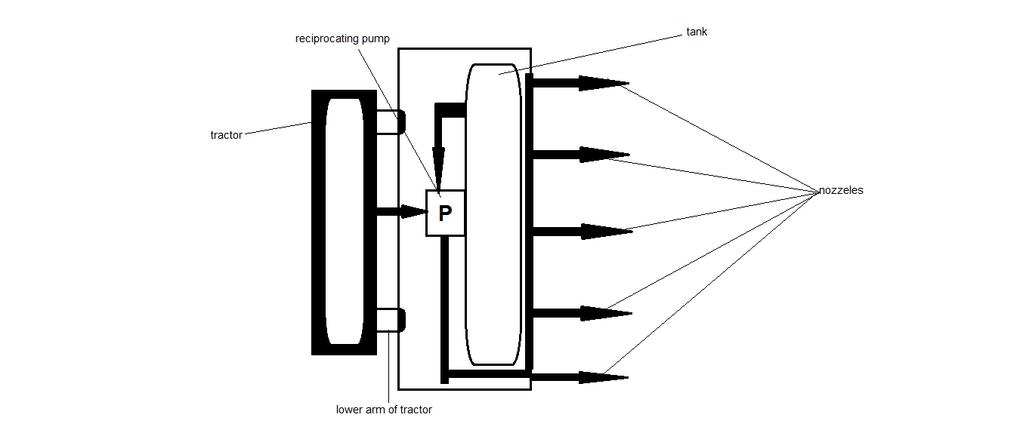
Fig. Block diagram of unit.
compression by the piston the liquid with high pressure is discharged.
This discharged liquid is sprayed on the crops with use of diffuser nozzle.

- Results and Observations
As per survey and research following are the parameters which have been studied following results are obtained.

Table 5.1 Result and observation
Sr . no. | Parameter | Spraying machine
1 | construction | Light and compact
2 | weight | 30 kg
3 | Power required | 1 hp
4 | efficiency | High
5 | Cost | Low
6 | Maintenance | Low
7 | Ground clearance | High
8 | Versatility | More

- Conclusion
After manufacturing and analysis on automatic pesticides and insecticides spraying machine, conclusion which we made are as follows:
Based on the overall performance of the machine we can definitely say that the project will satisfy the need of small scale farmers, because they are not able to purchase costly agricultural equipment.
The machine required less man power and less time compared to traditional methods, so if we manufacture it on a large scale its cost gets significantly reduced and we hope this will satisfy the partial thrust of Indian agriculture
- Future Scope
- We can interface sensors to this unit so that it can monitor some parameters
- We can add wireless technology to control machine
- We can add multiple nozzle attachments with various diffusers and hoods
- We can add solar panel to run the pump
- We may use power take off pump instead of double acting reciprocating pump
- We can develop various extensions for spraying on wide range of crops, trees etc.
- We can use the pressure developed by the equipment for advanced spraying technique which will consume less time.

REFERENCES
- M. V. Achuta, sarnath chandra.n, natraj g.k.), concept design and analysis of multipurpose farm equipment. , international journal of innovative research in advanced engineering (ijirae) issn: 2349-2763 issue 02 , volume 3 (february 2016)
- Shailesh malonde , shubham kathwate , pratik kolhe , roadney jacob , nishant ingole , rupesh d. Khorgade design and development of multipurpose pesticides spraying machine, international journal of advanced engineering and global technology vol-04 , issue -03 may 2016
- Prashant kshirsagar , kuldip ghotan , pritesh kadam , omkar arekar , ketan insulkar . Modeling and analysis of multifunctional agriculture vehicle . International journal of research in advent technology vol.04 no.1 , January 2016 e-issn :2321-9637
- Ebeworse s. O. Adaptation level of farm machines by crop farmers in delta state, Nigeria. Scholars journal of agriculture and veterinary sciences e- issn 2348-1854 January 2016
- Nasir .s. Hassen ,nor azwadi .c.sidik and jamaludin. M sheriff .effect of nozzle type, angle and pressure on spray volumetric distribution of broadcasting and banding application. Journal of mechanical engineering research vol5(4) pp. 76-81 , April 2013
- Siddharth kshirsagar , vaibhav dadmal, prashant umak ,govind munde and p.r. Mahale . Design and development of agriculture sprayer vehicle . International journal of current engineering and technology e-issn 2277-4106 (march 2016)

