Online Examination System

Anshul Rajurkar¹,Rushikesh Shinde² ,Hritik Parate³,Gopal Jsani⁴,Aditi mate⁵,Prerna Uprikar⁶

- Sandhya Dhage, Professor G.H. Raisoni Institute of Engineering And Technology, Nagpur ,India , 440028

anshul.rajurkar.cs@ghrietn.raisoni.net
Received on: 11 June ,2022 Revised on: 08 August ,2022, Published on: 10 August ,2022

Abstract: - Projects play an important role in the education system. At the end of 2019, COVID 2019 came into existence which made people quarantined in their places. At that time learning and education did not stop. Learning through the video calls and watching videos made learning ease at that time. Conforming to the project title, introducing the project to the guide, project in-charge, HODs, and making proper communication was tedious. This generates the need for automating the process. An efficient Online Examination system not only ensures significant of let the students to give the online exams through this website, which made easy for students to learn as well as to practice test papers. The main object of this research is to give the exams online because of the conditions of COVID-19 Which were the tough years to give the exams offline by the afraid of offline exams. EXAM or Online Examination System a desktop app and which is for online exam registration. MySql used for database management and php used as back end scripting language, javascript as front end. The future scope of this project is to work on candidate, admin, super-admin panel functionalities with full determinations to deliver EXAM project well and good.
Keywords: -MySql used for database management and php used as back end scripting language, javascript as front end
- INTRODUCTION
EXAM is a desktop app and which is for online exam registration. MySql used for database management and php used as backend scripting language, JavaScript as frontend. The future scope of this project is to work on candidate, admin, super admin panel functionalities with full determinations to deliver EXAM project well and good. Online Examination System is a technology- driven way to simplify examination activities like defining exam patterns with question banks, defining exam timer, objective/ subjective question sections, conducting exams using the computer or mobile devices in a paperless manner. Online Examination System is a cost-effective, scalable way to convert traditional pen and paper-based exams to online and paper less mode. Candidates can appear for the exam using any desktop, laptop, or mobile device with a browser. Exam results can be generated instantly for the objective type of questions. It can simplify overall examination management and result in generation activity. Today, Online Examination System is considered a fast-developing examination method because of its accuracy and speed. It is also needed less manpower to handle the examination. It is used to conduct assessment test, aptitude test, psychometric test, personality test, entrance exam and campus exams. Organizations can also easily monitor the progress of the student that they give through an examination [1]. As a result of this, the result is calculated in less time. It also helps diminishing the need for paper. Online examination project in PHP is very useful to learn it, According to today’s requirement Online examination system is significantly important to the educational institution to prepare the exams, saving the time and effort that is required to check the exam papers and to prepare the results reports.
- LITERATURE REVIEW

Online examination system is one of the methods of taking exams which is doesn’t require any kind of a piece of paper or a pen. It is the fast growing method to take exams over online. Speed and accuracy is the reason behind the famous of this method because speed and accuracy is the backbone of this system. Many researchers have already researched about online examination system and we have developed a online examination system to keep an eye on this researches as a reference and these all are the following: [2]Zhenming et al (2003):They developed an online examination system based on web browser/server framework.[3]SIETTE Guzman and Cenejo (2005):They developed a online examination system called as SIETTE; (System of intelligent Evaluation using Tests for Tele education). [4]Ayo et a (2007):They proposed a model of e- examination.[5]Jim and sean (2006):They justified the eassessment can be taken in different ways.[6]Zhenming et al (2003):They developed an online examination system based on web browser/server framework. Which supports some premium basic features ,carriers out the examination and provide the auto grading system for objective questions and operating questions like programming, edit MS word,Power point,MS windows, Excel etc. These are the really necessary keywords of any developed system.SIETTE Guzman and Cenejo (2005):They developed a online examination system called as SIETTE (System of intelligent Evaluation using Tests for Tele education).The above developed system supports the login and some basic features but doesn’t supports the premium features such as random questions selection ,random choices distribution, resumption capabilities, random questions distribution.
Ayo et a (2007): They proposed a model of e- examination. The software was developed in private university in Nigeria. The reason behind the developed such as software is to conduct the entrance examination for all Nigeria universities called JAMB(Joint Admission Matriculation Board). This software was designed and tested in Covenant university they were the private university in Nigeria. They foundthe software really helpful for conducting neat and clean with accuracy entrance examination. It is eliminates the problems that are associated with the traditional methods of entrance examination. Jim and sean (2006):They justified the assessment can be taken in different ways. First of all they made a e-assessment via internet and then the mindset has been done that we can enhance the e- assessment to a online examination system. And they thought that there will be a many different ways to take the assessment and examination. They continuously added the content and they took the shape of e- examination portal finally. Because it is the far away different and accurate than of the traditional method to take any of the entrance examination or assessment. Computer based examination is one of the best and satisfied method of taking.
System Design:-
System Design Online Examination System is a web based application system is available at www.ex-am.com is EXAM project website. Superadding and admin can schedule exam and survey to candidates. Candidates can attend live exams and surveys with mail notifications and can receive certificate if got pass in live exam without functionality issues.

- SUPER ADMIN PANEL- This is the main panel of the website which has access to all the working system of the website.

- ADMIN panel: - This Is for the higher authority just like teachers which handles the paper attending and the paper setting in the website.

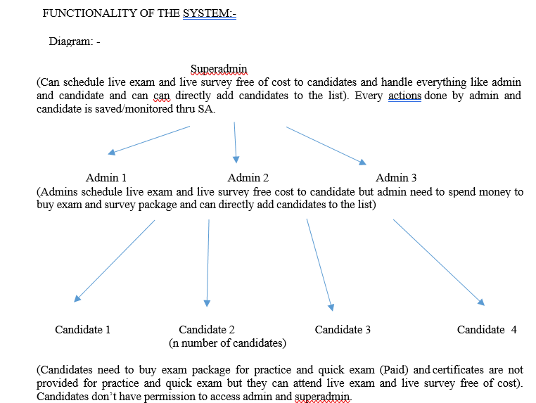
- Candidate login: This is for the students that registered for the site for the paper sample, practicing and to attain the online examination
Online examination system can make the student’s life easier because they don’t need any paper and pen for examination. It is eco-friendly and forward-thinking approach to daily processes is essential in a world where students can graduate into an environmental crisis caused by climate change. Students will imbibe these values over the course of their education. online examination can be effective and efficient. The students don’t waste so much time to answer the questions because they only click on the best answer that is provided.
Great features with this exam conducting system is that there is not any compromise with data security. Question paper leak in online examination is not possible at all. All can full believe on examination process over its security feature. In this online system, set of question papers are a lock in a security system an thatwill only open at the time of examination. The sheer amount of resources that can be used to set up a single exam is mindboggling — from teachers setting the test to administrators ensuring that all students receive enough copies of the exam paper. The online examination system removes many of these procedures and the related labor costs, which have a significant and positive impact
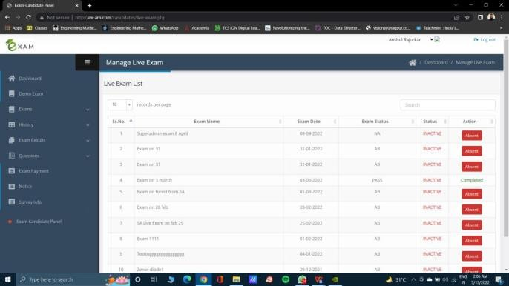
on the bottom line of the method implementing educational institution. Another advantage of online examination is that we can know our scores just after the exam. Student can give online exam anytime anywhere. Report analysis can check anytime and can improve yourself. The major feature which adds up to the online examination system. It can serve a larger audience and has the potential to do so. Sometimes, instructors can be very busy on a given day and do not have any time to check the exams. Online examination can solve this problem. The instructor does not need to check all of the exams. Online examination can do. It can be easily accessed 24/7 over the open test period. It can be timed to allow M minutes to answer N number of questions. It gives immediate test feedback when a test is submitted. Students can take advantage of special media; video, audio, or pictures.
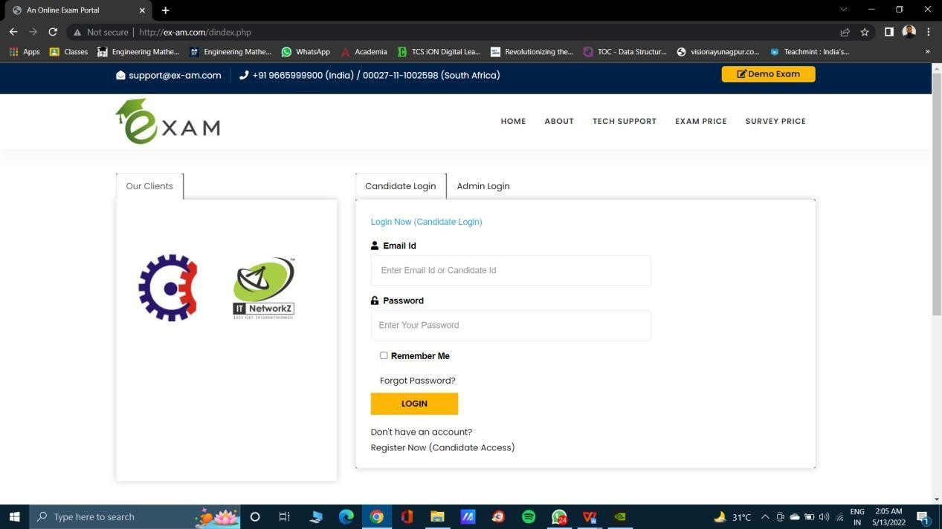
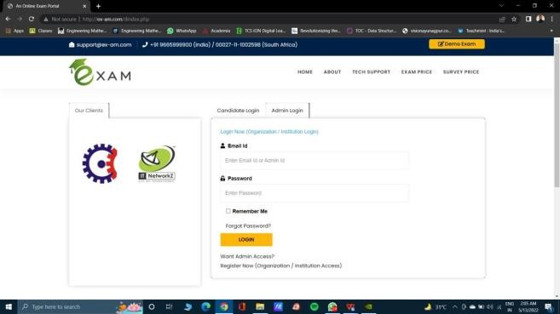
Student can check their progress on a single click. This enables you to track the report and progress of a child just on a click. Improvement in a child is checked through a progress report made by the website.

Conclusion:-
This system seeks to research the current popular examination system, build a set of common examinations for the college platform, and provide a good environment for arranging exams.

Expected output:-
Candidates can be scheduled for exams and surveys by Superadmin, and admin. Candidates can participate in live tests and surveys via email notifications, and if they pass the live exam, they will obtain a certificate.

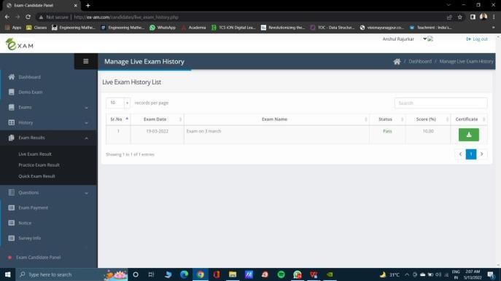

REFERENCE
[1] Sweaver D., et.al. 9 (2005) , Evaluation: WebCT and the student experience. Evaluation and assessment Conference
[2] Yang Zhigang, Network Optimization algorithms in test system [j] lectures 2006,1:91-92
[3] Li Yueru, Algorithmic Online Examination System Design [J]. Fijian computer. 2009, 1:66-67
[4] Li Xueling Guan Qun, Design and implementation of Online Examination System Based on PHP technology
[5] Yin Xiaoling, Xia Qishou, Fan Xuli, Analysis and study of Volume Patteren in Network Text Sysstem.

