Achieving Economical High Rise Steel Structure Using PEB With Use Of Different Advanced Technologies

Pratik Deshmukh¹, Prof RVRK Prasad², Dr Ramesh Meghrajani ³
¹M.Tech Fourth Semester Student, Professor
KDK College Of Engineering, Nagpur, India, 440008
²Associate Professor. R.V.R.K Prasad,
KDK College Of Engineering, Nagpur, India, 440008
³Dr.Ramesh Meghrajani ,
MD Neo Consultants Nagpur

Received on: xxxx,20xx, Revised on: xxxx,20xx, Published on: xxxx,20xx

Abstract – High rise structure due to its exposure to various gravity loads,lateral loads and the exponential height of structure has become a costlier solution.The increasing cost of concrete structure and the lead time of construction in concrete high rise structure has given chance to explore and research new technologies and new materials to make the structure more stable and economical. PEB is one of the construction type that can make building light weight yet strong in strength. This paper highlights all the research carried out on Steel high rise building with respect to loading's,material,different lateral systems,floor types and code references of various countries.The paper also includes the comparison of conventional steel building section sizes and PEB section sizes with its advantages over conventional steel building.
Keywords- High Rise Structure,Pre-Engineered Building,Lateral Systems,Steel Structures, floor types,advanced construction technologies,shear walls,cold form steel
INTRODUCTION
The need of an hour for High Rise building is the use of light weight and structurally strong materials.Steel as an material has tremendously excessive strength to weight ratio.Steel structure allows larger spans and gives exposure to light weight constructions.High rise buildings are prone to higher wind loads and the steel being flexible does not make the structure rigid like concrete.PEB buildings have numerous advantages over concrete or conventional steel buildings such as fast construction,less labour,flexible and environment friendly,suitable for all type of environmental conditions.PEB buildings can be used for the various types of buildings like hospitals,schools,community building,affordable housing and apartments etc.
There are different ways where we can achieve more economy using PEB construction sandwich with good lateral resisting systems/frames,(for high Seismic and wind forces) with the option of light weight composite floors, light weight cold form steel structural or non load bearing walls (infill walls) to decrease the dead load of building.
The point of research would also include which shape section sizes example (hollow square tube or I beams or tapered sections to be used for beams/columns/floor etc.

REVIEWS
[1] Study of Wind Analysis on High Rise Building
Ashish Sadh and Ankit Pal has done study on irregularity in building geometry and result of high wind over high vertical building, as the height of structure increases we get higher wind forces becomes one of the most governing force acting on the core face of the structure and when the plan geometry is irregular it generates torsion in the building and hence it is mandatory to do the analysis and understand such forces during designing.The building behaviour of high rise building against the wind force in wind zone II and shape of building as L shape is studied and analyzed for specific heights. “After performing the detailed survey of the literature available and building structure conclusion was due to a wide variety of buildings, the in depth understanding in the field of wind Analysis and design of building structures is inadequate. The IS codes has provided certain guideline which can be used while designing the building subjected to wind loads. The literature survey in the performance and behaviour of building structures when subjected to wind loads suggests that the requirement of establishing a methodology for studying the response of building structure to wind loads has become essential. Many researchers has performed work over different types of building and find out parameters which are useful for understanding behaviour of wind forces over the high rise building.
- Effect of Composite Interaction on Moment of Resistance: Analytical Studies on Composite Slab
Dr Merool Vakil has studied steel-concrete composite block as a flooring choice to structural designers. Composite block system has been trending fashionable in India attributable to its edges over standard R.C.C. In composite slabs, composite action between completely different deck profile’s and light-weight weight concrete is achieved by protrusions or studs. At the time of profile deck producing, poor roller setup or roller wear will cause non-uniform size and form of the protrusion. These result in loss of composite action and strength. The composite block systems is appropriate in business despite of its restricted study on impact of protrusion on the strength. The paper study impact of profile form, profile thickness and protrusion height on moment of resistance by completely different analytical strategies.

The paper presents comparison of analytical approaches like Full Interaction, Lutrell Approach and No Interaction for 2 completely different deck sections 'PD51' and 'PD46'. Results of the study indicate that moment of resistance of the deck doubles with increase exhaustive of protrusion from zero.5 mm to 2.5 mm. However, the capability reduces to at least one fourth, if protrusion isn't effective.
Table 1 & Table 2- Geometrical and Material Properties
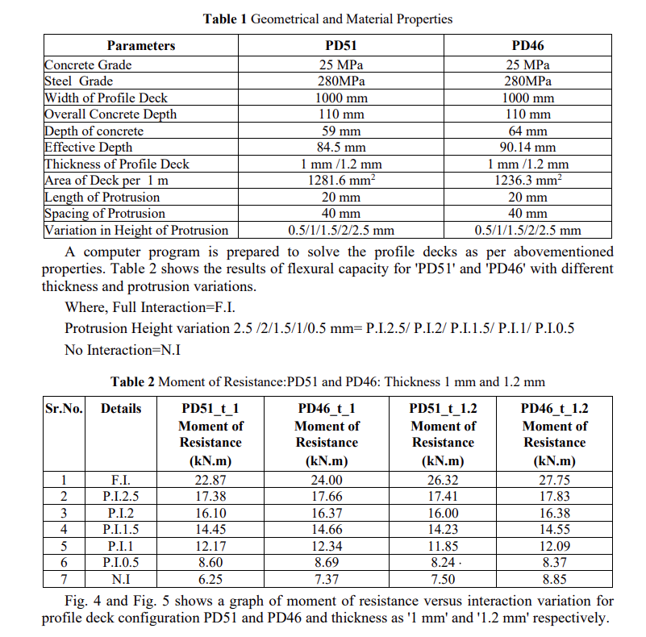
After performing the detailed survey of the literature available and building structure conclusion was due to a wide variety of buildings, the in depth understanding in the field of wind Analysis and design of building structures is inadequate.The IS codes has provided certain guideline which can be used while designing the building subjected to wind loads. The paper in performance and behaviour of building structures when subjected to wind loads ,suggests that the requirement of standardizing the methodology for studying the response of building structure to wind loads has become essential for the overall analysis of the structure.Many researchers has performed work over different types of building and find out parameters which are useful for understanding behaviour of wind forces over the high rise building.
- Research on Cold Formed Steel Stud Walls

A Mirza & Zahedi has studied Cold-formed steel (CFS) is an amazing option to traditional materials,construction types and light steel framed (LSF) building is an replacement to conventional building systems and construction types. Light steel framed (LSF) ,cold formed steel members can be widely used for low and medium rise residential, industrial and commercial building construction.
Countries like US, Australia, Canada, Japan and some European countries have made use of CFS convincingly. The lateral behaviour of sheathed Cold-Formed Steel shear walls and Cold-Formed Steel strap-braced walls was discussed in depth in this paper.
Paper also evaluates the earthquake performance of light steel framed structures. The researches characterized the results of wall panels experimentally and numerically to study problem of seismic response of CFS structures. The present paper summarizes overall behaviour of wall panels. However, according to reviewed papers, the performance of the wall panels, as a whole, is governed by the performance of the connectors e.g.: sheeting-to-sheeting connectors, and sheeting-to-framing connectors.
- Comparative study of multi-storey multi-span buildings by PEB and CSB concept
Shahid Wasim, Vishwajeet Kadlang & Nagesh Shelke studied the comparison of PEB and CSB construction for high rise building. The analysis and design of G+4 commercial building having eave height of 18m with IS800-2007 code and bentley Stadd Pro software.
The structural performance of each steel buildings is well analyzed and reviewed ,adequate code provisions presently available are researched to make sure satisfactory structural behavior of structure in high wind zone. Steel structure additionally had far better strength-to-weight ratios than RCC. The results obtained from study shows that multi storied building of PEB also are advantageous over CSB and can be adoptable by the designers. The output from the study are as follows:
1.As per study it was determined that the weight and material needed for PEB model is lesser than the CSB model of same length breadth and height. Reduction in weight leads to reduction in the weight of steel required, 39% reduction in steel weight was observed between PEB and CSB structure.
2. Moment, Shear Forces and Support Reactions are lesser in PEB structure.
3. PEB structures provided better resistance to earthquake forces.
4.The construction of PEB structure is lighter, faster, price and material saver than CSB .
5.PEB structures can be adopted for the larger scale more effectively than the smaller scale structure.
[5] Lateral Stability of High Rise Steel Building
Tejesh R, Ummer Farroq studied effects on tall buildings such as p-delta effect, bracing axial contraction of columns. Cost of the building is directly proportional to the height of the building and increased weight of the building and increased forces .Many methods are researched to reduce the cost and to increase the height of the building one among them is composite construction (with concrete and steel structure). As the height of the building increases, lateral movement of the building increases allowing building to sway.To reduce the sway in building ‘bracing’ can be added. Different types of bracing normally used in the practice such as x-bracing ,v-bracing, inverted v-bracing, eccentric bracing, k-bracing etc. In the current paper 15 storey steel structure of height 45m (3m each storey) was analyzed. IS 800:2007 code with dead load, live load earthquake load combinations and wind load combinations was used. Dynamic analysis (response spectra)method was adopted using E-tabs software considering response reduction factor as 5,importance factor as 1,seismic zone II and type of soil is 2.
The analysis carried out according to IS 1893.The analysis was performed for building without bracing, with X bracing and v-bracing. The Results were compared and studied. Displacement of the structure was more in the structure without bracing.It was also observed that lateral loads were more in the case of X-bracing. X-bracing was found better for wind loading and V-bracing looked better for earthquake loading ,yet more studies is required to conclude further. Displacements in wind load combination were found to be more than response spectra combination, which concluded that steel structures are more critical against wind loads.

[6] Study On Bracing Systems On High Rise Steel Structures:
Jagadish J.S during this paper throw lights on , Strengthening of Steel frame to resist lateral mass of structure. Systems are often moment resisting beam-column, braced frames with moment-resisting connections, braced frames with pin joint connections and braced frames with each pin-jointed and moment-resisting connections. Braced frame is often used steel buildings the foremost most wide used technique of constructing lateral load resisting system. Hence, the most concern is to pick out the suitable bracing model and to choose the acceptable association kind.Bracing systems square measure utilized in structure so as to resist lateral forces.These systems facilitate the structure to cut back the bending of columns and beams stiffness of the system is multiplied. There are lots of benefits of the bracing systems so they are used widely.
Displacement criteria proved that the bracings are good to minimize the displacement and in method of K and V-bracing, the displacement is larger in case of non bracing because of irregularity in shape of structure.The reactions and weight of the structure are more in various types of bracings when compared to unbraced structure with same configuration of the structure.It is conjointly seen that as these bracing systems are used the displacement and storey drifts, can increase or decrease for the braced buildings with the same parameters.
[7] Finite element analysis of cold form perforated steel beam column
Amit M. Chavan1, Dr.S.S.Angalekar2, aimed in this paper to present simple and accurate three dimensional finite element Model (FE) capable of predicting the actual behaviour of beam-to-column joints in cold form perforated steel frame subjected to static loads. ANSYS is used to model the joint. This was selected for its complexity in the analysis and non-linear behaviour of cold form steel. The experimental test in the paper for normal section was chosen to verify the finite element model.While comparing the two perforated section for the section size 100X50X1.6 with four bolt (type 1) arrangements the normal section showed deflection 16.016mm, circular perforated section showed deflection 16.932mm and square perforated section gives deflection 17.488mm. Simultaneously the rotation for the same section is 0.0712 radian (Normal section), 0.0727radian (circular perforated section) &0.0734 radian (square perforated section).
[8] DESIGN AND ANALYSIS OF SPECIAL STEEL CONNECTIONS ON PRE-ENGINEERED STEEL BUILDINGS
Neeraja Gaidhani1 , Dr. M Helen Santhi2 studied various connection details for PEB structures they classified there connections supported on basis of IS codes special moment connection needs requirements (light moment connections and moment connections) they researched for the clip angle connections ,the split beam connections,the unstiffened seat connections etc.After all the analysis they detected that the Pre-engineered steel structures building offers low price, strength, durability,flexibility, adaptability and recyclability. Basic material used is steel that’s utilized in the materials that are used for Pre-engineered steel building. For longer span structures, Conventional buildings are not preferred with clear spans. Pre-engineered building are the best solution for extended span structures neglecting interior column in between as seen in the work.Saving of material on low bending and shear force area stress area of the primary framing members makes Pre-engineered buildings more economical than Conventional steel buildings especially for low rise buildings.In smaller span structures PEB structures are found costlier as compared to Conventional structures. The PEB sections where found to be lesser in size and the requirement of number of bolts was minimum.
- A Study On Pre-Engineered Building – A Construction Technique
Shrunkhal V Bhagatkar/ Bhanu Prakash in this paper the authors have studied different members of PEB and its different components and the applications of PEB as a construction techniques.And they interpreted that from the previous advancement, the use of PEB is implemented and rapidly increasing, but its use is not throughout the construction industry. It is analyzed that PEB structures can be easy to analyse and design by simple design procedures with country codes and standards, it is energy efficient, rapid in construction, saves construction cost, sustainable and most important its reliable as compared to conventional buildings. Hence PEB methodology must be implemented and researched for more outputs.

CONCLUSION
The following points are concluded from the above review:
- PEB structure has a lot of advantages over CSB
- PEB can be used as an innovative construction technology if used with proper materials and can work well with the lateral forces
- Connections for the PEB building is cost saving
- Cold form steel along with the wood sheathing can work better as a light weight system than concrete over metal deck and composite floors
- Use of cold form steel shear walls can reduce the amount of hot rolled steel member and decrease the weight of building
- Wind forces are governing on the high rise steel building, steel structure can be a good option over RCC due to flexibility and sway
- Cold form steel beams and columns can be used as a structural elements over openings
- High rise building construction can be achieved in PEB if suitable light weight materials are used
REFERENCES
[1] Zammel and Kirby Steel Structure Manuals

[2] Design of steel structure by R.A Ajmani

[3] Design of Steel Structure by Dr N Subramanian

[4] Ashish Sadh , Ankit Pal (Nov-2018) “A Literature Study of Wind

[5] Analysis on High Rise Building” [Vol-5, Issue-11, Nov- 2018] ISSN: 2349-6495(P) | 2456-1908(O) International Journal of Advanced Engineering Research and Science (IJAERS)

[6]Dr. Merool Vakil(July 2017,)“Effect of composite interaction on moment of resistance analytical studies on composite slabs”International Journal of Civil Engineering and Technology (IJCIET) Volume 8, Issue 7, July 2017

[7]A. Mirza Goltabar Roshan & F. Zahedi Tajrishi “Research on Cold Formed Steel Stud Walls”University of Technology, Babol, Mazandaran, Iran May-2019

[8]Md ShahidWasim Chaudhary, Vishwajeet Kadlag , Dr. Nagesh Shelke(May-2019)“Comparative Study of Multi-Storey Multi-Span G+4 Building by PEB and CSB Concept”International Research Journal of Engineering and Technology (IRJET)

[9] TEJESH R, UMMMER FAROOQ PASHA (Jan-2018) “LATERAL STABILITY OF HIGH RISE STEEL BUILDINGS”International Research Journal of Engineering and Technology
Jagadish J. S ( July 2013) “A Study On Bracing Systems On High Rise Steel Structures”International Research Journal of Engineering and Technology (IRJET)

[10] Amit M. Chavavn, Dr.S.S.Angalekar,(July-2016) “Finite element analysis of cold form perforated steel beam column connection” International Research Journal of Engineering and Technology (IRJET)

[11]Jagadish J. S ( July 2013) “A Study On Bracing Systems On High Rise Steel Structures”International Research Journal of Engineering and Technology (IRJET)

Websites:
- www.infinityfab.com
- www.zamilsteel.com
- www.kirbyinternational.com
- www.tatabluescopesteel.com

