A Thermal Adaptation Architecture - Heliotrope

Vandana N.Mahajan¹, Pushkaraj Sant², Mayur Patil³, Krushna Ugale⁴

¹Assistant Professor, ^{2,3,4} UG student,
Government Mechanical Dept., Govt.College of Engineering, Jalgaon, India, 425002,

er.vandana@rediffmail.com

Received on: 03April,2023 Revised on: 28 April,2023 Published on: 30April,2023

Abstract – The Heliotrope is a unique solar-powered home designed by architect Ralph Disch in 1994. It has a rotating structure that allows it to track the sun's movement and maximize energy generation. The Heliotrope was a ground-breaking project that gave rise to the Sonnenschiff Solar Development and played a role in the development of the German solar sector. One of the Heliotrope's most remarkable features is its energy efficiency. It generates five times more energy than it consumes, making it one of the world's first truly energy-surplus homes. The Heliotrope achieves this through a combination of design features, including triple-pane thermal glass windows, solar thermal pipes, and a large solar array mounted on its roof.
The Heliotrope's rotating structure allows it to adjust its orientation to the sun's position in the sky, ensuring maximum energy generation throughout the day. The building's triple-pane thermal glass windows and solar thermal pipes also help to maintain a comfortable indoor temperature regardless of the weather outside. With its innovative design and energy efficiency, the Heliotrope is a testament to the possibilities of sustainable architecture.
Keywords – Heliotrope, Energy efficiency, Sonnenschiff, Sustainable architecture.
- INTRODUCTION
The building derives its name from a biological process called heliotropy, which plants in the Arctic use to capture the maximum amount of light during the flowering season, which is shorter than elsewhere. However, Heliotrope also has another biological process called Para heliotropism, in which the plant rotates to avoid direct sunlight. Valerian accomplishes this from one side of the house, which has an insulated wooden side instead of glass and can essentially be turned to provide shade. [1]
In this project, experiments were carried out with the help of Taguchi's method using parameters such as atmospheric temperature, wall thickness and building angles. This helps to visualize the hexagonal structure of the house because it satisfies the need to heat the inside when it's cold outside and vice versa.
- LITERATURE REVIEW
According to Research report Wind driven architecture
As for the design with modern aerodynamics, no. First, two important aspects of the wind itself. direction and speed. They are given truth. An object can be modified or played with by shaping it.
The second parameter is where the wind blows. The uneven terrain causes the wind to be blocked. How bad is the road? Using the wind will be more difficult. The same is not available for artifacts.
Due to location and geometry, air can be directed and used or blocked and ignored.[1]
According to Design Methodology: Kinetic Architecture
From all the above-mentioned definitions, the word "dynamic architecture" can be defined as a structure that responds to changes in a building or its surroundings, even indoor/outdoor or environment/people that change. Although the first definition of the term "kinetic architecture" was made in the 1970s, there are many different solutions from building materials to finished products. Kinetic energy is used for different purposes such as bridge protection, entertainment facilities (such as stages and revolving restaurants), medical facilities (such as nursing homes and solariums), and residences. Dynamic trends in the design environment now refer to ideas or human conditions, or even both, and fall into four groups:[2]
i. Field Optimization System
ii. Multifunctional design
iii. Situational Compatibility
iv. Mobility
According to Part B - Rotating Architecture Research report
The house does not have the highest running machine, but the small machine and the business that turns into the middle column with the lowest product. Therefore, the energy production efficiency is very good.[1]
According to the Role of Energy Technologies and Scenarios in the Decarburization Process
Renewable energy production is surprisingly threatened by climate change, and most of the energy we use at home comes from fossil fuels. It would be wrong to think that there is an advantage only if energy is only renewable. This is impossible as the simultaneous location is random; Consider the wind required for a wind turbine to operate. When there is no wind at a certain speed, there is no power.[4]
- METHOLOGY
Heliotrope is a rotating house that rotates with respect to suns position. The project is design with the help of Taguchi method.
Building structure: - As all the Heliotrope buildings are made circular then as an experimental basis, we decided to build the building in hexagonal shape, made with the help of KTM Plywood and foam. But the two side of hexagon will be open for sunlight.
Methods for Finding Airflow Patterns Around Hexagonal Tall Building Model with Multiple Aerodynamic Modifications The drag coefficients and the pressure coefficients of each model have been found out. The pressure distribution on each face of every model has been studied. On a comparison with the basic corner hexagon model without any modifications, the modified models have showed better performance in reducing drag coefficient. The rounded corner and chamfered corner models have reduced the drag coefficient by 22% and 6% respectively. Whereas the recessed corner model has reduced the drag coefficient by 35%. Hence, corner recession is finalized as the best effective model amongst the corner modified models. On comparing the modifications to the form of the building, the tapered model has reduced the drag coefficient by 18% and the set-back model has reduced the same by 13%. Hence the tapered model performed best in terms of form modifications. It can be concluded that the corner modification has outperformed the form modification on basis of drag coefficient [21].
Walls of building: - There are three Floors to building, the first-floor walls made with the only 4mm KTM plywood, second floor of building is made with the 4mm KTM plywood and 6mm foam while third floor is made of 4mm KTM plywood and 12mm foam. 4 sides of hexagon are made of plywood and foam while remaining 2 is open but covered with thin polyethylene or transparent plastic.
Taguchi Method: - An engineering method used in product or process design that focuses on identifying negative (factor) settings to create high quality characteristics with minimal deviation. Taguchi Design uses a powerful and efficient approach to design processes that are used consistently and effectively in a variety of situations. Effective design validation requires the use of prospective design experiments that present procedures with different design levels. An experimental design was developed.[3]
We have decided three parameters as Atmospheric Temperature, building angle, Wall thickness by using taguchi design we decided some values for test and these are as follows..

Table 1- Combination of value parameter

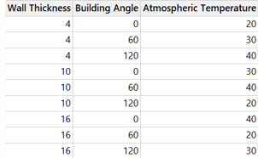

All readings are taken according to this design. The test is performed on the prototype.
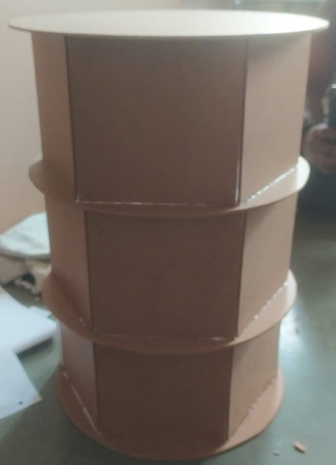
Fig. 1- Rear view of prototype
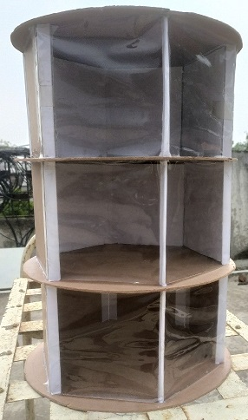
Fig. 2- Front view of prototype
Readings of experiment – As Taguchi design suggested we taken readings as follow.
There are three variables which are Wall Thickness, Building Angle, and Atmospheric Temperature. Every reading is taken after 10 min of proper external conditions are matched with the predefined values. Reading is taken with the help of Digital thermometer.

Table 2- Readings taken by experimental performance

Wall Thickness | Building Angle | Atmospheric Temperature | Inside Temperate of Prototype
4 | 0 | 20 | 21
4 | 60 | 30 | 28.8
4 | 120 | 40 | 38
10 | 0 | 30 | 27.6
10 | 60 | 40 | 36.3
10 | 120 | 20 | 21.4
16 | 0 | 40 | 33.8
16 | 60 | 20 | 24
16 | 120 | 30 | 25.6

VI- TAGUCHI ANALYSIS
The Taguchi analysis show many things as required but the results are as follows.
Table 3- Response Table for Means
Response Table for Means

Level | Wall  Thickness | Building  Angle | Atmospheric  Temperature
1 | 29.27 | 27.47 | 22.13
2 | 28.43 | 29.70 | 27.33
3 | 27.80 | 28.33 | 36.03
Delta | 1.47 | 2.23 | 13.90
Rank | 3 | 2 | 1

Main Effects Plot for Means
Data Gleans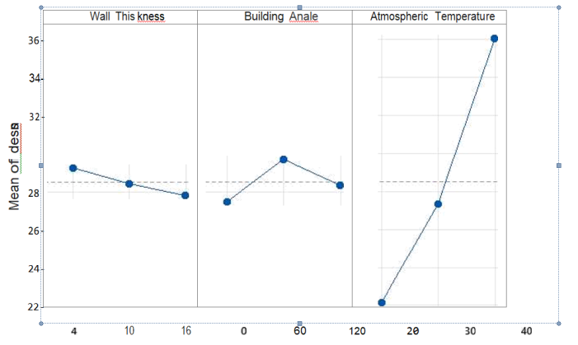
Fig. 3- Main Effects Plot for Means
As shown in Taguchi analysis, the tables and chart are shown above. The interpretation of table shows that Atmospheric Temperature is most effective parameter as the reading says. The second most effective parameter is Building Angle and third is Wall Thickness.
VII- RESULT & DISCUSSION
The readings show that if the temperature is lower outside, it is higher inside. Because when the atmospheric temperature is lower, i.e., 20ºC, the temperature of the prototype is found on the higher side, when the atmospheric temperature is 40ºC, it seems that the temperature of the prototype is found on the lower side.
The wall thickness is also playing a major role in the temperature of the prototype because it seems that from the readings, the higher the wall thickness, the higher the temperature increases or decreases in respective cases.
VIII- CONCLUSION
The Heliotrope is an edifice that is energy positive and rotates according to the sun's position as per pre-determined parameters. The prototype model is tested under these parameters: wall thickness, building angle, and atmospheric temperature. The experiment shows that the objective of keeping the infrastructure cold in a warm environmental condition of atmospheric temperature and warm in a colder environmental condition of atmospheric temperature is identical. Also, as results discussed all readings shows that the Inside Temperate of Prototype is always tends to come towards 25 to 27 ºC .
IX. ACKNOWLEDGMENT
The Mechanical Engineering Department, Government College of Engineering, Jalgaon.
REFERENCES

- ReinhardProphitius, Wind driven Scheveningen, P2-Research report, Wind driven architecture, 2012
- Architect Soha Mohamed Abd El-HadyFouad, B.Sc. of Architecture, Alexandria University, Design Methodology: Kinetic Architecture, July 2012
- https://eng.libretexts.org/Bookshelves/Industrial_and_Systems_Engineering/Book%3A_Chemical_Process_Dynamics_and_Controls_(Woolf)/14%3A_Design_of_Experiments/14.01%3A_Design_of_Experiments_via_Taguchi_Methods_-_Orthogonal_Arrays#:~:text=The%20Taguchi%20method%20is%20best,a%20few%20variables%20contribute%20significantly.
- Anthony Denzer, Ph.D., M.Arch., Associate Professor, University of Wyoming, Dept. of Civil and Architectural Engineering, modern architecture and theories of solar orientation,2009

- https://www.nrcan.gc.ca/energy-efficiency/homes/make-your-home-more-energy-efficient/keeping-the-heat/chapter-7-insulating-walls/15641
- http://www.bubblemania.fr/en/bulles-architecture-rolf-disch-maison-heliotrope-solaire-tournante-1994/
- JifengSonga, Yong Zhub, DanchengXiab, Yongping Yang, A photovoltaic solar tracking system with bidirectional sliding axle for building integration, Science Direct, Energy Procedia 61 (2014) 1638 –1641
- https://www.electronicshub.org/sun-tracking-solar-panel/
- https://gist.githubusercontent.com/elktros/3deabec4a261deae22273de59bd041f8/raw/ecfe14f6e17d1637e3d820b30530840a03f0fd79/Sun_Tracking_Solar_Panel.ino
- https://en.wikipedia.org/wiki/Heliotrope_(building)
- http://www.loftenberg.com/revolving-house-in-italy/
- http://www.everinghamrotatinghouse.com.au/
- http://www.visionair.nl/ideeen/ideeen1/hoger-rendement-windturbines-door-kite
- http://www.windfinder.com/windstats/
- http://www.airvent.com/homeowner/resources/troubleshooting.shtml 2121 21
- Randl, C Revolving architecture A history of buildings that rotate, swivel and Pivot. New York, Princeton Architectural press. (2008).
- http://www.techniker.co.uk/projects/enlarge.cfm?iProject_id=121&sMedia=image&i Medicaid=935
- Bessel van, G. J. wind energy online reader ". Retrieved 20 November, 2011, from. (2008).
- Siddharth Mahesh Remane1, Dayanand Vasant Davane, case study on rooftop solar panels, International Research Journal of Engineering and Technology (IRJET) Volume: 08 Issue: 08 | Aug 2021
- Miguel de Simón-Martín, Cristina Alonso-Tristán, Montserrat Díez-Mediavilla, Performance Indicators for Sun-Tracking Systems: A Case Study in Spain, Received 25 June 2014; revised 30 July 2014; accepted 13 August 2014

