Minimization and Utilization of Byproduct

Aditya Rane¹, Pranav Singh², Prashant Prasad³ , Nimisha Shirbhate⁴

¹ UG student, Department of Mechanical Engineering, Lokmanya Tilak College of Engineering, Navi Mumbai, India,400709, raneaddy16@gmail.com
²UG student, Department of Mechanical Engineering,Lokmanya Tilak College of Engineering,NaviMumbai,India,400709, singhpranav.2002@gmail.com
³UG student, Department of Mechanical Engineering, Lokmanya Tilak College of Engineering, Navi Mumbai, India,400709, prashantprasad2002@gmail.com
⁴Professor, Department of Mechancial Engineering, Lokmanya Tilak College of Engineering, Navi Mumbai, India,400709

raneaddy16@gmail.com

Received on: 03April,2023 Revised on: 28 April,2023 Published on: 30April,2023

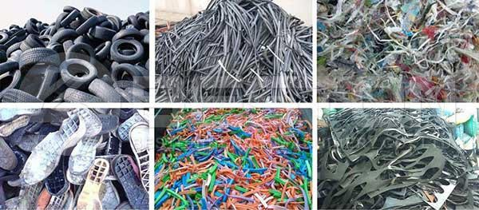
Abstract - Negative effects arising from the presence of waste materials on the environment is a major problem worldwide, requiring emphasizing of the recycling processes and reuse processes. In this context, the objective of the research was based on finding of a for a sustainable development. To date, for a higher recovery of waste rubber is necessary to transform them into reclaimed rubber involving the use of polluting technologies. Thus, through the proposed technology, respectively through the grinding with tools activated in an ultrasonic field, has been possible to decrease rubber particle size and there was obtained a crumb rubber with a particle size of 100–150 μm. It can replace a large proportion of reclaimed rubber from the composition of a type of analyzed rubber, and the obtained results demonstrate changes in the physico- mechanical rubber properties thus produced with effects on the growth of the life of rubber products and reduce environmental pollution. Also, by applying new technology there is a clear improvement of sustainable development indicator (SDI) defined and analyzed in the paper. Currently, worldwide it is put increasing emphasis on ensuring sustainable development through innovation or, in accordance with the European Commission, on eco-innovation (represented by any innovation which may determine economic development and has a positive impact on the environment). Thus, eco-innovation is considered, “key” to competitiveness”, given that the manufacturing sector is stimulated to shift from methods such as “end-of-pipe” to the “closed- loop”, with positive effects on consumption of raw materials and energy (European Comission).
These clarifications were the basis of research conducted in the field of waste rubber regeneration, problem solved now by various methods, but that involving many technological operations, that, in turn, determine some environmental

pollution.

Keywords: Rubber Waste, Pollution , Recycling.

1. INTRODUCTION

The economic models specific to market economy that rely on consumer satisfaction and getting of profit, have generated major imbalances and pollution, determining an unsustainable growth. Thus the problem of raw materials and energy crisis, depletion of natural resources, excessive environmental pollution and the damage to human health are just some aspects of a general crisis that threatens all humanity, in the context of challenges generated by their application. Therefore, applying the principles of sustainable development has become a necessity, imposing the replacement of the “homo economics” behavior type with the type “rational homo”. Moving from technology to ecotechnology may be the key to ensure sustainable development. But what is sustainable development?

Figure No.1 Rubber Waste

Sustainable development is a concept extremely debated in recent years, though, can be identified a concern for its requirements with decades ago. Thus, the paper “Limits to Growth” (Meadows et al., 1972) is an important point in starting the debate on the rational use of resources. The bio- economy theory founded by Georgescu - Roegen contributed decisively to identify the correlation between technical progress and environmental protection. The theory of sustainable development is still under development and has generated numerous debates on environmental protection. In this regard, we can mention the Stockholm Conference, the Rio Conference (1992, Rio +5, Rio + 10, Rio +20) etc. An important document, in which it is presented a definition of the concept of sustainable development, is the ”Report of the World Commission on Environment and Development: Our Common Future” by approach perspectives. Thus, the authors of this report have an interesting opinion regarding the influences on sustainable development. In this context, the sustainable development ”is not a fixed state of harmony, but rather a process of change in which the exploitation of resources, the direction of investments, the orientation of technological development, and institutional change are made consistent with future as well as present needs”. (WCED report, 1987). In accordance with this point of view, it is obvious that between innovation and sustainable development there is a strong link. Innovation is, incontestably, an engine of sustainable economic growth, no matter the domain where it is realised. At the same time, sustainable development is a source of innovation, more and more companies allot significant resources to research and to identify new solutions.
Currently, worldwide it is put increasing emphasis on ensuring sustainable development through innovation or, in accordance with the European Commission, on eco-innovation (represented by any innovation which may determine economic development and has a positive impact on the environment). Thus, eco-innovation is considered, “key” to competitiveness”, given that the manufacturing sector is stimulated to shift from methods such as “end-of-pipe” to the “closed- loop”, with positive effects on consumption of raw materials and energy (European Comission).
These clarifications were the basis of research conducted in the field of waste rubber regeneration, problem solved now by various methods, but that involving many technological operations, that, in turn, determine some environmental pollution.

II -LITERATURE REVIEW :

The rubber from waste can be recycled normally by the grinding to produce fine powders with a wide domain of the specific surface. Until now, there could be produced powder in a wide range of specific surface using only grinding processes “at heat”, whose efficiency of the particle with granulometry ranging between 400 and 600 μm is quite low (Torretta et al., 2015). In order to increase the efficiency of recycling waste made of rubber the upside of the fineness of the rubber particle .

DEFECTS AND SOLUTION :

DEFECTS : Negative effects arising from the presence of rubber waste materials on the environment is a major problem worldwide.

SOULUTION :
The research has aimed to identify a new technology enabling a higher recovery of waste rubber.
Superior grinding of waste rubber and reusing in the mills with ultrasonic activation leads to a crumb of rubber with a very good particle size distribution and particle sizes in the range of 100–150 μm.
Crumb rubber obtained can be used in this state in the rubber composition of the various types of rubber mostly replacing the reclaimed rubber

CHARACTERISTICS AND PROPERTIES OF ADDITIVES IN RUBBER

- ZnO:
Characteristic - Catalytic properties
Uses- Used as baking agent ,colourant, skin protectant.
- Steric Acid :
Characteristic - Odourless in nature ,wax like
Uses- Used as lubricating agent food additive used in making insulators
- N550 carbon black :
Characteristic -Exist in powder form and odourless, high melting and boiling point.
Uses- Used in car cases ,inner tube ,gasket and plastic compounds.
- DOP (dioctyl phthalate) :
Characteristic - Flexibility, coldresistant, electrical insulation.
Uses- Used as plasticiser.
- TMTD (tetramethyl thiuram disulphide):
Uses- Used in processing of rubber and in blending of lubricant oil.
- Crude rubber :
Characteristic - High level of wear and heat resistant, high strength High compressible.
- Filler :
Characteristic - Improve particle packing and give the fresh concentrate and even to reduce amount of cement in concrete without losin
- Softner :
Characteristic - It is an finishing agent it gives pleasing touch to product.
- Antioxidant :
Uses- Mainly used to prevent thermal and oxygen ageing and could effectively prevent copper damage used in light coloured and transparent rubber products and in foam latex products.

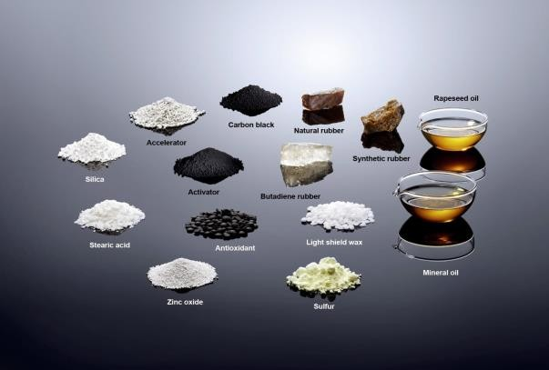
Figure No 2.Additives
DESIGN METHODOLOGY
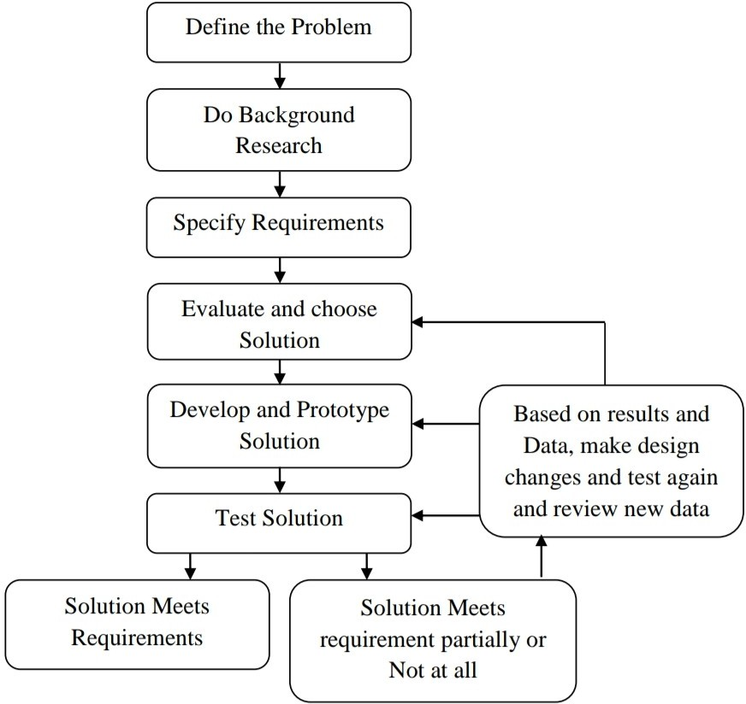

Observation Table:-
In this step we are going to implement our information gathered and try to make a prototype solution. We already know the effect of temperature on rubber and properties of natural rubber and properties of byproducts.
We are going to add a specific amount in 1 kg of raw material in presence and absence of cork oil. Then we are going to measure the effects on product hardness is it constant, increased or decreased. We are going to find out if there is presence of cracks on the product and we are concluding if our requirement is fulfilled or not fulfilled.

Amount of material added in every 1 kg | Presence of oil (Cork) | Effect on Hardness | Cracks | Requirement is fulfilled
0 | Absent | No Effect | Absent | Yes
5 | Absent | No Effect | Absent | Yes
10 | Absent | Increased | Present | No
10 | Present | No Effect | Absent | Yes
20 | Present | No Effect | Absent | Yes
30 | Present | No Effect | Absent | Yes
40 | Present | No Effect | Absent | Yes
50 | Present | No Effect | Absent | Yes
60 | Present | No Effect | Absent | Yes
70 | Present | Increased | Present | No
67 | Present | Increased | Present | No
65 | Present | Increased | Absent | No
62 | Present | No Effect | Absent | Yes
- Define the Problem:- In this step we define our problem or objectives of project.
- Background Research:- In this step we do analysis of products required in our project
and the materials in what quantity involved in the manufacturing what are effect on
product by the process.
- Specify Requirements:- In this we are specifying our requirements of project i.e. we
need to utilities and reuse byproduct without changing product characteristics.
- Evaluate and Choose Solution:- In this step we choose proper solution by conducting
Solution financial and available resources.
- Prototype Solution:- Now we are developing a prototype solution to test is our process is
working or not if it is not working or not giving required results then we again go to step
number 4.
- Testing:- Here we are doing test on actual or full scale model.
- Solution not meeting requirement :- In this step we check is our solution is meeting or
not meeting our requirements then we decide is we need to go again doing process from
step number 4 or finish our project.

CONCLUSION

The research has aimed to identify a new technology enabling a higher recovery of waste rubber. Thus the investigations, the following conclusions can be synthesized:

  - superior grinding of waste rubber in the mills with ultrasonic activation leads to a crumb of rubber with a very good particle size distribution and particle sizes in the range of 100–150 μm.
  - crumb rubber obtained can be used in this state in the rubber composition of the various types of rubber mostly replacing the reclaimed rubber.

ACKNOWLEDGEMENT

I acknowledge my deep gratitude to my course Prof. Nimisha Shirbhate for her inspiration, guidance and valuable suggestions for this Research paper.

REFERENCES

- Morton,M.:”RubberTechnology”,Van Nostrand Reinhold, New York, 1987
- Donnet,J.,A.Voet:”CarbonBlack—Physics, Chemistry, and Elastomer Reinforcement”,ǁMarcel Dekker, New York, 1976.
- Eirich, F. R., and A. Y. Coran: ―Science and Technology of Rubber,ǁ Academic Press, New York, 1994.
- Long, H.: ―Basic Compounding and Processing of Rubber,ǁ Lancaster Press, Lancaster, Pa., 1985.
- Brown, R. P.:―Physical Testing of Rubber,ǁ Elsevier Applied Science Publishers, New York, 1986.
- Figure No 1 ,,MEKODEXIM CO., LTD, available at https://uqC3oEuhJQbEQJmD8
- Figure No 2 ,Seien Gum Industrial,https:// j2P2WqmZbZhnzv538
- Figure No 3,lantor labs available at http://lanotr.com

