An IoT-based Solution for Military Healthcare Monitoring

Swapnili Karmore¹, Priyanka Gajbhiye², Nisha Dhonde³, Pooja Gondane⁴, Pallavi Kanhere⁵, Shweta Marode⁶

¹ Associate Professor, Data Science, ^{2,3,4,5,6} Student
G H Raisoni Institute of Engineering and Technology, Nagpur, India - 440016

swapnili.karmore@raisoni.net

Received on: 11 June ,2022 Revised on: 31 July ,2022, Published on: 02 August ,2022

Abstract- On the battlefield, troops face a range of hurdles, including sickness, loss of track, and communication issues with the base station, all of which can endanger their lives. To assist soldiers in overcoming these problems, we have created a system that would allow us to offer army members with safety measures. For the suggested system, we are utilising Internet of Things technology. This technology allows GPS tracking of the soldier's location, as well as communications containing temperature, pulse, and heart rate, which can be detected by sensors and transmitted to the base station. This paper suggests the methodology and implementation behind the development of this system.
Keywords- GPS Module, Heartbeat Sensor, Temperature Sensor, Pulse Sensor, Humidity Sensor, LCD Display, Wi-Fi Module

I – INTRODUCTION
Soldiers must protect themselves in addition to securing the nation by embedding some advanced security systems, and it is critical for army control units to maintain track of them. To serve this purpose, we are integrating advanced wireless sensor network with a GPS module to keep track on soldier’s wellbeing and data can
be sent between the two key units i.e., soldier’s unit and the base station unit. The soldier's unit is coupled to the soldier's armour, which is outfitted with smart biomedical sensors such a temperature sensor, pulse detector, oxygen sensor, and GPS module, allowing for complete mobility. It gathers data on the soldier's health as well as the surrounding environment. Additionally, this data is relayed to the base station and processed on our software platform. Data is collected and analysed at the base

station to assist the base station in determining the whereabouts of the soldiers and providing the appropriate precautionary health measures. The station can determine the exact location of the soldiers and guide them accordingly using a GPS basis. The integrated component must be lightweight and provide the desired output while consuming little power. Furthermore, proper navigation between soldiers and base units is critical for coordination and proper on-field planning. This device will provide statistics on the solder's health to the control unit via this gadget mounted on the soldier's armour.
This will allow the control unit to determine the actual scenario on the battlefield to be tracked and organise their subsequent strategy accordingly. This document allows soldiers who have become lost or wounded on the battlefield to be followed and monitored in real time. It supports in the time management and search and rescue duties of the army stations unit. Soldiers involved in special operations or missions will benefit from this.

II -LITERATURE REVIEW

GPS and Internet of Things (IoT) based Soldier Tracking and Health Indication System ^{[1]}in 2019, the author proposed that we could interact indefinitely. Soldiers can communicate from anyplace, which can let them communicate with their comrades when necessary. The addition of incapable demanding peripherals and Advanced RICS Machine chips minimises the schedule's total superiority consumption. The supplemental employees of a small number and burden, allowing soldiers to transport them in safety and security. Soldiers' GPS coordinates may be tracked from anywhere on the planet, and the health system monitors crucial health data to ensure their safety and security.
Health Monitoring and Soldier Tracking System using IoT ^{[2]} this paper presents an IoT-based health monitoring and tracking system for troops. This proposed module can be installed on the soldiers' bodies and used to determine their health state and current location using GPS. These data will be transmitted to the base station through IoT. It is possible to build a low-cost circuit around the stated module to protect the lives of valuable soldiers on the battlefield.
IoT and GPS based Soldier Position Tracking and Health Monitoring System ^{[3]}Author presented it in 2018. The scientists studied a variety of clothing, moveable, light-weight, small-size biosensors designed as military health auditors. Soldiers can wear BSN, which consists of detectors such as heart rate and degrees, to check their health in real time. This article presents a method for establishing an interconnected BSN system for real-time soldier health monitoring.

IoT based Healthcare Monitoring System for War Soldiers using Machine Learning ^{[4]} made use of intelligent retrieval. This device, which employs GPS, temperature sensors, and heart rate sensors, allows army base stations to inquire about the whereabouts and preventive health of warriors. The transmission data from the trigger and high-frequency direction finder values were relayed to the other soldiers. Furthermore, in combat ranges where radiophone scope is non-existent, cloud technology has been recommended for use between the head and central office. Using the flat clustering technique, the data will be transferred to the cloud for future research and prediction.
IoT based Health Monitoring via LoRaWAN ^{[5]}where acquired bio sensor data is supplied to an analysis module using a Wi-Fi network framework for low-cost, low-power, and secure connection Heart rate, temperature, and glucose levels were monitored in remote areas where cellular network service is either non-existent or non-existent. The average area covered by Wi-Fi at a 12-meter altitude is roughly 33 kilometres. This monitoring module is said to consume ten times less power than existing long-distance cellular alternatives such as GPRS/3G/4G.
III -PROPOSED SYSTEM
Soldiers may be tracked in real time due to military health monitoring and position tracking devices. This suggested device also tracks the soldier's condition, including heartbeat movements. In this system, we also monitor the soldier's pulse sensor, oxygen level, and normal body temperature. The plan is divided into two sections: Soldier Unit and Control Unit. The sensor network used to monitor health and the environment was lowered by the military unit. To transport data, we used a Wi-Fi module.
Our technology is extremely useful in determining soldiers' health status and delivering health treatment to them. The data is received by the Trans receiver, which stores and checks it on the cloud platform, while the control room gets data on the soldier's location. The hardware specifications include Arduino UNO, Temperature Sensor LM35, Pulse Sensor RC-A-4015, Humidity Sensor DHT11, GPS Module Neo-6M, and WIFI-module ESP8266.
  - Hardware Specifications
The Arduino platform is a low-cost, open-source electrical platform that includes hardware. The Arduino UNO microcontroller board uses the ATmega328P 8-bit AVR, which features 14 digital I/O pins, 6 of which can be utilised as PWM output pins. It has 6(A0-A5) analogue input pins, 5V operating voltage, 7-12V recommended input voltage, 32 KB flash memory, 0.5 KB of which is used by the boot loader, 16 MHz clock speed, 68.6 mm length, 2 KB SRAM, 1 KB EEPROM, and 6-20V input voltage limitations. In this arrangement, a temperature detection sensor (LM35) is used. When two metals detect variations in temperature, they generate an electrical potential. The pulse sensor is connected by red, black, and purple cables. It has 24 color-coded wires and 3 pin connectors.
The Arduino pulse sensor (RC-A-4015) is a heart rate sensor that is simple to use. Pulse sensors can be used by students, artists, and others. The soldier's current location is tracked using the GPS receiver Neo-6M. It is linked to 32 satellites and gives accurate measurements. It operates in a specific area and has a temperature range of -40°C to 85°C. It navigates or follows 161 decibels. The ESP 8266 Wi-Fi module includes 32KB of instruction memory and 80KB of user data memory. The data sharing module is 3.3 volts DC powered and has 4 MB of flash memory. The ESP 8266 is a self-contained Wi-Fi module capable of running software. It may operate in three modes: access point, station, and both at the same time. Jumper wires are frequently used.
The suggested system is divided into two sections: Soldier Unit and Control Unit. In the soldier unit, temperature sensors, oxygen sensors, GPS, Wi-Fi modules, heartbeat sensors, and other sensors are linked to the Arduino. This unit is made up of sensor networks for temperature, oxygen, and heartbeat. This sensor was used to track soldiers' movements as well as detect their health and environmental conditions. The Wi-Fi module is used to communicate between the soldier and the base station. The soldier's amour is vital to the entire system. This unit has body area sensor networks for temperature, pulse, heart rate, humidity, and GPS. These sensors detect bomb explosions in the vicinity by tracing explosive components in the environment. Using an analogue to digital converter, the analogue signals will be converted into digital signals and compared to the normal conditional signals. If there is a difference between observed and defined normal signals, it will be considered an emergency. This study also suggests using a paper bomb detector to detect the presence of any explosive chemical in the surrounding environment. To communicate with the base station, a WIFI module will be inserted in the soldier's unit.
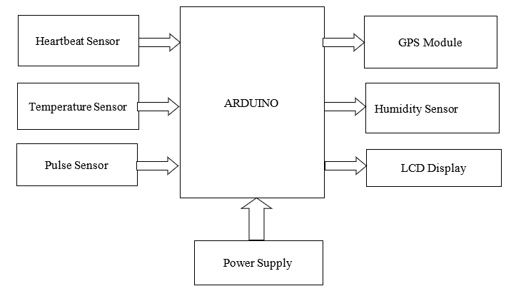 Fig. 1 – Soldier’s Unit
  - Software Specifications
ESP 8266, control unit, cloud, and storage are all included in this control unit.
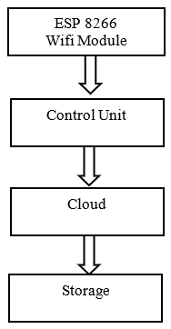
Fig. 2 - Control Unit
The ESP8266 module grants access to the Wi-Fi network, the control unit controls the system, and the cloud collects and stores data on the soldier's health, bodily condition, temperature, and atmospheric state. Data in the cloud is stored in graphical form and can be seen as a graphical representation. Data from the ESP8266 Wi-Fi module will be shown on the control unit screen via a GUI or a web portal.
  - Flow Chart
The flowchart of GPS is being explained is shown in Fig. 3
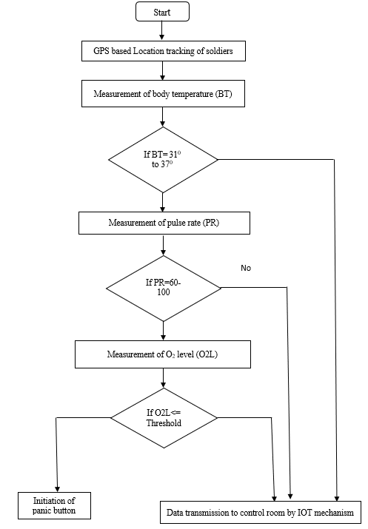
Fig. 3 - Flowchart of GPS location
1. Start.
2. Set GPS modem.
3. GPS based location tracking of soldier.
4. If BT=31⁰ to 37⁰ if BT is more than 37⁰ then data transmission to control room by IOT mechanism.
5. Otherwise, Measurement of pulse rate (PR).
6. If PR=60-100 then, measurement of _{o2} level if no then then data transmission to control room by IOT mechanism.
7. After o₂<= threshold then initiation of panic button and data transmission to control room by IOT mechanism.
8. Stop.

  - Circuit Diagram
This is the full project's circuit design; there are numerous sensors connected, including an LM35 Temperature Sensor for monitoring temperature, a Pulse Sensor for checking pulse rates, and an Oxygen Sensor for measuring troop health status, among others. A GPS module will also be included in the equipment, which will track the soldier's present location. The Wi-Fi module ESP 8266 is also used to convey information about the soldier to the soldier and control unit. The sensors, Wi-Fi module, and GPS module are all linked to the Arduino Nano. The control unit is linked to the soldier unit via a breadboard.
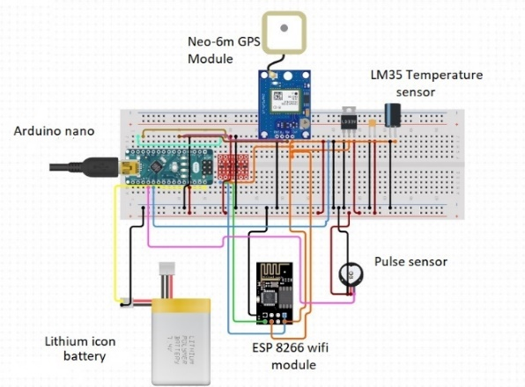
Fig. 4 -Circuit Diagram
One of the most important aspects of the website is the event description. The events are listed on the website so that potential guests may schedule their days around the sessions, breaks, and networking opportunities. Considering web marketing is crucial for raising event awareness and attendance, this page is one of the most efficient ways for us to market our events. This page is expected to target the correct audience, better accurately anticipate attendance numbers, and deliver event announcements more rapidly. This page will be the source of information for visitors about the event, including its workshops, panellists, and agenda. Attendees will learn all they need to know about the meeting or event, and you will collect everything they require to execute it efficiently.
1. Data Sensing in the Field in Real Time
Data acquired in the fighting zone will be used to determine the health of soldiers. This method can provide information such as local temperature, pulse, and humidity detection. Appropriate sensors are recommended for placement in order to collect data. The control unit uses K-Means analytics to map the conditions around the soldiers.
2. Transmission of Data
The Wi-Fi module is used to transmit data from the soldier to the squadron commander. The squadron leader then collects the data and sends it to the control unit via Cloud. Data can be sent on a regular basis, at specified intervals, or only when a substantial change in the soldier's biological sensor data is detected.
3. Prediction and Data Analysis
As an alternative to simple conditional statements, the K-Means Clustering approach has been proposed. Clustering is an unsupervised learning technique that can be used to visualize and group related types of data. Because real-time soldier data was unavailable, clustering was explored first. K-Means classification may be easily applied to real-time data that will eventually be gathered. The discrepancies in sensor values will help us categorize the data into categories like healthy, ill, abnormal, and deceased. After the data has been collected and sorted, the clusters can be shown at the control unit for a more intuitive comprehension.
- RESULT
In a result section, when a body parameter (temperature, heartbeat,humidity) deviates from threshold levels, an alert notification is sent to the base station, along with the soldier's current location. To locate and provide medical facilities.

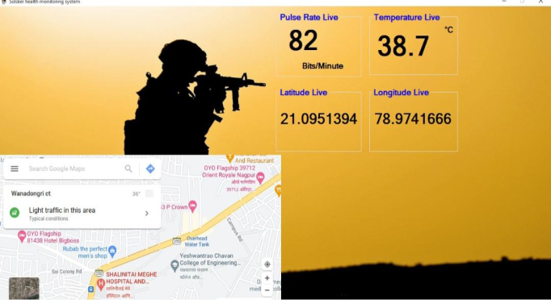

Fig. 5- Output of Base Station

In Fig 5, We use GPS to communicate with military and authorities. GPS is used to determine location and health. All relevant data will be transmitted to the base station, and the proper actions will be taken. As pulse and temperature readings, as well as longitude and latitude coordinates, are taken on the base station via GPS, this result indicates the warrior's body parameters.
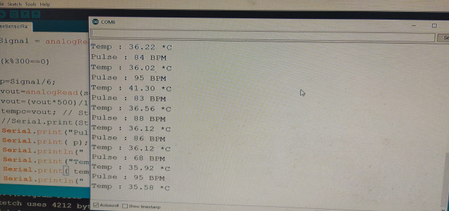
Fig. 6- Snapshot of Pulse and Temperature Range

In Fig 6 represent a cable varies beat and temperature to attach the Arduino to take the range from detector.
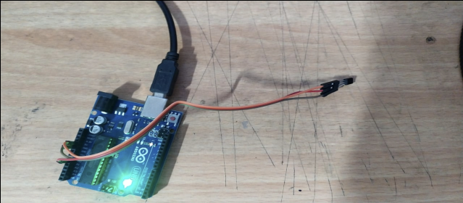
Fig. 7- Snapshot of Pulse Sensor Connection

In a Fig 7 represent Checking the beat detector with Arduino the beat detector has three pins. Connect the VCC leg of the Sensor to Arduino 5V Pin & GND to GND. Connect the Analog affair leg of the detector to the A0 pin of the Arduino.

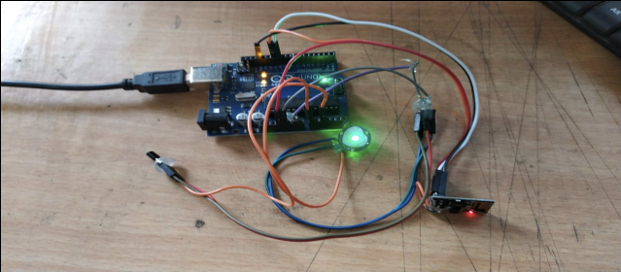

Fig 8 -Snapshot of The Establishing the Hardware

In a Fig 8 Represent connecting all the sensor (beat sensor, Temperature sensor and moisture sensor) with the Arduino board.

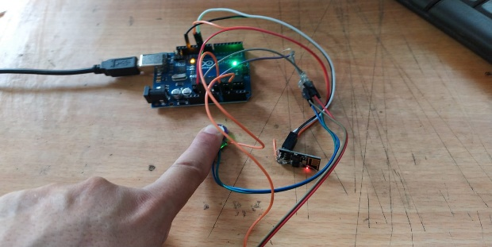

Fig. 9- Snapshot of Hardware Connectivity checking and its output show in Fig 5.

In fig 9 Represent Heart Beat and Body Temperature Monitoring using Arduino will descry the heart beat using the beat Sensor and body temperature using LM- 35 detector. Detector and will show the readings in BPM (Beat Per Minute) on the Base station connected toit.The body Temperature will be displayed on output voltage that's proportionate to the Celsius temperature

Parameter | SenseValue
LM-35 Temperature Sensor | 36ºc
Pulse Sensor | 69 bpm
Humidity Sensor | 20 to 90% RH

In this way give security to ensure that there were no electrical hazards, all the cables were taped together for a zero-mortal contact. The factors and batteries were enclosed in the box to be placed in a warrior jacket, to assure the safety of both the user and the circuit boards. There were holes made away case and jacket to assure air moment through the circuitry i- e no heat ups would do during operation. The external detectors cables we isolated.
V - CONCLUSION
This project describes an IoT-based device for continuously monitoring the squaddies' health. Biomedical sensors provide each warrior's heartbeat, outline temperature, and natural bounds to the control room. This idea may be effective in locating a missing trooper in a critical scenario and overcoming the challenge of policemen who are ill in real life. The addressing machine is also useful for improving the communication between officers and troopers in a crisis situation and providing the correct route to the control room.
As a result, we may conclude that this apparatus will serve as a lifeguard for tactical representatives all over the world. In advance, a versatile hand-held sensor device with extra detecting options can be developed to benefit the infantrymen. Furthermore, Grove gas sensors may be set up to estimate oxygen consideration in environmental elements, clinical practise can be offered to officers to overcome the situation, and Arduino innovation can be used to increase the variety of local area for verbal commerce.
REFERENCES

- Jasvinder Singh Chhabra, Akshay Chhajed, Shamlee Pandita, Suchita Wagh, “GPS and IoT Based Soldier Tracking and Health Indication System”, Sinhgad Institute of Technology & Science, Pune, Maharashtra, India, International Research Journal of Engineering and Technology (IRJET) e-ISSN: 2395 -0056 Volume: 04 Issue: 06 | June-2017
- Swapnili Karmore, Rushikesh Bodhe, “IoT-based Humanoid Software for Identification and Diagnosis of Covid-19 Suspects”, IEEE Sensors Journal, 21 Oct 2020
- Archana Padikar A, Cinmayee C K, Chaithra E, Chethan, Puneeth Kumar D N, “Health Monitoring and Soldier Tracking System using IoT”, Published online: 20 Aug 2020, International Journal of Engineering Research and Technology, Volume 8 - Issue 14
- Monika V Bhivarkar, Anuja G Asole, P B Damkondwar, “IoT and GPS based Soldier Position Tracking and Health Monitoring System”, International Journal of Emerging Technologies in Engineering Research (IJETER) January 2018
- Aashay Gondalia, Dhruv Dixit, Shubham Parashar, Vijayanand Raghava, Animesh Sengupta, Vergin Raja Sarobin, “IoT-based Healthcare Monitoring System for War Soldiers using Machine Learning”, International Conference on Robotics and Smart Manufacturing (RoSMa2018) Volume 133, 2018
- Afef Mdhaffar, Tarak Chaari, Kaouthar Larbi, Mohamed Jmaiel, Bernd Freisleben, “IoT-based Health Monitoring via LoRaWAN”, IEEE EUROCON 2017 – 17th International Conference on Smart Technologies
- M Arun, E Baraneetharan, A Kanchana, “Detection and Monitoring of the Asymptotic COVID-19 Patients using IoT Devices and Sensors”, International Journal of Pervasive Computing and Communications, 2020
- K K Kumbhare, Swati Umate, Suwarna Khadke, “Survey Paper on Soldiers Health Tracking System using Internet of Things”, International Journal of Innovative Science and Research Technology, Volume 4, Issue 3, March-2019
- Pallavi Kulkarni, Tripti Kulkarni, “Secure Health Monitoring of Soldiers with Tracking System using IoT: A Survey”, International Journal of Trend in Scientific Research and Development, Volume -3, Issue – 4, May-Jun 2019
- Fathima, N., Ahammed, A., Banu, R., Parameshachari, B.D. and Naik, N.M., “Optimized neighbour discovery in Internet of Things (IoT)” In 2017 International Conference on Electrical, Electronics, Communication, Computer, and Optimization Techniques (ICEECCOT) (pp. 1-5). IEEE.

