Comparative study of compressive strength of concrete by water curing V/S steam curing
Harishankar patel^{1 ,} virat kantode², preetam verma³
Pradeep Nirmal⁴, Dr. Lokesh Singh⁵
R.S.R. Rungta College of Engineering and Technology, Kohka, Bhilai, Durg Chhattisgarh, INDIA 490020

ABSTRACT
The objective of curing is to keep concrete saturated or as nearly wet to assist the hydration of cement. Curing has a strong influence on the properties of hardened concrete; proper curing will increase durability, strength, water-tightness, abrasion resistance, volume stability, and resistance to freezing and thawing and de-icers. Curing must be undertaken for reasonable period of time if the concrete is to achieve its potential strength and durability. The most effective method for curing concrete depends on the materials used, method of construction, and the intended use of the hardened concrete.
Keywords- Mortar, steam curing, hydration, heat and mass transport, magnetic resonance imaging
INTRODUCTION
Steam curing of concrete at atmospheric pressure has the advantage of accelerating the hydration reactions of Portland cement. Consequently, the material develops compressive strength and reduces its permeability in a shorter time compared with standard curing under ambient conditions. Under normal ambient conditions, depending on the type of cement and its fineness, the compressive strength can reach up to 50 % of the final strength in 3 days, and 80 % in 10 days [1]. Accelerated curing increases the strength gain at early ages, even though there is often a strength reduction at later ages compared to standard curing [2]. Cement hydration reactions are exothermic and the rate of reaction depends on the water to-cement ratio (w/c), type of cement, and curing conditions. Heat generated by the hydration reactions contributes to the increase in temperature of the material. Temperature gradients that develop may have adverse effects on concrete durability. For instance, it has been reported that thermal gradients during hardening play an important role in the performance of joints in concrete pavements [3]. Krauss and Rogallo state that proper control of temperature may lead to reduced cracking in columns of bridges [4]. Temperature differences between the surface and the interior concrete higher than 20 °C may cause cracking, due to the magnitude of the coefficient of thermal expansion (CTE) of the concrete [4–6]. Also, an excessive increase in concrete temperature must be avoided during the heating phase in steam-cured concrete, as well the maintenance of moderate cooling ramps to prevent rapid changes in volume. During steam curing, the curing temperature should not be increased or decreased by more than 22 °C to 33 °C per hour, 3 depending on the type of concrete, and the size and shape of the element [7], as well as on the pre-set time (the time delay prior to steam curing). It is also necessary to avoid concrete temperatures above 70 °C [8], as higher temperatures inhibit the formation of ettringite. At a later age and under certain conditions of temperature and humidity, a hardened concrete previously exposed to these higher temperatures may present delayed ettringite formation (DEF). If this occurs, the growing ettringite crystals may exert pressure on the surrounding cement paste causing it to crack [9]. On the other hand, at early ages, excessive water loss by evaporation at the concrete cover may cause an inadequate hydration and drying shrinkage cracking [10]. Hence, it is necessary to use alternative curing methods to ensure appropriate hydration. Moisture gradients inside concrete during hydration may cause drying shrinkage due to the generation of capillary pressure in the pores, and with the restrictions exerted by aggregates and the reinforcing steel, cracking may occur. In order to predict these phenomena and determine curing conditions and mixture proportions that would avoid or minimize cracking, the aim of this work is to numerically simulate the moisture content, temperature, and degree of hydration during steam curing at atmospheric pressure of mortar specimens and in an AASHTO type VI beam with w/c of 0.30 and 0.45. The model previously developed by Hernández-Bautista et al. [11,12] is used as the basis and compared to experimental results obtained from nuclear magnetic resonance/magnetic resonance imaging (NMR), loss on ignition (LOI), and Fourier Transform Infrared (FTIR) spectroscopy tests.
Concrete failures at site are associated to several reasons; right from concrete mix design, properties of materials used, mixing, placing, compaction, curing procedures and many more. There are many misconceptions about the duration of curing of concrete, especially when we refer to site conditions. On many occasions, it is found that the curing period of concrete elements, plasters, brickwork, etc is left to the discretion of the site staff. Improper curing is considered as one of the significant reasons for concrete failures in columns, beams, slabs, pavements, etc, evident in the form of cracks, which are easily noticeable by the naked eyes. The vertical member like a column, in particular, is one of the most victimized RCC elements which must be carefully cured, as the entire load from the slabs and beams are supported by columns and transferred to the foundations. Unfortunately, adequate curing is not given much importance at most of the sites leading to reduction in the durability of the structure.
Curing of concrete plays a major role in developing the microstructure and pore structure of concrete. Curing of concrete means maintaining moisture inside the body of concrete during the early ages and beyond in order to develop the desired properties in terms of strength & durability. A good curing practice involves keeping the concrete damp until the concrete is strong enough to do its job. However, good curing practices are not always religiously followed in most of the cases, leading to a weak concrete. This article summarizes various aspects of curing of concrete which can be of valuable assistance in adopting good construction practices at site.
Curing methods
Steam curing: Once the specimens were cast, they were placed in an environmental chamber at 25 °C and covered with a wet cloth for 3 hours (Figure 1b). The steam curing cycle inside the environmental chamber consisted of four stages: 1) a pre-set period prior to heating; 2) a heating ramp of 17.5 °C/hour, for a period of 2 hours, 3) a constant temperature at 60 °C for 10 hours, and 4) a cooling period at a rate of 17.5 °C/hour, for 2 hours. This curing program was based on ACI 517-2R-80 for accelerated steam curing of concrete at atmospheric pressure [7]. In order to maintain a relative humidity close to 100 % at a temperature of 60 °C inside the chamber, a steam generator was necessary. The relative humidity and the 5 temperatures inside the chamber were recorded with a thermo-hygrometer with a range of 0 % to 100 % relative humidity with an accuracy of ± 2.5 %. Because the temperature and relative humidity of the air inside the curing chamber were controlled and there was no forced convection, it was considered that heat transfer was by natural convection. Mass transfer coefficients were therefore small and were calculated using experimental data. During curing, the specimens were removed from the environmental chamber every 2 hours to perform NMR measurements. These measurements were undertaken using an Oxford Instruments DRX-HF 12/50 system (Oxford Instruments Ltd, Abingdon, Oxford, UK)1 operating at a resonant frequency of 12.9 MHz The instrument was equipped with Techron gradient amplifiers (Type 7782, AE Technron, Elkhart, IN, USA)1. The RF probe was a vertical solenoid 51 mm in diameter. The Single Point Imaging (SPI) [14] and the Carr-Purcell-Meiboorn-Gill (CPMG) [15] techniques were used to obtain the evaporable water distribution and the pore size distribution changes during curing, respectively. In addition, mortar samples of various ages were ground in the presence of ethanol to stop hydration and the powder was oven-dried at a temperature of 105 °C for 24 hours. Powder samples were used to estimate the degree of hydration by the mass-based LOI technique, firing the dry powder to 1000 °C [8]. The degree of hydration is then estimated based on the non-evaporable water content determined from the LOI measurement. With the purpose of characterizing the progress of cement hydration, powder samples were also analysed by FTIR spectroscopy to identify the main functional groups and their corresponding peak intensities. The functional groups characteristic of hydrated cement and their intensities were identified. 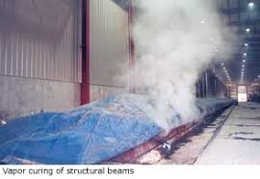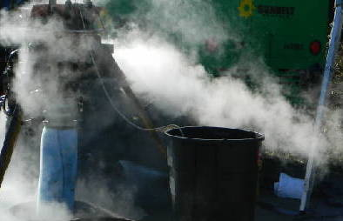
Fig.: STEAM CURING
Water curing: is done by spraying or sprinkling water over the concrete surface to ensure that the concrete surface remains continuously moist. This prevents the moisture from the body of concrete from evaporating and contributes to the strength gain of concrete.
Ponding This is the most common and inexpensive method of curing flat surfaces such as floor slabs, flat roofs, pavements and other horizontal surfaces. A dike around the edge of the slab, which may be sub-divided into smaller dikes, is erected and water is filled to create a shallow pond. Care must be taken to ensure that the water in the pond does not dry up, as it may lead to an alternate drying and wetting condition.
Sprinkling, fogging & mist curing: Using a fine spray or fog or mist of water can be an efficient method of supplying water to the concrete surface especially during hot weather, which helps to reduce the temperature of concrete, eventually conserving moisture inside the body of concrete.
Wet coverings: Water absorbent fabrics such as hessian, burlaps, cotton mats, rugs etc. may be used to maintain water on the concrete surface by completely covering the surface immediately after the concrete has set. They must be continuously kept moist to prevent the fabric from absorbing water from the body of concrete, due to capillary action.In rural areas, straw sprinkled with water regularly can be used to cure concrete. Care must be taken when using straw, as dry straw can fly away if the wind velocity is very high and it can also cause fire hazards. Moist earth, sand or saw dust can be used to cure horizontal surfaces. However, staining of the surface can occur due to certain organic matter, if present.
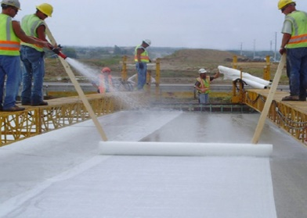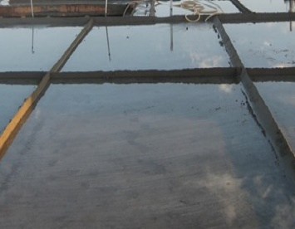
Fig.: water curing
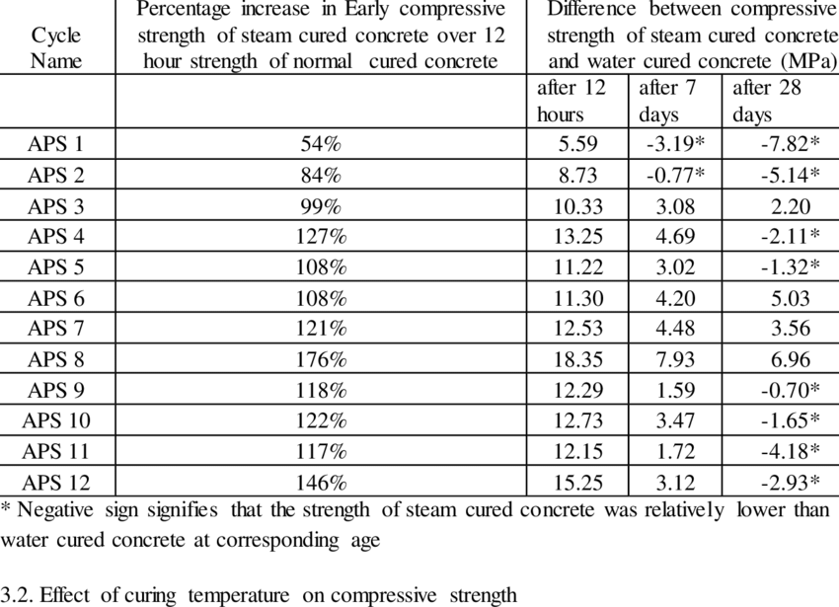CONCLUSIONS
Steam curing: For the small mortar specimens, the simulations were compared with experimental data for two water/cement ratios (w/c = 0.30 and w/c = 0.45). The main conclusions are as follows: The model correctly characterizes the moisture distribution in the mortar samples due to water consumption by hydration reactions, as compared with the experimental moisture content determined by NMR. The moisture distribution pattern is nearly homogeneous over time, but a small evaporative process was identified in the cooling period. The FTIR results allowed estimation of the hydration kinetics for the two main hydration products, CH and C-S-H. The pattern of the normalized peaks, representing the formation of these products during hydration, shows an evolution similar to the experimental and simulated degree of hydration (based on LOI) curves. The results of the simulation of an AASTHO Type VI beam indicate a maximum temperature difference of 12 °C in the period of constant temperature, between the centre and the surface of the beam. Using a rate of change of temperature of 17.5 °C/hour during the cooling period, a maximum temperature difference of 26 °C is observed, which could cause cracking. For the same conditions of curing, but for a beam with w/c = 0.45, the internal temperature reaches 79 °C (w/c = 0.30 mortar reaches 76 °C), indicating that the beam potentially can be damaged by delayed ettringite formation, for example. The moisture content profiles in the beams are generally homogeneous due to the applied curing conditions. There is effectively no drying during the process, but there is water consumption due to the hydration reactions. A change in the diffusion coefficient of the fluid with curing time was observed, especially in the w/c = 0.45 system. 16 These simulations provide the means to evaluate curing cycle changes, since their predictions are applicable to any geometry and water/cement ratio, provided that the required parameters in the maturity model and specifics of the curing conditions are known and used as inputs.
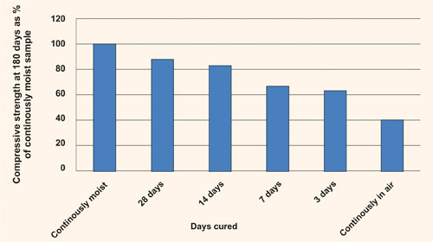
Fig.: compressive strength in 180 days
Water curing: The chemical reactions between cement & water produces C-S-H gel which bonds the ingredients of concrete, viz. coarse & fine aggregates, mineral admixtures, etc, and converts these fragments into a rock-solid mass. This is possible only if continuous curing is done for at least 14 days; irrespective of the type of cement used. It is understood that blended cements require prolonged curing to convert calcium hydroxide into C-S-H gel. However, in case of OPC as well, voids within the concrete mass gets filled up and disconnected by the formation of C-S-H gel after about 10 days of curing. To have a dense microstructure and impermeability, prolonged curing is a must which leads to enhanced durability. Well-designed concrete may give poor durability if not properly cured and on the other hand a moderately designed concrete if well cured can give a better durability. Hence importance of curing should never be ignored.
It has been observed that at several sites in India curing of concrete is left to the decision and comfort of the unskilled labourer. Site engineers & supervisors should put an extra effort to ensure that curing is not ignored at site & they should provide the necessary resources to maintain satisfactory levels of curing, by using the best technique available at site. Just as a new born baby, when it comes into this world needs the utmost care for its development and protection from this new environment, in the similar manner, a freshly placed concrete requires proper protection and care from the encapsulating & aggressive environment. Strictly adopting good curing practices at site will help concrete to achieve the properties of designed strength, enhanced durability, improved microstructure and a long-lasting serviceability.
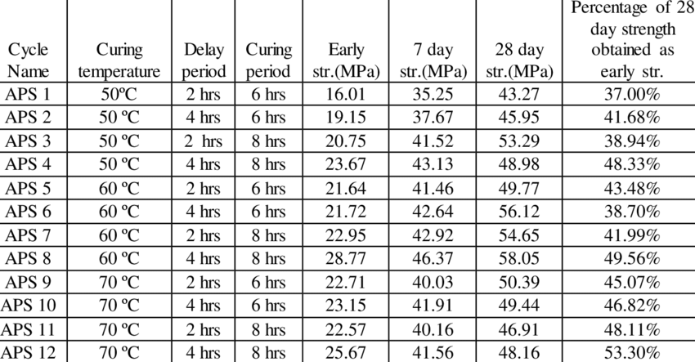
Fig.: comparison of compressive strength in 3days 7days 28days

References:
[1] J.G. Wilson, N.K. Gupta, Equipment for the investigation of the accelerated curing of concrete using direct electrical conduction, Measurement. 35 (2004) 243–250. doi:10.1016/j.measurement.2003.11.002.
[2] N. Carino, H. Lew, Temperature Effects on Strength-Maturity Relations of Mortar, ACI Mater. J. 80 (1983) 177–182.
[3] H. Yu, L. Khazanovich, M. Darter, A. Ardani, Analysis of Concrete Pavement Responses to Temperature and Wheel Loads Measured from Instrumented Slabs, Transp. Res. Rec. J. Transp. Res. Board. 1639 (1998) 94–101. doi:10.3141/1639-10.
[4] P.D. Krauss, E. Rogalla, Transverse Cracking in Newly Constructed Bridge Decks, National Cooperative Highway Research Program (NCHRP), 1996.
[5] A.M. Neville, Properties of Concrete, 5th ed., USA, 2012.
[6] A.K. Schindler, Temperature Control During Construction to Improve the Long Term Performance of Portland Cement Concrete Pavements, Texas Department of Transportation, 2002.
[7] American Concrete Institute, ACI 517-2R-80 Accelerated Curing of Concrete at Atmospheric Pressure, ACI J. (1980) 429–448.
[8] S.H. Kosmatka, B. Kerkhoff, W.C. Panarese, Design and Control Design and Control of Concrete Mixtures, Fourteenth, Portland Cement Association, 2003.
[9] Z. Zhang, J. Olek, Studies on delayed ettringite formation in heat-cured mortars II. Characteristics of cement that may be susceptible to DEF, Cem. Concr. Res. 32 (2002) 1737–1742. 20
[10] P.K. Mehta, P.J.M. Monteiro, Concrete Microestructure, properties, and Materials, Third Edit, New York, USA, 2006

