Planning, Designing And Analysis Of Hostel Building

Mohammad Asad^{[1]} , Jayesh Sajwani^{[2]}, Satyam Agrawal^{[3]} , Nikkey Jain^{[4]}, Divyansh Gupta^{[5]} , Deepak Kumar^{[6]}

Department of Civil Engineering
RSR Rungta College of Engineering & Technology
Bhilai , India

ABSTRACT

Planning, scheduling, and designing and engineering activities is challenged now a days not only by the strong competition, but also by the technology and the way by which projects are propagated. The project organization challenges the planning process through its variety of people, organizations. 3D modeling is a tool that necessitates and help for providing better way of visualization to the engineers and a more collaborative way of engineering a project. The fields of project management and lean construction deal with planning and measuring design/engineering activities in a concurrent engineering process that is globally dispersed both on engineering and on production part of a project. In this project, the design of G+1 floors Hostel building is done according to the Indian standards. The analysis and designing of beams & columns are done by the “STAAD PRO” software tool. The footings are designed manually / “ STAAD PRO ” after complete detailed estimation.

Keywords:- Structural member, design, Analysis.

- INTRODUCTION

Nowadays, due to the increase in population leads to the availability of horizontal coordination system (due to large area available per person) has been decreasing so that adoption of vertical co-ordination System (high rise building due to deficiency of area) is needed.

ETABS can also handle the largest and most complex building models, including a wide range of nonlinear behaviours, making it the tool of choice for structural engineers in the building industry. ETABS can be effectively used in the analysis and design of building structures which might consists of structural members like beams, columns, slabs, shear walls etc., With ETABS you can easily apply various construction materials to your structural members like concrete, structural steel, Reinforced Concrete etc. ETABS automatically generates the self-weight and the resultant gravity and lateral loads.

Codes recommended are IS 456-2000, SP 16, IS 875-1987 (Part I), IS 875-1987 (Part II)

for higher education and the high number of form four candidates who qualify for university admission.

This has created accommodation shortage such that each year some students lack accommodation within the school hostel. This is a disadvantage to those who cannot afford accommodation outside the university , to those who do not hail from Nairobi and probably they have never been to Nairobi before. If a hostel is put up in this land it will reduce the problem if not eradicate it The proposed hostel will provide the following:

- Appropriate environment for living as well as studying

- Opportunities for informal academic and social interchange

- Privacy and quiet place where people are living in close proximity and are sharing facilities most students will not have the opportunity to choose their neighbours

II. OBJECTIVES

- Provide more accommodation to the university students

- Provide an environment that will ensure social and academic growth
- Reduce the current accommodation crisis at the university.

BACKGROUND AND PROJECT JUSTIFICATION

Now a day in most universities the number of students admitted is not determined by the bed spaces available. This is as a result of the high demand

III. DESIGN REQUIREMENTS

Structural design is an art and science of designing with economy and elegance, a safe, serviceable and a durable structure, primarily to meet the functional requirements of the user or client. The functional requirements and economy of the structure for its intended use over the life span of the structure are looked by the structural designer.

The design of the structure must satisfy three basic requirements:

LIMIT STATE METHOD (LSM):

Limit state method is judicious amalgamation of WSM and ULM removing all drawbacks of both methods, but maintaining their good points. LSM aims for a comprehensive and rational solution to design problems by considering safety at ultimate loads and serviceability at working loads. The structures shall be designed to carry design loads safety throughout its life, and also satisfy the serviceability requirements such as limitations on deflection and cracking. The acceptable limit for safety and serviceability requirements before failure occurs is called a “Limit state “. The aim of design is to achieve acceptable probabilities so that the structures will not become unfit for the use for which it is intended.

There are two types of limit states:

Limit state of collapse: Deals with strength, overturning, sliding, buckling, fatigue, fracture etc.,

Limit state of serviceability : Deals with comfort to accompany and malfunction, caused by excessive deflection, crack width, vibration etc., and loss of durability etc.,

METHOD OF ANALYSIS:

Structural analysis involves the determination of internal forces like axial forces, bending moments, shear forces etc., in the component members for which these members are to designed under the action of given external loads.

The different approaches to structural analysis are as given below…

Elastic analysis based on elastic theory

Limit analysis based on plastic theory or ultimate load theory

LOADS AND CALCULATIONS:

The various loads acting on the structure which need consideration in building design are as follows:

Dead loads.

Live loads.

Wind loads.

Seismic loads.

DEAD LOADS: [IS: 875-1987(Part-I)]

Dead loads are the loads which do not vary in magnitude and in position. The dead Load of a structure is not known before it is not known before it is designed. After designing, the assumed load is compared with the actual dead load. If the difference is in significant, the assumed dead load is revised and the structure is redesigned. The dead calculations should also include the superimposed loads that are permanently attached the structure.

The dead loads include:

Self-weight of members.

Weight of finishes.

Weight of partitions, walls etc.

The unit weights of different materials are as follows:

Reinforced concrete : 25KN/ m3

Hollow Brick masonry: 19KN/ m3

Brick masonry: 20KN/ m3

Floor finishes: 1KN/ m2

LIVE LOADS:

In this project, an elastic analysis has been adopted. Elastic | Live loads | are | the loads | which | very | in
analysis deals with the study of strength and behaviour of | magnitude | and | in position. | Live | loads | on
members and structures at working loads. | roofs and floors are as follows:
The elastic analysis is based on the following assumptions: | Roof slab: |  |  |  |  | 4.0 KN/m2
Relation between force and displacement is linear. | Other slabs: |  |  |  |  | 4.0 KN/m
 | Balconies : |  |  |  |  | 3.0 KN/m2

PLAN OF HOSTEL:

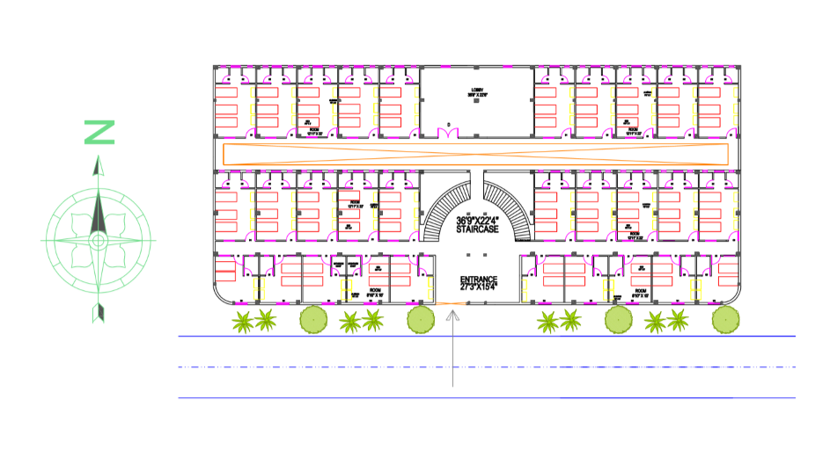

DESIGN OF STRUCTURAL ELEMENTS

DESIGN OF BEAM: Depth = 228.6 x 381 mm ( 9” x 12” ) DESIGN OF COLOUMN: Size = 381 x 458 mm ( 15” x 18”) DESIGN OF FOOTING: Size = 2.8 x 1.8m
DESIGN OF STAIR CASE: Open newel staircase used DESIGN OF SLAB: Two way Slab

STAAD PRO RESULTS:

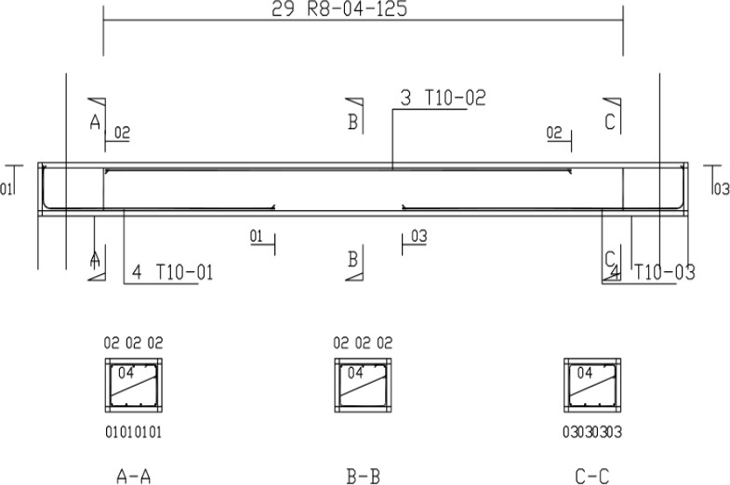

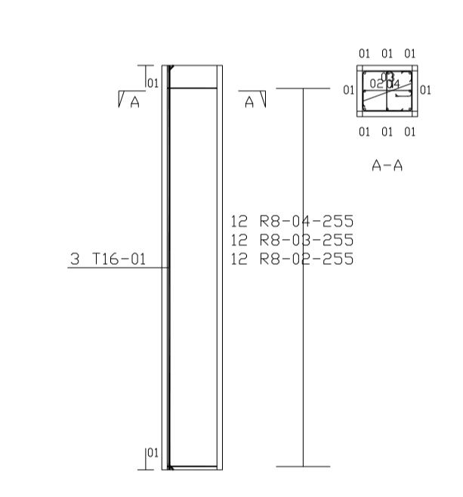

IV. CONCLUSION

In this present work ETABS is used to analyse the R.C moment resting frame structure of G+2 considering the gravity loads. The following conclusion is drawn from present work.

- G+1 Hostel Building Plan has been drawn in Auto CAD software and designed for Beams, Columns, Footings, stairs and slabs. The dead load, live load are referred using IS 875-1987

- Part I and Part II And Design According to the IS 456-2000 and SP16 by considering concrete grade of M25 and steel of HYSD bars Fe500 are used.

- By proposing our project on Hostel building which meets the requirements of our JIT girls.

- The Result obtain are safe from manual calculation i.e., in MS Excel as well as in software results.

- Manual design has been done for one of the different dimensions of the beam, column, stairs, footing and slab of the Hostel building as per the IS 456-2000 and SP16.

BIBLIOGRAPHY

- Abhay Gulgeria, (2016) pub1. Abhay Gulgeria, (2016) published as “structural analysis of a multi storey building using ETABS for different plan configurations” in the journal, International Journal of Engineering Research & Technology (IJERT) ISSN: 2278-0181 IJERTV3 IS051552 Vol. 3 Issue 5.

- Anjaneyulu B, Jaya Prakash K, (2016) published as “Analysis and Design Of Flat Slab By Using Etabs Software” in the journal, International Journal of

Science Engineering and Advance Technology,IJSEAT, Vol. 4, Issue 2ISSN 2321-6905.

- Mahamad Sabeer, Gouse Peera D, (August 2015) published as “comparison design result of RCC building” using STAAD and ETAABS software

  - Chintha Santhosh, Venkatesh Wadki, MadanMohan S, Sreenatha Reddy S(2016) published as “Analysis and Design of Multistory Building with Grid Slab Using ETABS” in the journal, Research paper volume4; Issue -7; ISSN NO-2277-8179.

  - Geeta Mehta, Bidhan Sharma and Anuj Kumar(2016) published as “Optimization of Member Size and Materials for Multistoried RCC Buildings using ETABS” in the journal, International Journal of Science and Technology, vol9(44),

.

- Mahamad Sabeer, Gouse Peera D, (August 2015) published as “comparison design result of RCC building” using STAAD and ETAABS software the journal, International Journal of

Innovative research in aduaval engineering(IJIRAE ISSN:2349=2163;Issue 8; volume 2

- Mahesh S, Dr.Panduranga B Rao (2014) published as “Comparison of analysis and design of regular and irregular configuration of multi Story building in various seismic zones and various types of soils using ETABS and STAAD” in the journal, IOSR Journal of mechanical and civil engineering IOSR- JMCE;ISSN:2278-1684;p-ISSN-2320-334X-volume11:Issue-6 ver

Details of All Authors:-

Sr No. | Author Name | Email & Contact | Details | Photo
1. | Mohammad Asad | mohammad.asad497442@gmail.com  +917987529431 | BE CIVIL  (2016-2020)  RSR RUNGTA COLLEGE OF ENGG. & TECH.
2. | Jayesh Sajwani | Jayeshsajwani070@gmail.com  +917000083846 | BE CIVIL  (2016-2020)  RSR RUNGTA COLLEGE OF ENGG. & TECH.
3. | Satyam Agrawal | agrawalsatyam200@gmail.com  +917745968588 | BE CIVIL  (2016-2020)  RSR RUNGTA COLLEGE OF ENGG. & TECH.
4. | Nikkey Jain | nikkey008@gmail.com  +918889980223 | BE CIVIL  (2016-2020)  RSR RUNGTA COLLEGE OF ENGG. & TECH.
5. | Divyansh Gupta | divyanshsitapur@gmail.com  +917746000146 | BE CIVIL  (2016-2020)  RSR RUNGTA COLLEGE OF ENGG. & TECH.

