Dual Band Rectangular Micro-strip Patch Antenna

Amin Pinjari¹, Pallavi Nikum², Pratiksha Patil³, Mr.R.V.Patil⁴, Mahesh N. Patil⁵,
Vijay D. Chaudhari⁶
^{1,2,3} B.E. Students, ⁴Asso. Prof. , ^{5,6} Asstt. Prof.
^{1,2,3,4,5,6} E&Tc Dept., GF’S GCOE, Jalgaon-425003, India
aminpinjari983@gmail.com ¹, rajendrapatil1966@gmail.com ⁴, mahesh_npatil@rediffmail.com ⁵

Abstract- This paper presents review work on rectangular shaped microstrip patch antennas. Rectangular microstrip antennas have been studied and analyzed. It has been noticed that the metamaterial considerably enhances the bandwidth and gain of the patch antenna. Rectangular patch is excited using transmission lines of particular length and width. Various parameters, for example the gain, S parameters, directivity and efficiency of the rectangular antenna are studied. These antennas find application for wireless communication systems.
Keyword-Rectangular, Microstrip Patch Antenna, strip line.
- INTRODUCTION
Now days the communication plays an excellent role in the worldwide society and almost all the communication systems are changing rapidly from wired to wireless. Wireless communication is much more flexible way of communication and antenna is the most important part of it. Recently the microstrip antenna is very useful due to its low cost, ease of Installation and integration with feed networks, low profile and small size. On the move internet browsing, E banking, digital cable TV, etc. and small handheld devices, it is often required that the antenna to be achieved low profile good gain and wideband/multi-band characteristics. A number of approaches have been reported to obtain compact dual band micro-strip antenna such as loading of rectangular, circular and triangular patches by shorting pins, crossed slot and the use of a rectangular ring. Rectangular patch antenna is popular in patch antenna design. The rectangular patch antenna design is simple and convenient to fabricate. The effect of the probe position in pentagonal and hexagonal patch antenna was reported in. The rectangular patch antenna was deeply analyzed and found that the bandwidth is greater than circular patch antenna. A rectangular microstrip patch antenna in its simplest form. These antennas find huge applications in missile applications, spacecraft, aircraft and satellite communications. Microstrip antennas are one of the most important antennas in the wireless communication market, and we can find applications of microstrip antennas in various fields of the hightech technology like in mobile and satellite communication, missile telemetry, biomedical uses and radar systems. [7]

- LITERATURE SURVEY

2.1 Review of earlier work

In this paper, A theoretical survey on microstrip patch antenna is presented. After study of various research papers it concluded that Lower gain and low power handling capacity can be overcome through an array configuration and slotted patch. Particular microstrip patch antenna can be designed for each application and different merits are compared with conventional microwave antenna.
Antenna is one of the important elements in the system for receiving transmitting signals from and into the air as medium. Without proper design of the antenna, the signal generated by the RF system will not be transmitted and no information or signal can be received at the receiver [1].
In this paper presents review work on rectangular shaped microstrip patch antennas. In this paper four rectangular microstrip antennas have been studied and analyzed. We start our work with a reference rectangular patch which has six parallel slits of 5mmx37mm, and then we proceed with variation in length and width of those slits. We examine our results on two configurations, single layer and multi layer all antennas are simulated in IE3D simulation software, and all Antennas are designed on FR4 substrate. [2]
In this paper presents. The purpose of this paper is to design a microstrip rectangular antenna in Advance Design System Momentum (ADS). The resonant frequency of antenna is 4.1GHz. The reflection coefficient is less than 10dB for a frequency range of 3.1GHz to 5.1 GHz. The proposed rectangular patch antenna has been devise using Glass Epoxy substrate (FR4) with dielectric constant (єr = 4.4), loss tangent (tan δ) equal to 0.02. This rectangular patch is excited using transmission lines of particular length and width. Various parameters, for example the gain, S parameters, directivity and efficiency of the designed rectangular antenna are obtained from ADS Momentum. As the outlook work, we may extend our research to study a various slot antenna in affects the resonance frequency and the bandwidth. [3]
In this paper a survey on the micro strip patch antenna and there historical perspectives. The micro strip antenna has better prospects and advantages which make greater progress in recent years. In this paper we discuss micro strip antenna, types, feeding techniques and application, advantage and disadvantages over conventional microwave antennas. We also discuss their dual and circular polarizations, dual-frequency operation, frequency agility, broad band-width and feed line flexibili .The technology used and research work increases the use of Micro strip antenna and their performance day by day and also make better utilization in future. Many techniques improve gain and bandwidth of the Micro strip A There are many simulation software are developed for micro strip antenna which make easy of designing in proper ,accurately and in automatic way with eliminating all complexity antenna.[4]
In this paper present The overall design is cost effective as the cuts are introduced in ground base as well as size is kept as small as possible. To the environment instead of stored by radiating energy of the antenna. The effects of the inset-fed position, the spacing between the patch and the feed-line, and the air thickness between two layers on the antennas are investigated. The effects of the aperture slot width, length and position to patch center have been studied to improve the maximum coupling between patch and feed line. With the frequency reconfiguration and stable radiation patterns, the proposed antenna can find potential application for future wireless communications. [5]
In this paper present gives the concept of designed UWB rectangular microstrip patch antenna using three layers substrate and each layers having different permittivity. Various parameters of this antenna designed are optimized and the optimized design is prototyped. The various simulation results like return loss characteristics, input impedance, 2D radiation pattern and 3D radiation pattern. Here study the graph of return loss, input impedance, 2D radiation pattern and 3D radiation pattern. [6]
2.2 Problem Statement
With bandwidths as low as a few percent, broadband applications using conventional Microstrip patch designs are limited. Other drawbacks of patch antennas include low efficiency, limited power capacity, spurious feed radiation, poor polarization purity, narrow bandwidth, and manufacturing tolerance problems. For over two decades, research scientists have developed several methods to increase the bandwidth and low frequency ratio of a patch antenna. Many of these techniques involve adjusting the placement and/or type of element used to feed (or excite) the antenna. Dual-frequency operation of antennas has become a necessity for many applications in recent wireless communication systems, such as GPS, GSM services operating at two different frequency bands. In satellite communication, antennas with low frequency ratio are very much essential. A dual-frequency patch antenna with an inset feed can produce a dual-frequency response, with both frequencies having the same polarization sense with a low frequency ratio. It is also less sensitive to feed position, which allows the use of an inset planar feed. While optimizing the antenna parameters, using Zealand IE3D simulator, the overlapping problem is most often encountered.
2.3 Proposed Method
The fig.2.3.1 of rectangular patch antenna. Rectangular geometries are separable in nature and their analysis is also simple. The rectangular patch antenna has the advantage of their radiation pattern being symmetric. The conducting patch is not the only element responsible about the power radiation but also the dielectric material shares the task. Moreover, the dielectric plays an important role in designing the microstrip radiating structure for any radioelectric desire. In addition, the substrate material having low relative permittivity, such as Teflon or polytetrafluoroethylene are commonly used.
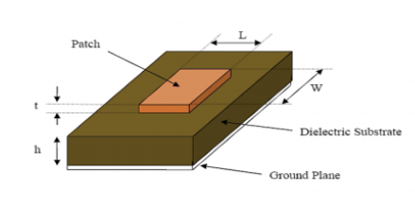Fig.2.3.1 Rectangular patch antenna. [3]

The radiating element can have several shapes as shown in figure 2.1, but the rectangular and circular are the commonly used. Other shapes can also be designed to satisfy some radioelectric properties that cannot be achieved using conventional shapes. Example of the proposed structures is the plus antenna that is the subject of our work. There are numerous substrates that can be used for the design of microstrip antennas, and their dielectric constants are usually in the range of 2.2 ≤ ≤ 12. The ones that are most desirable for good antenna performance are thick substrates whose dielectric constant is in the lower end of the range because they provide better efficiency. [3,7]

2.4 Feeding Techniques
Many configurations are available for feeding microstrip antennas whereas the four most popular methods are the microstrip line, aperture coupling, coaxial probe feeding and proximity coupling.
2.2.1 Coaxial Feed
Coaxial feed also known as probe feed is a very commonly used technique to feed microstrip patch antennas. This technque is appreciated for it has the advantage of placing the feed at any location inside the patch to get perfect impedance matching. The inner conductor of coaxial connector goes through the dielectric and is soldered to the radiating patch, whereas the outer conductor is connected to the ground plane w hich can be easily seen in Figure 2.4.1
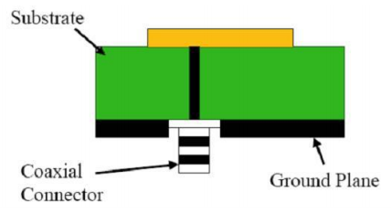Fig 2.4.1 Coaxial feeding technique [3]
Like microstrip feeding this technique is also easy to fabricate but has low spurious radiation. However it has a disadvantage of narrow bandwidth. Also the modelling is quite difficult especially when substrate thickness is high since a hole has to be drilled into the substrate. For thicker substrates input impedance becomes more inductive due to increase in probe length which leads to matching problems.I have used to coaxial prob feed in this project on feeding. [3]
2.5 Antenna Parameters
2.5.1 Gain
Gain is the parameter which measures the degree of the directivity of the antenna’s radiation pattern. It is defined as the ratio of the radiated power Pr to the input power Pi. The input power is transformed into radiated power and surface wave power while a small portion is dissipated due to conductor and dielectric losses of the materials used. Antenna gain can also be specified using the total efficiency instead of the radiation efficiency only. This total efficiency is a combinationof the radiation efficiency and efficiency linked to the impedance matching of the antenna . [1]
2.5.2 Radiation Pattern
The radiation pattern is defined as a mathematical function or a graphical representation of the radiation properties of the antenna as a function of space coordinates. [1]
2.5.3 Antenna Efficiency
It is a ratio of total power radiated by an antenna to the input power of antenna. [1]
2.5.4 VSWR
Voltage standing wave ratio is defined as VSWR=Vmax/Vmin.It should lie between 1 and 2. VSWR is defined as the ratio of the maximum voltage to the minimum voltage in a stading wave pattern.A standing wave developed when power is reflected from a load. This happens because of improper impedance matching.According to the maximum power transfer theorem, maximum power can be transferred only if the impedance of the transmitter Zs is match with impedance Zin. [1]
2.5.5 Return Loss
Return loss is the reflection of signal power from the insertion of a device in a transmission line. Hence the RL is a parameter similar to the VSWR to indicate how well the matching between the transmitter and antenna has taken place. The RL is given as by RL=-20 log10 (Γ) dB For perfect matching between the transmitter and the antenna, Γ = 0 and RL = ∞ which means no power would be reflected back, whereas a Γ = 1 has a RL = 0 dB, which implies that all incident power is reflected. For practical applications, a VSWR of 2 is acceptable, since this corresponds to a RL of -9.54 dB. [1]
- METHODOLOGY
Development during this decade was accelerated by other researchers’ by the availability of low-loss tangent substrate materials. Others factors for the development include improved photo-lithographic techniques, better theoretical modelling and attractive thermal and mechanical properties of the substrate. The first practical antenna was developed by Munson and Howell. Since then extensive research and development of microstrip antennas and their arrays have led to diversified application within the broad field of microwave antennas. Microstrip or printed patch antennas are used in almost all wireless systems with recent advancements in printed circuit technology. The purpose of microstrip or patch antenna is to radiate and receive electromagnetic energy in microwave range and it plays an important role in wireless communication applications. The performance and operation of a microstrip antenna is dependent on the geometry of the printed patch and the material characteristics of the substrate.

3.1 System Software
3.1.1 Zealand IE3D Simulator
IE3D is an Electro Magnetic simulation and optimization software useful for circuit and antenna design. IE3D has a menu driven graphic interface with automatic meshing, and uses a field solver based on a full-wave, method-of-moments to solve current distribution on 3D and multi layer structures of general shape. High Performance and Robust Network Distributed EM Simulation and Optimizations on IE3D.Multi-fold speed improvement and multi-CPU support for improved efficiency in IE3D.The speed of IE3D engine is improved without multi-CPU support. With multi-CPUs, you can finish your jobs much sooner in higher quality.Equation-based schematic layout editor with Boolean operations for flexible geometry editing and parameterization in IE3D Simulator.IE3D Library is further improved. It allows you to create complicated layouts with parameterized objects in a schematic way. All dimensions of the objects are equation-based. Thanks to the implementation of Boolean objects and void objects, users can create structures beyond the coverage of the limited object types available in the library. Users can use Boolean objects to create any shape and use void objects to combine objects together for sophisticated structures.Lumped element equivalent circuit automatic extraction and optimization for convenient circuit designs.Lumped element equivalent circuits are needed for modern RFIC designs and signal integrity. IE3D 12 simulations yield the frequency dependent lumped element equivalent circuit models automatically. Users can visualize the parameters. Users can also optimize the circuit parameters to achieve desired goals.Improved integration into Microwave Office from Applied Wave ResearchThe EM Socket for IE3D integrated into MWO is further improved to provide stable seamless IE3D integration into MWO. [4]
4. RESULTS AND DISCUSSION
4.1 Dual Band concept
The boom in wireless communication technology sector has led to increased demand for highly efficient antennas with high bandwidth and maximum gain. Microstrip patch antennas have the advantage over other antennas being very light weight and economical. They exhibit very low profile and can be realized very easily. However, the general microstrip patch antennas have some disadvantages such as narrow bandwidth etc. Their performance need to be enhanced so as to achieve greater bandwidth. There are a huge number of methods available to enhance the bandwidth of microstrip antennas, such as increasing the substrate thickness, using low dielectric constant for substrate, slotted patch antenna, incorporating various techniques for impedance matching and feeding methods. In principle, multi-band planar antennas should operate with similar features, both in terms of radiation and impedance matching, at two or more separate frequencies. It is known, a simple rectangular Microstrip patch can be regarded as a cavity with magnetic walls on the radiating edges. The first three modes with the same polarization can be indicated by TM10, TM20 and TM30. TM10 is the mode typically used in practical applications. TM20 and TM30 are associated with a frequency approximately twice and triple of that of the mode. This provides the possibility to operate at multiple frequencies. In practice, the TM20 and TM30 modes cannot be used owing to the facts that the TM20 pattern has a broad side null and the pattern has grating lobes. The easiest method to simultaneously operate at two frequencies is to consider the first resonance of the existing two orthogonal dimensions of the rectangular patch antenna, which are the TM10 and TM01 modes. Here the frequency ratio is given by the ratio of two orthogonal sides which is an approximate value. Though this approach is very much acceptable in terms of simplicity but has an disadvantage that two orthogonal polarizations are excited because of the two different frequencies. However, when much stress is not given to the polarization this method can be used without a hitch such as in short range low cost applications.
4.2 Simulation Results
4.2.1 Proposed Design
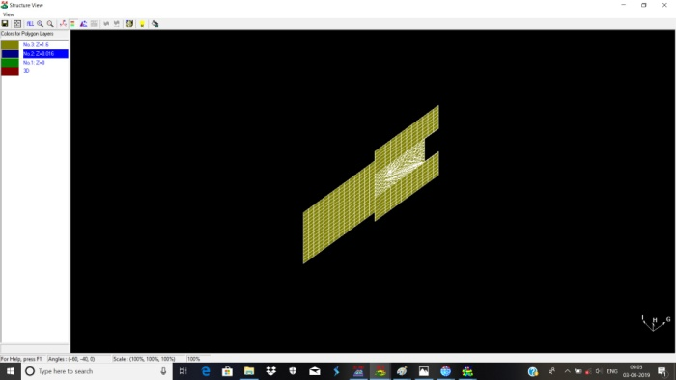
Fig. 4.2.1.1 Design of Rectangular Patch Antenna
This design consists of microstrip patch made of copper of 0.7mm thickness etched over a 4.56mm thick FR 4 lossy substrate with dielectric constant 4.3. The bottom side of the substrate is etched with a 0.7mm thick copper material which constitutes the ground plane.
The patch antenna has been introduced with two inset notches one on each side of the microstrip feed line. The introduction of notch creates an additional current distribution thus introducing an additional TM0δ resonant mode along with the previously existing resonant mode of the patch antenna while unchanging the same polarization. 4.3 Simulations and Results
4.2.2 S parameter characteristics
The S-parameter plot shows the variation of return loss (in dB) over a range of frequencies. Since at resonance the antenna is having the best impedance matching so the return loss would be minimum.
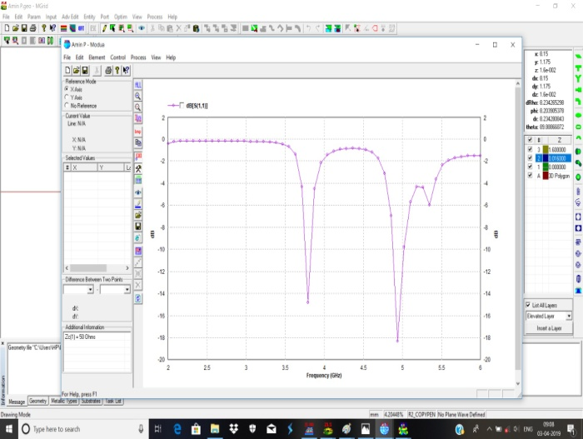
fig 4.2.2.1 S parameter characteristics
The return loss characteristics as shown in Figure 4.2 (a) is the one obtained by simulating the microstrip patch antenna through Zealand IE3D Software.
4.2.3 Radiation Pattern Plot
The Figure 4.4.1 shows the 2D radiation pattern for the 2 GHz to 6 GHz frequencies. These patterns present the relationship between the co-polarization that is desired component and cross-polarization that is undesired component

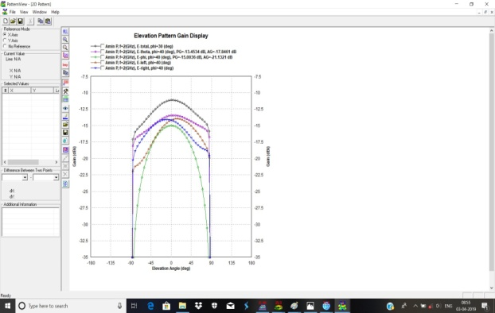
fig 4.2.3.1 2D Radiation Plot

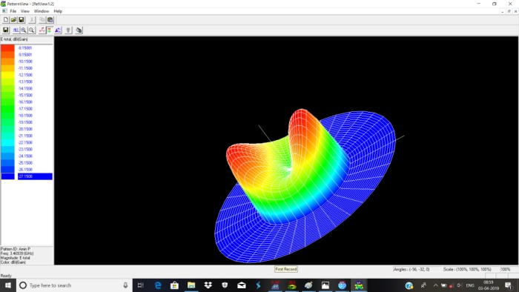
fig 4.2.3.2 3D Radiation Plot
The Figure 4.4.2 shows the 3D radiation pattern for the 2 GHz to 6 GHz frequencies. These patterns present the relationship between the co-polarization that is desired component and cross-polarization that is undesired component. Moreover it gives a clear picture as to the nature of polarization of the fields propagating through the UWB microstrip patch antenna.
- CONCLUSION
Rectangular microstrip antennas have been studied and analyzed. It has been noticed that the metamaterial considerably enhances the bandwidth and gain of the patch antenna. Rectangular patch is excited using transmission lines of particular length and width. Various parameters, for example the gain, S parameters, directivity and efficiency of the rectangular antenna are studied. Also studied 2D & 3D Radiation pattern on dual band Rectangular patch antenna. These antennas find application for wireless communication systems.
REFERENCES
[1] Nivedita Girase, Dept. of E&Tc, TIT(E) Bhopal, “A Review Paper on Rectangular Microstrip Patch Antenna’’,International journal of research in technology & management ISSN 2454-6246.
[2] Deepak Verma, Dheeraj Bhardwaj, Kanika Joshi, Komal Sharma,“Review Paper on Modified Rectangular Shaped Microstrip Patch Antennas”,IJCTE vol7,Issue 2 ,APRIL-JUNE-2016
[3] Houda Werfelli, Khaoula Tayari, Mondher Chaoui, Mongi Lahiani, Hamadi Ghariani, “Design of Rectangular Microstrip Patch Antenna’’,2nd International Conference on Advanced Technologies for Signal and Image Processing - ATSIP'2016 March 21-24, 2016, Monastir, Tunisia.
[4] Nikita Sharma, Bhawana Jain, Pradeep Singla, Raj Ranjan Prasad, “Rectangular Patch Micro Strip Antenna: A Survey’’,International Advanced Research Journal in Science, Engineering and Technology Vol. 1, Issue 3, November 2014
[5] M.Poovizhi, “Survey of Microstrip Patch Antenna’’, International Journal of Science, Engineering and Technology Research (IJSETR) Volume 6, Issue 2, February 2017, ISSN: 2278 -7798.
[6] Hashibul Alam Department of Electronics and Communication Engineering, Aliah University, Kolkata, India, “Design Rectangular Microstrip Patch Antenna for IEEE 802.15.3a (WPAN) with MB-OFDM Ultra Wide Band Communication System’’, International Journal of Scientific and Research Publications, Volume 4, Issue 2, February 2014 1 ISSN 2250-3153.
[7] C. A. Balanis, “Antenna Theory, Analysis and Design”, John Wiley & Sons, New York, 2005.

