A Review On IOT Based Railway Track Crack Detection with Live Video Streaming

Ankush V. Chaudhari¹, Kalpesh S. Banait², Lavanya R. Koli³ , R. V. Patl⁴,
Devendra P. Marathe ⁵
¹²³BE Student, Asso. Prof.⁴ , ⁵ Asst. Prof
^{1,2,3,4,5} Department of Electronics and Telecommunication,
GF’s Godavari College of Engineering, Jalgaon - 425003, India
¹ ankushvc44@gmail.com

Abstract-.This paper describes an Internet of things (IoT) based track monitoring system for increasing the comfort of rail track transportation. Usually, rail tracks are inspected only at midnight and also the inspection is carried out only once in a month or lesser. Unfortunately, any emergency issues not detected within the stipulated time leads to train derailment and other safety concerns. Hence in service vehicle has been introduced to increase the safety of train transportation. In this paper, track irregularities are detected using bogie and car body acceleration measurements and these measurements is further optimized using particle swarm optimization algorithm (PSO). The proposed system is compared with the conventional track geometry measurement system. The monitoring and control information can be sent through IoT.

Keywords- Railway Track,Track Detection, Video Streaming, GSM
- INTRODUCTION

Railway is one of the most conventional methods of travelling and is the most commonly used means of transport. India has the world’s seventh largest railway system. The detection of fractures in such extensive system of 115,000 km of track around the country increases the probability of error rate. The GSM (Global System for Mobile Communications), GPS (Global Positioning System) and microcontroller based broken railway track detection when implemented is an efficient method of detection of cracks which is present in the tracks and thus avoiding derailment of the trains. The implementation of Internet of Things (IoT), which is a fast growing technology in the present times, is used for smart surveillance system. This system is used in-between two stations which will detect the cracks present on the track using ultrasonic sensors which transmit sine waves for an ideal track. If a crack is detected the ultrasonic sensor will send a signal to the Arduino Uno board which will activate the GPS receiver. The GPS receiver will pin point the exact location which will then be messaged to the authorities. Once the ultrasonic sensor sends a signal to the controller, the controller will initiate the webcam. The webcam will provide the live feed of the track. The live feed and the data from the GPS will be updated in the website.
- LITERATURE SURVEY
The cracks and other problems with the rails generally go unnoticed due to improper maintenance and irregular manual track line monitoring that is being carried out in the current situation. Nowadays system have some limitations, if the bridge or track damaged, that information goes to railway authority people, they notifies and informs to the corresponding trains it will takes more time informing those information. In the literature survey, the commonly employed rail crack detection schemes in foreign countries are usually ultrasonic or eddy current based techniques which are the reasonably good accuracy in most cases. However, the one characteristic which the above mentioned methods have in common is that they are both expensive, which makes them ineligible for implementation in the current Indian scenario. Also, the ultrasonic can only inspect the core of materials; that is, the method cannot check for surface and near surface cracking where many of the faults are located. Many of the most serious defects that can develop in the rail head can be very difficult to detect using the currently available inspection equipment [1]. This system is mainly concerned in identifying the cracks in railway tracks and helps to prevent the accidents without manual power. It’s not only concentrated on finding damaged tracks but also helpful to find out the derailment and the exact place where it is. In this technical solutions offered by many companies in the detection of cracks in rails involve periodic maintenance coupled with occasional monitoring usually once a month or in a similar time frame. But the robotics possesses the inherent advantage of facilitating monitoring of rail tracks on a daily basis during nights, when the usual train traffic is suspended. Further, that the simplicity of this idea and easy availability of the components make for implementation on a large scale with very little initial investment [2]. The simplicity of this work ensures robustness of operation and also the design has been carefully modified to permit rugged operation. Another disadvantage that can be attributed to the conventional commercially available testing equipment’s is that they are heavy which poses a practical limitation. This important disadvantage has been rectified in robotics project as the design is simple and sensible enabling the device to be easily portable. While designing the mechanical parts of the robot, due consideration has been given to the variable nature of the tracks and the unique challenges possessed by the deviations in the Indian scenario. For example, in areas near road crossings the outer part of the track is usually covered with cement. Also, there is always the problem of rocks obstructing the path on the inside parts of the rails. So the specialized wheels that have been provided in robot that has taken into account and are specifically designed to overcome this aforementioned problem. The railway track crack detection is used to detect the crack whiles the train running on the track [3]. The proposed system is used to detect the crack on railway track before 10km.

- METHODOLOGY
The proposed system uses ultrasonic senor, which produces sound waves at 18 KHz, for sensing the presence of a gap in the rails. In addition to the traditional sensing system and the GSM and GPS system to notify the authorities we have implemented IoT which is a technology which has infinite functions. In our proposed systems are three modules

I. Crack Detection system using ultrasonic sensors.
II. Live video streaming module.
III. Internet of Things

The functionality of the paradigm starts with the ultrasonic sensor transmitting a perfect sine wave to the controller in case of an ideal track. When a rupture is detected a disrupted signal is sent to the Arduino Uno controller which in turn signals the GPS receiver. The GPS receiver will identify the exact latitude and longitude coordinates. The coordinates are sent as a message to the GSM. The GSM module is pre-programmed with the contact information and the coordinates are sent to the intended authorities and railway station. Once a crack is detected, the Raspberry pi controller will initiate the camera. The camera gives a live feed of the crack and can help in the investigation of the intensity and depth of the detected fracture. If the crack detected is only 10% of the accepted range the bot can be programmed to move on till it finds the next crack. The Internet of Things is employed for the authorities to inspect and obtain the live feed sent by the camera. The advantageous embellishments will allow the users to view the developments of the track. The video log can be accessed locally using WLAN hotspot in android mobile phones or through the internet by using the Wi-Fi modem.
3.1 System Hardware
The chip first came to the attention of western makers in August 2014 with the ESP-01 module, made by a third-party manufacturer Ai-Thinker. This small module allows microcontrollers to connect to a Wi-Fi network and make simple TCP/IP connections using Hayes-style commands. However, at the time there was almost no English-language documentation on the chip and the commands it accepted.[2] The very low price and the fact that there were very few external components on the module, which suggested that it could eventually be very inexpensive in volume, attracted many hackers to explore the module, chip, and the software on it, as well as to translate the Chinese documentation

3.1.1 ESP8266

ESP8266. The ESP8266 is a low-cost Wi-Fi microchip with full TCP/IP stack and microcontroller capability produced by Shanghai-based Chinese manufacturer Espressif Systems.
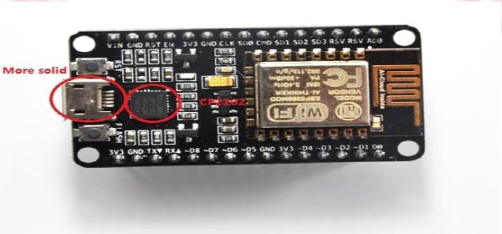
Fig 1 : ESP8266 Model
The ESP8285 is an ESP8266 with 1 MiB of built-in flash, allowing for single-chip devices capable of connecting to Wi-Fi.

3.1.2 TCRT5000
The TCRT5000 and TCRT5000L are reflective sensors which include an infrared emitter and phototransistor in a leaded package which blocks visible light. The package includes two mounting clips. TCRT5000L is the longleadversion. 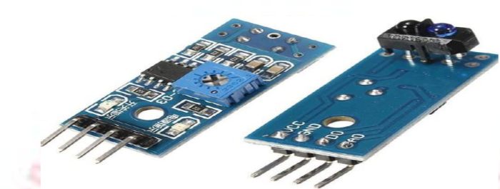

f
Fig 2 : TCRT5000

3.1.3 GSM Module
The Global Positioning System (GPS) shown in Figure is used to determine and detect its meticulous location, and therefore that of its carrier, at intervals. The recorded location can be stored in the tracking unit, or it can be transmitted to a central location database, or Internet-connected computer, using a mobile (GPRS or SMS), radio, or satellite device embedded in the unit.
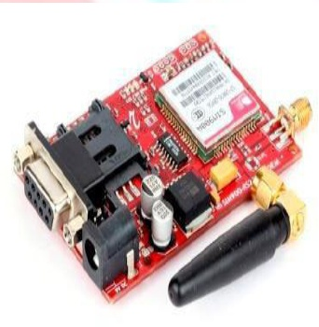
Fig 3. GSM Model
The Global Positioning System (GPS) shown in Figure is used to determine and detect its meticulous location, and therefore that of its carrier, at intervals. The recorded location can be stored in the tracking unit, or it can be transmitted to a central location database, or Internet-connected computer, using a mobile (GPRS or SMS), radio, or satellite device embedded in the unit

3.2 System Software
The software tools such as python v2.7, BLYNK and VNC viewer is used for programming and controlling the system. Python v2.7 is used for coding the raspberry pi microcontroller. Python is high level programming language which accentuates on the importance of code readability and the codes involved ensures reduced code lines than other high level languages such as Java, C, C++ .

- CONCLUSION
The railway is the most commonly used mode of transportation by the people and for goods. The transport system must always be secure. Utilising the benefit of embedded system we can build a system which helps the cause of safe travel. The proposed system is an amalgamation of the conventional method of crack detection and the innovative method of live video streaming and IoT. The entire system is placed on a four wheeler bot which travels along the rails. When compared to existing system which uses IR transmitter and receiver, the proposed system is an innovative technique which lowers the burden of the authorities and increases the accuracy of the crack detection. The process is done at a periodic rate to check for cracks so that causalities can be avoided entirely. The entirety of the model is to ensure that defective rails can be found in time to stop derailment of trains, to save the loss of lives and property.

REFERENCES
[1] Kim, N.Stubbs “ Crack Detection in beam type structures using frequency data” Elseveir volume 2592,January 2003.
[2] Akhil N,Dinu Mohan,Fayis P,Sija Gopinath, “Railway Crack Detection System” ISSN 2395 0056 International Research Journal of Engineering and Technology Volume-3,Issue-5,May 2016.
[3] Prof.P. Navaraja. “Crack Detection System For Railway Track By Using Ultrasonic and PIR Sensor” ISSN 2348-9928 International Journal of Advanced Informantion and Communication Technology Volume- 1, Issue-1, May-2014.

