Design and Development of Solar Mobile Charger with MPPT
Sonar Pratiksha¹, Devyani Mahajan^{2,} I. S. Jadhav³, Shafique Ansari⁴, D. P. Marathe⁵,
Vijay D. Chaudhari⁶
¹ M. Tech. student, ² ACME PLC Controls Ltd., Mumbai ^{3,4,5,6} Faculty
^{1,3,4,5,6} E&TC Engg dept (VLSI & Embedded System Design), GF’s Godavari College of Engineering, Jalgaon – 425003, . Maharashtra, India
pratiksha.sonar@gmail.com¹, etc.devyani@gmail.com ², ishwar.jadhav@rediffmail.com³, vinuda.chaudhari@gmail.com⁶

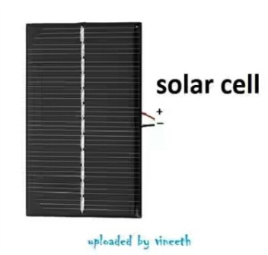
Abstract - We can charge mobile phones by using solar radiation. It’s big component is a compact solar panel. So, the output voltage stable and regulate, we using a voltage regulator circuit with the solar panel. Most of the mobile phones is computer connectivity via USB cable. USB port establishes 4 connection terminals. The connection terminals at the two insignificant ends are the supply terminals. In a female USB connector (port via which plug in computer to USB devices ), these terminals carry 5V DC. When a mobile phone is connected to the USB port of a computer, it utilize the 5V supply to recharge battery. This features is used in a solar mobile charger. It converts and regulates solar energy to 5V DC and the output will be available through the female USB connector, we can easily connect a mobile phone via data cable.
Keywords- solar panel, inverter, solar charge controller, battery, MPPT, motor, Sensor, Solar tracking system

- INTRODUCTION
This paper presents the solar charge controller circuit for controlling the overcharging and discharging from solar panel. This circuit regulates the charging of the battery in a solar system by monitoring battery voltage and switching the solar or other power source off when the battery reaches a preset voltage. This circuit is low voltages disconnect circuit. A charge controller circuit can increase battery life by preventing over charging which can cause loss of electrolyte. The flow chart is also provided.Solar energy and convert at in to electric energy and used for domestic purpose. A solar charger employs solar energy to supply electricity to device or charger batteries. They are generally portable. In a stationary location a series of solar cells are installed and can be connected to a battery bank to store energy for off-peak usage. Most portable chargers can obtain energy from the sun only.
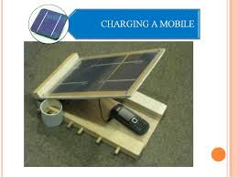
Figure 1. Solar photo cells
2. LITERATURE SURVEY
Paper [1] works on the principle that when light falls on the solar cell, electrons –holes pairs are created in then-type emitter and in the p-type base. The development of solar charger goes from the fundamental level like soldering lamination and making the panel etc. The developed charger is planned for 6 Volts with maximum capacity at bright sunlight and step down to 5Volts using regulator. The authors used the concept [2] of energy harvesting by using solar energy for battery charging purpose. The goal of wireless sola mobile phone charger is to develop a small solar panel that can be placed on mobile phone itself, so the mobile can charge independently. There won’t be any need of electrical outlets or solar panels. The mobile phone will be charged anywhere when exposed to sunlight. Paper [3] discusses system structures, in which mobile phones act as either active or passive devices depending on available communication between smart phones and their solar chargers. A suitable small size solar cell panel is selected that is easy to carry to any locations farther from city electric grids. The paper [4] proposes a universal mobile charger which can work on wind as well as solar energy. This charger is highly efficient and very economical as it uses non conventional energy sources of power. The work in [5] is about using non conventional energy i.e. solar energy for mobile battery charging. Solar chargers are simple, portable and ready to use devices which can be used by anyone especially in remote areas.
The authors studied in [6], the Maximum Power Point Tracking (MPPT) system are used four LDR sensors, when two sensors is sense then motor is rotate in E-W direction and other two sensors worked then rotate in N-S direction. This system advantage is maximum intensity of light and increase the panel efficiency. The project [7], gives idea about non- conventional Energy sources and why the authors were gone for that non-conventional energy sources. The proper uses of solar energy and its different application which are using at home defence sector, marines, remote area etc.

2.1 Problem Statement
The major factor that drove us to this project is that it is one the method of charging that utilizes the renewable sources of energy where we can overcome the exhaustible usage of power and charge. It reduces the environmental pollution and is much user friendly. Solar charger needs light to work. The efficiency of the photo-voltaic panels has increased greatly over the last decade or so, reaching the point where they do not need direct sunlight to work but will now create a satisfactory current even under overcast conditions. Charging a device by solar charger is much slower than the main charger.

2.2 Proposed Method/System
Now a days mobile plays a vital role in our life. So only one thing that I can predict about everyone is, everyone have experienced frustration at least once in your lifetime because of the low battery charge in your mobile phone. Am I right? But as I experienced it, I started to think about a Solar mobile charger with phone. Solar power is everywhere in the world. We don’t want to find a power plug. Just take the phone in contact with solar system. Nowadays, solar power is gaining increased attention. As a result Cost of solar panels has diminished dramatically. Solar power is renewable and it doesn’t have any environmental impact. The Solar mobile charger has following parts:
i. Solar panel 6V: You can buy solar panels online at cheap rates. It costs Less than 10$. The Solar panel is the most important part of this project. So buy a quality product from amazon.
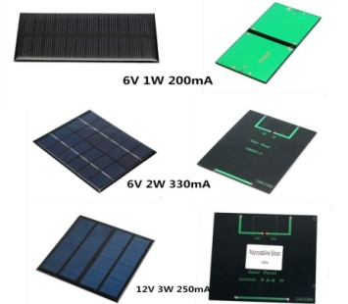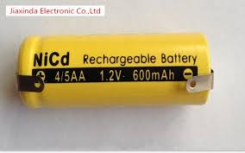
Solar panel 6V Rachargeble Battery 1.2V
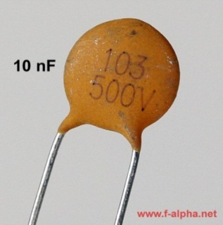 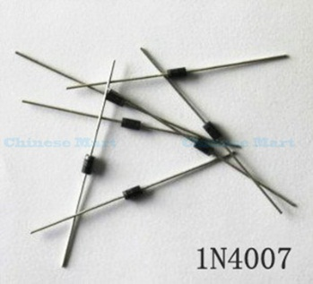 Capacitor of 10nf Diode IN4007
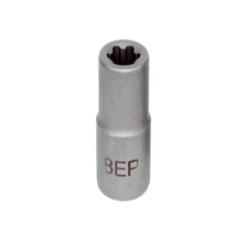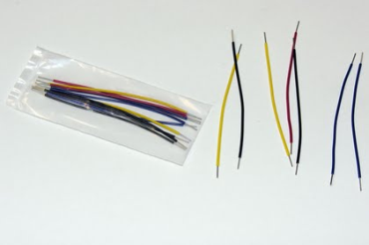
EP Sockets Connecting Wires
Figure 2. Components required
ii. Rechargeable Batteries 4*1.2v and holder: The output of a solar power is not constant. The main disadvantage of solar power is that it may not be able to provide enough power for our application in cloudy days. To avoid this problem we can implement a set of rechargeable batteries in the project design. So we can recharge the battery inside the charger and make it available later.
iii. Diodes IN4007: A diode is an electrical device allowing current to move through it unidirectional with easily in compare with other. The most common type of diode in modern circuit is the semiconductor diode, though other diode technologies exist. Take IN4007 Silicon Diode (any diode will work)
iv. Capacitor 10nf: The output of a solar panel may not be constant. Any small variations may affect the efficient charging of the mobile phone battery. To avoid this problem we can use a 10nf capacitor in parallel to the circuit.
v. Switch: Switches, EP sockets, Male sockets connecting Wires etc.
- METHODOLOGY
3.1 SYSTEM IMPLIMENTATION
A Solar mobile battery charger is a device that can automatically recharge a mobile battery when the charging in it gets low and the device is in directly contact with the solar radiation.
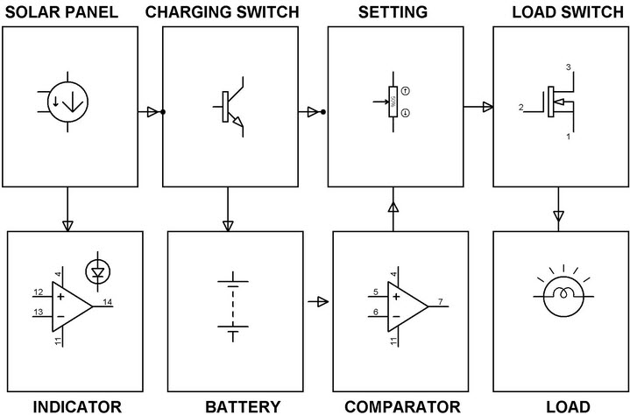
Figure 3. Solar Panel Charge Controller
Now a days mobile phones plays the vital role of everyone’s life and hence require frequent charging of battery owing to longer duration uses.Solar battery chargers produced as a simple, trickle, timer based, intelligent, universal battery charger-analyzers, fast, pulse, inductive, USB based, solar chargers and motion powered chargers. These battery chargers also vary with respect to the applications like mobile phone charger, battery charger for vehicles, batteries chargers for electric vehicle and charge stations. Charging methods are described into two categories: fast charge method and slow charge method. Fast charge is a method used to recharge a battery as early as possible i.e in about two hours or less than this, and in the slow charge method it takes much more time as compare to fast battery charger. But Slow charging is advantageous because it does not require any charge detection circuit. Also it is cheap in prise. The only drawback of this charging system is that it takes maximum time to recharge a battery.
The Solar Mobile Charger Circuit has the set of hardware components such as solar panel, Op-amps, MOSFET, diodes, LEDs, potentiometer and battery. To convert sun light energy into electrical energy solar panels are used. This converted energy is stored in a battery during day time and makes use of it during night time. For monitoring of panel voltage and lead current continuously a set of OP-AMPS are used as comparators. LEDS are used as indicators and when it glows green it indicates the battery as fully charged. Similarly, when it glows red it means that the battery is under charged or over loaded. The Charge controller makes use of MOSFET for a power semiconductor switch to cutoff the load when the battery is low or in overload condition. A transistor is used to bypass the solar energy into a dummy load when the battery is fully charged and it protects the battery from getting over charged.
3.2 System Hardware

Types of Solar Charger Controller:
There are three different types of solar charge controllers, they are:
- Simple 1 or 2 stage controls
- PWM (pulse width modulated)
- Maximum power point tracking (MPPT)
Simple 1 or 2 Controls: It has parallel transistors to control the voltage in one or two steps. This controller basically just shorts the solar panel when a certain voltage is arrived at. Their main genuine fuel for keeping such a notorious reputation is their unwavering quality –so not many segments, there is very little to break.
PWM (Pulse Width Modulated): This is the traditional type charge controller, It is used for instance anthrax. PWM signal is used in operation of solar mobile charger with the help of MPPT.
Maximum power point tracking (MPPT): The MPPT solar charge controller is the magical star of today’s solar systems. These controllers actually identify the best working voltage and ampere of the solar panel exhibit and compare it with the electric cell bank. The outcome is extend up to 10-30% more power out of our sun oriented cluster versus a PWM controller. It is usually worth the speculation for any solar electric systems over 200 watts.
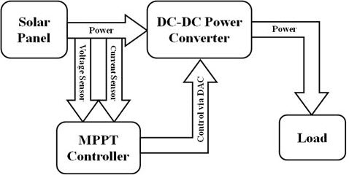
Figure 4. MPPT Circuit Diagram
Solar panels consist of photovoltaic cells. These photovoltaic cells are use light energy from the sun to generate electricity through photovoltaic effect. Maximum Power Point Tracking, i.e. MPPT, is an electronic system that operates the photovoltaic modules in solar panels to produce maximum power. MPPT changes the electrical operating point of the modules and enables them to deliver maximum available power. MPPT can be used in concurrence with a mechanical tracking system, but the two systems are completely different. MPPT Solar Charge Controller is a battery charger and load controller with integrated LED driver, these MPPT Solar Charge Controller features a smart tracking algorithm that maximizes energy result from solar panels. MPPT controller is made by using Power PSOC and it also uses the integrated hysteretic controllers.

- RESULTS

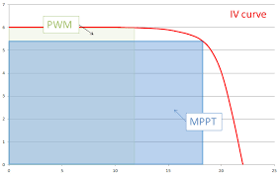
Figure 5. Graph MPPT against PWM

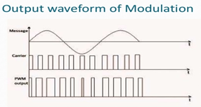
Figure 6. PWM Signal Waveform
- CONCLUSION
In this paper we described Solar mobile charger with MPPT. Different MPPT techniques discussed earlier. It will apply in different applications. For example, in space satellites and orbital stations that involve large amount of money, the costs and complexity of the MPP tracker are not as important as its performance and reliability. The tracker should be able to continuously track the true MPP in minimum amount of time and should not require periodic tuning. In this paper we have seen how solar charge controller is designed by the use of MPPT System and how the mobile phone charge with the help of Solar system.

REFERENCES
[1] ISSN(Online) : 2320-9801 ISSN (Print) : 2320-9798 International Journal of Innovative Research in Computer and Communication Engineering, An ISO 3297: 2007 Certified Organization Vol.5, Special Issue 4, June 2017
[2] International Journal of Advance Engineering and Research Development (IJAERD) Emerging Trends and Innovations in Electronics and Communication Engineering Volume 5, Special Issue 01, Jan.-2018
[3] International Advanced Research Journal in Science, Engineering and Technology (IARJSET) National Conference on Renewable Energy and Environment (NCREE-2015) IMS Engineering College, Ghaziabad Vol. 2, Issue 1, April 2015
[4] International Journal of Recent Research and Review, Vol. VII, Issue 4, December 2014 ISSN 2277 – 8322
[5] International Journal of Innovative Research in Computer Science & Technology (IJIRCST) ISSN: 2347-5552, Volume-2, Issue-4, July-2014
[6] International Research Journal of Engineering and Technology (IRJET) e-ISSN: 2395 -0056 Volume: 04 Issue: 04 | Apr -2017 www.irjet.net p-ISSN: 2395-0072
[7] IJEDR1702039 International Journal of Engineering Development and Research (www.ijedr.org)

