Weather Forecast With Map Using JavaScript

Pro. Rashmi Kannake¹, Abhishek Gedam², Akhilesh Yadav³, Dhanshree Borekar⁴, Rina Mohitkar⁵

¹Assistant Professor, ^{2,3,4,5,6} Students
Wainganga College Of Engineering & Management,Nagpur,Maharastra,441108

Email:yadavakhilesh9922@gmail.com
Received on:30/4/2023, Revised on:30/4/2023, Published on:30/4/2023

Abstract –Weather Forecast Using JavaScript is the application of science and technology to predict the state of the atmosphere for a given location.
Keywords-marine,wind,militrymachinelearning,Yeild Pridiction

INTRODUCTION
Weather forecasting is the application of science and technology to predict the conditions of the atmosphere for a given location and time. Weather forecasts are made by collecting quantitative data about the current state of the atmosphere at a given place and using meteorology to project how the atmosphere will change. The role of Technology has been remarkable in the field of weather forecasting. Weather data is not only necessary for researchers or scientists, ordinary people can be benefitted from it as well. People nowadays are feeling the necessity of weather data as well..

METHOLOGY
The following approach covers how to create a Weather Application in Using JavaScript using Weather API, Using this API, we can get weather data for each coordinate.
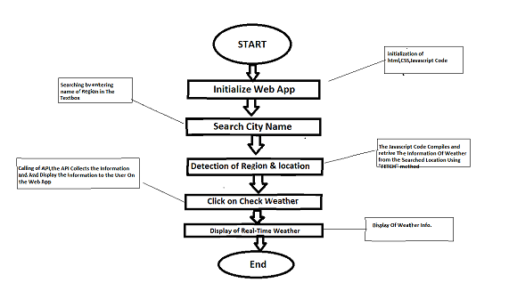
Image 1- Flowchart of Weather System
1.The user first needs to run the application. As the application starts, the user will input the necessary information like providing location for any particular city or state.
2.Now, in response the application will provide all the required details to the user.
3.The user can modify the information according to their choiceThe information provided by the user is fetched by the system
5.This system acts as an interface for user and database i.e.the data provided by the user is shared to system
6.The database here acts as a storage device for the application.

7.It provides the real-time weather details to the user.

DESIGN
The Design Of A Weather System are is Follows..
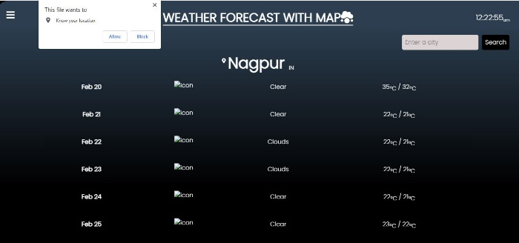
Image 2- UI of Weather Web App

CONCLUSION
In this project, we have designed a web application and completed its development by applying engineering knowledge which provides an approach in building a platform where in this system weather forecasting report generation becomes easy.
Less chances of malfunctioning are there. The system has reached a steady state but still improvements are to be made. The system is operated at a high level of efficiency and all the work and user associated with the system understand in advantage.
It was intended to solve as requirements specification. In future this system can be implemented to all over the world and will be designed for cross platform. During the development of the project, we understood the importance of individual and teamwork while project development and management.

APPLICATION
. Weather forecasting is used in many situations like severe weather alerts and advisories, predicting the behavior of the cloud for air transport, prediction of waterways in a sea, agricultural development and avoiding forest fire. Severe weather alerts and advisories A major part of modern weather forecasting is the severe weather alerts and advisories which are the national weather service’s issue in anticipation of severe or hazardous weather are expected. This is done to protect life and property. Some of the most commonly known of severe weather advisories are the severe thunderstorm and tornado warning, as well as the severe thunderstorm and tornado watch
Prediction of waterways in a sea Commercial and recreational use of waterways can be limited significantly by wind direction, speed, wave periodicity, high tides and precipitation. These factors can each influence the safety of marine transit. Consequently, a variety of codes have been established to efficiently transmit detailed marine weather forecasts to vessel pilots via radio, for example marine forecast. Typical weather forecasts can be received at sea through the use of Radio fax. Agricultural development Weather plays an important role in agricultural production. It has a profound influence on the growth, development and yields of a crop, incidence of pests and diseases, water needs and fertilizer requirements in terms of differences in nutrient mobilization due to water stresses and timeliness and effectiveness of prophylactic and cultural operations on crops. Weather aberrations may cause (i) physical damage to crops and (ii) soil erosion. The quality of the crop produced during movement from field to storage and transport to market depends on weather. Bad weather may affect the quality of the produce during transport and viability and vigor of seeds and planting material during storage.

FUTURE SCOPE
- The IoT weather reporting system has an application for farmers where they can ensure higher productivity of crops and lower the risk of weather hazards via the IoT weather.
- The IoT-based weather station proves helpful for monitoring the weather in areas like places with volcanoes or rain forests. This is especially important with drastic changes in the weather conditions we are experiencing.
- The IoT weather monitoring system using IoT supporting controllers is fully automated and efficient. It does not require any manual labor or attention.
- You can plan and visit the places anytime you like with prior notification of the weather conditions. You can simply get the status of the weather condition and the air quality, etc.
- Therefore, with the help of embedded devices and sensors, any environment can be converted to a smart environment for accumulating the data and analyzing the environment with real-time monitoring
REFERENCES
[1]. https://www.apk4fun.com/apps/no.nrk.yr/
[2]. https://oneplus-weather.en.uptodown.com/android
[3]. https://weather-weather-forecast/id1363846787
[6]. An interactive predictive system for weather forecasting Ayham Omary; Ahmad Wedyan; Ahmed Zghoul; Ahmad Banihani; Izzat Alsmadi(21 June 2012).
[7]. The Weather Forecast Using Data Mining Research Based on Cloud Computing ZhanJie Wang and A. B. M. Mazharul Mujib(18 August 2017).
[8]. A real-time weather forecasting and analysis Sushmitha Kothapalli; S. G. Totad(21 June 2018).

