Smart Helmet Base Alcohol Detection and Auto Ignition Control System

Mr. Tushar M. Sontakke¹ , Prof. Rohini pochhi²

¹Student, ² Professor
Tulshiramji Gawande-Patil College of Engineering And Technology Nagpur India 441108

sontakketushar30@gmail.com

Received on: 05 April, 2022 Revised on: 11 May, 2022, Published on: 13 May,2022

Abstract- A Smart Helmet is a unique concept that improves the safety of motorcycle riding. It is a method of preventing vehicles from starting when the driver is not wearing a helmet or is inebriated. Furthermore, it has a fantastic feature that detects accidents and notifies certain persons by SMS with the location and speed of the bike before the accident occurs, using a GPS and GSM-based tracking system, assisting the ambulance in arriving at the exact spot in the event of an accident. When the NODEMCU ESP8266 detects a high alcohol signal from the MQ3 alcohol sensor, the dc motor stops and the Buzzer Alarm sounds, indicating engine lockout. To start the engine, the device requires a push button. If alcohol is detected during engine start-up, the engine will not start at all. If alcohol is detected after the engine has started, the system locks it and sends an email to the registered mobile number. This project proposes an innovative method for securing autos against inebriated driving. The Arduinouno microcontroller board (based on ATMEGA 328) was used throughout the system, and the hardware chart is displayed . Arduinouno alcohol sensor module (MQ3), LCD display, buzzer, and relay are the key functionalities modules.
Keywords- Arduinouno alcohol sensor module (MQ3), LCD display, buzzer

INTRODUCTION
Drunk driving is currently a serious public health issue that is expected to become one of the most serious issues in the near future. The mechanism in place seeks to

reduce road accidents caused by drunk drivers in the near future. This paper details the progress made in employing an alcohol detector, which is a device that detects changes in the alcoholic gas content of the surrounding air. It is also known as a breath analyzer since it analyses the alcohol level of a person's breath..When the system detects the presence of alcohol in the vehicle, the engine is immediately locked. when the sensor detects alcohol, the ESP 8266 microcontroller transmits the needed voltage to the buzzer, which automatically turns off the vehicle's ignition and displays the proportion of alcohol consumed.

The microcontroller monitors the condition of the ignition by using a relay switch.

The regular default limit is set at 456 points, according to the application. The buzzer and relay switch both activate and perform their functions. In addition, the microcontroller communicates with the server (UBIDOTS) through wifi. So that it sends an alarm message / mail to the Here, a software written in C Language has been built in such a way that anytime the limit of alcohol content surpasses 456, mail will be sent over the cloud and server.

II-FACILITIES REQUIRED FOR PROPOSED WORK
Hardware Requirement
- Esp 8266 Wifi Module
- Voltage Regulator(7805)
- Dc Motor
- Buzzer/Alarm / Led
- Mq-03 Alcohol Sensor
- Wifi Module
- Limit Switch

ARDUINO BOARD

The arduino board serves as the system's brain. The ATmega 328 microcontroller board is used in the Arduinouno. It's an electromechanical prototype microcontroller with programmable capabilities. It includes 14 digital input/output pins (six of which can be utilised as PWM outputs), six analogue inputs, and sixteen MHz ceramic resonators. The arduino is different from the other boards in that it does not use the FTDI USB to serial driver chip.

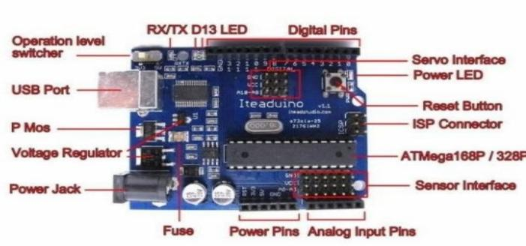
Fig. 1- Arduino Board Discription
ALCOHOL SENSOR (MQ3)
The MQ3 alcohol gas sensor is designed to detect alcohol and can be used in a breath analyzer. Alcohol sensitivity is strong, but benzene sensitivity is low. The sensitivity of the MQ3 gas sensor can be changed using the potentiometer. The sensitive material is SnO2, which has a reduced conductivity in clean air. When the target alcohol gas is present, the sensors conductivity increases along with the gas concentration, and a simple electrical circuit is used to convert the change in conductivity to a gas concentration output signal. The MQ-3 gas sensor has a high sensitivity to alcohol and is resistant to fuel, smoke, and vapour interference. It has a 2 metre fine sensitivity range. The sensor can detect varied concentrations of alcohol; it is inexpensive and suited for a variety of applications.

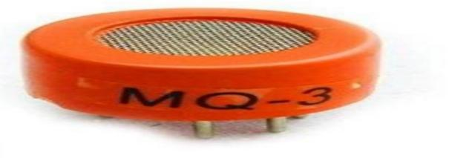

Fig. 2.- Alcohol Sensor

Sensitivity Adjustment:

The resistance value of MQ-3 varies depending on the kind and concentration of gas. As a result, sensitivity adjustment is essential while using these components. It is advised that the detector be calibrated for an alcohol content in air of 0.4 mg/L (about 200ppm) and a load resistance of 200 K (100K to 470 K). When measuring properly, the proper alert point for the gas detector must be determined after taking temperature and humidity into account.

Character configuration:
1. Alcohol gas sensitivity is good.
2. The circuit is simply powered.
3. Low cost and long service life
4. Low sensitivity to benzene and high sensitivity to alcohol.
5. High sensitivity and stability, as well as a lengthy life span.
Specification:
1. A 5 volt power supply is required.
2. Type of interference: just analogue.
3. Pin requirements: 1 output, 2 GND, 3 VCC
4. High sensitivity and quick reaction
5. Long life and stability
6. Low sensitivity to benzene, but high sensitivity to alcohol Simple drive circuit, 40*20mm in size.
Buzzer
- The PS series of buzzers are high-performance buzzers with unimorph piezoelectric elements that are easy to integrate into various circuits.
- In comparison to electromagnetic equipment, they consume very little power.
- Because these buzzers are built for external stimulation, they can function as a musical tone oscillator and a buzzer at the same time.
- They can be used with automated inserters, and there are moisture-resistant models available.
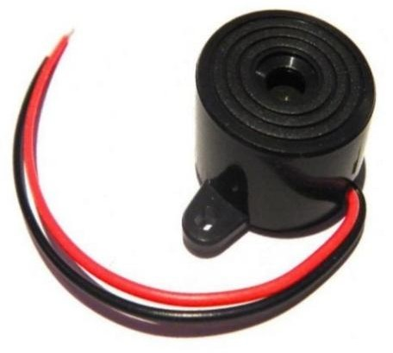
Fig. 3 Buzzer

III - ADVANTAGES

To avoid an accident caused by intoxicated driving.

Testing the alcohol concentration in the body is simple and quick.

Accurate and quick results

It assists police officers and provides automatic safety measures for cars and other vehicles.

An autonomous safety system for cars and other vehicles is provided by an alcohol detecting system in autos.

IV- APPLICATIONS

The alcohol detector project can be installed in a variety of automobiles to detect whether or not the driver has ingested alcohol.

This can be utilised in a variety of firms or organisations to detect employee alcohol consumption.
V- FUTURE SCOPE
- We can use GSM technology to notify relatives or car owners about alcohol consumption.
- We can use GPS technology to track the vehicle's whereabouts.
- The configuration is simple, which allows it to adapt to future needs without having to construct everything from start, making it more efficient.
- This can be changed to allow communication with the vehicle owner via GSM modem.

VI- RESULT
The “Smart helmet base alcohol detection and auto Ignition Control system” was designed such that the driver alcohol content is transmitted to the owner on his mobile phone as a short message (SMS) at his request. The microcontroller gets the information regarding the alcohol through the alcohol sensor and alerts about the condition being sensed using Buzzer and also automatically the motors of the vehicle turns off using relay switch.
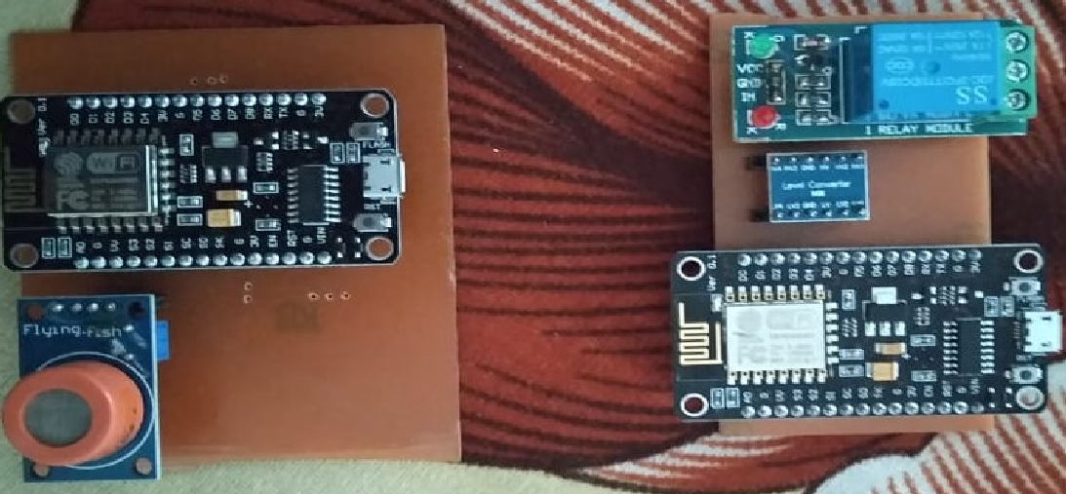
Fig.4- hardware of alcohol detection
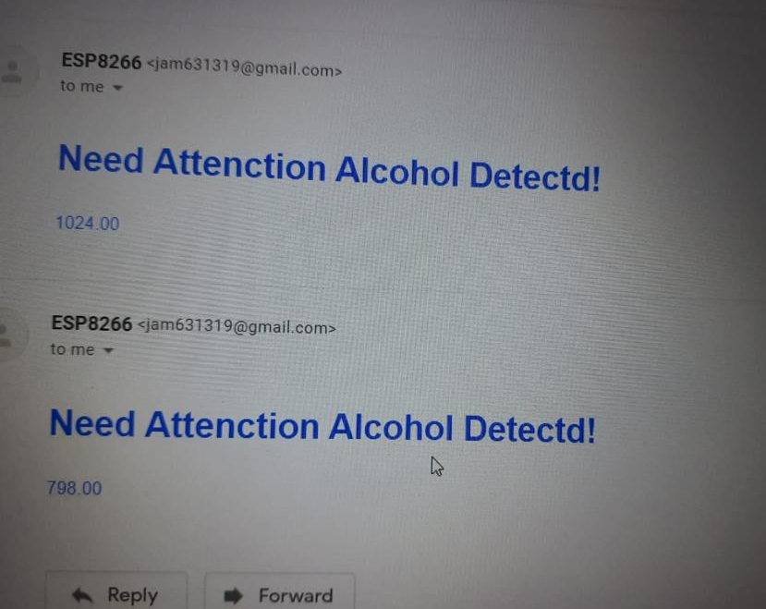
Fig.5- Mail send to Relatives of driver

REFERENCES
- Lea Angelica Navarro, Mark Anthony Diño, ExechielJoson, Rommel Anacan, Roberto Dela Cruz Electronics Engineering Department, Technological Institute of the Philippines- Manila Manila, Philippines-Design of Alcohol Detection System for Car Users thru Iris Recognition Pattern Using Wavelet Transform[2016 7th International Conference on Intelligent Systems, Modelling and Simulation]
- Cahalan, D., I. Cisin, and Crossley, American Drinking Practices: A National Study of Driving Behaviour and Attitudes. 1969, Rutgers University Press: New Brunswick, NJ.
- Mugila.g, muthulakshmi.m, santhiya.k, prof.dhivya.p- smart helmet system using alcohol detection for vehicle p rotection[International Journal of Innovative Research in Science Engineering and Technology (IJIRTSE) ISSN: 2395- 5619, Volume – 2, Issue – 7. July 2016]
- Dhivya M and Kathiravan S, Dept. of ECE, KalaignarKarunanidhi Institute of Technology- Driver Authentication and Accident-Avoidance System for Vehicles [Smart Computing Review, vol. 5, no. 1, February 2015]
- Babor, AUDIT: The alcohol use disorders identification Test: Guidelines for use in primary health care. 1992, Geneva, Switzerland: World Health Organization.
- Lee, Assessing the Feasibility of Vehicle-Based Sensors To Detect Alcohol Impairment. 2010, National Highway Traffic Safety Administration: Washington, DC.
- http://www.arduino.cc/
- A. ISuge, H.Takigawa, H.Osuga, H.Soma, K.Morisaki, Accident Vehicle Automatic Detection System By Image Processing Technology , ©IEEE 1994 Vehiclee Navigation & information Systems Conference Paul Baskett , Yi Shang , Michael V. Patterson , Timothy Trull , Towards A System for Body-Area Sensing and Detection of Alcohol Craving and Mood Dvsregulation

