**Root Cause Analysis of Defects in Duplex Mould**

**Casting**

**A.G.Thakare1, Dr.D.J.Tidke2**

*1Research Scholar,*

*G.H.Raisoni College of Engineering, Nagpur, India*

*2Ex. Professor*

*G.H.Raisoni College of Enginering, Nagpur, India*

***Abstract –*** *Casting defects are usually easy to characterize but to eradicate them can be a difficult task. Defects are the result of combination of different factors whose identification is often a very difficult task. Casting is a complex process which involves complex interactions among various parameters and operations related to metal composition, methods process, melting, pouring, machining. Presence of these defects exposes foundaries to contribute over 70% of total quality costs.Foundaries try to reduce rejections by experimenting with process parameters, when this is ineffective they try to modify methods design, when this fails then they try to modify tooling design. So approach of foundaries is completely on trial and error basis. Foundaries must try to reduce rejections by systematically finding the reasons responsible for occurrence of defects and analyse them.In this paper analysis of defects in Duplex Mould Casting has been carried out. All the major defects in Duplex Mould Casting along with causes and remedies have been discussed. This will be helpful to quality control engineers for root cause analysis and* *finding correct remedial action so as to avoid the defects before they result in rejection of Duplex mould casting, which is very costly affair.*

***Keywords-******Casting defects, Duplex Mould Casting***

**INTRODUCTION**

Metal casting is one of the direct methods of manufacturing desired geometry of component. Casting is manufactured by creating a cavity inside sand mould and then pouring the molten metal directly into mould .It’s a versatile process which is capable of being used in mass production. All sizes of components can be manufactured right from very small to large with complex designs. Casting process is also known as process of uncertainty. Defects in casting occur even in a completely controlled process which challenges explanation about the cause of casting defects. Foundry industry suffers from poor quality and productivity due to large process parameters, combined with lower penetration of manufacturing automation and shortage of skilled workers compared to other industries. It is very difficult to find the cause of defects because casting process itself is very complex due to involvement of various disciplines of science and engineering. Often cause of defects is combination of several factors rather than a single one. When these various factors are combined, the root cause analysis can actually become a mystery. Defect symptoms should be correctly identified prior to assigning cause to the problem. Defects should be correctly identified for right remedial measures otherwise false remedies not only fail to solve the problem but they can confuse the issues and make it more difficult to cure the defect which might result into new defects [1].This shows how complex and how difficult it is to carry out the root cause analysis of casting defects in Duplex Mould Casting.

**DUPLEX MOULD CASTING**

In this paper different defects observed in Duplex Mould Casting are analyzed. Pencil ingots are being made with the help of these cast iron ingot moulds. For manufacturing these moulds high quality metals are used which are very costly. Weight of each duplex mould varies from a minimum of 442 kilograms to maximum 667 kilograms. This study has been carried out at one of the leading casting manufacturer in Central Maharashtra which has manufacturing capacity of 30,000 metric ton per year and range of products. It manufactures around 200 ton/month of Duplex Mould .It is also observed that rate of rejection of these casting is very high, maximum rejection of around 12% in rainy season and minimum rejection of around 4% in summer. Owing to such heavy rejection capital losses are also very high. Study has been carried out to find the exact causes of rejection on the basis of data collected for past three years. After analysis it is observed that few defects were repetitive resulting in defective castings. In this paper critical defects resulting in rejection of duplex mould casting, causes of defects and remedies to minimize these defects are discussed, which will be immensely beneficial for cast iron ingot mould manufacturers.

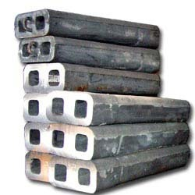

**Fig. 1 : Duplex Mould**

**DEFECTS IN DUPLEX MOULD**

Bar Chart shows analysis of defects observed during span of one year .It is observed that these defects were main contributors leading to rejection of Duplex Mould Casting.

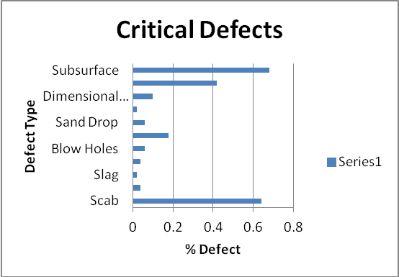

Fig. 2:Critical defects leading to rejection

1. Scab

This type of defect occurs when portion of face of a mould breaks down and the recess thus made is filled by metal. When the metal is poured into the cavity, gas may be disengaged with such violence as to break up the sand which is then washed away and the resulting cavity filled with metal. Scab is a projection on casting which occurs when a portion of mould face or core lifts and the metal flows beneath a thin layer. They are rough irregular projections on the surface containing embedded sand.

Causes

1. It may be caused due to Hard or uneven ramming.

2. If the Mould poured too slowly then it might result in scab.

3. Another reason scab may be because Sand grain is too uniform.

4. It may also be the result of excessive moisture or volatile content.

5. Low permeability of sand also results in scab on casting surface.

6. Sand erosion due to weak bond or facing sand also leads to this type of defect.

2. Sand erosion due to prolonged metal impingement also leads to scab.

Remedy

1. To control scab avoid hard rammed areas especially close to pattern.

2. Another way of controlling scab is Increase the ingate area and/or number of gates.

3. Change sand grading or make an addition of anti-scabbing additive

2. Shrinkage

These are rough cavities entering casting on heavy sections or at junction of change of sections. These are saucer shaped depressions on exterior of heavy sections usually with rough edges. These are dark spongy areas seen in fracture. When feed metal is not available to compensate for shrinkage as the metal solidifies, shrinkage defect occurs. These are classified into two categories: open shrinkage defects and closed shrinkage defects. In open shrinkage defects as the shrinkage cavity forms air compensates because they are open to the atmosphere. Closed shrinkage defects are formed within the casting. They are also known as shrinkage porosity [2].

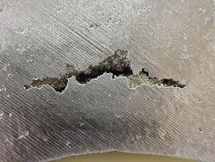

Fig. 3: Shrinkage

Causes

1. One of the major reason contributing to shrinkage defects is Incorrect gating and feeding.

2. Another reason resulting into shrinkage defects is unsuitable composition in relation to suitable thickness of casting.

3. Poor design of casting might also result in shrinkage defects.

Remedy

1. To avoid shrinkage defects always use risers to feed heavy sections and ensure that they are filled with hot metal. If open risers are used always use feeding aids, if using blind risers use blind sleeves with Williams cores where a heavy section or boss cannot fed directly with riser.
2. Another way of controlling shrinkage defects is adjust silicon and /or carbon content.

3. If possible and not controlled through other means consider modification of design

3. Slag

This is pitted surface or inclusions found on machining. Cavities are saucer shaped and smooth. Slag may be seen before cleaning the casting. Slag is an Irregular-shape, non-metallic inclusions, frequently on upper casting surfaces, which may occur in association with gas blowholes. It is found at the microstructure grain boundaries as well as on the surface of the casting. It appears in association with gas cavities. Highly viscous slags appear in the microstructure of casting. Low viscosity slags rise more quickly to the surface of the casting. Low viscosity slag may also be included in the casting in event of severe turbulence and a short solidification time. During the casting of iron-carbon alloys, oxide inclusions and slag with a high oxidation potential (e.g. high manganese and ferrous oxide contents) react with the graphite, resulting in the formation of CO blowholes. Other gases from the melt may migrate into the CO cavities.

When melting metal in the presence of oxygen, slag and oxides occur .These frequently react with the furnace or ladle lining. Oxides generated also react with the ash residues from the pit coal coke, when melting grey cast iron in cupola which results in silicate slag. The metal flowing into the mould also forms oxides, which may react with the moulding sand and its components. Highly oxidizing additions (alloy components, inoculants) may be responsible for the formation of oxides and sand.

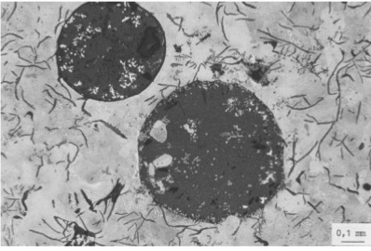

Fig. 4 : Slag

Causes

1. One of the major cause of slag is dirty metal and ladle linings, poor skimming practice.

2. Slag is also the result of Incorrect gating, causing turbulence.

3. Excess of sulphur with high manganese and low pouring temperature also results into slag.

4. Another reason resulting in slag is because of Manganese and silicon contents approaching same level.

Remedy

1. Remove all slag from metal before pouring. Control slag with a slag coagulant. Keep ladle linings free from buildup.

2. To avoid slag incorporate skim gates or strainer cores in runner systems. Keep runner bush full while pouring. Use runner extensions.

3. Restrict sulphur pick-up and avoid pouring with dull iron to avoid slag.

4. Avoid large excess of manganese in order to avoid slag.

4. Crack

Crack is formed at low temperatures in the spot where the alloy is subjected to elastic deformation. It is a straight or slightly curved and zigzagging crevice in casting wall. Cracks are formed after the casting is cooled down in a mould or while knocked out or due to premature removal from mould. Rarely it is observed that cracks also occur during later heat treatment. Depending on the temperature and on the process stage at which the crack is formed i.e. when cooling down in a mould, during de-gating and infusions with oxygen, or while heat treated. Surface of the crack is usually grainy and clean, sometimes with coloured swelling, or distinct signs of oxidation [3].When broken, discolouration shows that crack was produced while casting was hot. No discolouration shows cold crack.

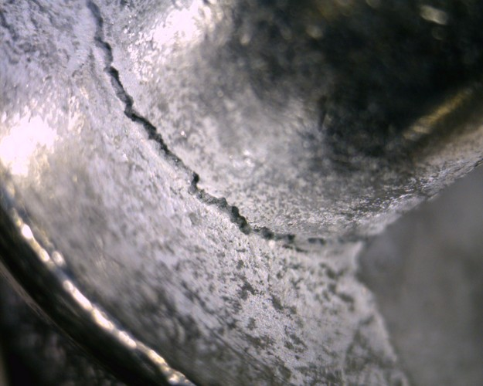

Fig. 5 : Crack

Causes

1. One of the major reasons for crack is high dry strength of sand.

2. Crack also occurs when the cores are too hard.

3. Crack may also happen because of the casting strains.

4. Mechanical reasons can also result in cracks on casting.

Remedy

1. To avoid cracks on casting ram softer to allow casting to contract.

2. Reduce binder content of cores to avoid cracks on casting.

3. Another method of avoiding the occurrence of cracks on casting is gate evenly. Cracks can also be reduced by modifying pattern design.

4. Pack casting with wood or old tyres in tumbler. Take care in breaking off risers. See that risers are provided with correctly designed necks.

5. Blow Holes

When hot metal is poured inside the sand mold, sand and sand contents gets heated and large amount of gases are produced inside the casting. This is one of the major reasons of rejection of castings. This is caused due to evolution of gases which results into holes (gas holes) on casting surface. Gas holes are pinholes and blowholes. These are smooth walled cavities, essentially spherical, often not contacting the external casting surface. The largest cavities are often isolated. In some cases these are scattered over the casting surface. The interior walls of blowholes can be shiny, more or less oxidized or in case of cast iron can be covered with a thin layer of graphite [4].

Blowholes are usually revealed by machining or by heavy shot blasting. This defect may take form of well defined bubble shaped cavities beneath the surface of casting. Major reason for blow holes is entrapment of more than one sort of gas during the course of mould filling and solidification. For correct diagnosis of these defects origin of and reactions producing these gases should be known.

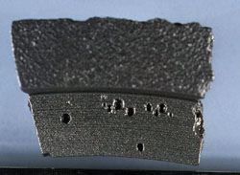

Fig . 6 : Blow Holes

Causes

1. One of the major reasons resulting in blow holes is because of insufficient permeability of moulding or core sand.

2. Hard ramming also results in blow holes on casting.

3. High moisture content is another reason resulting in blow holes in casting.

4. Blow holes also occur on casting surface because of rusty or damp chills and chaplets.

5. Blowing from core jointing material results in blow holes on casting surface.

6. Insufficient head pressure might also lead to blow holes on casting surface.

7. Incomplete baking of cores etc. also results in blow holes.

8. Damp pouring ladles is another reason which results in blow holes.

9. Too low pouring temperature might also result in blow holes on casting surface.

10. Lack of venting or blocked vents is another major reason which results in blow holes.

11. Incompletely dried dressings might also result in blow holes.

Remedy

1. Increase permeability by use of vent wire or open sand with additions of a coarser silica sand.

2. Avoid excess ramming in order to avoid blow holes.

3. Reduce moisture to minimum, consistent with workability.

4. Ensure chaplets are dry and coat chills with suitable dressing before use.

5. Use core jointing pastes of proved reliability to avoid blow holes.

6. Blow holes can also be avoided by ensuring adequate pouring head.

7. Another way of reducing blow holes is to bake until centre is dry and hard.

8. Thoroughly preheating all pouring ladles is another way by which we can reduce blow

holes.

9. To reduce blow holes increase pouring temperature.

10. Another effective method of controlling blow holes is vent well and keeps metal from entering core prints.

6. Sand Inclusion

Areas of sand are torn away by metal stream and then float to the surface of casting because they cannot be wetted by the molten metal. In combination with metal oxides and slags they can also be trapped under the casting surface and only visible during machining.

Sand inclusions occur at widely varying positions and are therefore very difficult to attribute to a local cause and to diagnose. It is one of the most important cause of casting rejection. Sand inclusions appear along with CO blowholes and slag particles [2].

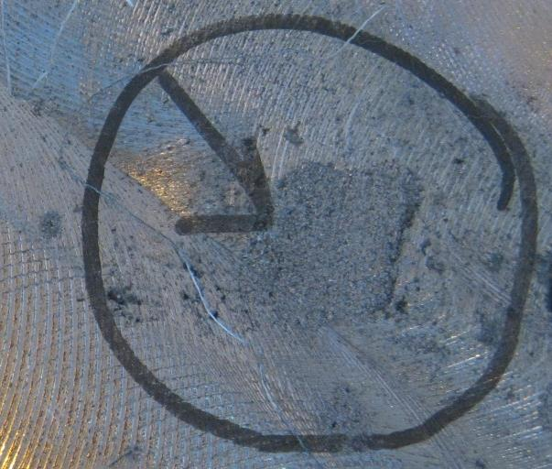

Fig. 7 : Sand Inclusion

Causes

1. Loose sand that is emulsified during pouring into the mould results in sand inclusion.

2. Erosion of packed or loosely bonded sand under areas of turbulent stream contact with the mould.

3. Corrosion of mould due to the combination of turbulent stream and reoxidation also results in this type of defect.

4. Corrosion of the mould due to high pouring temperatures and high mould preheats also results in sand inclusion on casting surface.

Remedy

1. To avoid sand inclusion check moulds for pressure marks and, if necessary, inserts pressure pads.

2. Improve pattern plates, increase pattern tapers and radii to reduce sand inclusion.

3. Ensure uniform mould compaction, avoid over compacted sections to reduce sand inclusion.

4. Another way of reducing sand inclusion is to raise compatibility and thus plasticity of the sand.

5. By increasing bentonite content we can reduce sand inclusion. Also use bentonite with high specific binding capacity.

6. Reduce inert dust content. Decreasing dust content reduces lumps in the sand and thus reduces chances of sand inclusion in sand casting.

7. Avoid high pouring rates and impact of metal stream against mould walls to avoid sand inclusion in casting.

8. Another method of controlling this defect is to shorten pouring times, improve distribution of gates.

9. Avoid core mismatching to reduce sand inclusion in castings.

7. Sand Drop/ Mould Crush

This defect resembles a sticker in appearance. This defect occurs due to the loss of a portion of sand from the core or other overhanging section [5]. It is irregularly shaped projection on the cope surface of a casting. This defect is caused by the break-away of a part of mould sand which falls into the cavity which results in dirty casting surface either on the top or bottom surface of casting depending upon the relative densities of the sand and the liquid. In this defect cope surface cracks and breaks, thus the pieces of sand fall into molten metal.

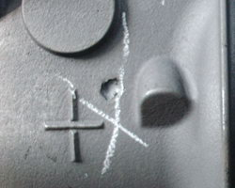

Fig. 8 : Sand Drop

Causes

1) One of the major reasons resulting in sand drop is due to weak or improperly rammed sand.

2) Existence of low moisture content also results in sand drop.

3) Another reason resulting in sand drop is due to rough and careless handling.

4) Worn out patterns or patched moulds also result in sand drop.

5) Insufficient draft on the pattern is another reason resulting in this type of defect.

Remedy

1) Ensure proper ramming of the moulds in order to reduce sand drop.

2) Handle moulds carefully in order to avoid sand drop.

3) Avoid sharp corners and deep pockets in order to avoid sand drop.

4) Ensure adequate moisture content in order to avoid sand drop.

8. Mould Breaking

During the pouring process the moulds are broken and the causes can be identified as.

Causes

1) Uneven and hard ramming results in mould crush.

2) Inadequate gating and risers is another reason for mould crush.

3) Use of sand with high moisture content and low clay content also results in mould crush.

4) Mould crush can also be the result of inadequate pouring rate and excessive pouring temperature.

Remedy

1) Ensure careful and soft ramming in order to avoid mould crush.

2) Use of sand with correct moisture content and clay content to avoid mould crush.

3) Increasing the percentage of coal or cereal also reduces chances of mould crush.

4) Avoid the usage of very high proportion of new sand in order to avoid mould crush.

5) Another method of avoiding mould crush is to maintain adequate pouring rate with correct pouring temperature.

9. Dimensional Variation

Sand casting is used to produce large parts because they cannot be cast by any other process. Almost any metal that is melted can be sand cast .As a result of sand mould; sand castings have a grainy surface with large dimensional variation. Local finish machining operations are often required to obtain necessary surface finish and dimensional tolerances on casting.

In sand casting material of pattern can also lead to large dimensional variations due to thermal expansion in situation where there are large ambient temperature variations especially if the material of pattern has high coefficient of expansion. Plastic or wood patterns are more thermally stable but might wear faster than metal patterns. Different metals have different heat capacities which affects the amount of expansion that occurs in the mould. Higher combined heat capacity and latent heat the greater the changes in size of mould.

Non uniform solidification and variations in the subsequent thermal contraction on cooling to room temperature can also be due to variation in the chemical composition of alloy. In cast irons a high carbon equivalent combined with a soft moulding medium can lead to an expansion of the casting with respect to the original mould size.Another reason of dimensional variation is mould media. For example silica sand goes through a phase change at around 530 ̊ and an accompanying change in particle size, so during this phase it is very difficult to control dimensions. The amount of sand that will change will depend on the amount of heat absorbed by the sand, which again is dependent on the section thickness of casting and the alloys being cast. Dimensional tolerances achievable in the sand casting process have a wide range as it is very process dependent. High tolerances are achieved mainly by trial and error. Ability to predict changes accurately and routinely without the expensive trial and error stage is still the holy grail of the process community.

Causes

1) One of the reasons resulting in dimensional variation of sand casting is due to sand packing density.

2) Process of withdrawing the pattern from the sand also results in dimensional variation of casting.

3) Moisture content of the sand is another major reason resulting in dimensional variation of casting.

4) Temperature of molten metal also results in dimensional variations of casting.

5) Speed of molten metal entering the mould cavity also results in dimensional variation of casting.

Remedy

1) To reduce dimensional variations in casting check the pattern equipment and core boxes.

2) Another remedial measure to control dimensional variation in casting is core print clearance.

3) To control dimensional variation in casting check the mould making, mould box guides.

4) Compacting the mould can be another way of reducing dimensional variation in sand casting.

10. Cold Shut

It is a visual and structural discontinuity caused by separate metal flows or where two or more metal streams have come together and fused. This usually occurs in thin flat sections of the casting[6].Cold shut is caused when molten metal flow comes into contact with the cooler die surface and solidifies before complete filling of the mould. Another flow of metal fills in the mould and lies on top of the previous metal instead of remelting it which causes the crack. Cold shuts can affect mechanical strength of the casting as cracks would extend when the casting is under certain loading. The crack will act as stress point and weaken the casting.

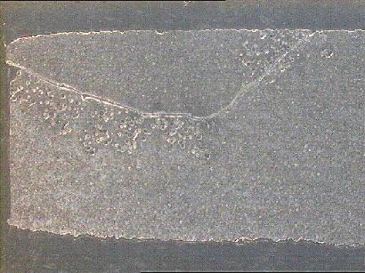

Fig. 9 : Cold Shut

Causes

1) Lack of fluidity in molten metal results in cold shut.

2) Faulty design of mould can also lead to cold shut in casting.

3) Faulty gating is another reason for cold shut in casting.

4) Low metal or mould temperature can also result in this type of defect.

5) Low shell permeability can also lead to cold shut.

6) Low metal fluidity is one of the main reasons for cold shut.

7) Poor pouring practice is very common in casting which results in this type of defect.

Remedy

1) Increase metal and mould temperature to avoid cold shut.

2) Another way of avoiding cold shut is to increase head pressure and /or rate of pour as well as avoid splashing.

3) Improve gating to enhance mould fill which also controls cold shut.

4) Another method of reducing cold shut is to modify alloy composition to enhance fluidity.

5) Reduce the amount of releasing agent used (Mould will be less cooled down)

6) Use mould layer that can reduce heat conduction.

7) Reduce the flow of cooling water or replace the cooling channel with smaller pipes which results in controlling this defect.

8) Add overflows at appropriate position to increase the mould temperature.

11. Subsurface

Defects such as small blowholes, pinholes or inclusions that occur within depths of 3 or 4 mm of the cast surface among the most difficult to detect. Freedom from such surface defects is however a very important aspect of quality of casting such defects are frequently revealed at late stages in the machining of a component leading to its rejection [7].

Causes

1) High initial gas content results in subsurface.

2) Mould metal reaction is another reason which results in this type of defect on casting surface.

3) Reaction of carbon and oxygen also leads to subsurface defect.



Fig. 10 : Subsurface

4) High pouring rate is another reason which results in this type of defect.

5) Excessive moisture in moulds and cores can also lead to subsurface defect.

6) Entrainment of air due to turbulence in the runner system also results in subsurface defect.

Remedy

1) To avoid subsurface make adequate provision for evacuation of air and gas from the mould cavity.

2) Increase permeability of mold and cores to reduce possibility of subsurface.

3) Another method of reducing subsurface is to avoid improper gating systems

4) Assure adequate baking of dry sand molds in order to avoid this defect on casting surface.

5) Control moisture levels in green sand molding to control occurrence of subsurface on casting.

6) Reduce amounts of binders and additives used or change to other types. Use blackings and washes, which provide a reducing atmosphere. Keep the spree filled and reduce pouring height.

7) Increase static pressure by enlarging runner height which helps to control this defect.

**CONCLUSION**

Casting manufacturing involves heavy investment of man, machine and material. Rejection of casting leads to heavy losses to casting manufacturers. This being an old method, till date problems are tackled using experience and hit and trial method. In this paper defects leading to rejection of Duplex Mould Casting are discussed along with their causes and remedies which will be helpful to all personnel involved in manufacturing of Duplex Mould Casting and will be immensely beneficial to reduce the rejection of Duplex Mould Casting leading to prevention of huge financial losses faced by Duplex Mould Manufacturers.

**REFERENCES**

1. *V.V.Mane, Amit Sata, and M. Y. Khire, “New Approach to Casting Defects Classification and Analysis Supported by Simulation”, a technical paper for 59th Indian foundry congress, Chandigarh, February, 2010, pp 87-104.*

[2] *Rajesh Rajkolhe et al., “Defects, Causes and Their*

*Remedies in Casting Process: A Review”, International Journal*

*of Research In Advent Technology, Vol.2, No.3, March 2014,E-*

*ISSN: 2321-9637.*

[3] *S. Kluska-Nawarecka et al. , “Diagnostics of crack formation in*

*castings using the logic of plausible reasoning “Archives of*

*Material Science and Engineering”, Volume 28, Issue 8, August*

*2007,Pages 479-482*.

[4] *Timothy et al. “Characterization and Correction of Casting*

*Defects”, Tech Form – Advanced Casting Technology,*

*L.L.C.,1999.*

[5] *Vaibhav Nerle et al.“Analysis of the Sand Drop Defect to Reduce*

*the Rejection Level of Cylinder Block Casting-A Case Study”,*

*International Journal of Engineering Research & Technology*

*(IJERT), Vol. 2 Issue 9, September – 2013.*

[6] *Prof B.R. Jadhav et al. “ INVESTIGATION AND ANALYSIS OF*

*COLD SHUT CASTING DEFECT AND DEFECT REDUCTION*

*BY USING 7 QUALITY CONTROL TOOLS”, International Journal*

*of Advanced Engineering Research and Studies July-Sept.,2013/28-*

*30,E-ISSN2249–8974*.

[7] *ASM Speciality Handbook: Cast Iron , Page 314**Everett, H.R. (1995). Sensors for Mobile Robots: Theory and Application. A K Peters, Ltd, MA, USA.*