**Analysis of Brushless DC Motor Drive for Three Different Types of MOSFET Based DC-DC Converter**

**Shivani S Pawar, Prof. U. E. Hiwase**

*Department of Electrical Engineering, M.Tech, Industrial Drives and Control, PCOE Hingna,*

*NAGPUR -440019*

***Abstract-*** *The use of Brushless DC motor has been increasing across industries and industrial applications because of its various advantages. This paper is about the performance of brushless DC motor in the Buck-Boost, Cuk and Sheppard Taylor topologies. The Duty ratio of the pulse signal sent to the power MOSFET has been varied for buck and boost operation and subsequently motor parameters across the three separate topologies have been compared. Design and simulation of the converter circuits have been done using MATLAB Simulink. The motor parameters under discussion are stator back emf, rotor speed and electromagnetic torque. At last the conclusion has been drawn on the best possible topology among the three to enable the motor to function efficiently and help us to get desirable results when the motor is in operation.*

***Keywords***—*Brushless DC Motor, Buck-Boost converter, Cuk Converter, Sheppard Taylor converter.*

**I. INTRODUCTION**

**T**he power MOSFET is a modern electronic switch which has good switching speed and operates even at low voltages. This is used for getting a faster dynamic response to rapid changes in load current or input voltage. For this paper we have used three DC-DC converters: buck-boost, cuk and Sheppard- Taylor topologies. Reasons behind selecting these converters are high efficiency, constant frequency operation and commercial availability of integrated circuit controllers. These converters generate their respective DC outputs which are fed to a permanent magnet Brushless DC (BLDC) motor through a three phase inverter. Brushless DC (BLDC) motor are used widely in automotive, electronic, medical industries and in various applications like actuators, compressors, medical instruments, heating and ventilation, motion control systems owing to their reliability and good response. Due to lack of field winding and absence of brushes enable the brushless DC motor to commutate electronically. This is a significant advantage over the ordinary brushed DC motor because electronic commutation nullifies the adverse effects of sparking and wear and tear of the brushes. This ensures low maintenance and high speed capability.

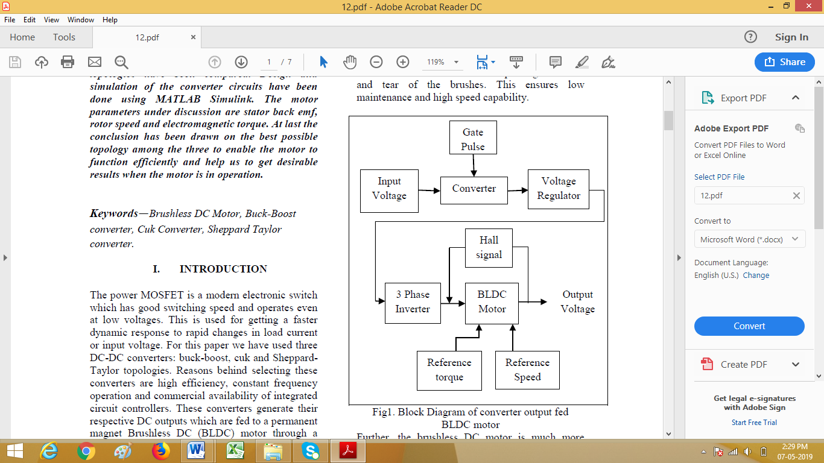

Fig1. Block Diagram of converter output fed BLDC motor

Further, the brushless DC motor is much more efficient (85-90%) compared to a traditional brushed DC motor whose efficiency is markedly lower at 75-80%. Considering the size of the motor, the torque delivered is quite high and thus it is practically usable in applications where space and weight are the constraints. For our work, we have taken a 3-phase synchronous permanent magnet brushless DC motor having trapezoidal back emf. An input DC voltage is supplied to the DC-DC converter as shown in Fig 1. The DC voltage generated by the converter is converted into a 3 phase AC voltage by an inverter to run the motor. The motor has the Hall Effect sensors placed 120° to each other, which sense the rotor position and generate a feedback signal to be used by the motor controller to ensure desirable functioning of the motor subject to reference parameters. The torque of BLDC motor is influenced by the waveform of the back emf. Although, ideally, the BLDC motors should have trapezoidal back emf and the torque should be constant. In practice that is not always the case. Waveform may deviate from their ideal nature which may lead to formation of torque ripples. Regardless, the BLDC motor has more advantages than disadvantages.

**II. BLDC MOTOR IMPLEMENTED IN BUCK BOOST AND CUK TOPOLOGIES**

**a. *Buck-Boost Converter Operation***

Fig. 2 is a diagram of the buck-boost topology. The buck-boost topologies allow operation of the circuit in buck (step down) and boost (step up) modes. This is determined by selection of a suitable duty ratio of the pulse sent to the MOSFET. If the duty ratio of the gate pulse is greater than 0.5 the circuit operation occurs in boost mode. Conversely, buck operation is achieved in the same circuit by making duty ratio of the gate pulse less than 0.5.

The DC voltage transfer function of the buck-boost converter is:

𝐕𝐨𝐮𝐭/𝐕𝐢𝐧 = - 𝑫/(𝟏−𝑫); (1)

D = duty ratio (0<D<1)

If inductor current reaches zero during off state before completion of the commutation cycle T, discontinuous mode of operation occurs. This is determined by the value of the inductor. The boundary value of the inductor between continuous conduction mode and discontinuous conduction is:

𝑳𝒃=(𝟏−𝑫)𝟐𝑹/𝟐𝒇 (2)

Where ‘f’ represents the switching frequency.

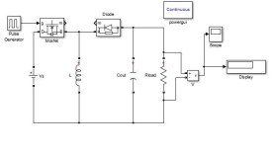

Fig 2. Buck-Boost converter Topology

***b. Cuk Converter Operation***

The Cuk converter is based on a boost-buck topology. The input part of the converter circuit comprises a DC voltage source Vs, as an input inductor L1, a MOSFET which functions as a switching device. A prominent feature of the cuk topology compared to the simple inverting buck-boost topology is the inclusion of a second inductor L2 and a capacitor, also known as the coupling capacitor (Cc). The coupling capacitor is instrumental in energy transfer in the circuit from the input to the output part of the circuit. This contrasts with the buck-boost topology where energy transfer occurs through the inductor.

The DC voltage transfer function of the Cuk topology is like the buck-boost topology. Assuming the ripple in inductor currents small enough to be neglected,

𝑽𝒐𝒖𝒕𝑽𝒊𝒏=−𝑫/(𝟏−𝑫); D= Duty ratio (0<D<1)

Depending on the inductors L1 and L2, current through these may reduce to zero during off state of the switch. In the Cuk topology, the inductor currents may be continuous or discontinuous for certain values of inductors:

Boundary value for the inductor L1 is:

𝑳𝒃𝟏=(𝟏−𝑫)𝑹/𝟐𝑫𝒇 (3)

Boundary value for the inductor L2 is:

𝑳𝒃𝟐=(𝟏−𝑫)𝑹/𝟐𝒇 (4)

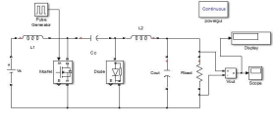

Fig 3. Cuk converter Topology

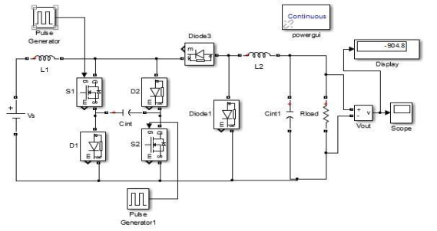

Fig 4. Sheppard Taylor Converter

**III. BLDC MOTOR IMPLEMENTED IN SHEPPARD TAYLOR TOPOLOGY**

**a. *Converter Circuit Description and operation***

The Sheppard Taylor topology may be regarded as a cascade of boosts and buck converters as seen in Fig 4. The circuit comprises of two MOSFET which functions as switches S1 and S2. Synchronization of these switches is important to determine on state and off state. The boost setup at the input consists of the input inductor L1 and diode D2 connected to a switch. When the two switches are on i.e., when gate pulse supplied to the MOSFET are high, input inductor and output inductor currents increases due to gradual build up of their respective magnetic fields. During this mode of operation, the capacitors start discharging. When gate pulse is low, switches are off and the inductor begins to discharge. The inductor current of L1 flows through diodes D1 and D2 and charges the intermediate capacitor Cint. L2 current also decreases as it flows through the diode D4. Charge of output capacitor Cout increases in the process. When inductor L1 is discharged completely, the inductor current is zero and thus operates in discontinuous conduction mode. Another mode of operation may be brought about by keeping L2 value below the boundary value or by markedly increasing the commutation time (T) such that the inductor current of L2 also reaches zero and operates in discontinuous Conduction mode. In this mode, the output capacitor is discharged. The involvement of two switches in this circuit makes its operation more complex. For simplicity, it may be assumed that the duty ratio is identical for the two switches. If the combined duty ratio of the two signals is greater than or equal to 1, the output is drastically reduced. If duty ratio of pulse at switch S1 is fixed at a certain value, the duty ratio of pulse at switch S2 may be changed (keeping the combined duty ratio less than 1).

Continually decreasing the duty ratio of S2, buck operation is seen to occur for low values of the duty ratio. This is an obvious advantage for the Sheppard Taylor converter where both buck and boost operations are achieved by keeping one duty cycle fixed and varying the other. For buck-boost and Cuk converters, for a certain duty ratio, the converter operates either in buck or boost mode; not both simultaneously. Another change may be brought about the Sheppard Taylor converter by decreasing the input inductor L1 below boundary value. For this change, the converter operates exclusively in boost mode for all values of variable duty ratio. Since this is a cascaded boost-buck converter, the boost value may be observed across the capacitor 𝑪𝒊𝒏𝒕. The final output is determined by the equation 𝑽𝒐𝒖𝒕=𝒅.𝑽𝒄, where 𝑽𝒄 represents voltage across the intermediate capacitor 𝑪𝒊𝒏𝒕 and d is the smaller of the two values of duty ratio of the pulses applied to the two circuit switches.

Boundary value of inductor L1 is:

𝑳𝒃𝟏=(𝑫𝒅𝒆𝒔/𝒇).(𝑽𝒊𝒏/𝟐.𝑰𝒏) (5)

Boundary value of inductor L2 is:

𝑳𝒃𝟐=((𝟏−𝑫𝒅𝒆𝒔)/𝒇).(𝑽𝒅𝒆𝒔/𝟐𝑰𝒐𝒖𝒕) (6)

Where 𝑫𝒅𝒆𝒔 is the designed duty ratio, f is the switching frequency, 𝑽𝒅𝒆𝒔 is the DC link voltage.

**b. Motor Parameter Comparison for all topologies**

Values of circuit elements and motor parameters have been tabulated for buck and boost operation of the three converters.

Motor parameters have been observed at 0.1s into simulation of the converter circuits.

We have attempted to make a comparable record of motor parameters for the three converter topologies. Accordingly, duty ratio across the parameters has been adjusted to make the recorded values as relatable as possible.

|  |  |  |  |
| --- | --- | --- | --- |
| **Circuit elemen Values & motor parameters** | **t Buck- Boost topology** | **Cuk topology** | **Sheppard**  **Taylor**  **Topology** |
| Input Voltage | 300V | 300V | 300V |
| Output Voltage | 99.24V | 99.15V | 146.6V |
| Input inductor | 0.001H | 0.001H | 0.001H |
| Output inductor | - | 0.001H | 0.001H |
| Intermediate  Capacitor | - | 47µF | 47µF |
| Output Capacitor | 47µF | 47µF | 47µF |
| Load Resistance | 10Ω | 10Ω | 10Ω |
| Duty ratio of signal to first switch | 0.25 | 0.25 | 0.25 |
| Duty ratio of signal to second switch | - | - | 0.25 |
| Stator current | -0.026A | -0.037A | -0.063A |
| Back emf | -49.08V | -49.3V | -72.8V |
| Rotor speed | 70.13rpm | 70.43rpm | 104rpm |
| Torque | 0.033Nm | 0.056Nm | 0.087Nm |

Table 1. Parameter Comparison for Buck mode

It is observed that for identical values of duty cycle for all converters, highest motor parameters values have been obtained for the Sheppard Taylor topology. Back emf has been found to be trapezoidal across all converters, with greater distortion noted for buck-boost converter. Output voltage, rotor speed and torque of motor are highest for Sheppard Taylor converter with the given values. By further decreasing input inductor value, thereby enabling it to operate in discontinuous conduction mode, motor parameter values will increase even more.

For comparable output voltage across the three converters, motor parameters are higher for cuk and Sheppard Taylor converters.

|  |  |  |  |
| --- | --- | --- | --- |
| **Circuit elemen Values & motor parameters** | **t Buck- Boost topology** | **Cuk topology** | **Sheppard**  **Taylor**  **Topology** |
| Input Voltage | 300V | 300V | 300V |
| Output Voltage | 812.8V | 897.8V | 904.8V |
| Input inductor | 0.001H | 0.001H | 0.001H |
| Output inductor | - | 0.001H | 0.001H |
| Intermediate  Capacitor | - | 47µF | 47µF |
| Output Capacitor | 47µF | 47µF | 47µF |
| Load Resistance | 10Ω | 10Ω | 10Ω |
| Duty ratio of signal to first switch | 0.75 | 0.75 | 0.44 |
| Duty ratio of signal to second switch | - | - | 0.44 |
| Stator current | 0.72A | -0.057A | 0.0994A |
| Back emf | -391.7V | -407.5V | -440.8V |
| Rotor speed | 559.5rpm | 625rpm | 629.8rpm |
| Torque | 0.607Nm | 0.510Nm | 0.797Nm |

Table 2. Parameter Comparison for Boost Mode

Regarding the torque in table 2, it may be seen that the value of torque for cuk topology is less than that of buck boost topology. However, this is only an instantaneous value at 0.1s, and marginal fluctuation means the recorded value of 0.510 Nm will rise to a value greater than that of buck-boost topology as time increases.

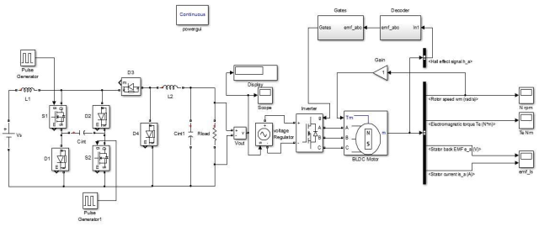

Fig 5. Sheppard Taylor topology converter in BLDC motor

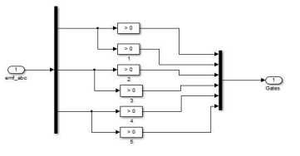Fig 5(a)

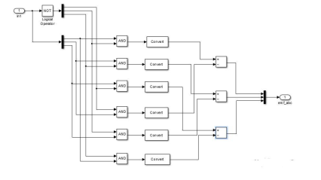

Fig 5(b)

**V. RESULTS**

**a. Parameters for Buck-Boost converter**

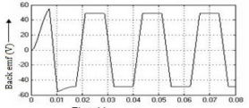

Fig 7(a) Back emf of motor for buck boost mode

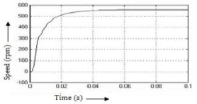

Fig 7(b) Speed of motor for buck boost mode

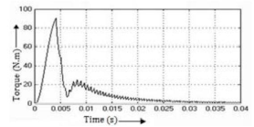

Fig 7(c) Torque for buck boost mode

**b. Parameters of Cuk converter**

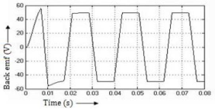

Fig 8(a) Back emf for cuk converter

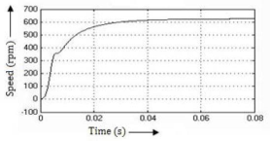

Fig 8(b) Speed for cuk converter

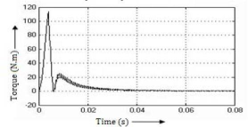

Fig 8(c) Torque for cuk converter

**c. Parameters for Sheppard Taylors converter**

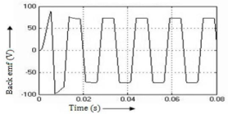

Fig 9(a) Back emf for Sheppard Taylor converter

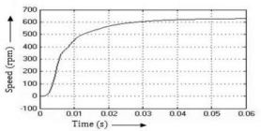

Fig 9(b) Speed for Sheppard Taylor converter



Fig 9(c) Torque for Sheppard Taylor converter

**VI. CONCLUSION**

It is observed that the Cuk converter produces more accurate output for boost mode. Motor parameter also has less distortion for cuk converter. In comparison to buck boost and cuk converters, the Sheppard Taylor converter provide very sharp buck and boost properties and the ability to achieve a wide range of buck and boost values by suitably adjusting the duty ratio of the switches along with the input inductor.

**REFERENCES**

1. *Muhammad H. Rashid, “Power Electronics Handbook, Devices, Circuits and Applications” 3rd edition.*
2. *MS. Juli Singh, “Analysis The Speed Control of BLDC Motor Drive Using Sensors”, International Journal of Engineering Research and Applications (IJERA), Vol.2, Issue 3, May-June 2012.*
3. *Santanu Mondal, Arunabha Mitra, Debjyoti Chowdhury, Madhurima Chattopadhyay, “A New Approach of Sensor less Control Methodology for Achieving Ideal Characteristics of Brushless DC Motor Using MATLAB/Simulink” Third International Conference on Computer, Communication, Control and Information Technology (C3IT), 7-8 February , IEEE 2015, ISBN:978-1-4799-4446-0*